**Course Description**

Learning Python is crucial for any aspiring data science practitioner. Learn to visualize real data with Matplotlib's functions and get acquainted with data structures such as the dictionary and the pandas Data Frame. After covering key concepts such as Boolean logic, control flow, and loops in Python, you'll be ready to blend together everything you've learned to solve a case study using hacker statistics.

**1. Matplotlib**

Data visualization is a key skill for aspiring data scientists. Matplotlib makes it easy to create meaningful and insightful plots. In this chapter, you’ll learn how to build various types of plots, and customize them to be more visually appealing and interpretable.



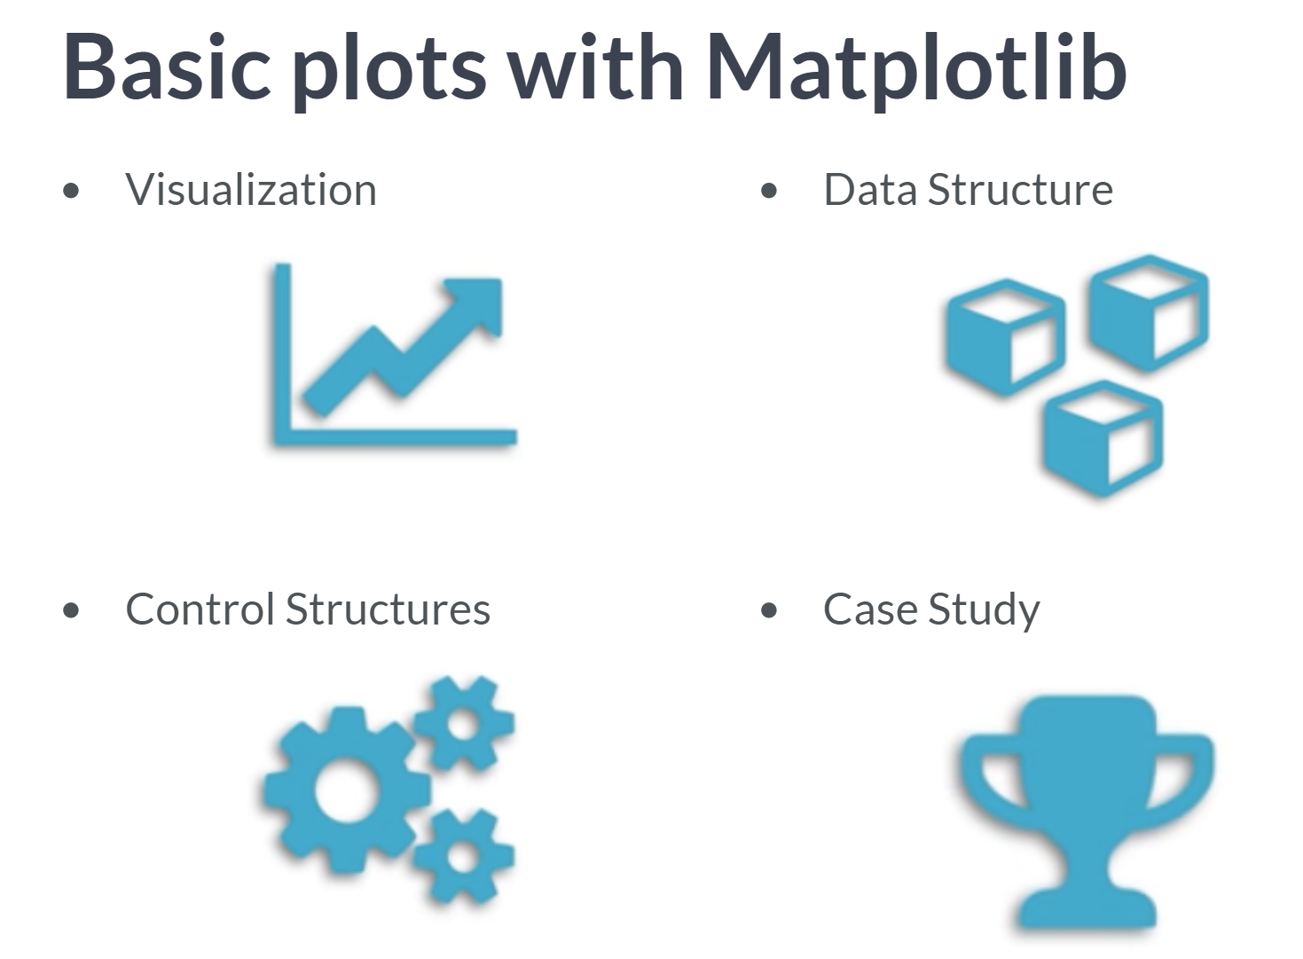  
In this course, we will learn how to visualize data and to store data in new data structures. Along the way, you will master control structure, which you will need to customize the flow of your scripts and algorithms. These are the types of things that data scientists use every day. We will finish this course with a case study, where you'll blend together everything you've learned to solve an exciting challenge.

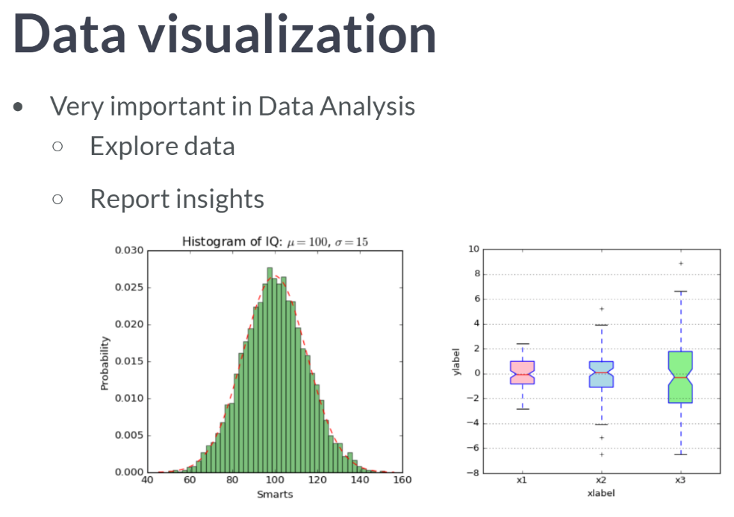  
This first chapter is about data visualization, which is a very important part of data analysis. First of all, you will use it to explore your dataset. The better you understand your data, the better you will be able to extract insights. And once you've found those insights, again, you will need to visualize to share that valuable insights with other people.

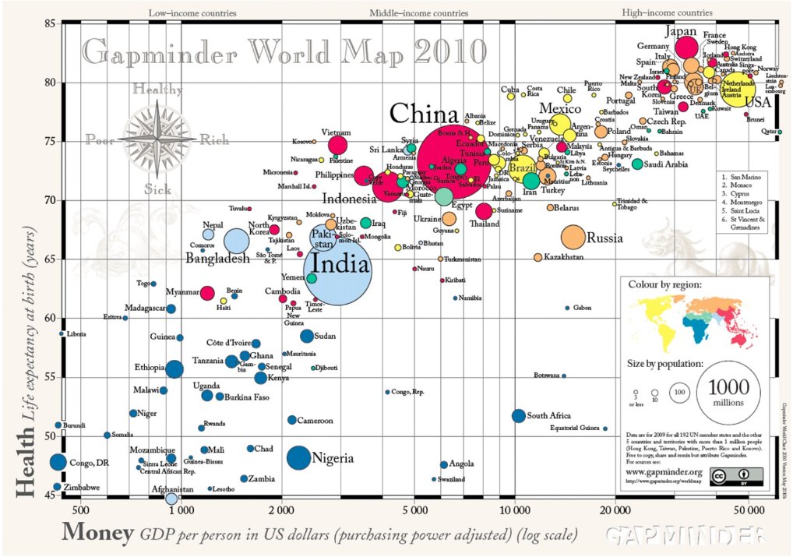  
As an example, have a look at this beautiful plot. It's made by the late, the great Swedish professor, *Hans Rosling*. His talks about global development have been viewed millions of times. And what makes them so intriguing, is that by making beautiful plots, he allows the data to tell their own story. Here we see a bubble chart, where each bubble represents a country. The bigger the bubble, the bigger he country's population, so the two biggest bubbles here are China and India. There are two axes: the horizontal axis shows the GDP per capita, in US dollars, and the vertical axis shows life expectancy. We clearly see that people live longer in countries with a higher GDP per capita. Still, there is a huge difference in life expectancy between countries on the same income level. Now why we are talking all about this? Well, it is because we will build this beautiful plot ourselves!

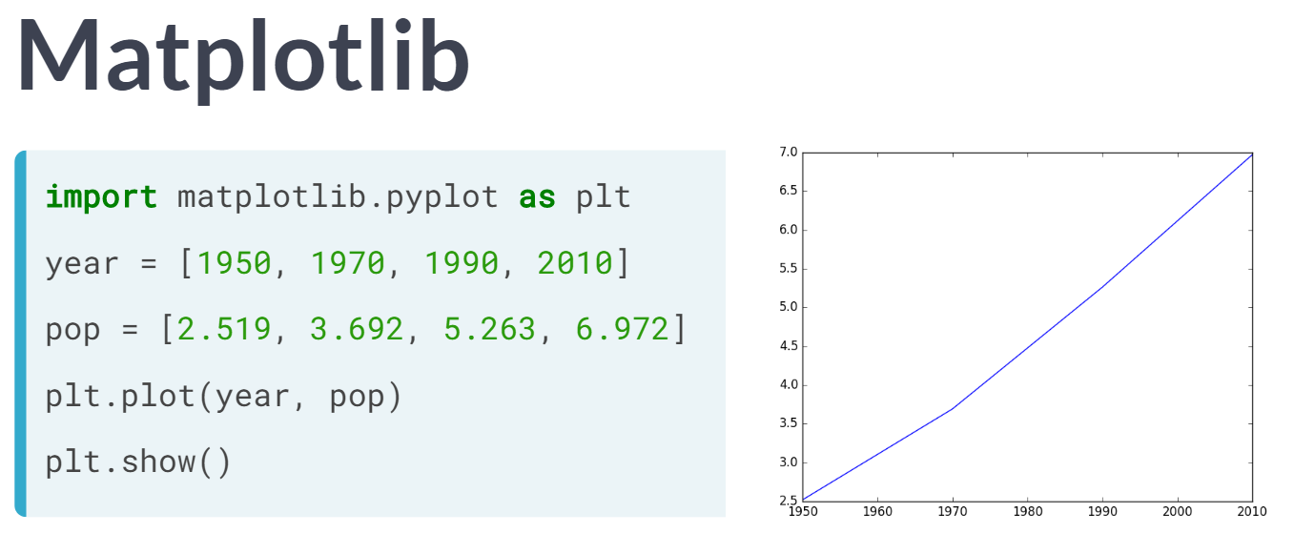  
There are many visualization packages in Python, but the mother of them all, is matplotlib. You will need its subpackage *pyplot*. By convention, this subpackage is imported as *plt*, as shown above.

For our first example, let's try to gain some insights in the evolution of the world population. We have a list with years here, *year*, and a list with corresponding populations expressed in billions, *pop*. In the year 1970, for example, 3.7 billion people lived on the planet Earth.

To plot this data as a line chart, we call *plt.plot* and use our two lists as arguments. The first argument corresponds to the horizontal axis. and the second one to the vertical axis. You might think that a plot will pop up right now, but Python is pretty lazy. It will wait for the ***plt.show()*** function to actually display the plot. This is because you might want to add some extra ingredients to your plot before actually displaying it, such as titles and label customizations.

Just remember this for now: the plot function tells Python what to plot and how to plot it. And show actually displays the plot.

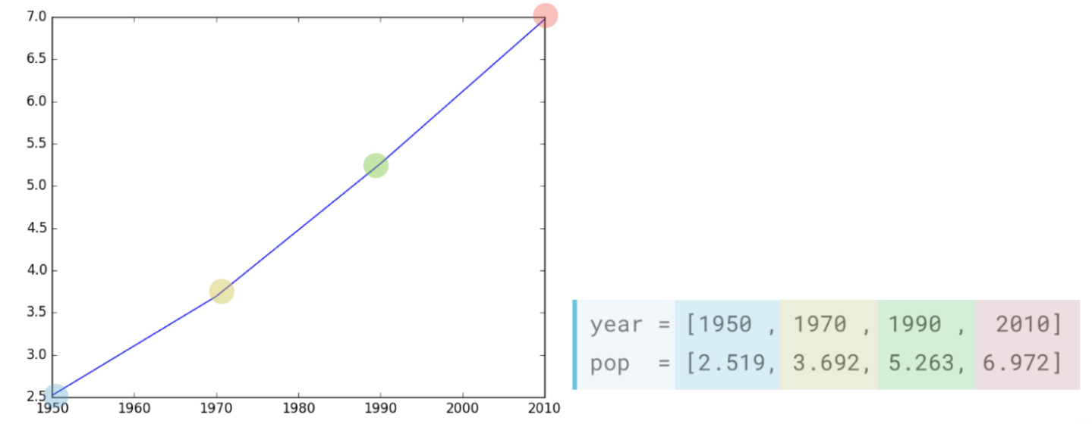  
When we look at our plot, we see that the years are indeed shown on the horizontal axis, and the populations on the vertical axis. There are four data points, and Python draws a line between them. In 1950, the world population was around 2.5 billion. In 2010, it was around 7 billion. So, the world population has almost tripled in sixty years. What if the population keeps growing like that? Will the world become overpopulated? We will find out through upcoming exercises.

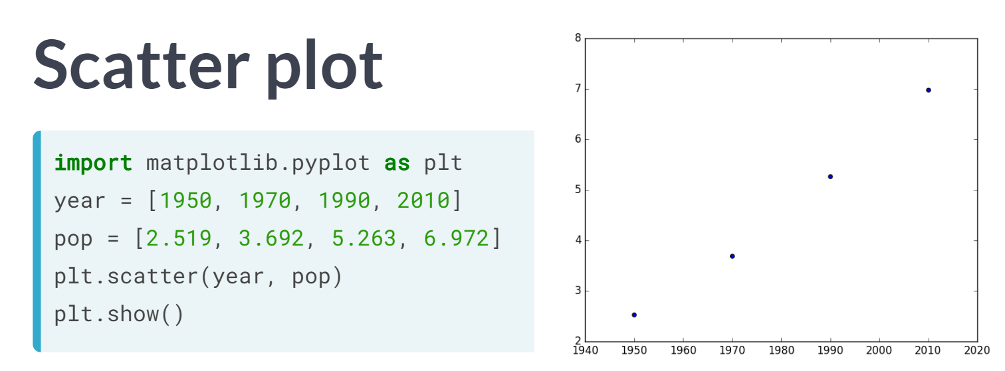

Let us also learn about another type of plot: the scatter plot. To create it, we can start from the code from before. This time, though, we change the plot function to scatter. The resulting scatter plot simply plots all the individual data points.

Python doesn't connect the dots with a line. For many applications, the scatterplot is often a better choice than the line plot, so remember this scatter function for later use. You could also say that this is more honest way of plotting the data, because you can clearly see that the plot is based on just four data points.

# Line plot (1)

With matplotlib, you can create a bunch of different plots in Python. The most basic plot is the line plot. A general recipe is given here.

import matplotlib.pyplot as plt

plt.plot(x,y)

plt.show()

In the video, you already saw how much the world population has grown over the past years. Will it continue to do so? The world bank has estimates of the world population for the years 1950 up to 2100. The years are loaded in your workspace as a list called year, and the corresponding populations as a list called pop.

This course touches on a lot of concepts you may have forgotten, so if you ever need a quick refresher, download the [***Python for data science Cheat Sheet***](https://datacamp-community-prod.s3.amazonaws.com/e30fbcd9-f595-4a9f-803d-05ca5bf84612) and keep it handy!

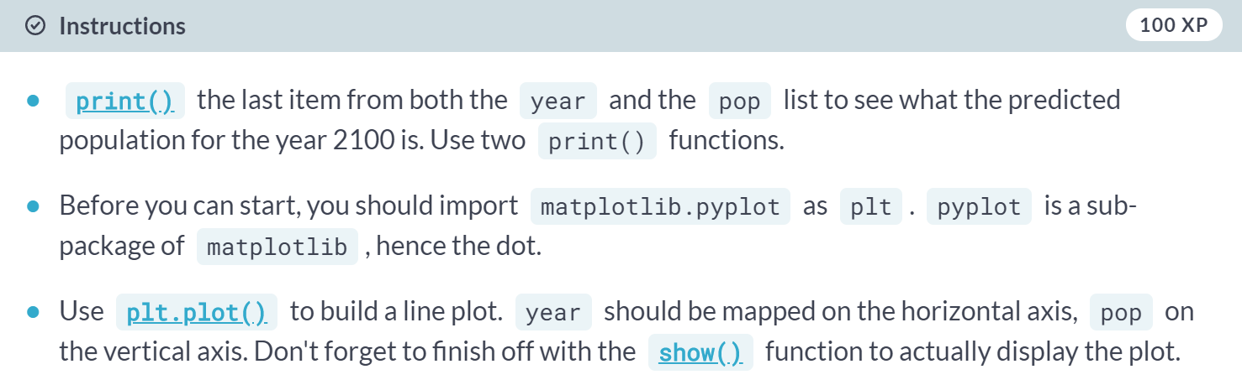

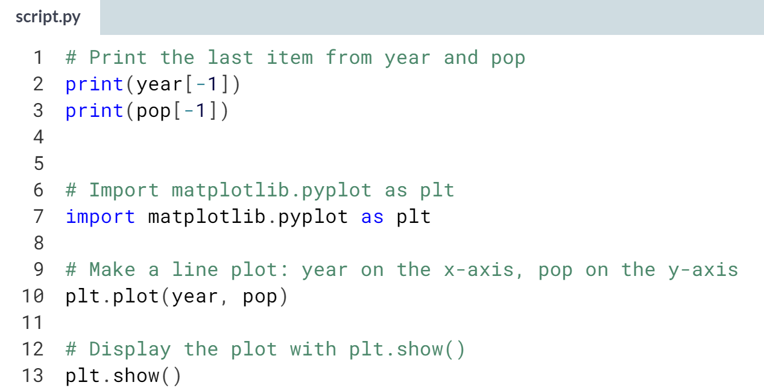

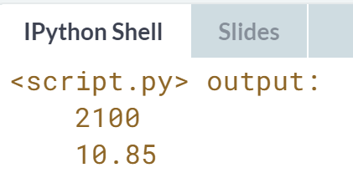

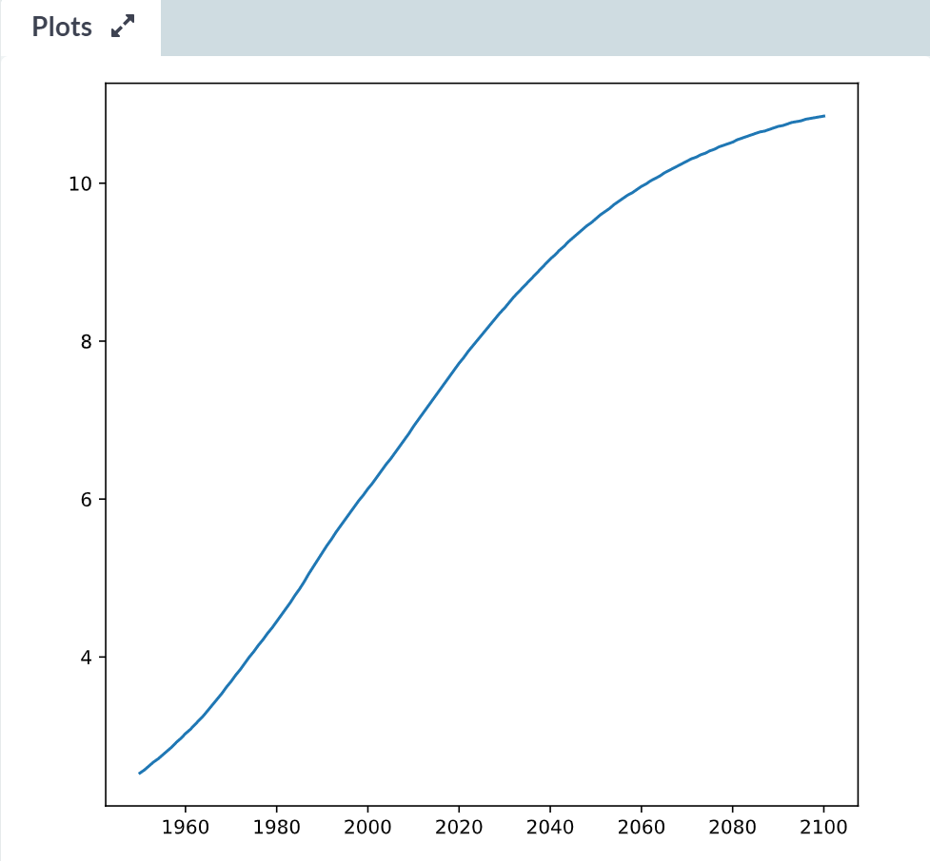

Great! Let's interpret the plot you just created.

# Line Plot (2): Interpretation

Have another look at the plot you created in the previous exercise; it's shown above. Based on the plot, in **approximately** what year will there be more than ten billion human beings on this planet?

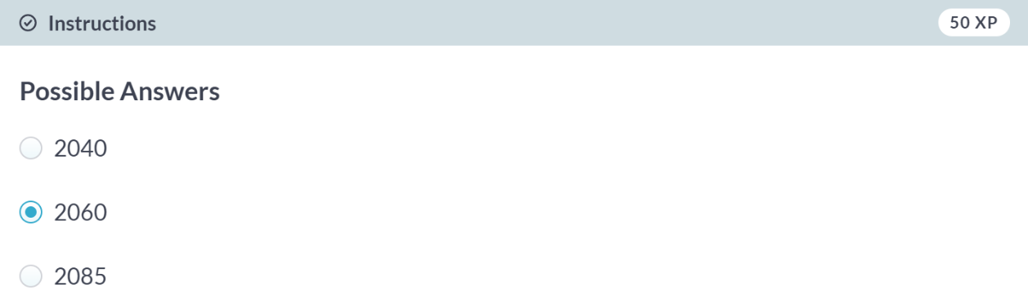

# Line plot (3)

Now that you've built your first line plot, let's start working on the data that professor Hans Rosling used to build his beautiful bubble chart. It was collected in 2007. Two lists are available for you:

* life\_exp which contains the life expectancy for each country and
* gdp\_cap, which contains the GDP per capita (i.e. per person) for each country expressed in US Dollars.

GDP stands for Gross Domestic Product. It basically represents the size of the economy of a country. Divide this by the population and you get the GDP per capita.

matplotlib.pyplot is already imported as plt, so you can get started straight away.

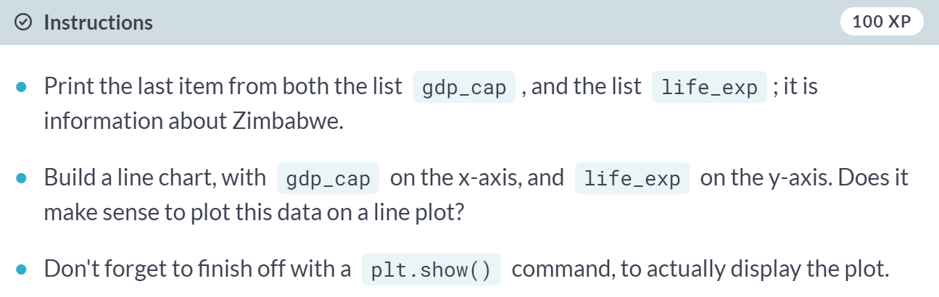

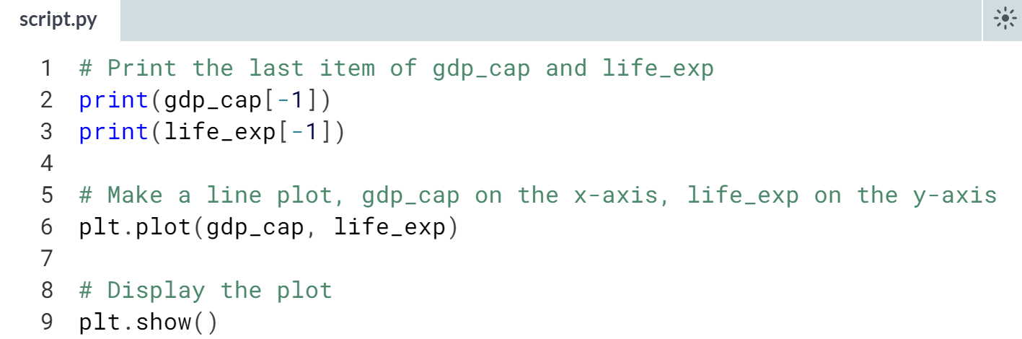

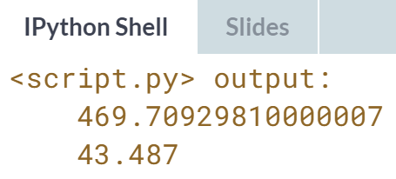

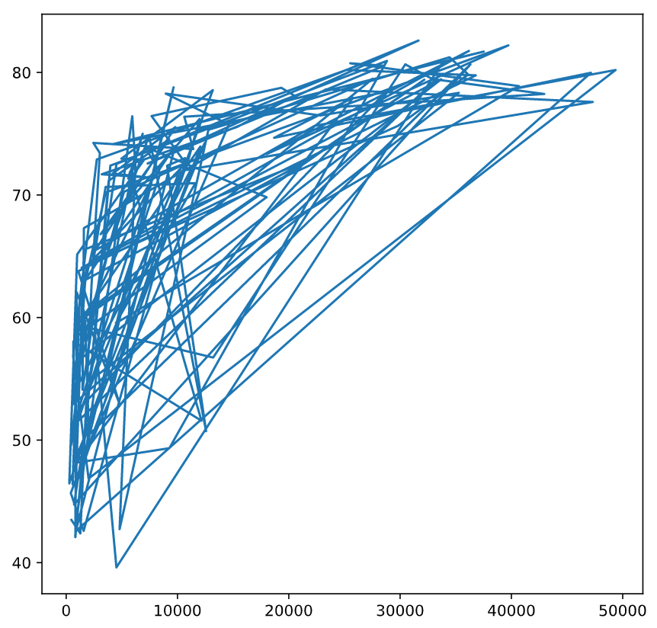  
Well done, but this doesn't look right. Let's build a plot that makes more sense.

# Scatter Plot (1)

When you have a time scale along the horizontal axis, the line plot is your friend. But in many other cases, when you're trying to assess if there's a correlation between two variables, for example, the scatter plot is the better choice. Below is an example of how to build a scatter plot.

import matplotlib.pyplot as plt

plt.scatter(x,y)

plt.show()

Let's continue with the gdp\_cap versus life\_exp plot, the GDP and life expectancy data for different countries in 2007. Maybe a scatter plot will be a better alternative?

Again, the matplotlib.pyplot package is available as plt.

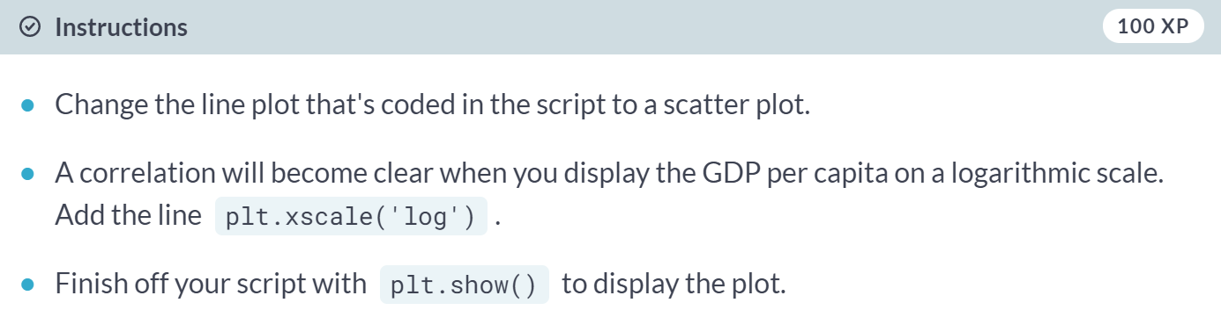  
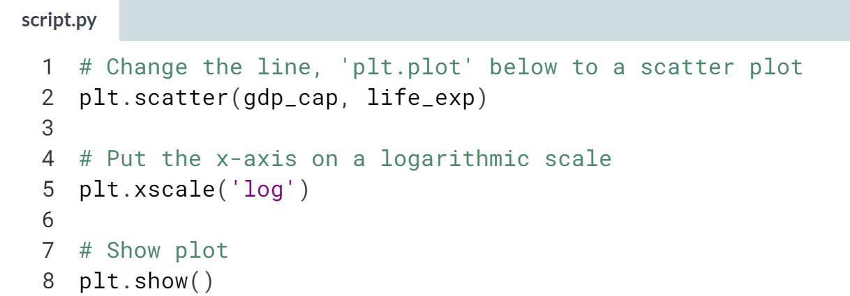  
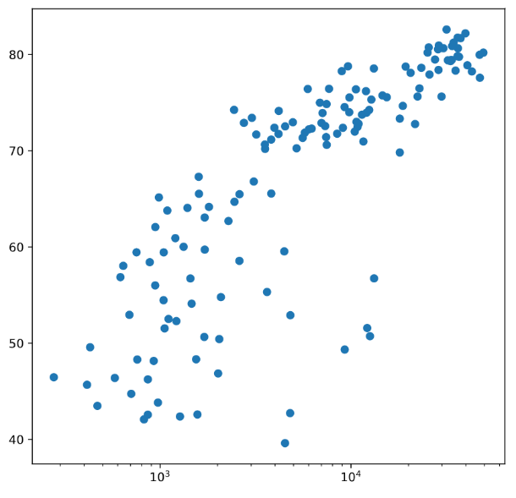

# Scatter plot (2)

In the previous exercise, you saw that the higher GDP usually corresponds to a higher life expectancy. In other words, there is a positive correlation.

Do you think there's a relationship between population and life expectancy of a country? The list life\_exp from the previous exercise is already available. In addition, now also pop is available, listing the corresponding populations for the countries in 2007. The populations are in millions of people.

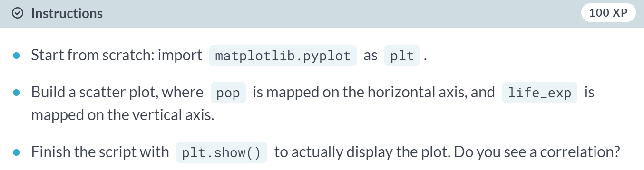  
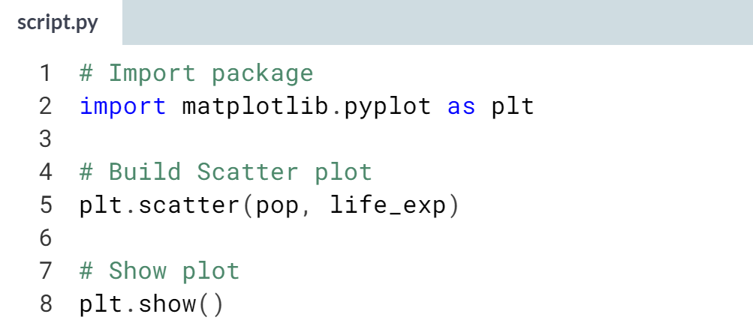  
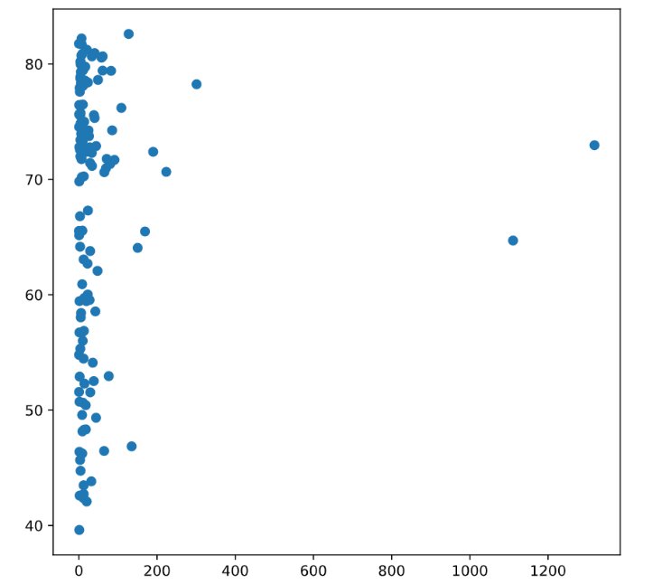   
Nice! There's no clear relationship between population and life expectancy, which makes perfect sense.



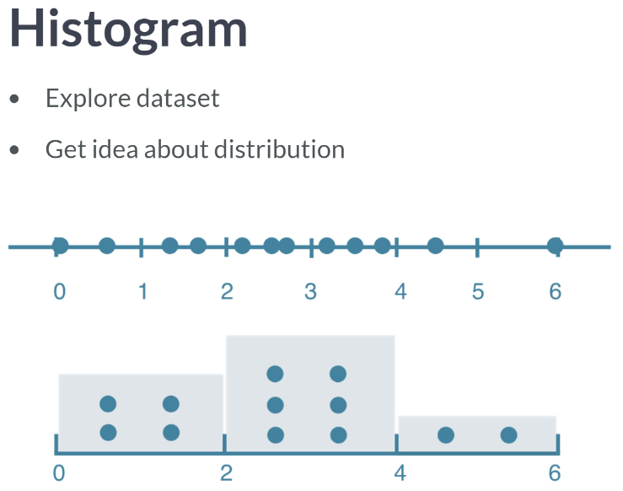

The histogram is a type of visualization that's very useful to explore your data. It can help us to get an idea about the distribution of your variables. To see how it works, imagine 12 values between 0 and 6. These numbers are put along a number line shown above.

To build a histogram for these values, we can divide the line into equal chunks, called bins. Suppose you go for 3 bins, that each have a width of 2. Next, you count how many data points sit inside each bin. There are four data points in the first bin, six in the second bin, and two in the third bin.

Finally, we draw a bar for each bin. The height of the bar corresponds to the number of data points that fall in this bin. The result is a histogram, which gives us a nice overview on how the 12 values are distributed. Most values are in the middle, but there are more values below 2 than there are above 4. Of course, we can use matplotlib to build histograms as well.

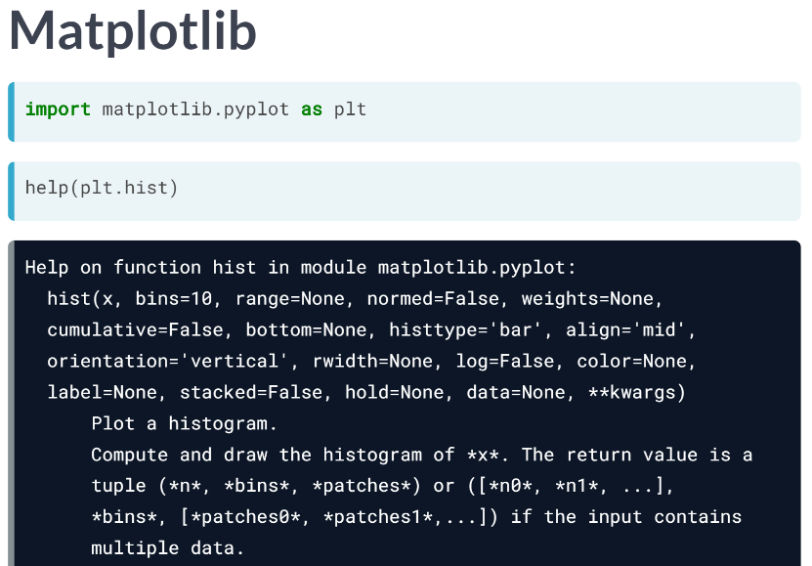  
As before, we should start by importing the *pyplot* package that's inside matplotlib. Next, we can use the hist function. Let's open up its documentation. There's a bunch of arguments we can specify, but the first two here are the most important ones.   
*x* should be a list of values you want to build a histogram for. You can use the second argument, *bins*, to tell Python into how many bins the data should be divided. Based on this number, *hist* will automatically find appropriate boundaries for all bins, and calculate how many values are in each one. If you don't specify the bins argument, it will be 10 by default.

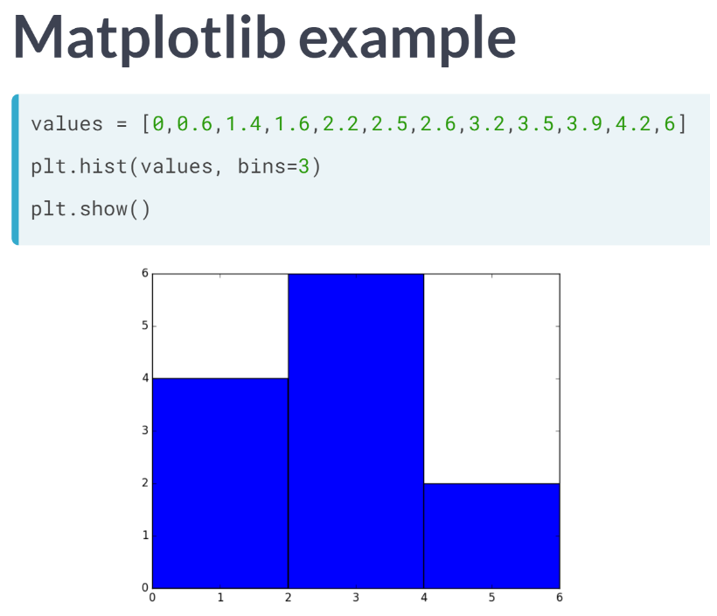  
So, to generate the histogram that you've seen before, let's start by building a list with the 12 values. Next, we simply call his and pass this list as an input, so it's matched to the argument *x*. I also specified the bins argument to be 3, so that the values are divided in three bins. If you finally call the show function, you get a histogram. Histograms are really useful to give a bigger picture.

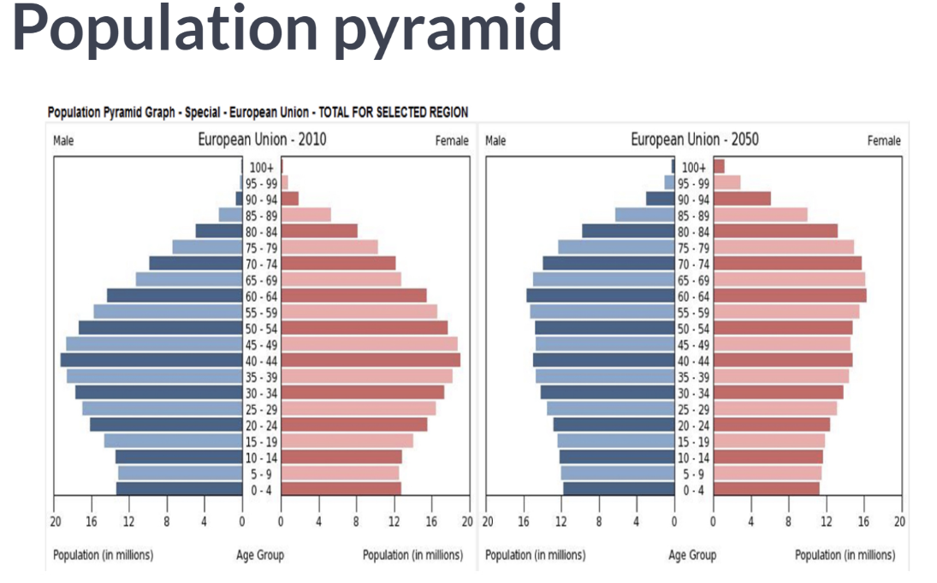  
As an example, have a look at this so-called population pyramid. The age distribution is shown, for both males and females, in the European Union. Notice that the histograms are flipped 90 degrees; the bins are horizontal now. First figure points to data in the year 2010. The bins are largest for the age 40 to 44, where there are 20 million males and 20 million females. They're so called baby boomers.

What do you think will have changed in 2050? Let's have a look. The distribution is flatter, and the baby boomer generation has gotten older. With the blink of an eye, you can easily observe how demographics will be changing over time. That's the true power of histograms at work here.

# Build a histogram (1)

life\_exp, the list containing data on the life expectancy for different countries in 2007, is available in your Python shell.

To see how life expectancy in different countries is distributed, let's create a histogram of life\_exp.

matplotlib.pyplot is already available as plt.

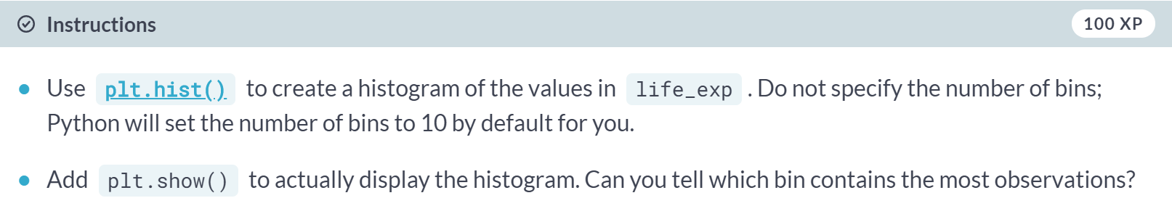

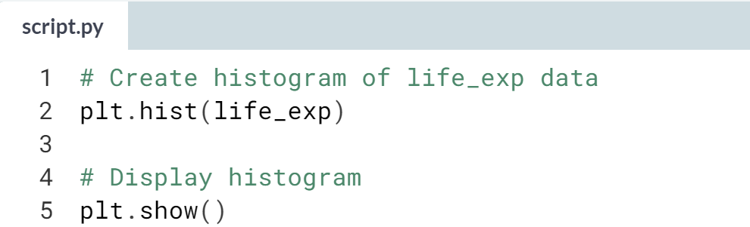  
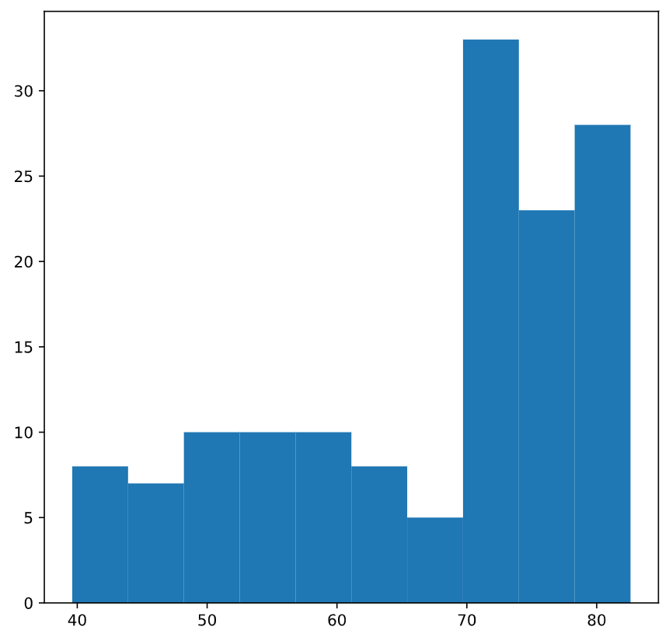

# Build a histogram (2): bins

In the previous exercise, you didn't specify the number of bins. By default, Python sets the number of bins to 10 in that case. The number of bins is pretty important. Too few bins will oversimplify reality and won't show you the details. Too many bins will overcomplicate reality and won't show the bigger picture.

To control the number of bins to divide your data in, you can set the bins argument.

That's exactly what you'll do in this exercise. You'll be making two plots here. The code in the script already includes plt.show() and plt.clf() calls; plt.show() displays a plot; plt.clf() cleans it up again so you can start afresh.

As before, life\_exp is available and matplotlib.pyplot is imported as plt.

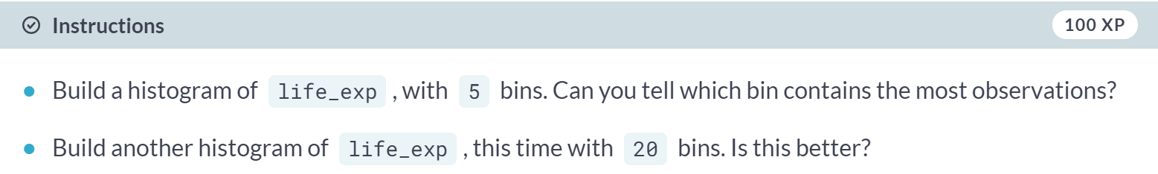  
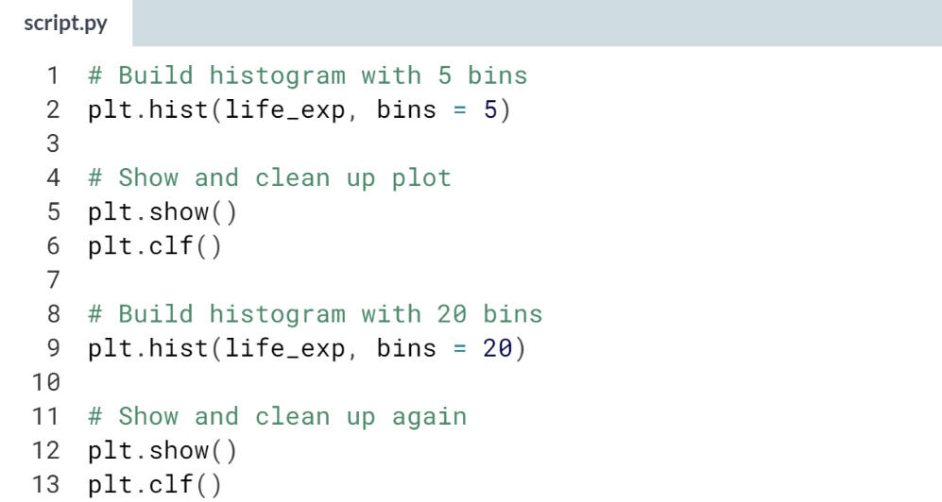  
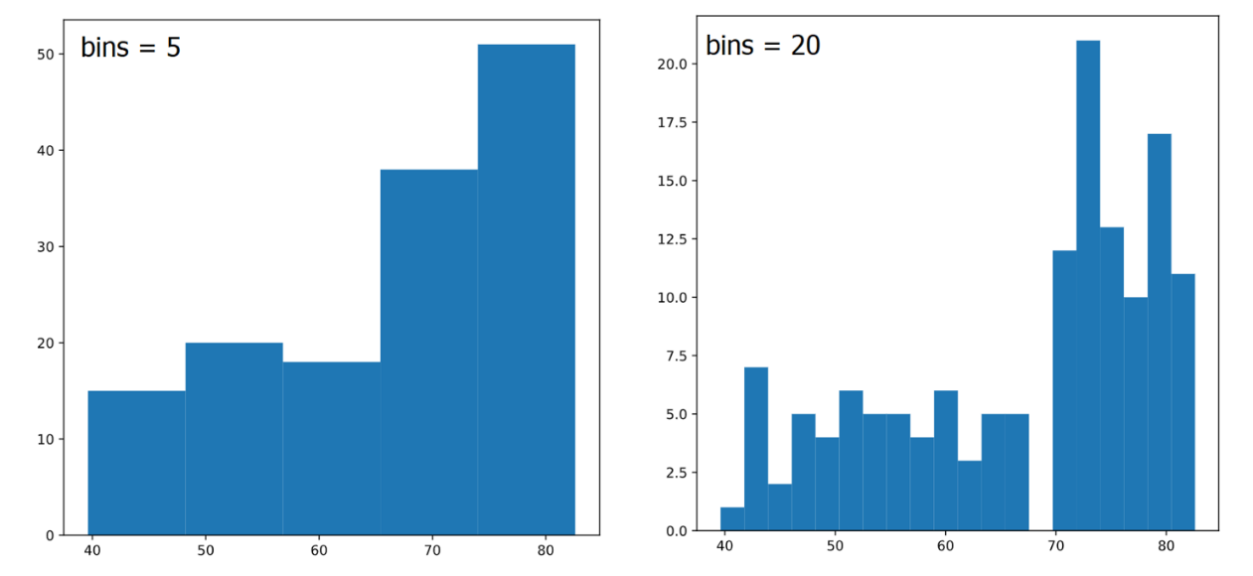

# Build a histogram (3): compare

In the video, you saw population pyramids for the present day and for the future. Because we were using a histogram, it was very easy to make a comparison.

Let's do a similar comparison. life\_exp contains life expectancy data for different countries in 2007. You also have access to a second list now, life\_exp1950, containing similar data for 1950. Can you make a histogram for both datasets?

You'll again be making two plots. The plt.show() and plt.clf() commands to render everything nicely are already included. Also, matplotlib.pyplot is imported for you, as plt.

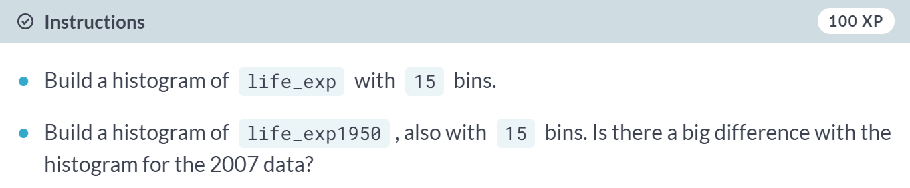  
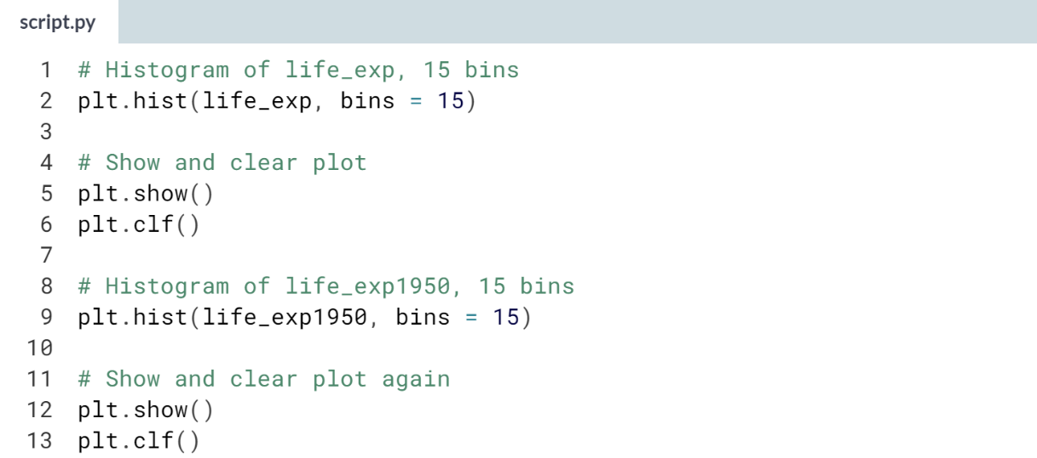  
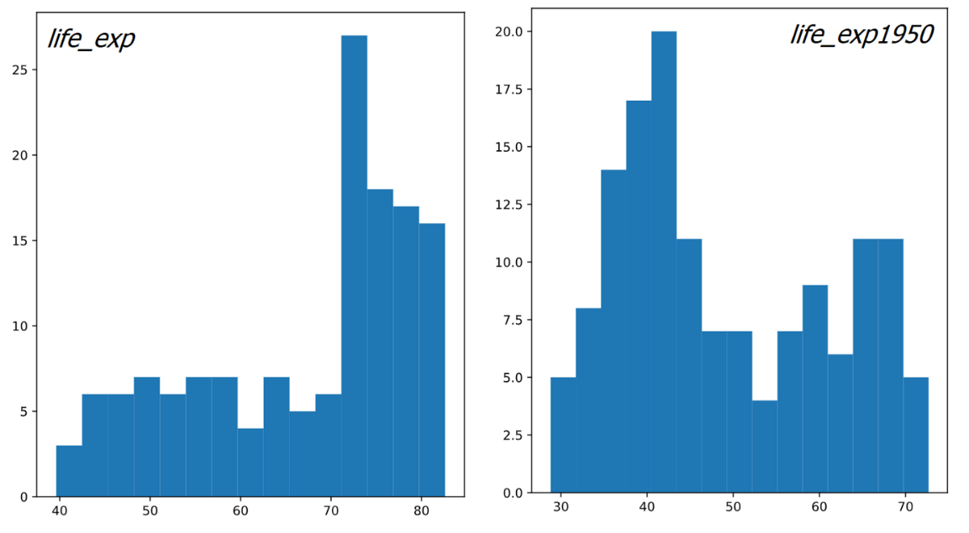

# Choose the right plot (1)

You're a professor teaching Data Science with Python, and you want to visually assess if the grades on your exam follow a particular distribution. Which plot do you use?

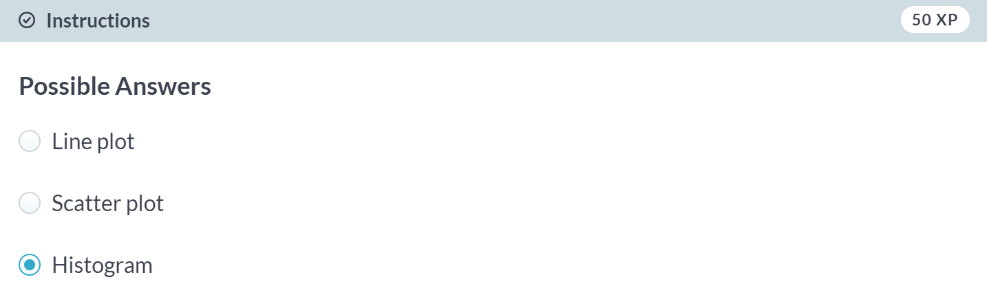

# Choose the right plot (2)

You're a professor in Data Analytics with Python, and you want to visually assess if longer answers on exam questions lead to higher grades. Which plot do you use?

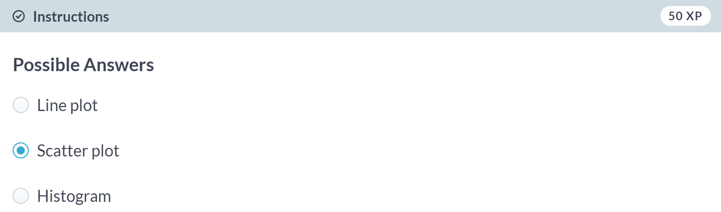



Let's figure out how to customize our plots. Creating a plot is one thing. Making the correct plot, that makes the message very clear. That's the real challenge.

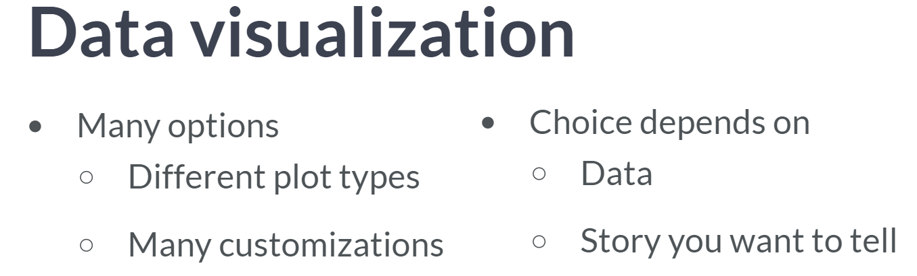  
For each visualization, you have many options. First of all, there are the different plot types. And for each plot. you can do an infinite number of customizations. You can change colors, shapes, labels, axes, and so on. The choice depends on the data and the story you want to tell with this data. Since there are so many possible customizations, the best way to learn this is by example.

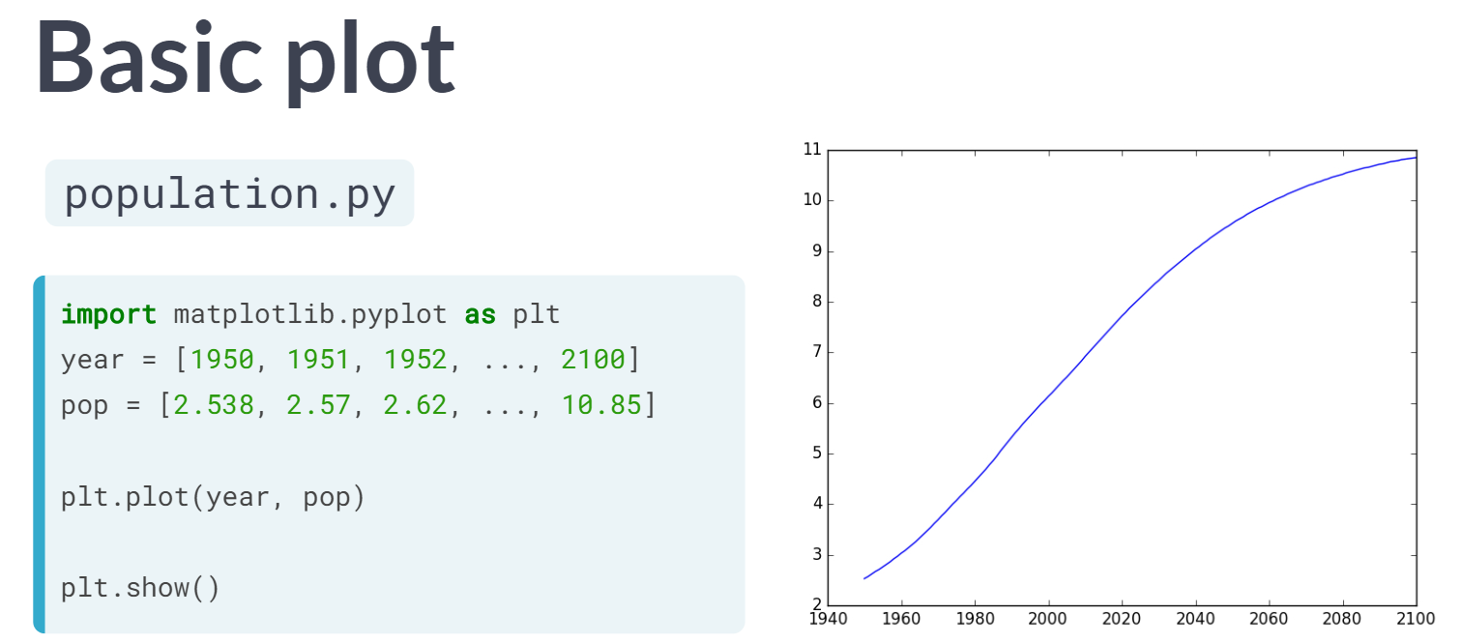  
Let's start with the code in this script to build a simple line plot. It's similar to the line plot we've created in the first video, but this time, the year and the pop lists contain more data, including projections until the year 2010, forecasted by the UN.

If we run this script, we already get a pretty nice plot: it shows that the population explosion that's going on will have slowed down by the end of the century. But some things can be improved.

First, it should be clear which data we are displaying. especially to people who are seeing the graph for the first time. And second, the plot really needs to draw the attention to the population explosion.

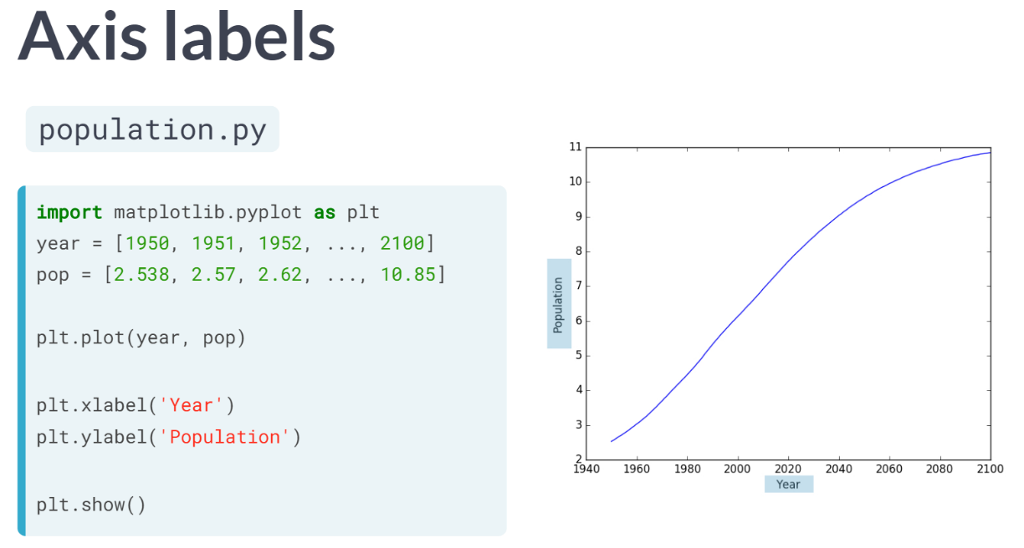  
The first thing you always need to do is label your axes. Let's do this by adding the *xlabel* and *ylabel* functions. As inputs, we pass strings that should be placed alongside the axes. Make sure to call these functions before calling the show function, otherwise your customization will not be displayed. If we run this script again this time, the axes are annotated.

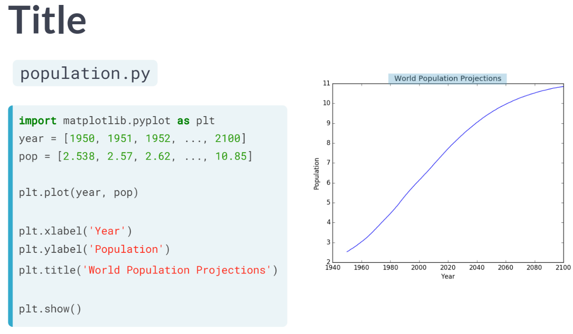  
We are also going to add a title to our input, with the title function. We pass the actual title, 'World Population Projections', as an argument. And there's the title! So, using *xlabel*, *ylabel*, and *title*, we can give the reader more information about the data on the plot: now they can at least tell what the plot is about.

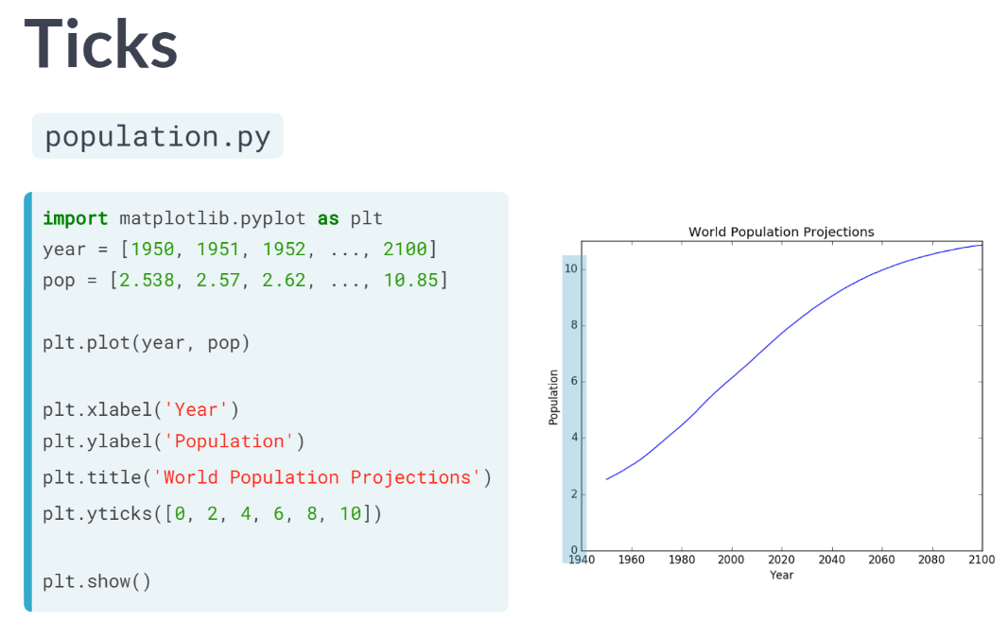  
To put the population growth in perspective, we want to have the y-axis starting from zero. You can do this with the ***yticks()*** function. The first input is a list, in this example with the numbers zero up to ten, with intervals of 2. If we run this code, the plot will change: the curves shift up. Now it's clear that already in 1950, there were already about 2.5 billion people on the planet.

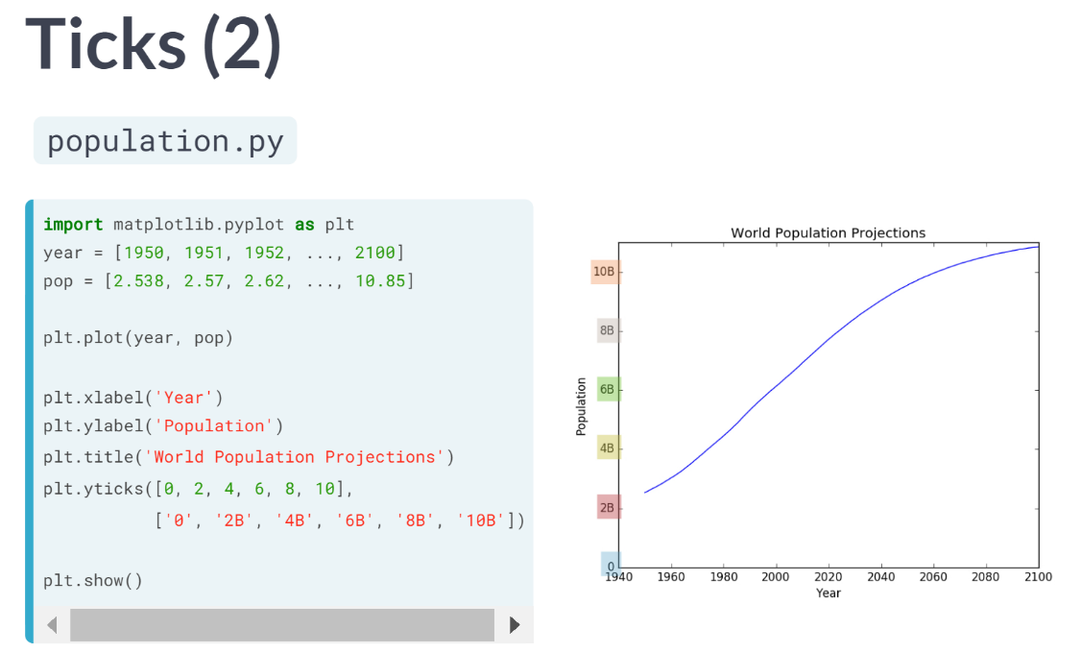  
Next to make it clear that we are talking about populations in billions, we can add a second argument to the ***yticks()*** function, which is a list with the display names of the ticks.

This list should have the same length as the first list. The tick 0 gets the name 0, the tick 2 gets the name 2B, the tick 4 gets the name 4B and so on. If we run this version of script, the labels will change accordingly.

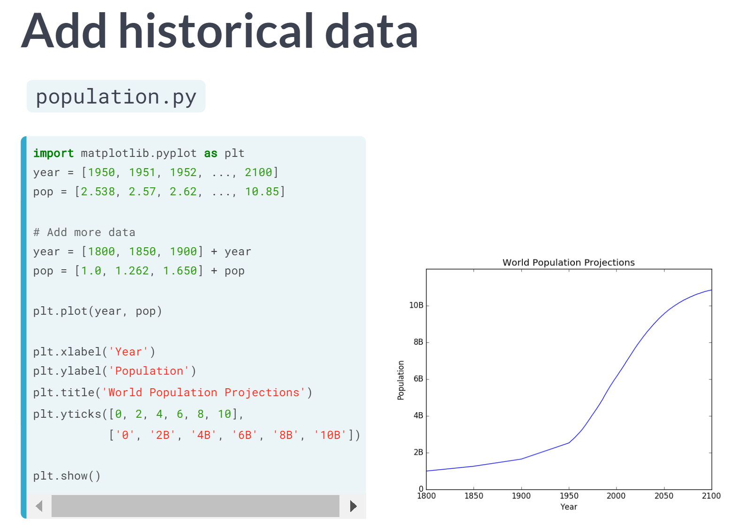  
Finally, let's add some more historical data to accentuate the population explosion in the last 60 years.

Let's suppose that we archive the population data from the years: 1800, 1850, and 1900. I can write them in the list form and append them to the pop and year lists with the plus sign.

If I now run the script once more, three data points are added to the graph, giving us a more complete picture.

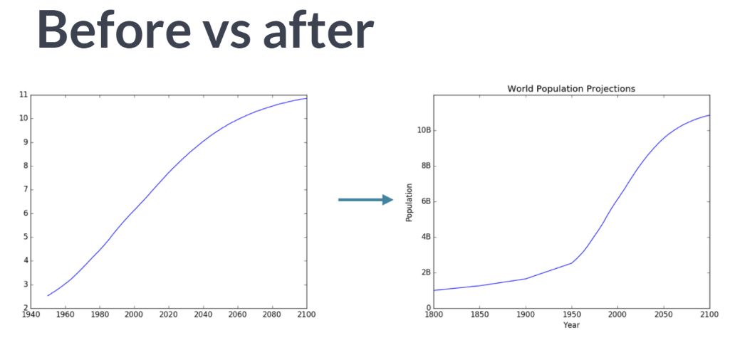  
Now that's how you turn an average line plot into a visual that has a clear story to tell.

# Labels

It's time to customize your own plot. This is the fun part; you will see your plot come to life!

You're going to work on the scatter plot with world development data: GDP per capita on the x-axis (logarithmic scale), life expectancy on the y-axis. The code for this plot is available in the script.

As a first step, let's add axis labels and a title to the plot. You can do this with the **[xlabel()](http://matplotlib.org/api/pyplot_api.html" \l "matplotlib.pyplot.xlabel" \t "_blank)**, **[ylabel()](http://matplotlib.org/api/pyplot_api.html" \l "matplotlib.pyplot.ylabel" \t "_blank)** and [**title()**](http://matplotlib.org/api/pyplot_api.html#matplotlib.pyplot.title) functions, available in matplotlib.pyplot. This sub-package is already imported as plt.

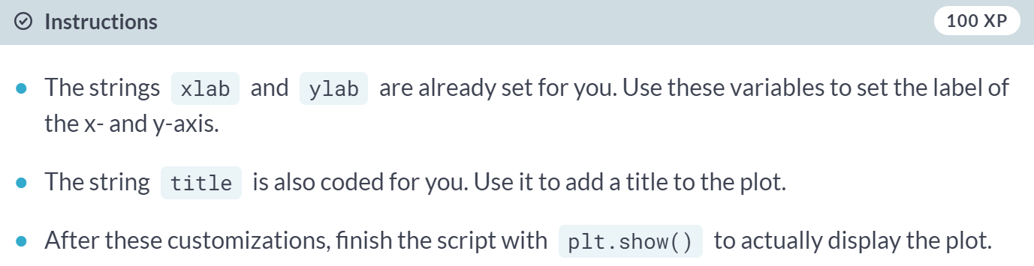

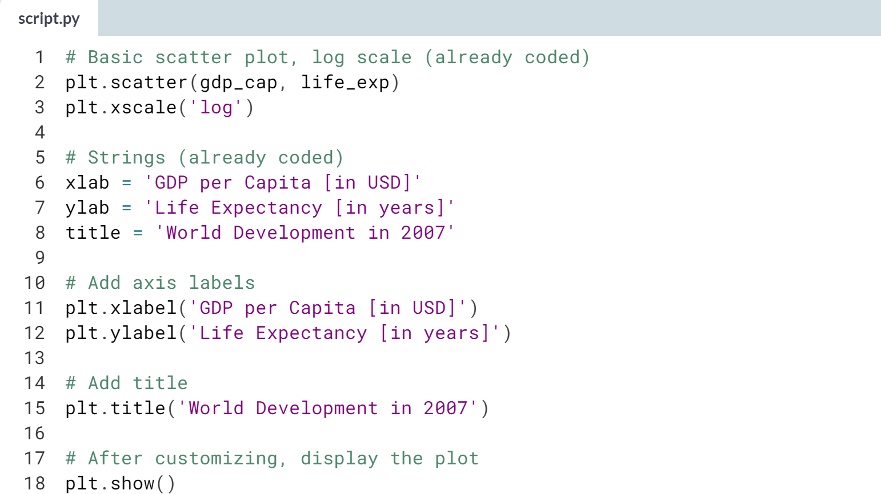

(Graph on the next page)

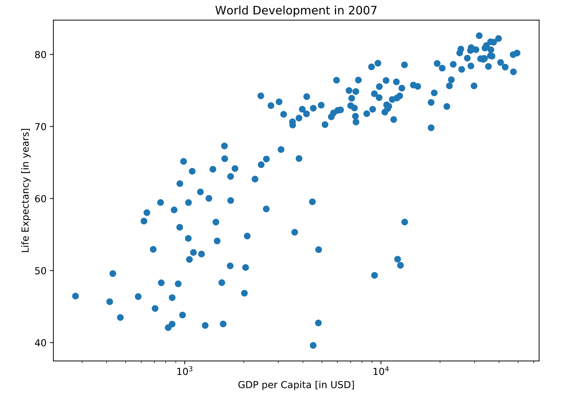

# Ticks

The customizations you've coded up to now are available in the script, in a more concise form.

In the video, Hugo has demonstrated how you could control the y-ticks by specifying two arguments:

plt.yticks([0,1,2], ["one","two","three"])

In this example, the ticks corresponding to the numbers 0, 1 and 2 will be replaced by one, two and three, respectively.

Let's do a similar thing for the x-axis of your world development chart, with the [**xticks()**](http://matplotlib.org/api/pyplot_api.html#matplotlib.pyplot.xticks) function. The tick values 1000, 10000 and 100000 should be replaced by 1k, 10k and 100k. To this end, two lists have already been created for you: tick\_val and tick\_lab.

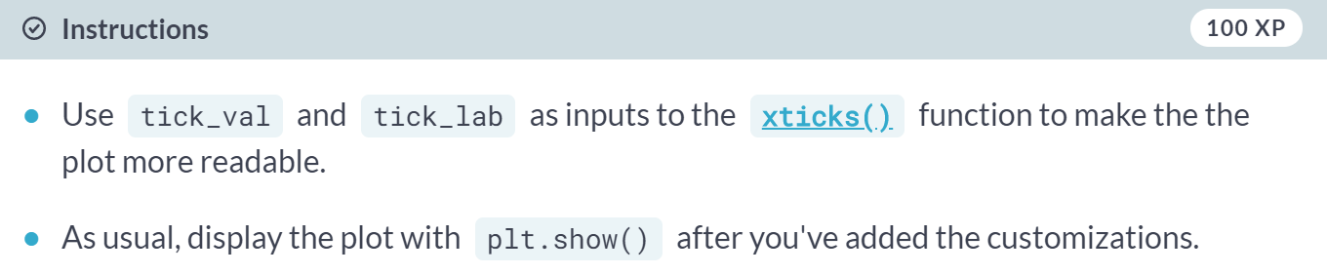

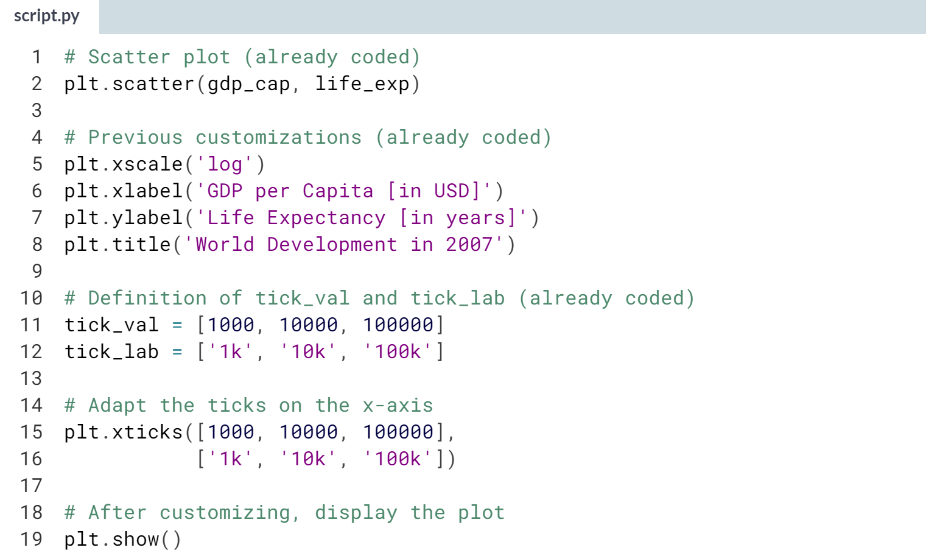  
(Graph on the next page)

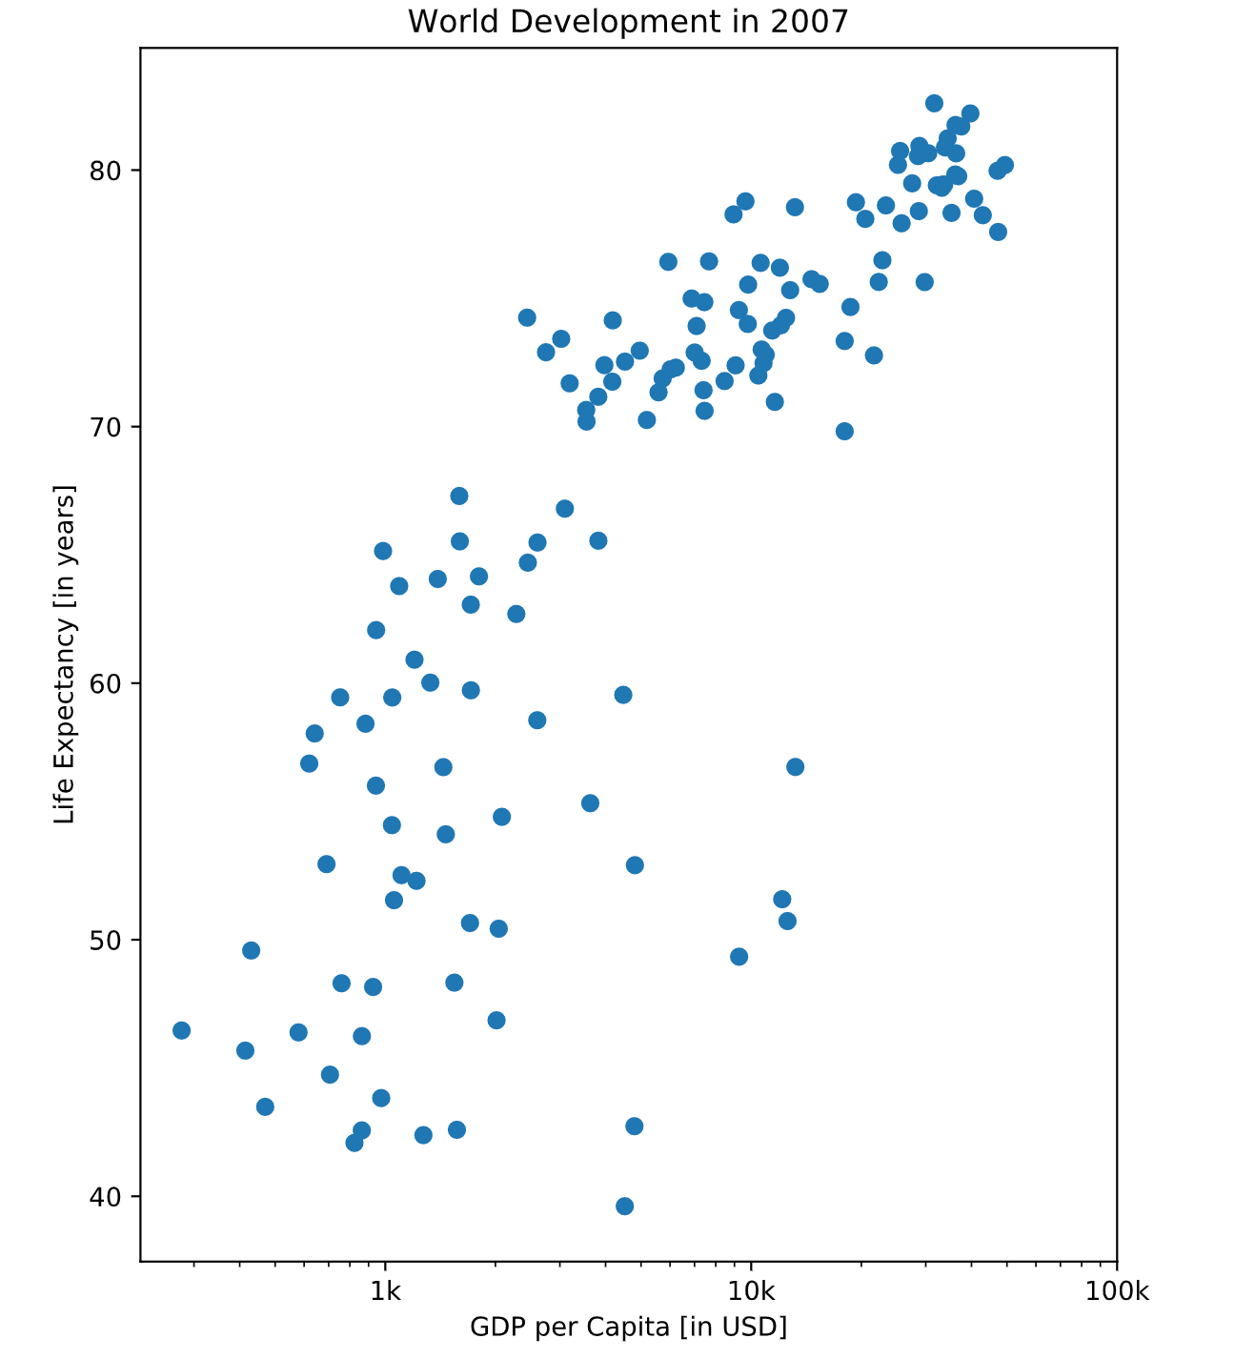

# Sizes

Right now, the scatter plot is just a cloud of blue dots, indistinguishable from each other. Let's change this. Wouldn't it be nice if the size of the dots corresponds to the population?

To accomplish this, there is a list pop loaded in your workspace. It contains population numbers for each country expressed in millions. You can see that this list is added to the scatter method, as the argument s, for size.

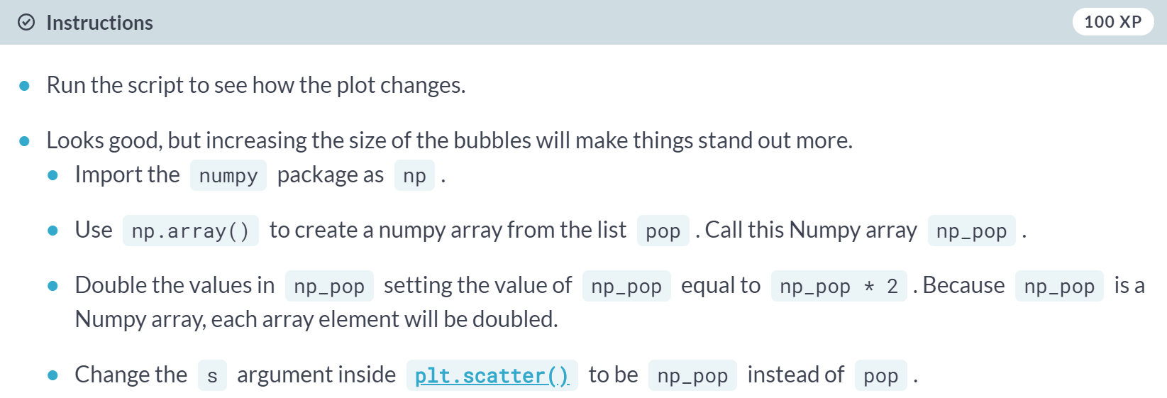

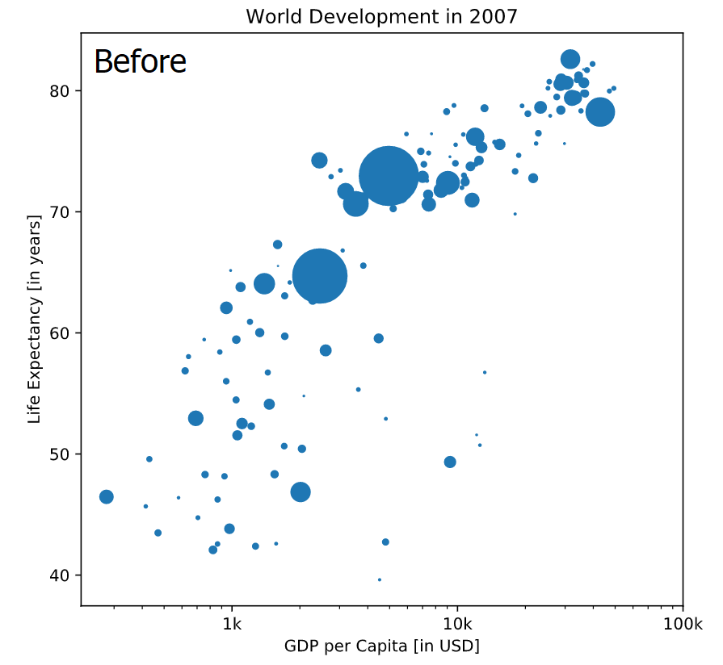

# Colors

The code you've written up to now is available in the script on the below.

The next step is making the plot more colorful! To do this, a list col has been created for you. It's a list with a color for each corresponding country, depending on the continent the country is part of.

How did we make the list col you ask? The Gapminder data contains a list continent with the continent each country belongs to. A dictionary is constructed that maps continents onto colors:

dict = {

'Asia':'red',

'Europe':'green',

'Africa':'blue',

'Americas':'yellow',

'Oceania':'black'

}

Nothing to worry about now; you will learn about dictionaries in the next chapter.

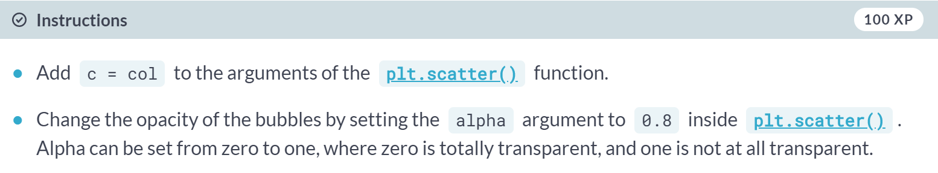

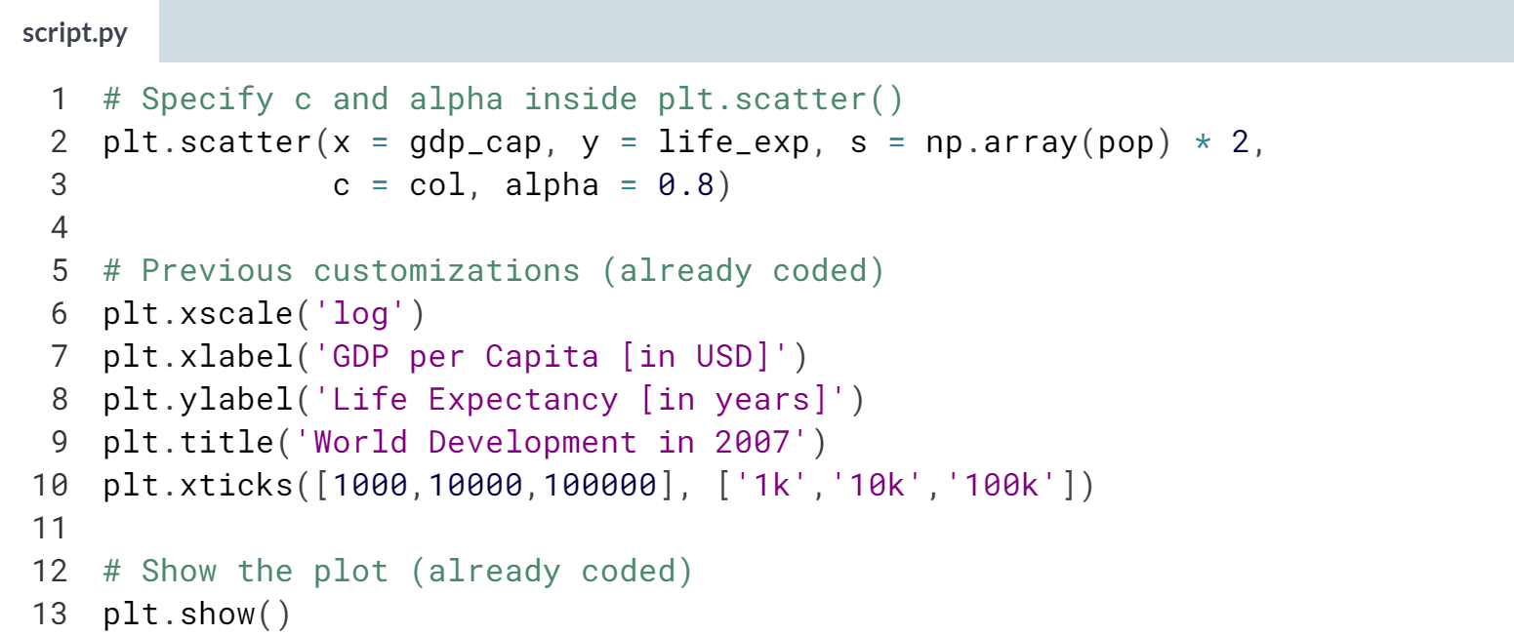

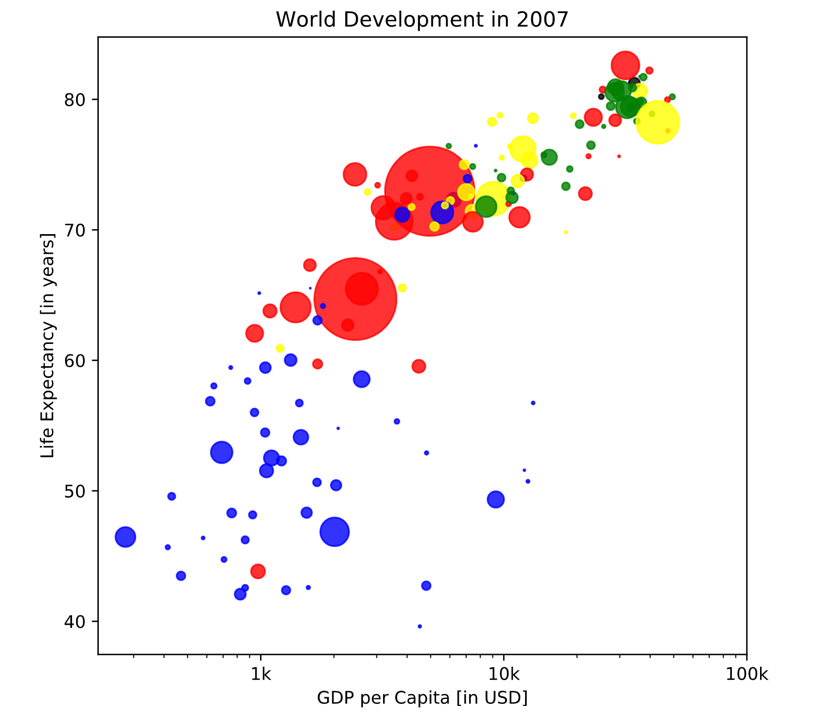  
Nice! This is looking more and more like Hans Rosling's plot!

# Additional Customizations

If you have another look at the script, under # Additional Customizations, you'll see that there are two **[plt.text()](http://matplotlib.org/api/pyplot_api.html" \l "matplotlib.pyplot.text" \t "_blank)** functions now. They add the words "India" and "China" in the plot.

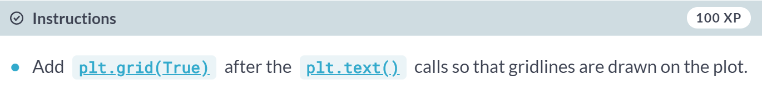

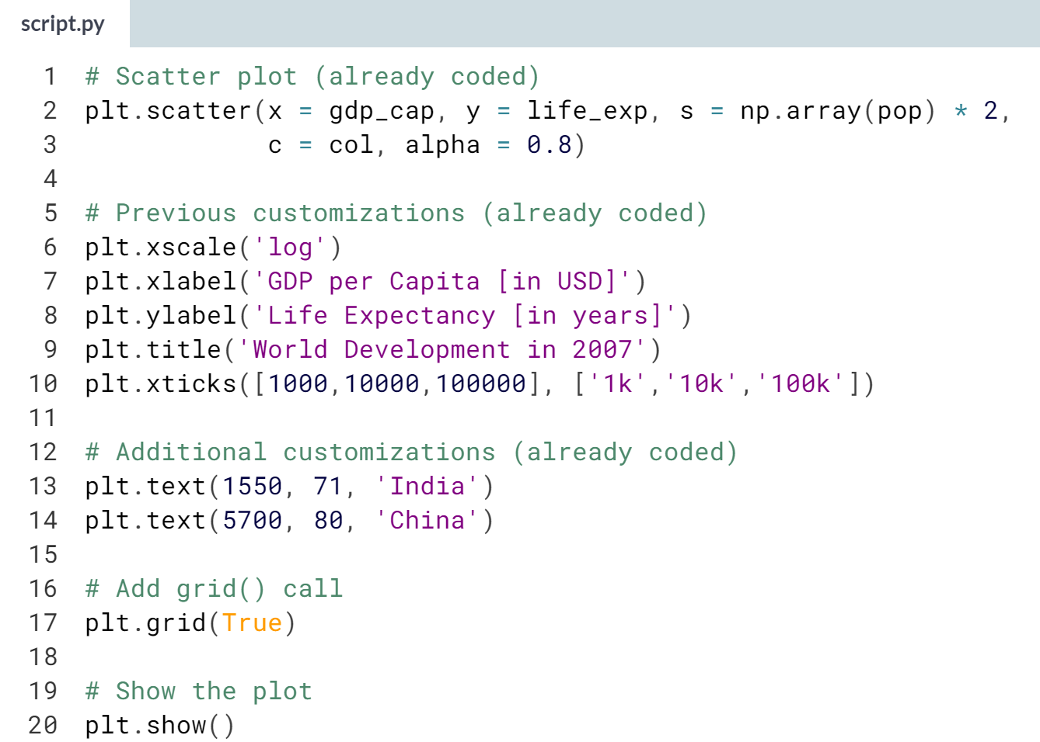

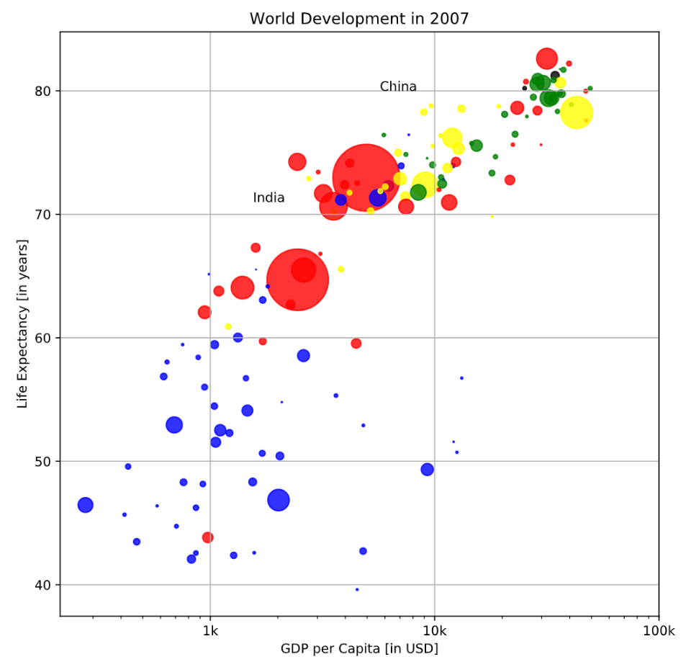

Beautiful! A visualization only makes sense if you can interpret it properly. Let's do that in the next exercise.

# Interpretation

If you have a look at your colorful plot above, it's clear that people live longer in countries with a higher GDP per capita. No high-income countries have really short life expectancy, and no low income countries have very long life expectancy. Still, there is a huge difference in life expectancy between countries on the same income level. Most people live in middle-income countries where difference in lifespan is huge between countries; depending on how income is distributed and how it is used.

What can you say about the plot?

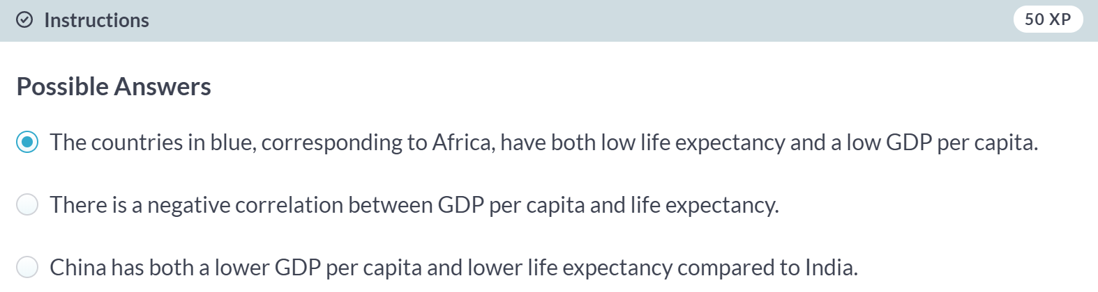

**2. Dictionaries & Pandas**

Learn about the dictionary, an alternative to the Python list, and the pandas DataFrame, the de facto standard to work with tabular data in Python. You will get hands-on practice with creating and manipulating datasets, and you’ll learn how to access the information you need from these data structures.



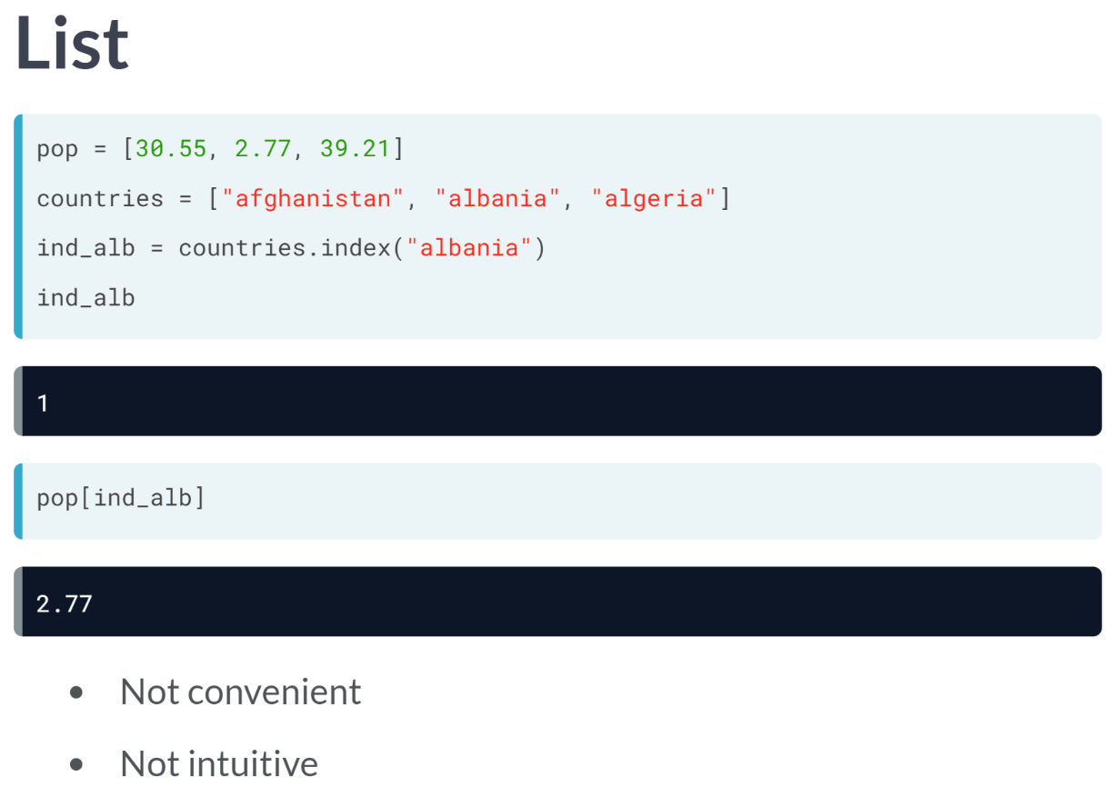  
We will talk about a new Python type: the dictionary. Let's suppose that you work for the World Bank and want to keep track of the population in each country. You can put the populations in a list. You start with Afghanistan, 30.55 million, Albania, 2.77 million, Algeria, around 40 million, and so on.

To keep track about which population belongs to which country, you can create a second list, with the names of the countries in the same order as the populations. Now suppose that want to get the population of Albania. First, you have to figure out where in the list Albania is, so that you can use this position to get the correct population.

Remember about the method ***index()***, a list method we learned earlier. Let's use it to get the index of Albania in countries, like this above. Now we can use this index to subset the pop list, to get the population corresponding to Albania. As expected, we get 2.77, the population of Albania in millions.

So, we built two lists and used the index to connect corresponding elements in both lists. It worked, but it's a pretty terrible approach: it's not convenient nor intuitive.

Wouldn't it be easier if we had a way to connect each country directly to its population, without using an index? This is where the dictionary comes into play.

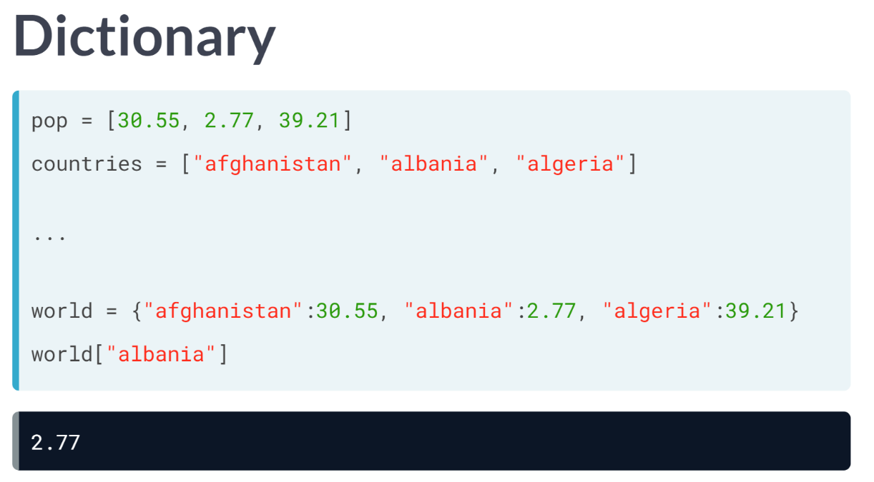  
Let's convert this population data to a dictionary. The lists are already included on the top here, so we can see what's going on. To create the dictionary, we need curly brackets. Next, inside the curly brackets, you have a bunch of that are called *key:value* pairs.

In our case, the keys are the country names, and the values are the corresponding populations. The first key is *"afghanistan"* and its corresponding value is 30.55. Notice the colon that separates the key and value here.

Let's do the same thing for the two other key-value pairs and store the dictionary under the name world. If you now want to find the population of Albania, you simply type world, and then the string *"albania"* inside the square brackets.

In other words, you pass the key in square brackets, and you get the corresponding value. the key opens the door to the value. This approach is not only intuitive, but also it is very efficient, because Python can make the lookup of these keys very fast, even for huge dictionaries.

# Motivation for dictionaries

To see why dictionaries are useful, have a look at the two lists defined on the right. countries  contains the names of some European countries. capitals  lists the corresponding names of their capital.

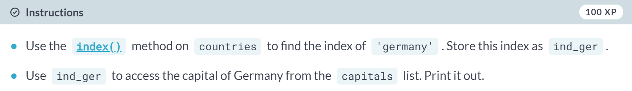

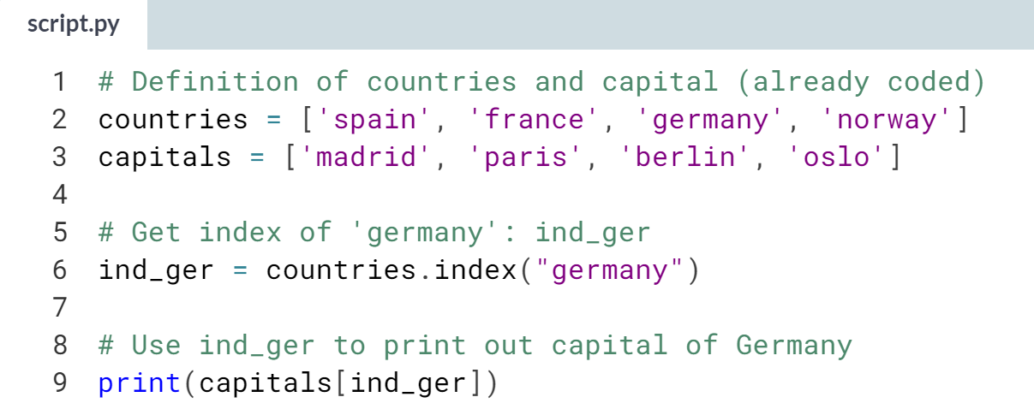

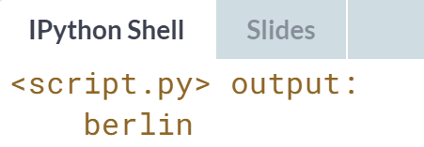

As we are told, this works, but it's not very convenient. Head over to the next exercise to create a dictionary of this data.

# Create dictionary

The countries and capitals lists are again available in the script. It's your job to convert this data to a dictionary where the country names are the keys and the capitals are the corresponding values. As a refresher, here is a recipe for creating a dictionary:

my\_dict = {

"key1":"value1",

"key2":"value2",

}

In this recipe, both the keys and the values are strings. This will also be the case for this exercise.

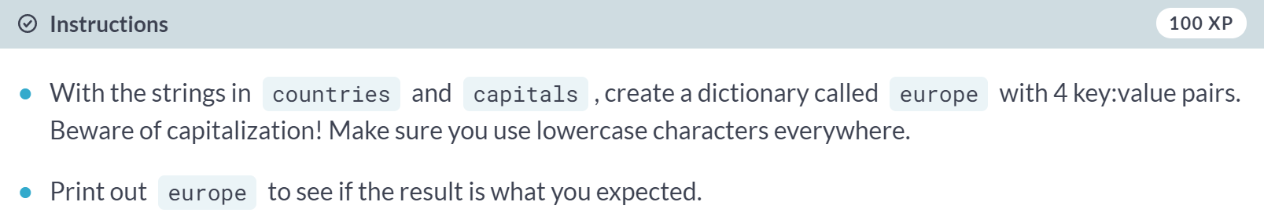

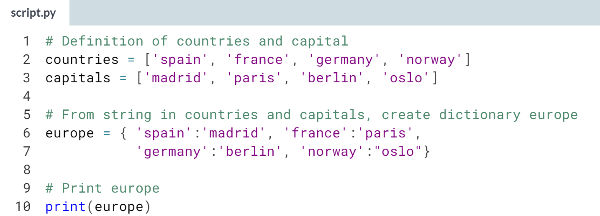

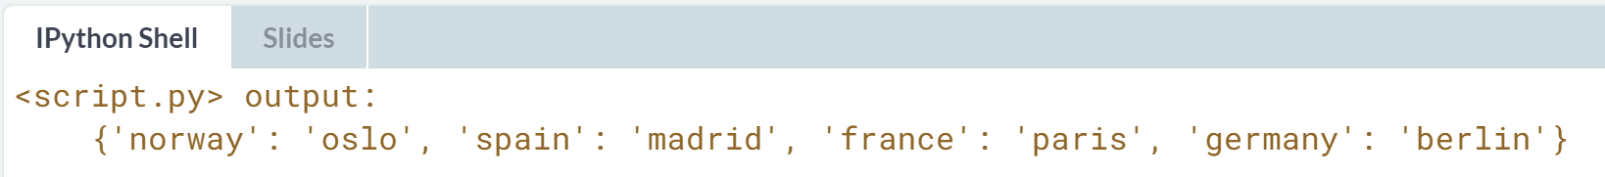

Great! Now that you've built your first dictionaries, let's get serious!

# Access dictionary

If the keys of a dictionary are chosen wisely, accessing the values in a dictionary is easy and intuitive. For example, to get the capital for France from europe you can use:

europe['france']

Here, 'france' is the key and 'paris' the value is returned.

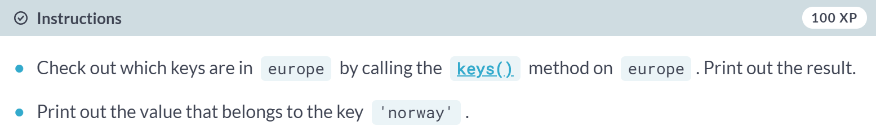

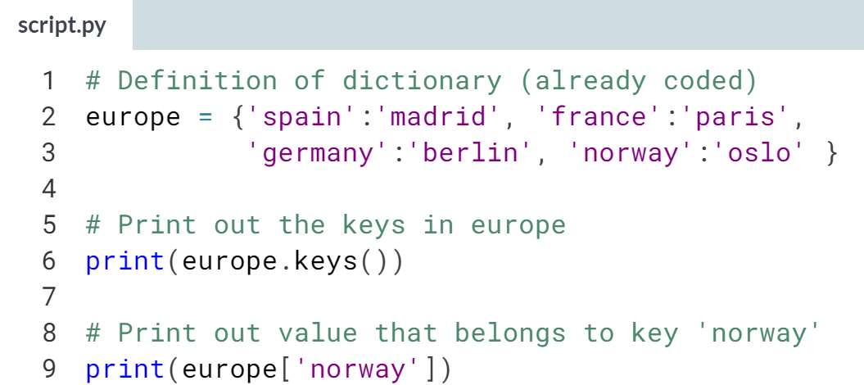

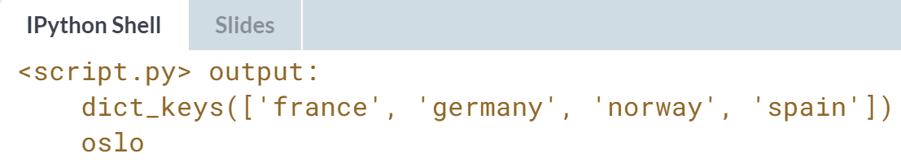



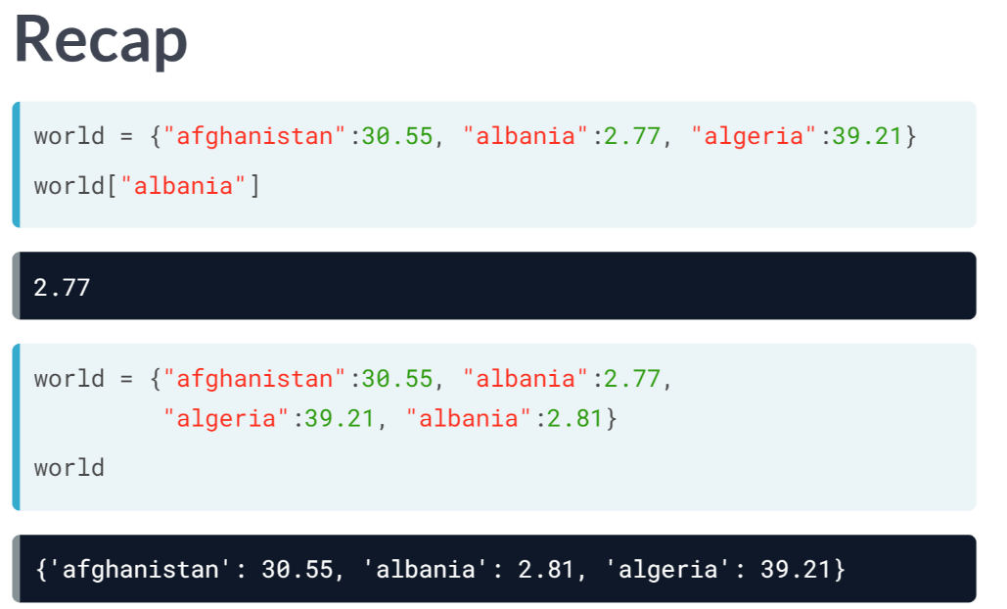

In the previous lesson, we created the dictionary *"world"*, which basically is a set of key value pairs. We could easily access the population of Albania, by passing the key in square brackets, like the above. For this lookup to work properly, the keys in a dictionary should be unique.

If you try to add another *key:value* pair to world with the same key, Albania, for example, you'll see that the resulting world dictionary still contains three pairs. The last pair that you specified in the curly brackets was kept in the resulting dictionary.

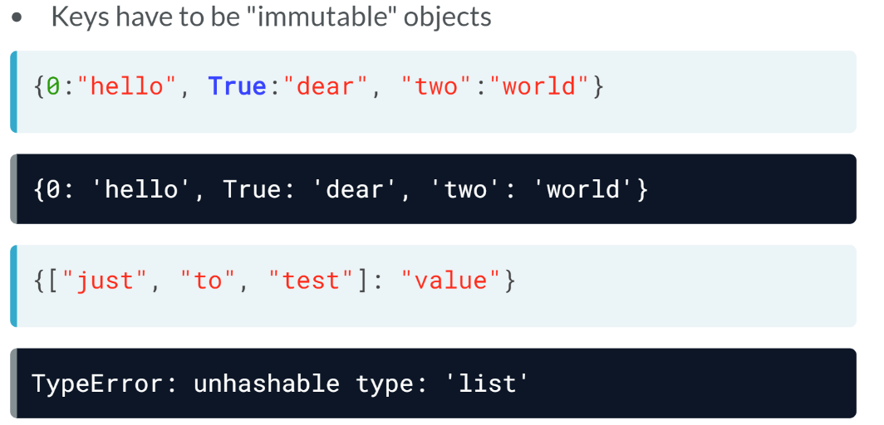  
Also, these unique keys in a dictionary should be so-called immutable objects, meaning its contents cannot be changed after they're created. Strings, Booleans, integers, and floats are immutable objects, but the list for example, is mutable, because you can change its contents after it's created. That's why this dictionary, that has all immutable objects as keys, is perfectly valid.

However, one shown in the second example, uses a list as a key and thus is not valid, getting an error. So now that we have an idea of how to build a valid dictionary and how to access it using square brackets, let's see how we can add more data to a dictionary that already exists.



Say, for example, that you, an employee of the World Bank, decide to acknowledge the Principality of Sealand. Sealand is an unorganized micronation, on an offshore platform located in the North Sea. At the moment, it has 27 inhabitants.

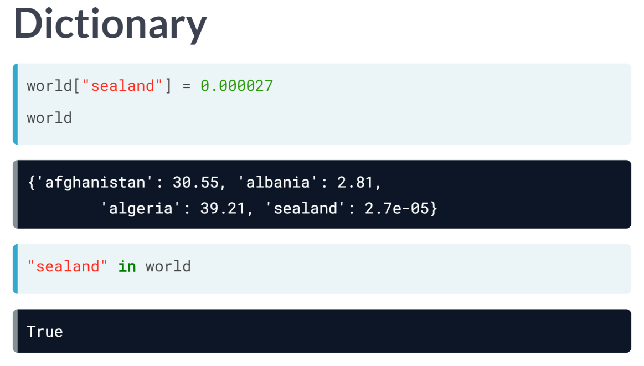  
To add this information, simply write the key *sealand* in square brackets and assign 27 expressed in millions to it with the equals sign. If you check out the *"world"* again, indeed, the *sealand* is in there.

To check this with code, you can also write *"sealand in world"*, which gives you *True* if the key *sealand* is in there.

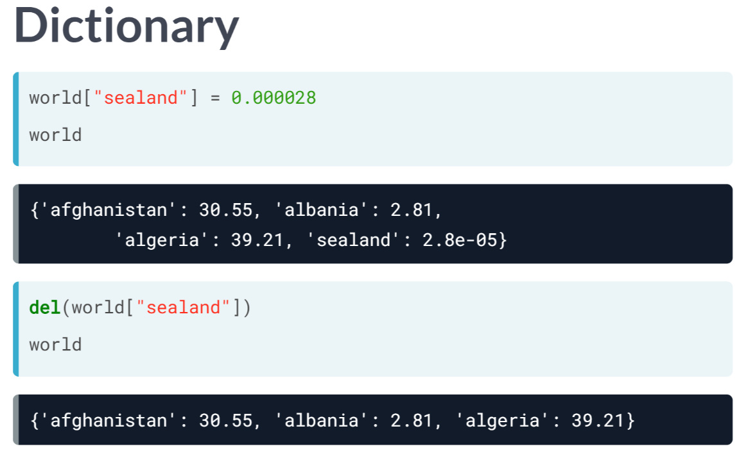  
With the same syntax, you can also change or update values, for example, to update the population of sealand to 28. Because each key in a dictionary is unique, Python knows that you are not trying to create a new pair but want to update the pairs that's already in there.

You can see this from the printout here. Suppose that your boss didn't see the humor of adding Sealand to the list and want you to remove it. You can do this with *'del'* pointing to the sealand inside square brackets. Now, if you print out world again, Sealand is no longer in there.

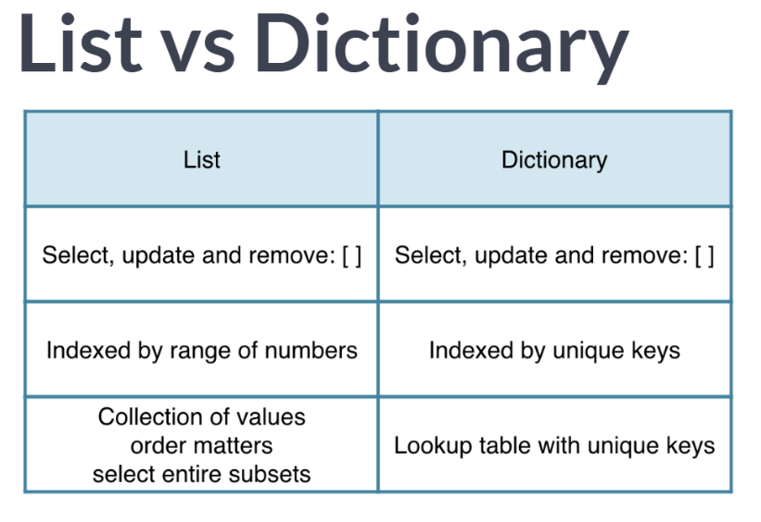  
If you remember the discussion of lists from the intro course, you will notice that using lists and dictionaries is pretty similar. You can select, update, and remove elements with square brackets.

There are some big differences, though. The list is a sequence of values that are indexed by a range of numbers. On the other hand, the dictionary is indexed by unique keys that can be any immutable type.

When to use which one? Well, if you have a collection of values where the order matters, and you want to easily select entire subsets of data, you'll want to go with a list.

If, on the other hand, you need some sort of look up table, where looking for data should be fast and where you can specify unique keys, a dictionary is the preferred option.

# Dictionary Manipulation (1)

If you know how to access a dictionary, you can also assign a new value to it. To add a new key-value pair to europe you can use something like this:

europe['iceland'] = 'reykjavik'

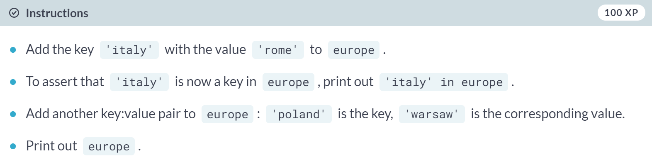

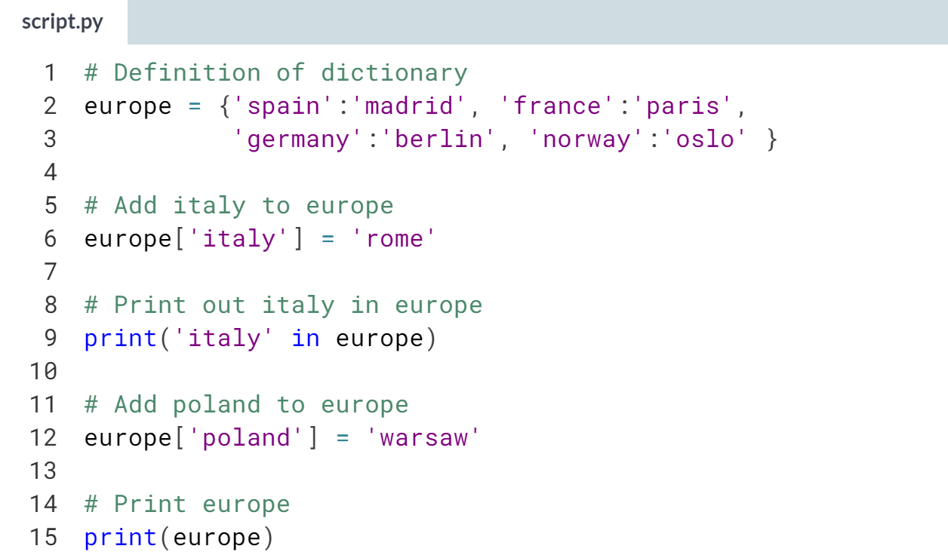  
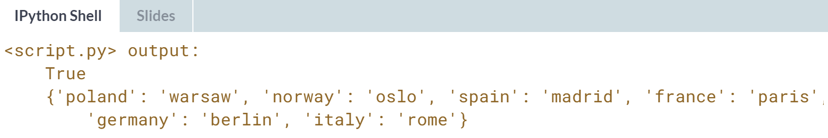  
Well done! Europe is growing by the minute! Did you notice that the order of the printout is not the same as the order in the dictionary's definition? That's because dictionaries are inherently unordered.

# Dictionary Manipulation (2)

Somebody thought it would be funny to mess with your accurately generated dictionary. An adapted version of the europe dictionary is available in the script on the right.

Can you clean up? Do not do this by adapting the definition of europe, but by adding Python commands to the script to update and remove key:value pairs.

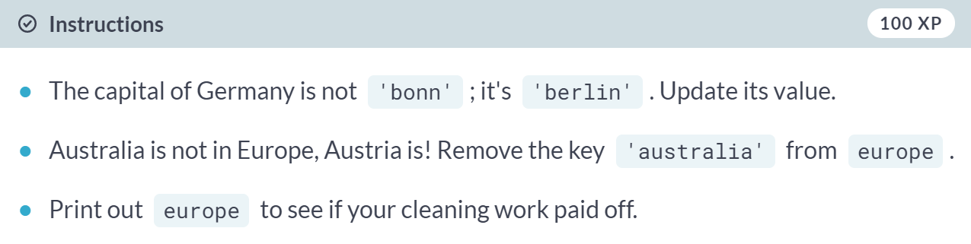

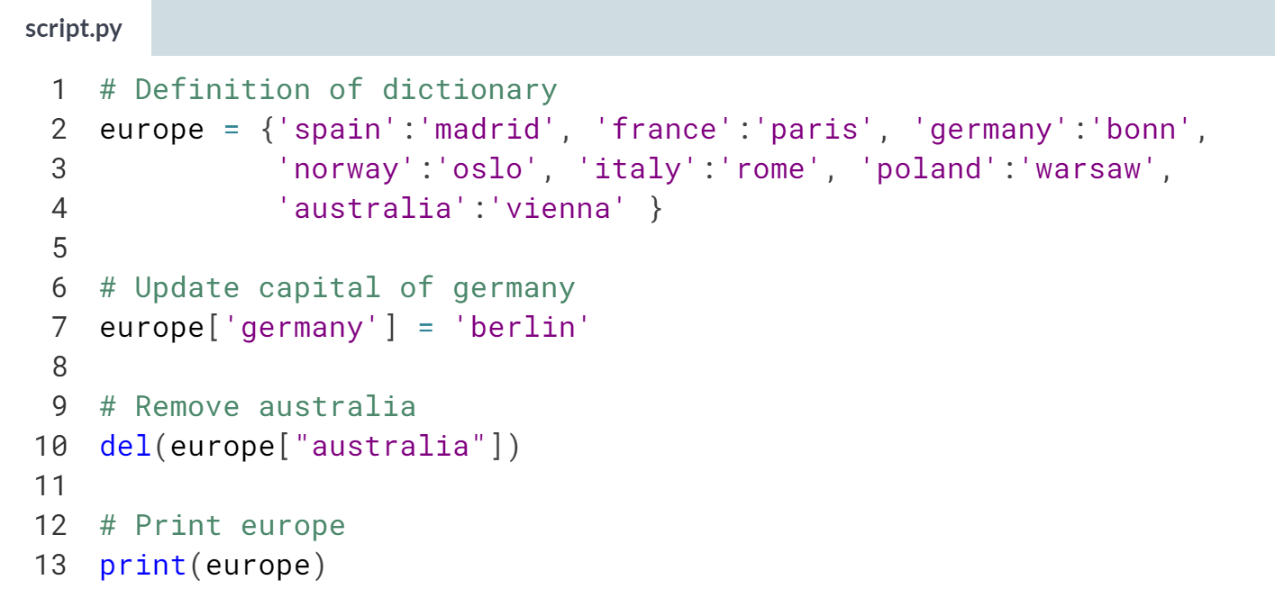

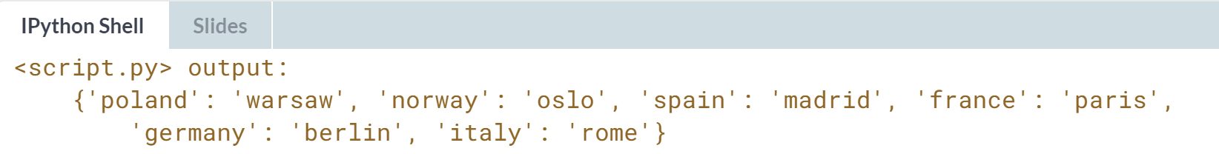

# Dictionariception

Remember lists? They could contain anything, even other lists. Well, for dictionaries the same holds. Dictionaries can contain key:value pairs where the values are again dictionaries.

As an example, have a look at the script where another version of europe - the dictionary you've been working with all along - is coded. The keys are still the country names, but the values are dictionaries that contain more information than just the capital.

It's perfectly possible to chain square brackets to select elements. To fetch the population for Spain from europe, for example, you need:

europe['spain']['population']

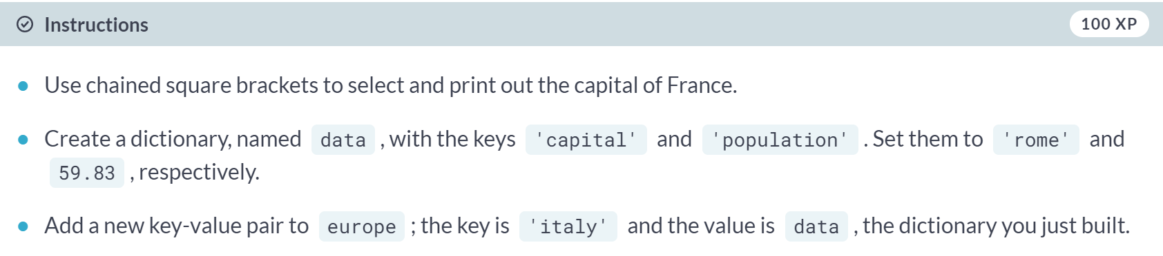

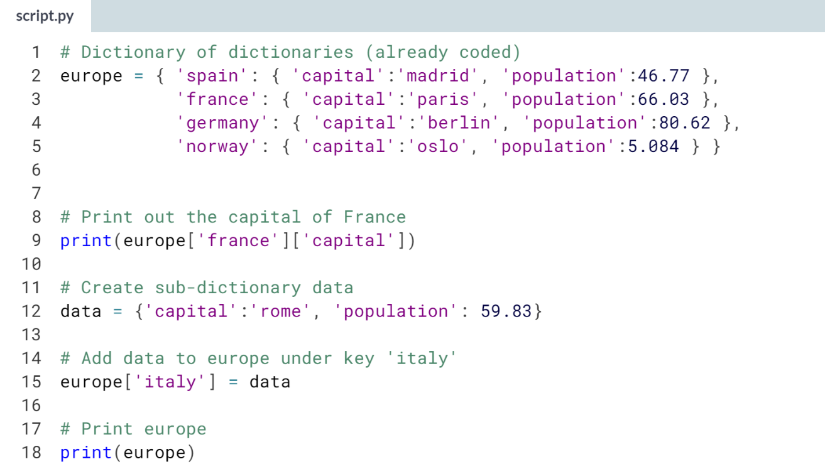  
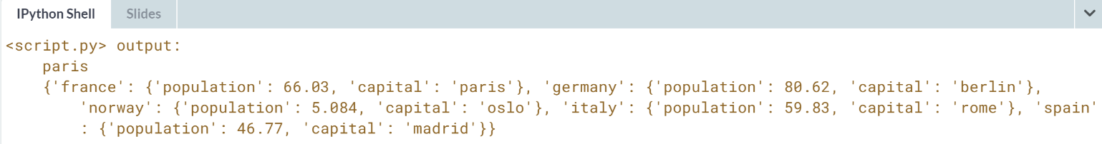



As a data scientist, you'll often be working with tons of data. The form of this data can vary greatly, but pretty often, you can boil it down to a tabular structure that is in the form of a table like in a spreadsheet. Let's look at some example.

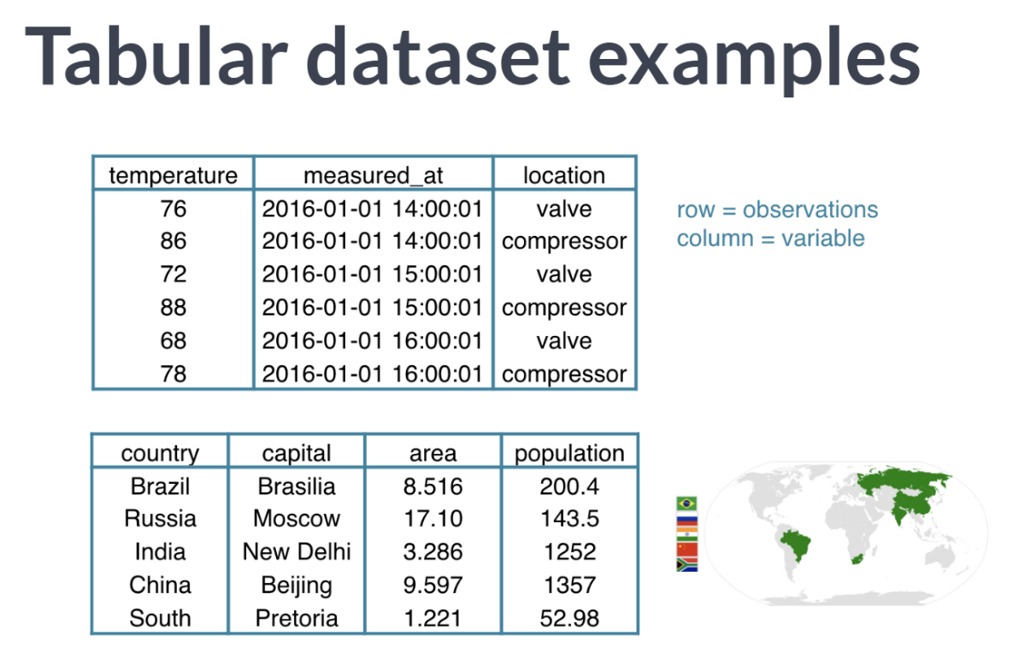  
Suppose you are working in a chemical plant and have a ton of temperature measurements to analyze. This data can come in the following form: every row is a measurement, or an observation, and for each observation, there are different variables.

For each observation, there's of course the temperature, but also the data and time of the measurement, and the location.

Another example: you have collected information on the so-called BRICS countries, Brazil, Russia, India, China, and South Africa.

You can again build a table with this data, like the second example. Each row is an observation and represents a country.

Each observation has the same variables: the country name, the capital, the area in millions of square kilometers and the population in millions.

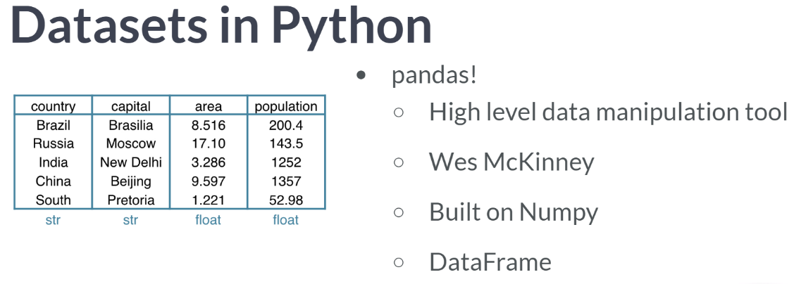

To start working on this data in Python, you will need some kind of rectangular data structure. That's easy and we already know one. The 2D NumPy array, right? Well, it's an option, but not necessarily the best one.

In the two example we covered, there are different data types and NumPy arrays are not great at handling these. In the BRICS example, the area and populations are floats, while the country and capital are strings, for example.

Your dataset will typically comprise different data types, so we need a tool that's better suited for the job. To handle this data easily and efficiently, there's the Pandas package. Pandas is a high-level data manipulation tool developed by Wes McKinney, built on the NumPy package.

Compared to NumPy, it's more high level, making it very interesting for data scientists all over the world. In pandas, we store the tabular data like the BRICS table here in an object called a DataFrame.

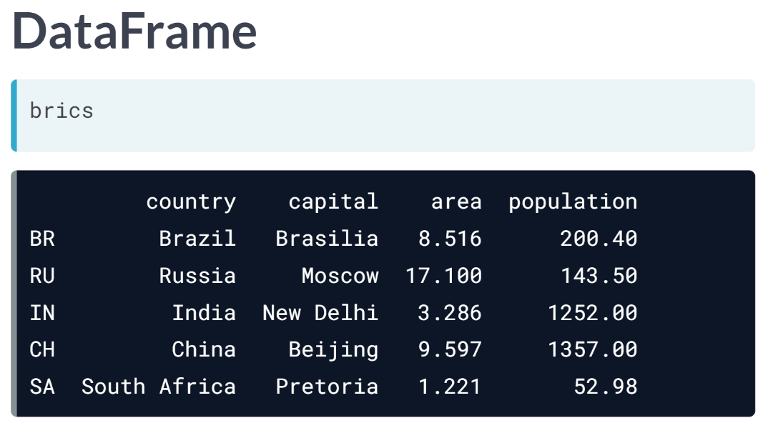  
Have a look at the Pandas DataFrame version of the BRICS data shown before: you see a similar structure: the rows represent the observations, and the columns represent the variables. Also notice that each row has a unique row label: BR for Brazil, RU for Russia, and so on.

The columns, or variables, also have labels: country, population, and so on. Notice that the values in the different columns have different types.

This is all great news, but how can we create this DataFrame in the first place? Well, there are different ways.

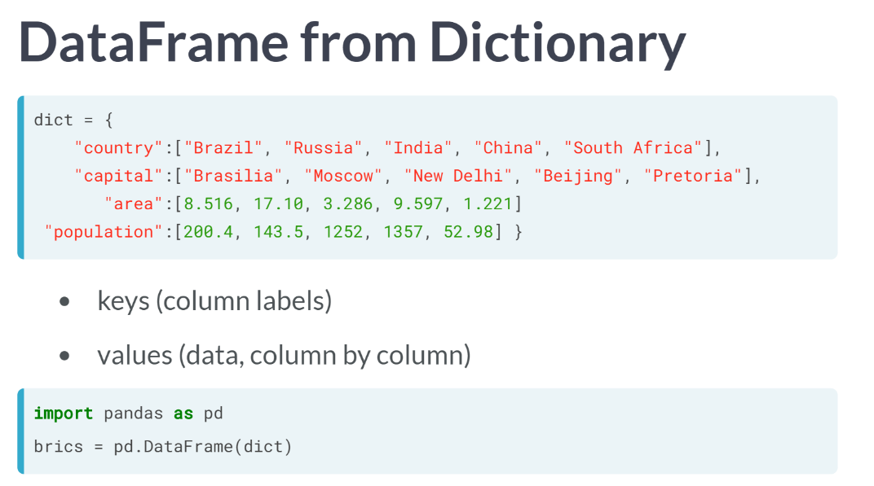  
First of all, you can build it manually, starting from a dictionary. Using the distinctive curly brackets, we create key value pairs. The keys are the column labels, and the values are the corresponding columns, in a list form.

After importing the *pandas* package as *pd*, you can create a DataFrame from the dictionary using ***pd.DataFrame***.

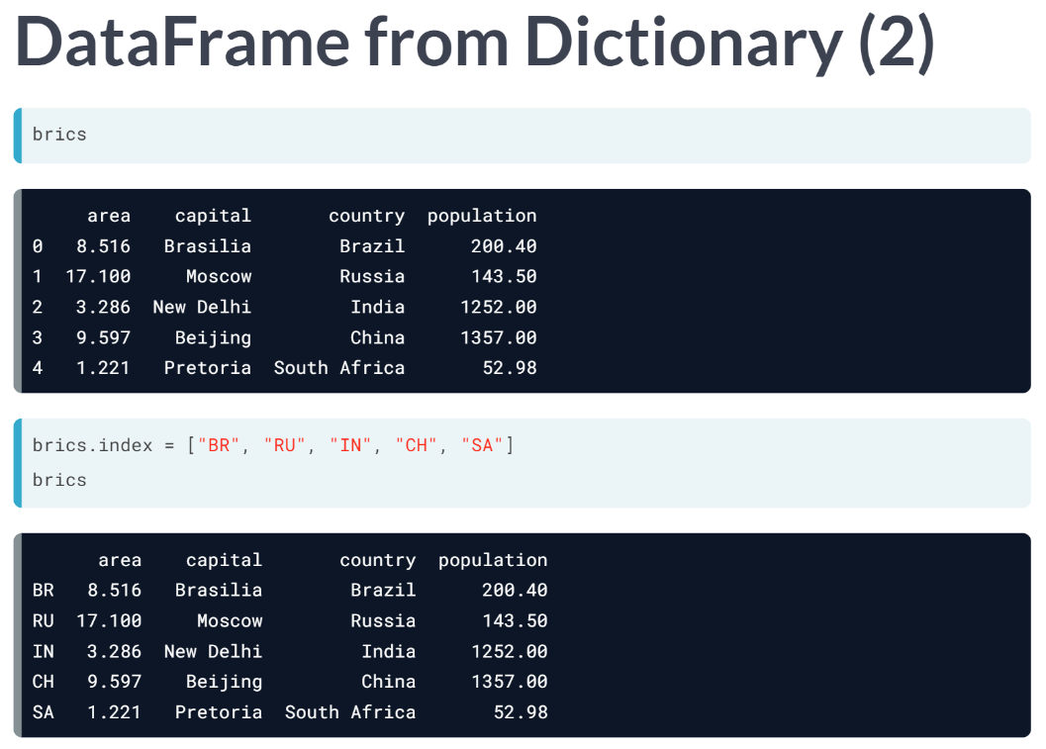  
If you check out *brics* now, we are almost there. Pandas have already assigned some automatic row labels, 0 up to 4.

To specify them manually, you can set the index attribute of brics to a list with the correct labels. The resulting *brics* DataFrame is the same one as you saw before.

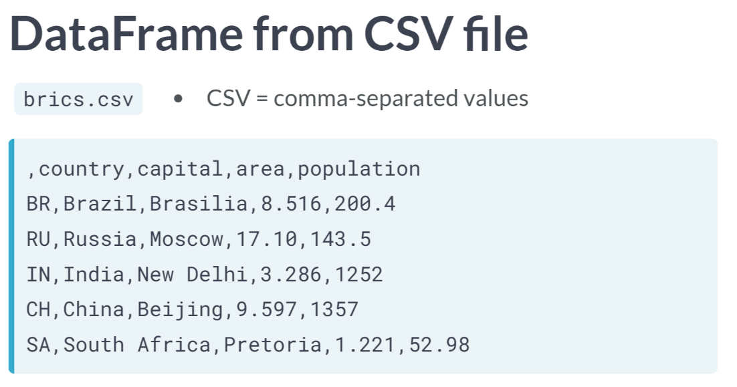  
Using a dictionary approach is fine, but what if you're working with tons of data, which is typically the case as a data scientist? Well, you won't build the DataFrame manually. Instead, you will import the data from an external file that contains all this data. Suppose the brics data that we saw previously comes in the form of a CSV file called *brics.csv*.

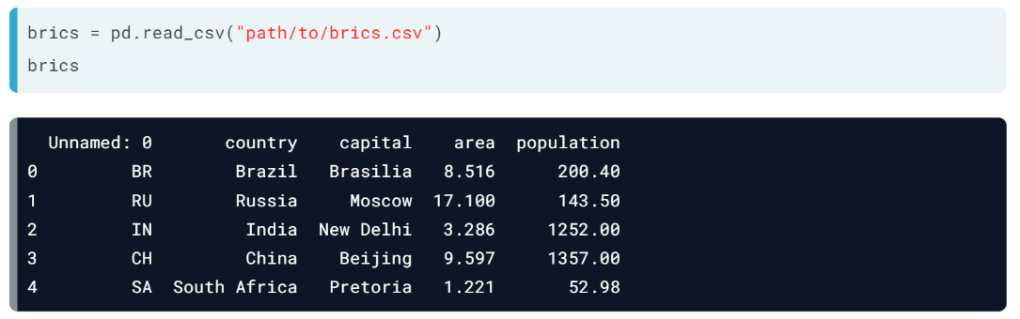  
Let's try to import this data into Python using Pandas ***read\_csv()*** function. You pass the path to the csv file as an argument. If you now print brics, there's still something wrong. The row labels are seen as a column in their own right. To solve this, we will have to tell the ***read\_csv()*** function that the first column contains the row indexes. You do this by setting the *index\_col* argument, like this below:

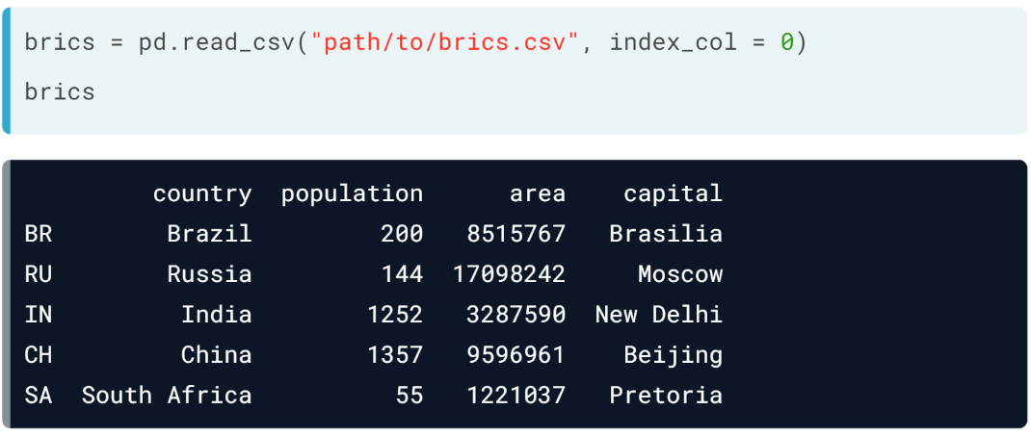  
This time, brics contains the data frame we started with in this lesson. It nicely contains the row and column labels. The ***read\_csv()*** function features many more arguments that allow you to customize your data import. Make sure to check out its documentation.

# Dictionary to DataFrame (1)

Pandas is an open source library, providing high-performance, easy-to-use data structures and data analysis tools for Python. Sounds promising!

The DataFrame is one of Pandas' most important data structures. It's basically a way to store tabular data where you can label the rows and the columns. One way to build a DataFrame is from a dictionary.

In the exercises that follow you will be working with vehicle data from different countries. Each observation corresponds to a country and the columns give information about the number of vehicles per capita, whether people drive left or right, and so on.

Three lists are defined in the script:

* names, containing the country names for which data is available.
* dr, a list with booleans that tells whether people drive left or right in the corresponding country.
* cpc, the number of motor vehicles per 1000 people in the corresponding country.

Each dictionary key is a column label and each value are a list which contains the column elements.

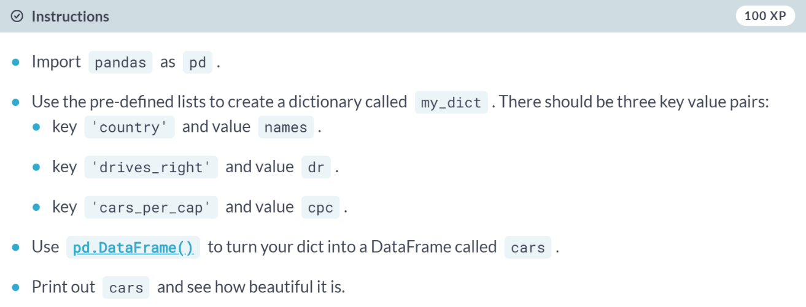  
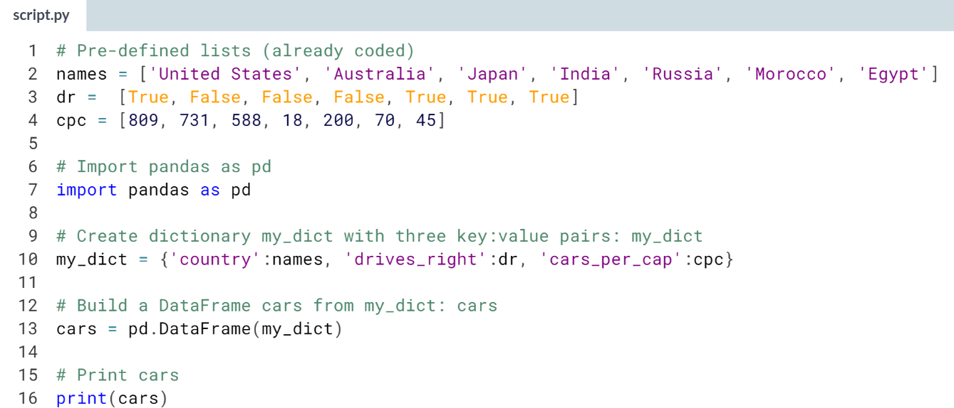

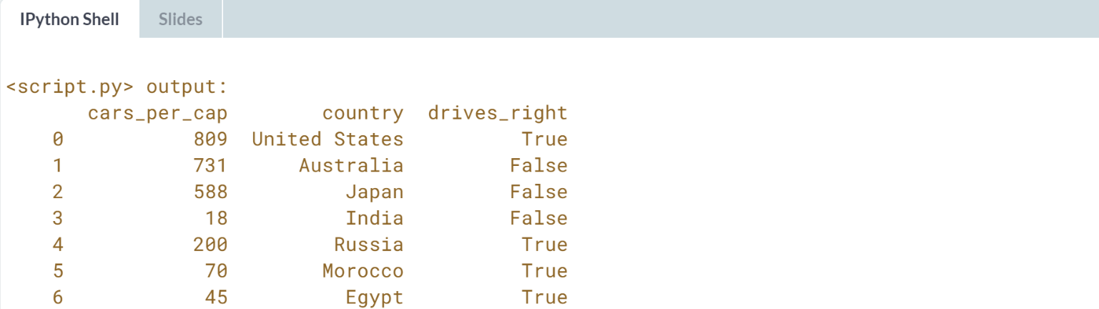  
Good job! Notice that the columns of cars can be of different types. This was not possible with 2D NumPy arrays, and that is one of the reasons why Pandas DataFrame is awesome.

# Dictionary to DataFrame (2)

The Python code that solves the previous exercise is included on the right. Have you noticed that the row labels (i.e. the labels for the different observations) were automatically set to integers from 0 up to 6?

To solve this a list row\_labels has been created. You can use it to specify the row labels of the cars DataFrame. You do this by setting the index attribute of cars, that you can access as cars.index.

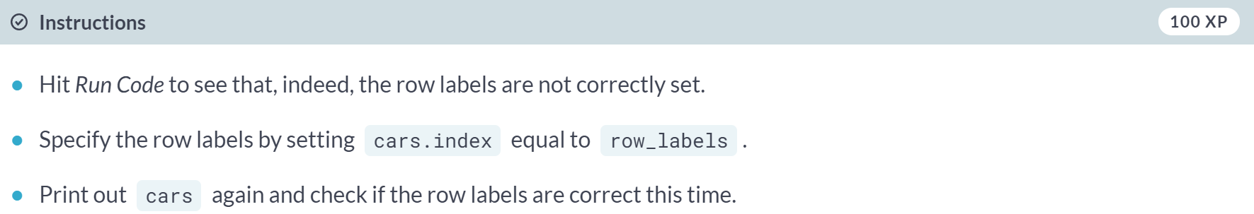

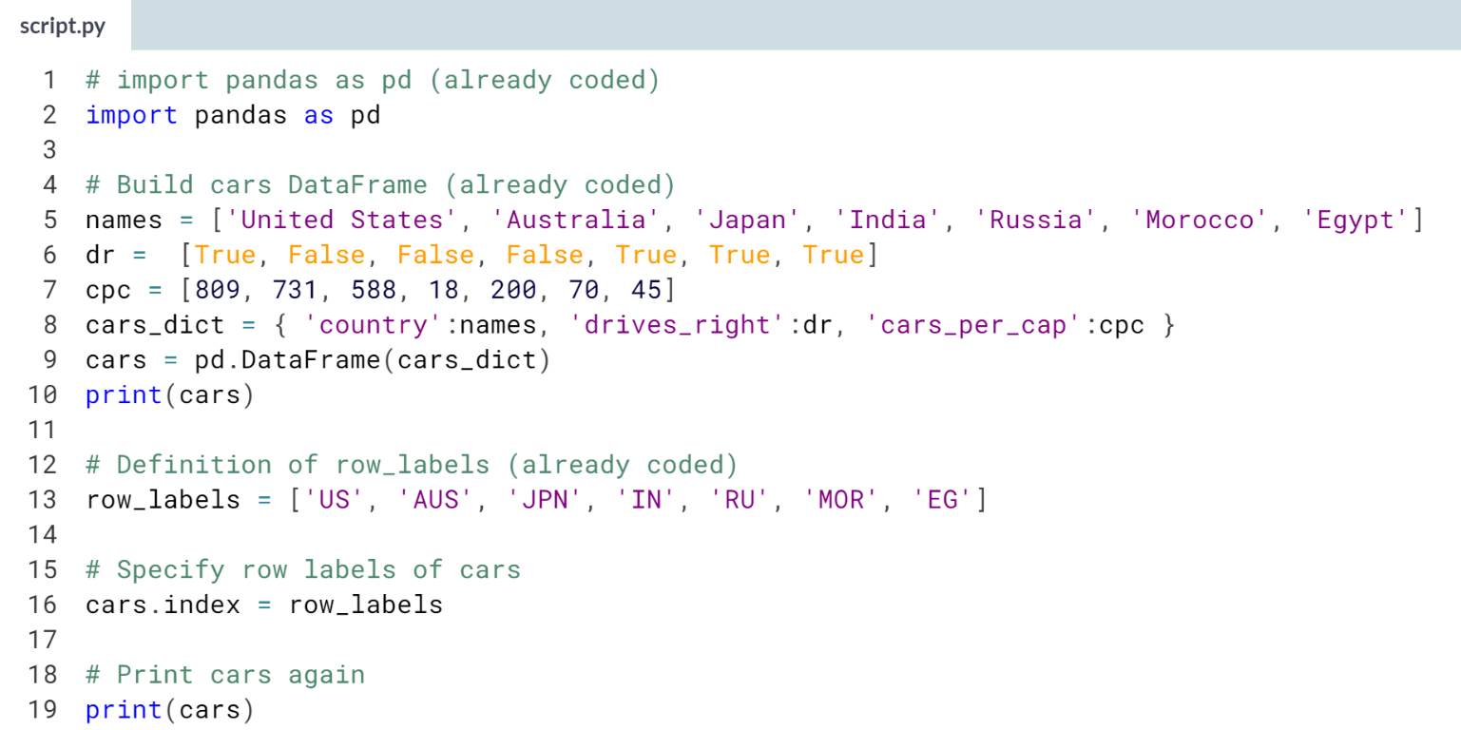

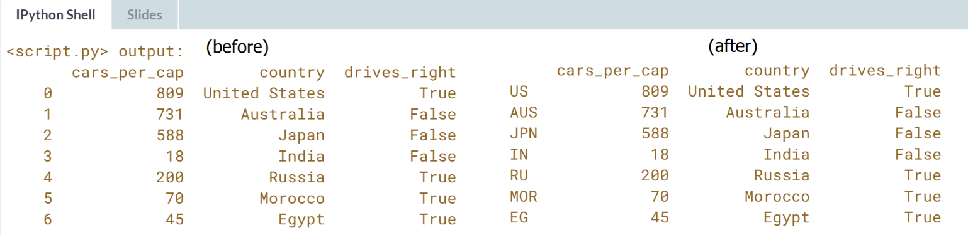

# CSV to DataFrame (1)

Putting data in a dictionary and then building a DataFrame works, but it's not very efficient. What if you're dealing with millions of observations? In those cases, the data is typically available as files with a regular structure. One of those file types is the CSV file, which is short for "comma-separated values".

To import CSV data into Python as a Pandas DataFrame you can use [**read\_csv()**](http://pandas.pydata.org/pandas-docs/stable/generated/pandas.read_csv.html).

Let's explore this function with the same cars data from the previous exercises. This time, however, the data is available in a CSV file, named cars.csv. It is available in your current working directory, so the path to the file is simply 'cars.csv'.

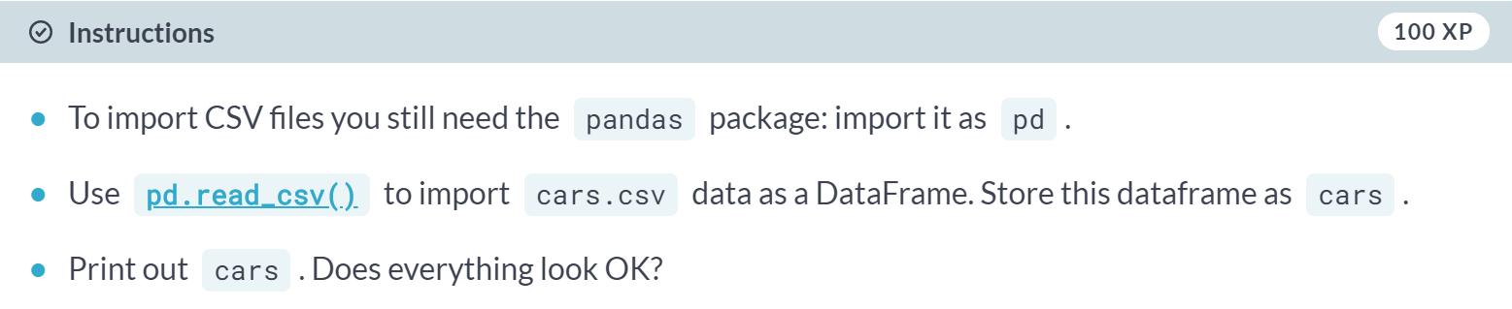

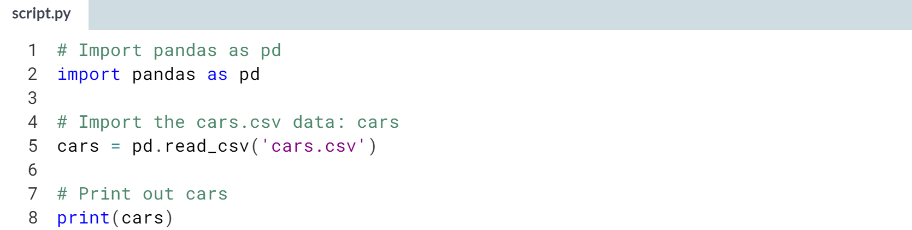

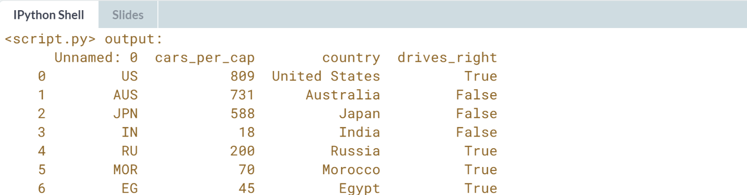  
Nice job! Looks nice, but not exactly what we expected. Let's fix this in the next exercise.

# CSV to DataFrame (2)

Your [**read\_csv()**](http://pandas.pydata.org/pandas-docs/stable/generated/pandas.read_csv.html) call to import the CSV data didn't generate an error, but the output is not entirely what we wanted. The row labels were imported as another column without a name.

Remember index\_col, an argument of [**read\_csv()**](http://pandas.pydata.org/pandas-docs/stable/generated/pandas.read_csv.html), that you can use to specify which column in the CSV file should be used as a row label? Well, that's exactly what you need here!

Python code that solves the previous exercise is already included; can you make the appropriate changes to fix the data import?

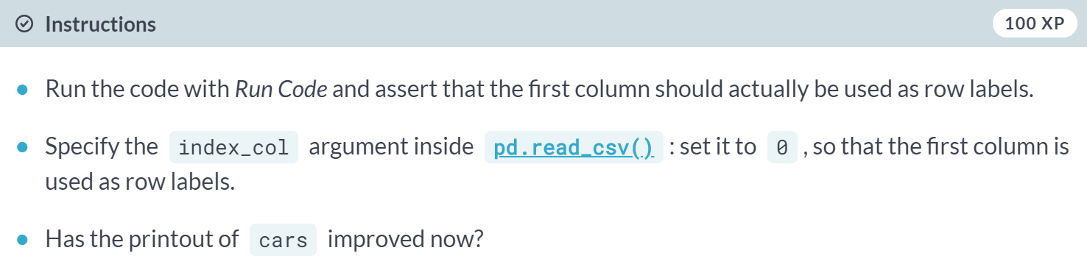

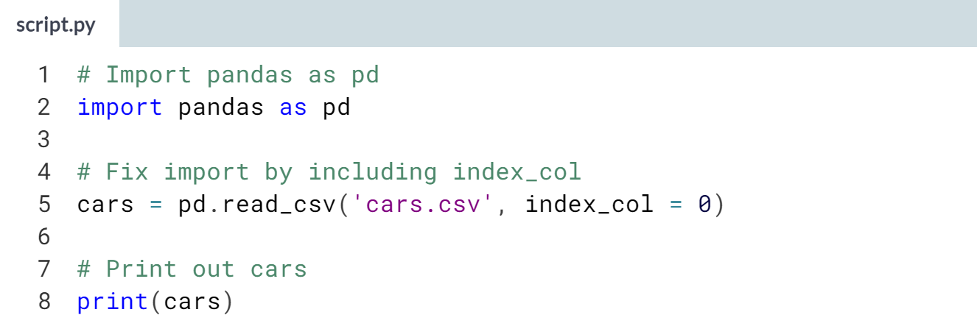

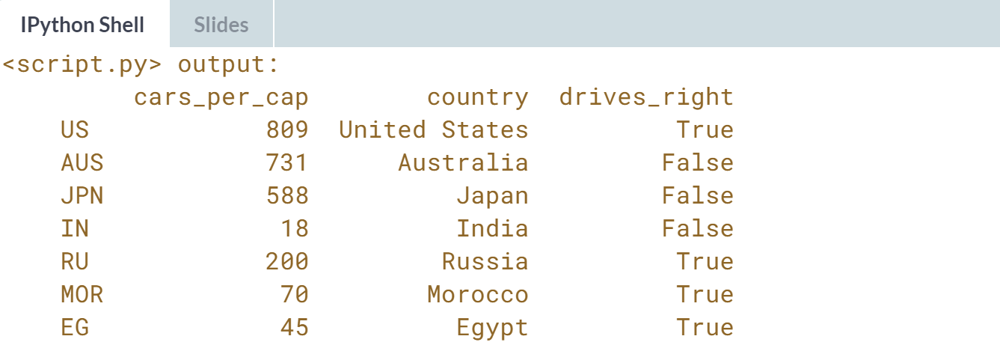

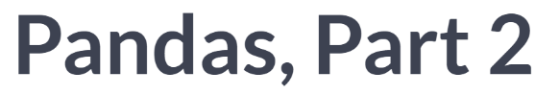

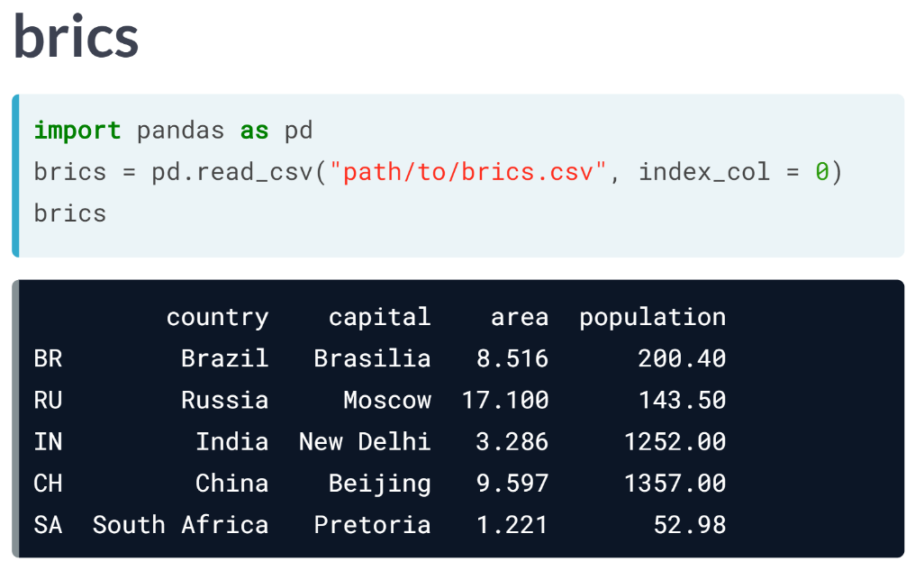  
In the previous video, we created the DataFrame brics, containing basic data on the BRICS countries. Here it is again.

The code here makes sure that the rows and columns are given appropriate labels, an important step to make accessing columns, rows, and single elements in your DataFrame easy. Now that's exactly what we will learn in this video.

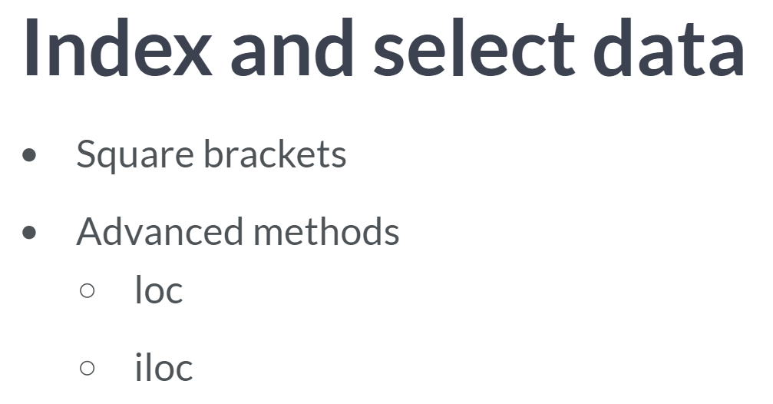  
There are numerous ways in which we can index and select data from DataFrames, so we will take this step by step.

First, we will talk about how to use square brackets; next, we are going to talk about advanced data access methods, *loc* and *iloc*, that make Pandas extra powerful.

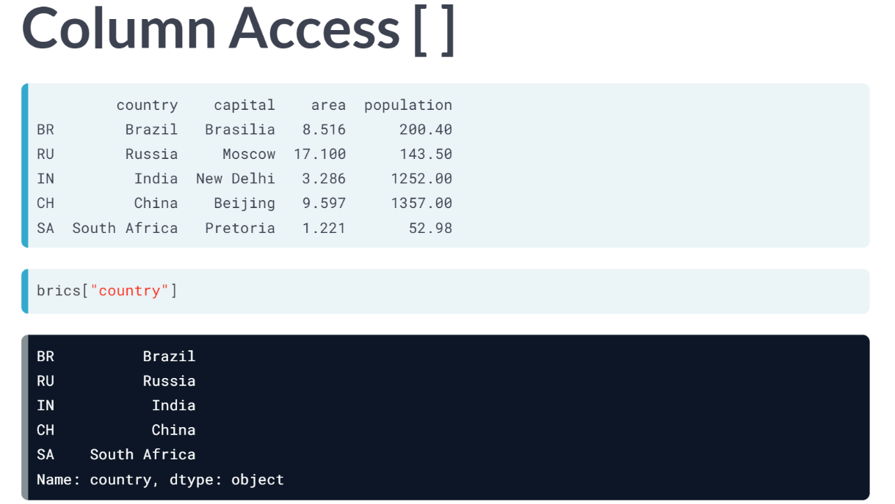

Suppose that you only want to select the country column from *brics*. How to do this with square brackets? You simply type *brics*, and then the column label inside square brackets.

Python prints out the entire column, together with the row labels. But there's something strange here. The last line says Name: *country*, *dtype: object*.

We are clearly not dealing with a regular DataFrame here. Let's find about the type of the object that gets returned with the type function, as follows.

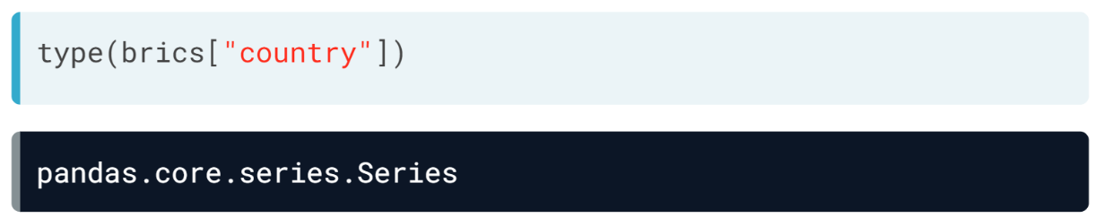

Okay, so we are dealing with a Pandas Series here. In a simplified sense, you can think of the Series as a one-dimensional array that can be labeled, just like the DataFrame. Otherwise put, if you paste together a bunch of Series, you can create a DataFrame.

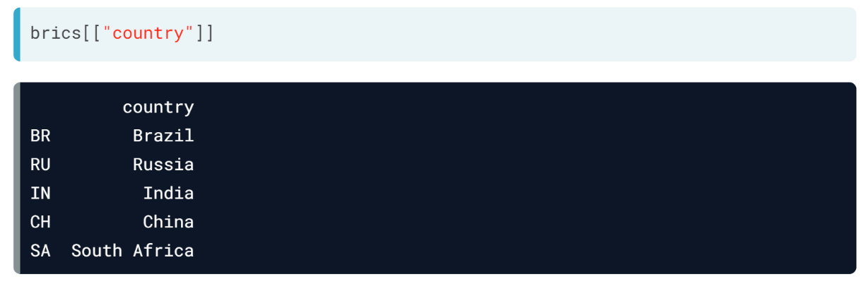  
If you want to select a country column but keep the data in a DataFrame, you will simply need double brackets, like this.

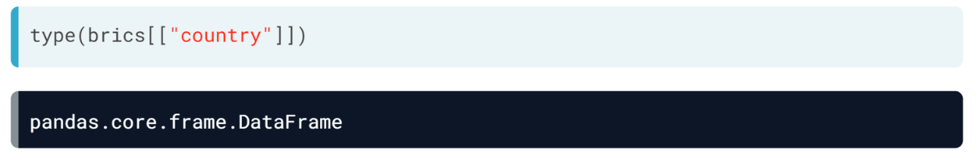  
If you check out the type of this, It's a good old Data Frame, this time with only one column though.

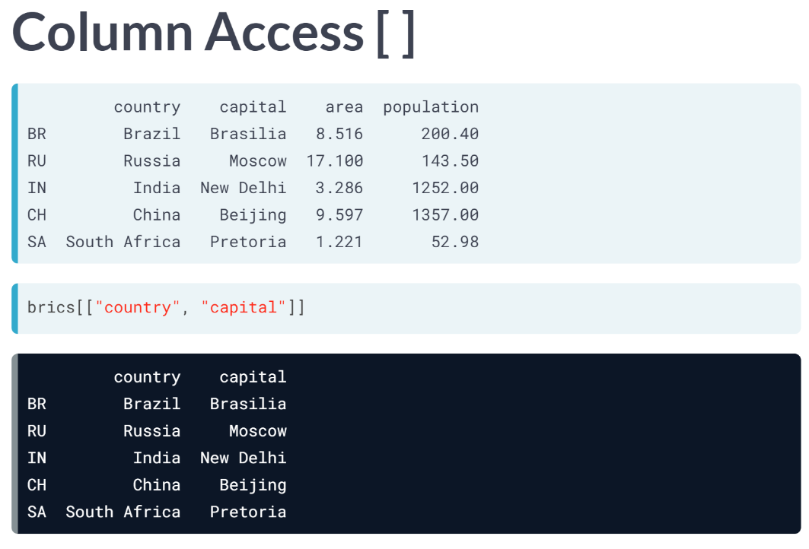  
You can perfectly extend this call to select two columns, country, and capital, for example. If you look at it from a different angle, you are actually putting a list with column labels inside another set of square brackets and end up with a *'sub data frame'*, containing only the country and capital columns.

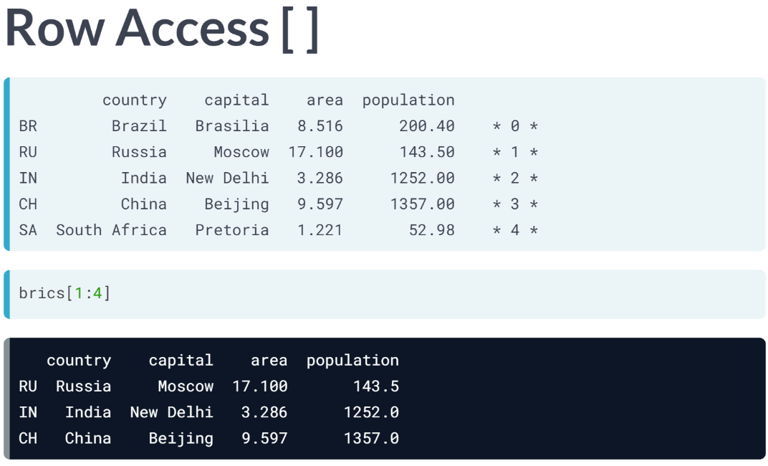  
You can also use the same square brackets to select rows from a DataFrame. The way to do it is by specifying a slice. To get the second to fourth rows of brics, we use slice 1:4. Remember that the end of slice is exclusive and that the index starts at zero. Here are the row indexes so that you see what's happening.

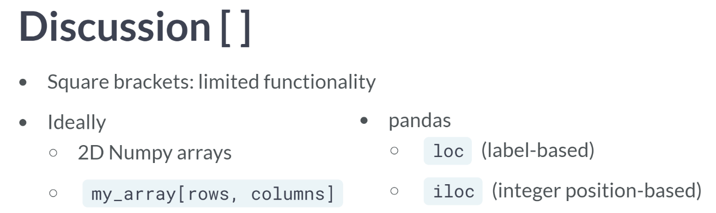

These square brackets work, but it only offers limited functionality. Ideally, we'd want something similar to 2D NumPy arrays. There, you also used square brackets, the index or slice before the comma referred to the rows, the index or slice after the comma referred to the columns.

If we want to do the similar thing with Pandas, we have to extend our toolbox with the *loc* and *iloc* functions. *loc* is a technique to select parts of your data based on labels, *iloc* is based on positions.

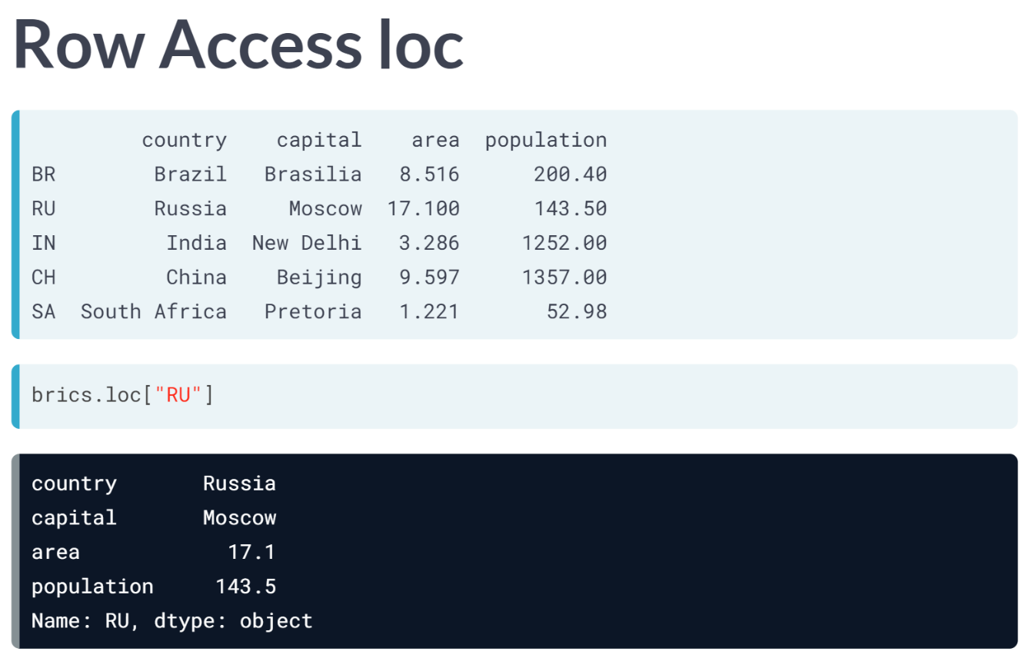  
Let's start with *loc* first. Let's have another look at the brics data frame and try to get the rows for Russia. this is how it is done. You put the label of the row of intersect in square brackets after *loc*. Again, we get a Pandas Series, containing all the row's information, rather inconveniently shown on different lines.

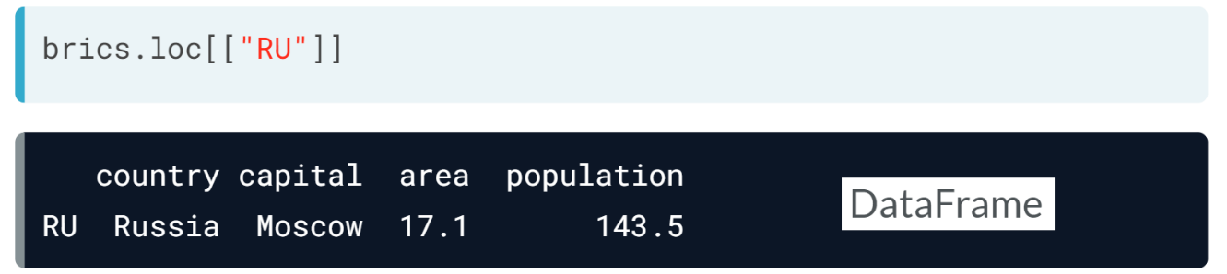  
To get a data frame, we have to put the *"RU"* string inside another pair of brackets.

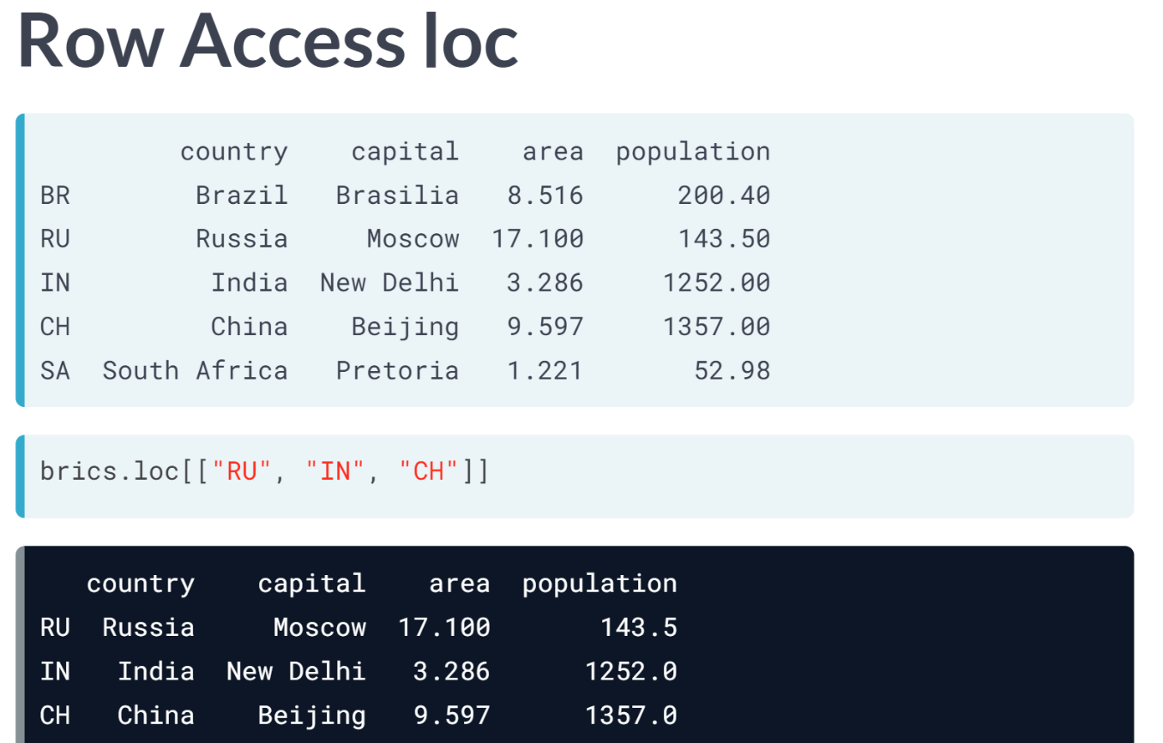  
We can also select multiple rows at the same time. Suppose you want to also include India and China. This will do the trick: simply add some more row labels to the list. This was only selecting entire rows, that's something you could also do with the basic square brackets.

The difference here is that you can extend your selection with a comma and a specification of the columns of interest. Let's extend the previous call to only include the country and capital columns.

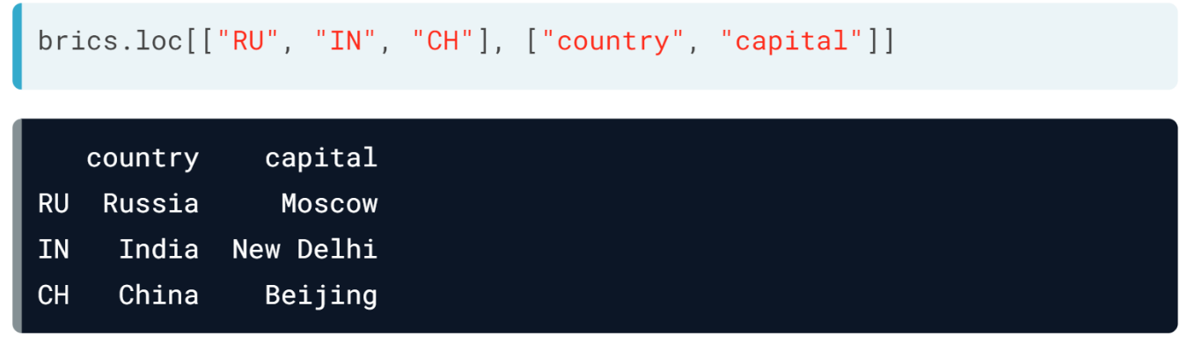

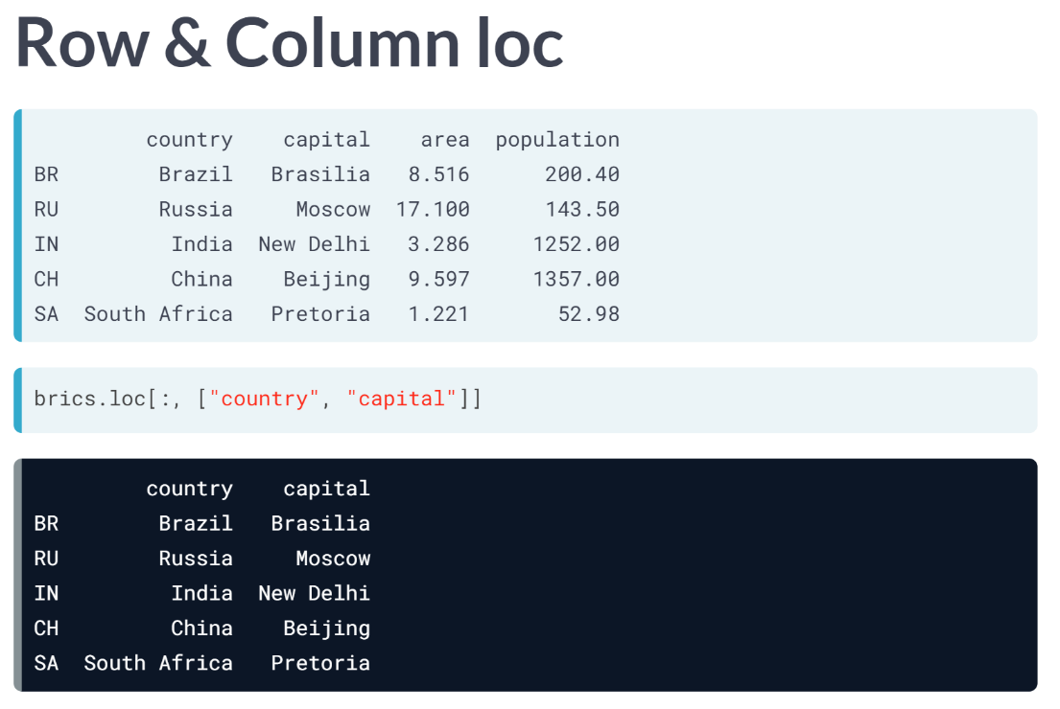  
We add a comma, and a list of column labels we want to keep. The intersection gets returned. Of course, you can also use *loc* to select all rows but only a specific number of columns. Simply replace the first list that specifies the row labels with a colon, a slice going from beginning to end. This time, the intersection spans all rows but only two columns.

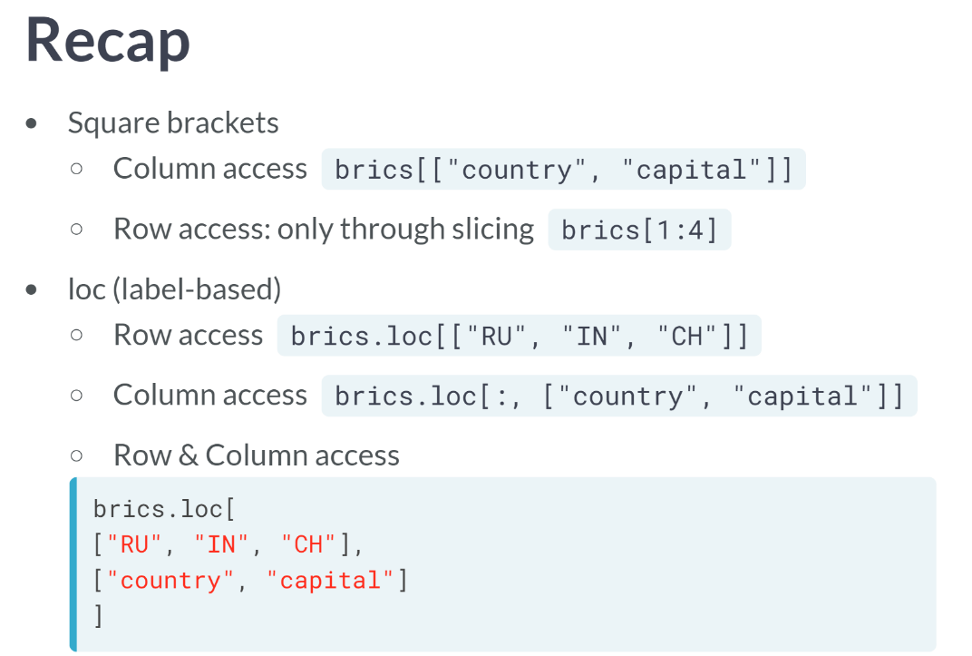

So, let's take a step back: simple square brackets work fine if you want to get columns; to get rows, you can use slicing. The *loc* function is more versatile: you can select rows, columns, but also rows and columns at the same time.

When you use *loc*, subsetting becomes remarkably similar to how you subsetted 2D NumPy arrays. The only difference is that you use row labels with *loc*, not the positions on the elements.

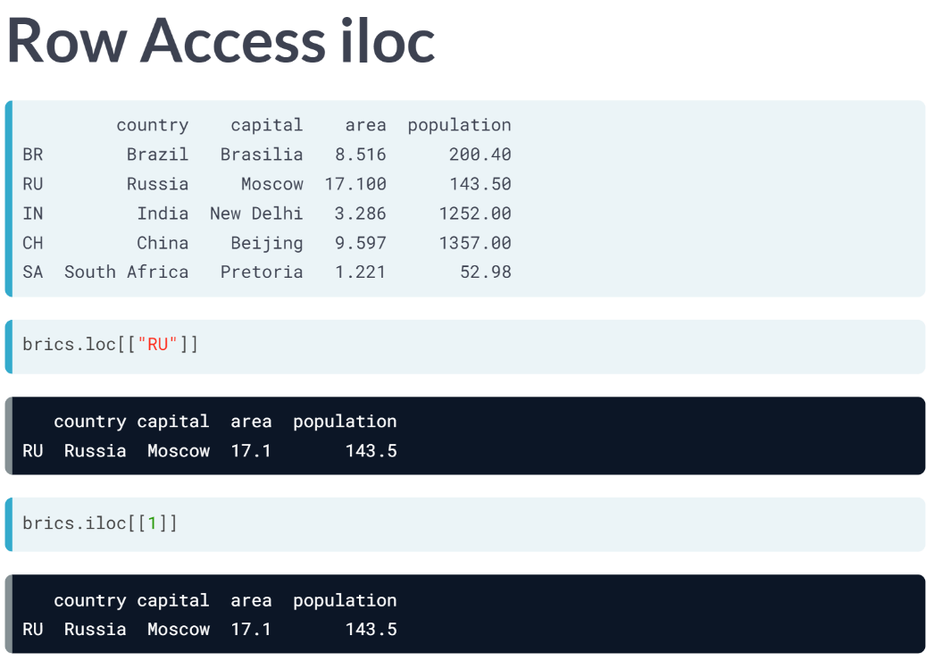  
If you want to subset Pandas DataFrames based on their positions, or index, you will need to use *iloc* function. Let's cover the same example as with *loc* and start with getting the row for Russia. In loc, you use the *"RU"* string in double square brackets, to get a DataFrame, like here. In *iloc*, you use the index 1 instead. The results are exactly the same.

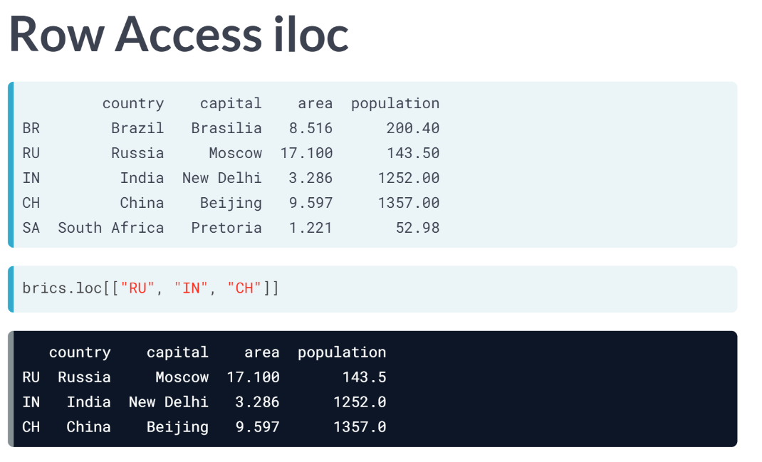  
To get the rows for Russia, India, and China, which was coded like this when using loc, you can now use a list with the index 1 to 3. Again, the same results.  
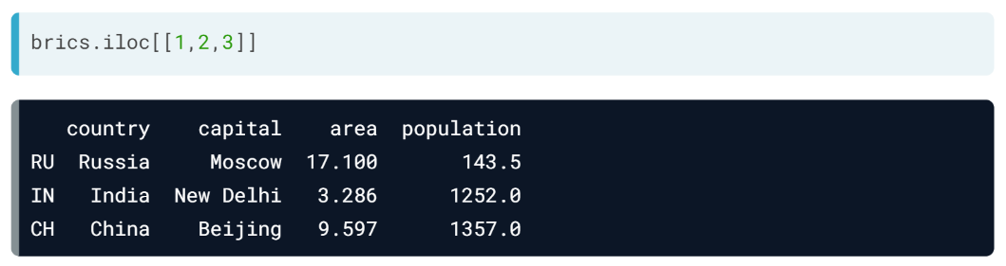

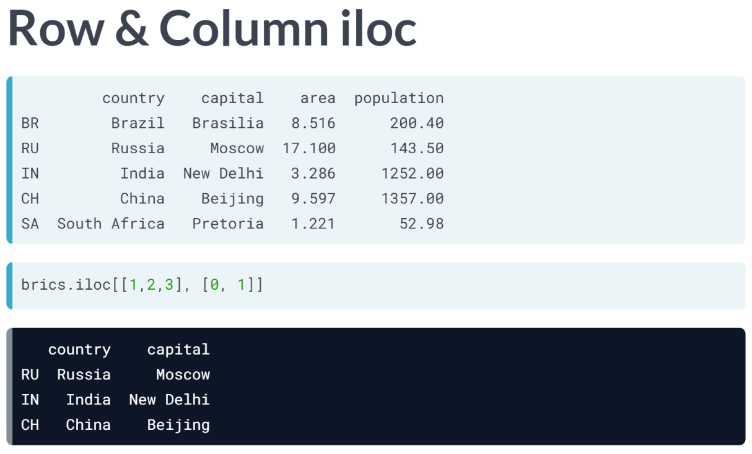  
In addition to only keeping the country and capital column, which we did as follows with *loc*, we put the indexes 0 and 1 in a list after the comma, referring to the country and capital column.

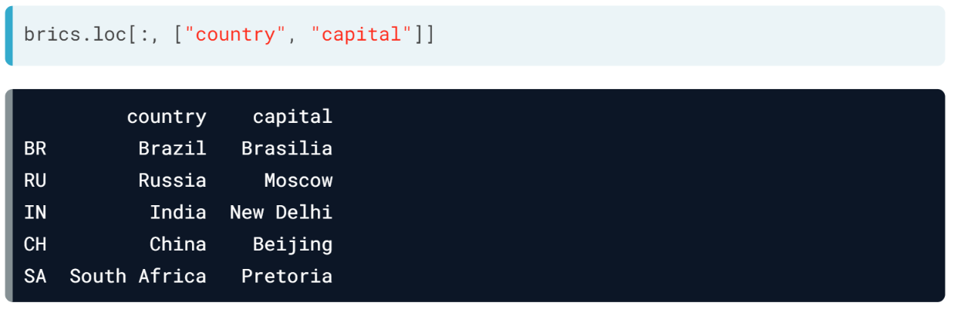  
Finally, you can keep all rows and keep only the country and capital column in a similar fashion. With *loc*, this is how it is done.  
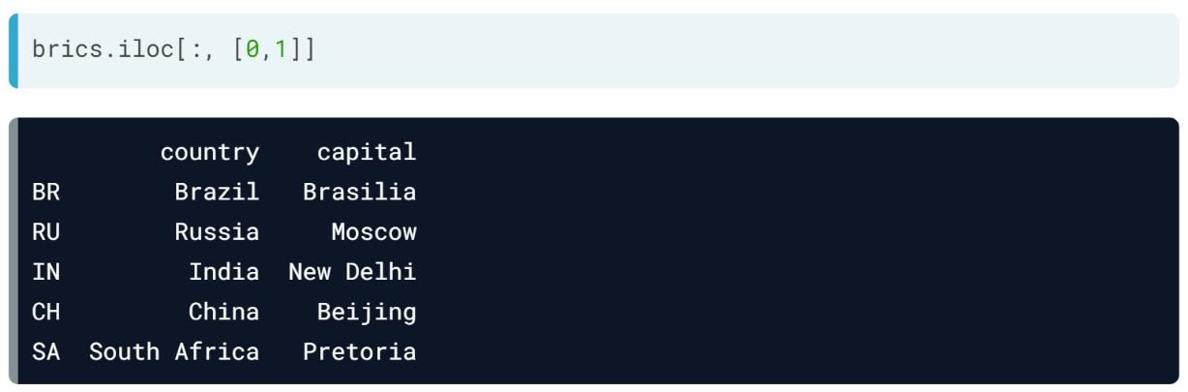  
For *iloc*, it's like this. *loc* and *iloc* are pretty similar, the only difference is how you refer to columns and rows.

# Square Brackets (1)

In the video, you saw that you can index and select Pandas DataFrames in many different ways. The simplest, but not the most powerful way, is to use square brackets.

In the sample code on the right, the same cars data is imported from a CSV files as a Pandas DataFrame. To select only the cars\_per\_cap column from cars, you can use:

cars['cars\_per\_cap']

cars[['cars\_per\_cap']]

The single bracket version gives a Pandas Series, the double bracket version gives a Pandas DataFrame.

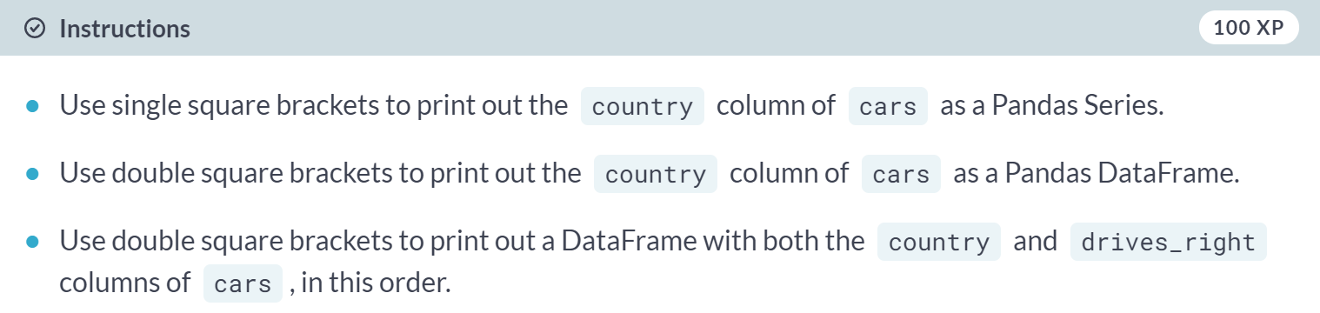  
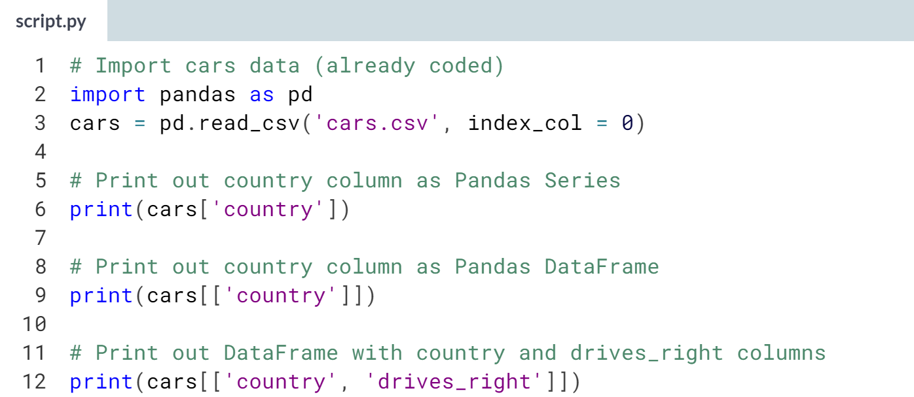  
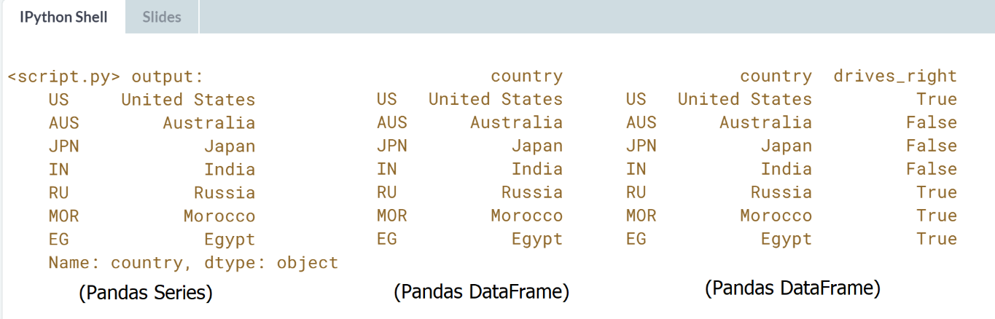

# Square Brackets (2)

Square brackets can do more than just selecting columns. You can also use them to get rows, or observations, from a DataFrame. The following call selects the first five rows from the cars DataFrame:

cars[0:5]

The result is another DataFrame containing only the rows you specified.

Pay attention: You can only select rows using square brackets if you specify a slice, like 0:4. Also, you're using the integer indexes of the rows here, not the row labels!

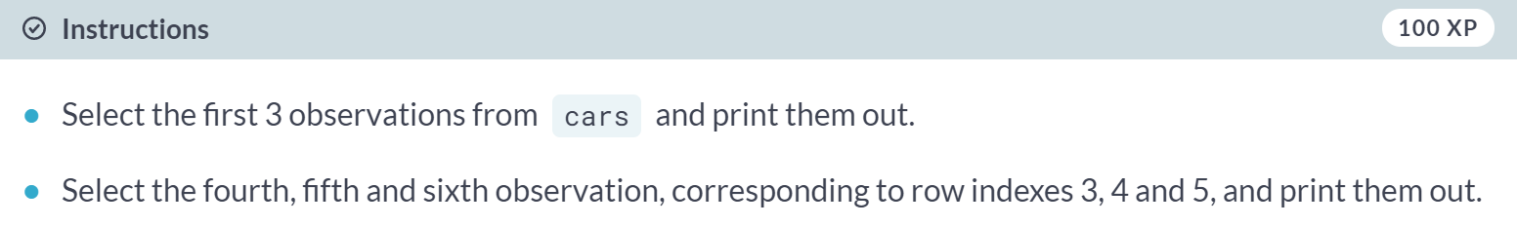

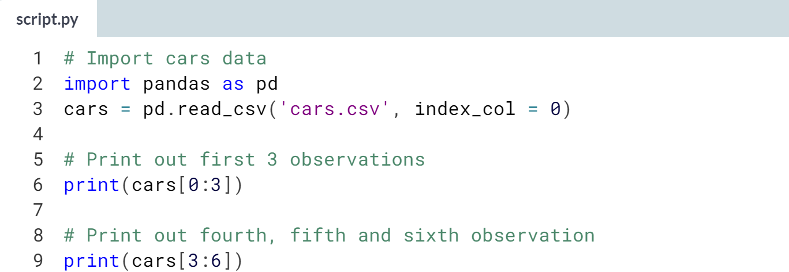

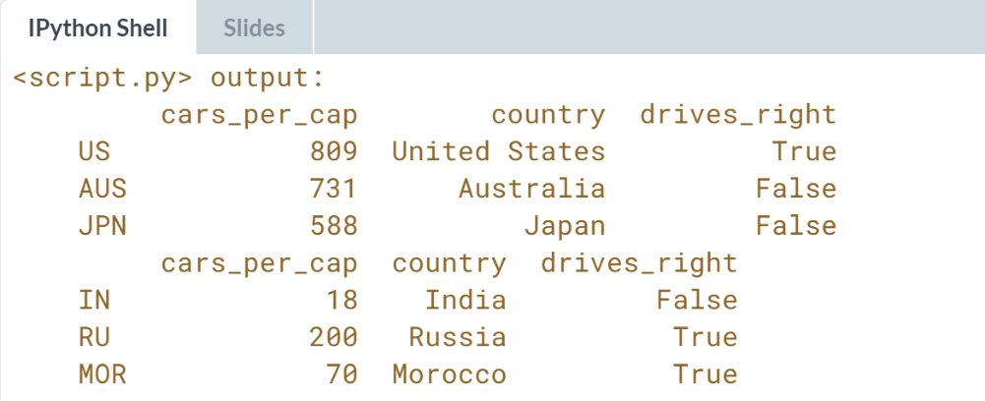  
Good job. You can get interesting information but using square brackets to do indexing is rather limited. Experiment with more advanced techniques in the following exercises.

# loc and iloc (1)

With [**loc**](http://pandas.pydata.org/pandas-docs/stable/indexing.html#different-choices-for-indexing) and [**iloc**](http://pandas.pydata.org/pandas-docs/stable/indexing.html#different-choices-for-indexing) you can do practically any data selection operation on DataFrames you can think of. [**loc**](http://pandas.pydata.org/pandas-docs/stable/indexing.html#different-choices-for-indexing) is label-based, which means that you have to specify rows and columns based on their row and column labels. [**iloc**](http://pandas.pydata.org/pandas-docs/stable/indexing.html#different-choices-for-indexing) is integer index based, so you have to specify rows and columns by their integer index like you did in the previous exercise.

Try out the following commands in the IPython Shell to experiment with [**loc**](http://pandas.pydata.org/pandas-docs/stable/indexing.html#different-choices-for-indexing) and [**iloc**](http://pandas.pydata.org/pandas-docs/stable/indexing.html#different-choices-for-indexing) to select observations. Each pair of commands here gives the same result.

cars.loc['RU']

cars.iloc[4]

cars.loc[['RU']]

cars.iloc[[4]]

cars.loc[['RU', 'AUS']]

cars.iloc[[4, 1]]

As before, code is included that imports the cars data as a Pandas DataFrame.

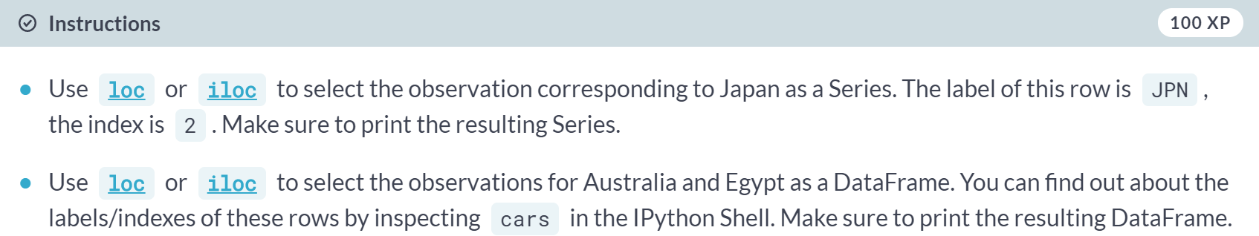

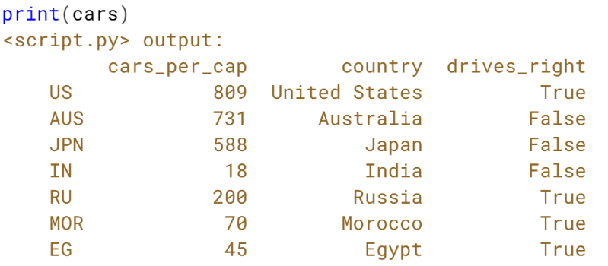  
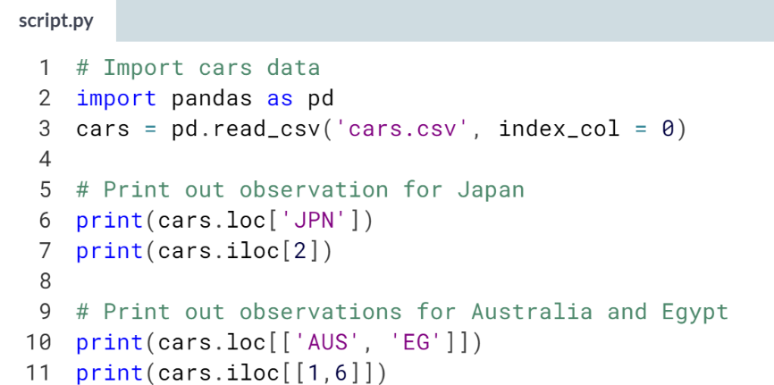 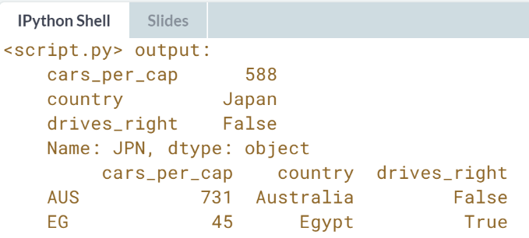  
You aced selecting observations from DataFrames; over to selecting both rows and columns!

# loc and iloc (2)

loc and iloc also allow you to select both rows and columns from a DataFrame. To experiment, try out the following commands in the IPython Shell. Again, paired commands produce the same result.

cars.loc['IN', 'cars\_per\_cap']

cars.iloc[3, 0]

cars.loc[['IN', 'RU'], 'cars\_per\_cap']

cars.iloc[[3, 4], 0]

cars.loc[['IN', 'RU'], ['cars\_per\_cap', 'country']]

cars.iloc[[3, 4], [0, 1]]

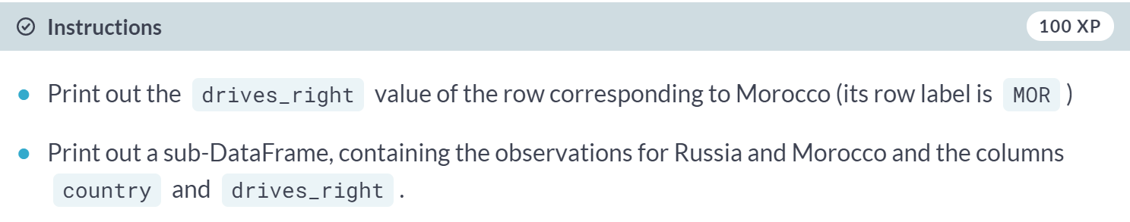

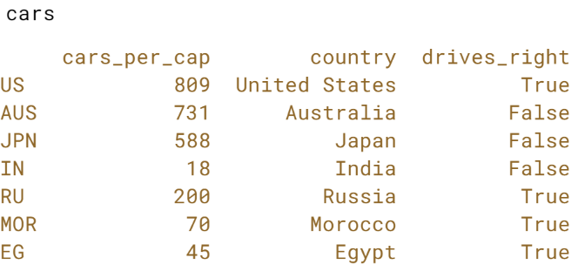  
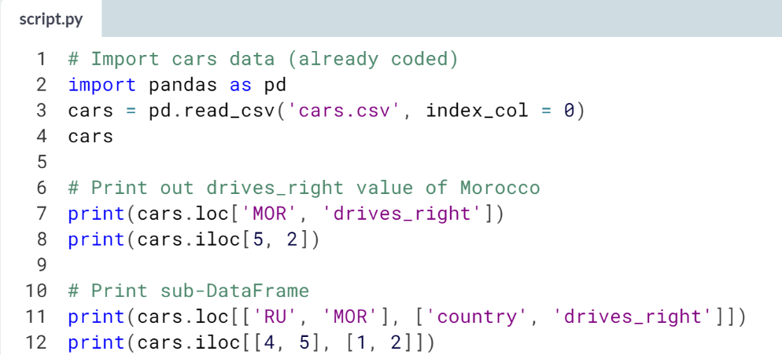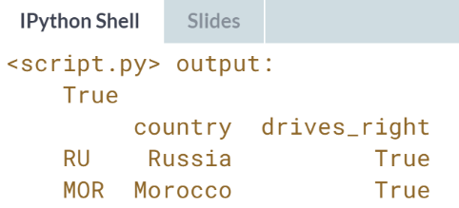  
Great! You might wonder if you can also combine label-based selection the *loc* way and index-based selection the *iloc* way. You can! It's done with *ix*, but we won't go into that here.

# loc and iloc (3) - **REVIEW**

It's also possible to select only columns with [**loc**](http://pandas.pydata.org/pandas-docs/stable/indexing.html#different-choices-for-indexing) and [**iloc**](http://pandas.pydata.org/pandas-docs/stable/indexing.html#different-choices-for-indexing). In both cases, you simply put a slice going from beginning to end in front of the comma:

cars.loc[:, 'country']

cars.iloc[:, 1]

cars.loc[:, ['country','drives\_right']]

cars.iloc[:, [1, 2]]

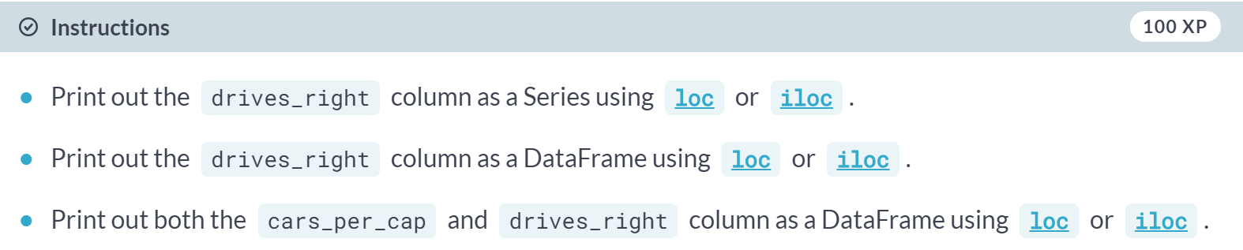

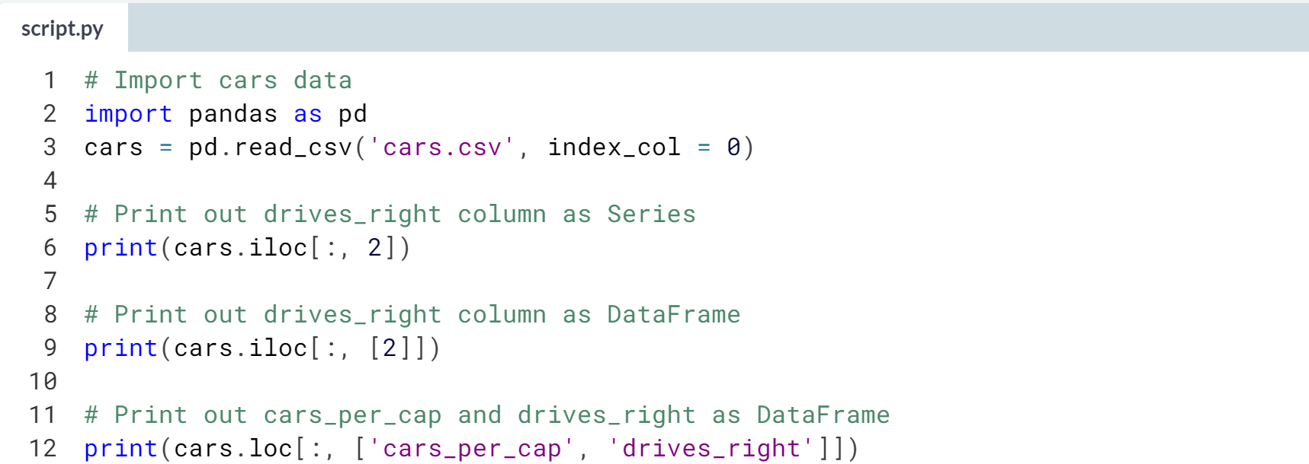  
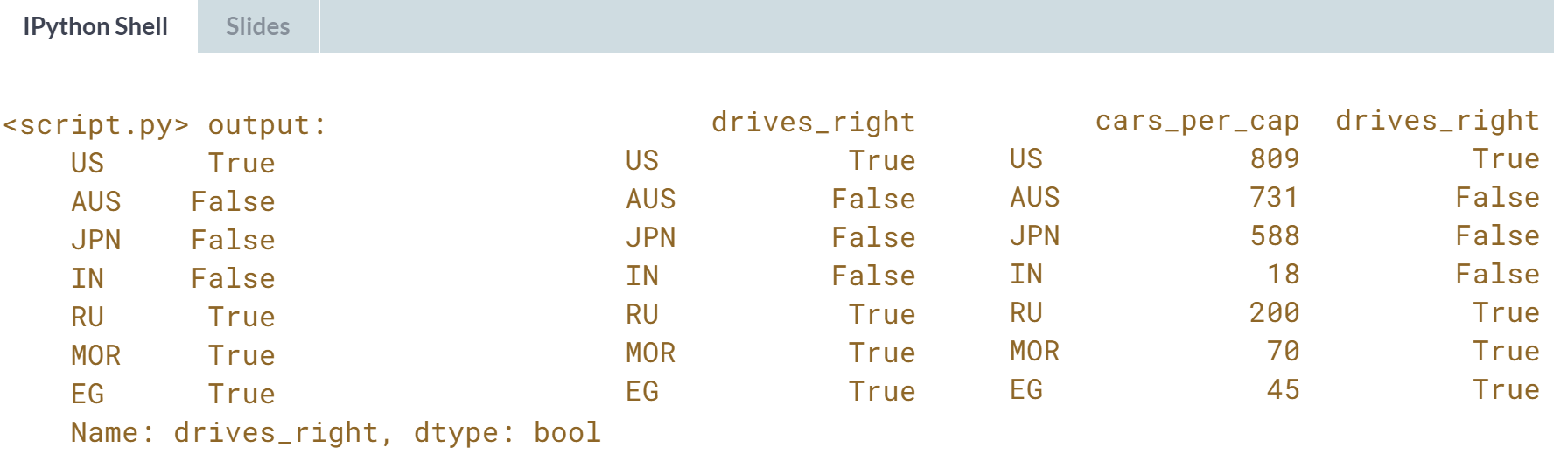  
What a drill on indexing and selecting data from Pandas DataFrames! You've done great! It's time to head over to chapter 3 to learn all about logic, control flow, and filtering!

**3. Logic, Control Flow and Filtering**

Boolean logic is the foundation of decision-making in Python programs. Learn about different comparison operators, how to combine them with Boolean operators, and how to use the Boolean outcomes in control structures. You'll also learn to filter data in pandas DataFrames using logic.



Do you remember the *bmi* array form the intro course? Here it is again. Using the greater than sign, we could find out which values in BMI were above 23.

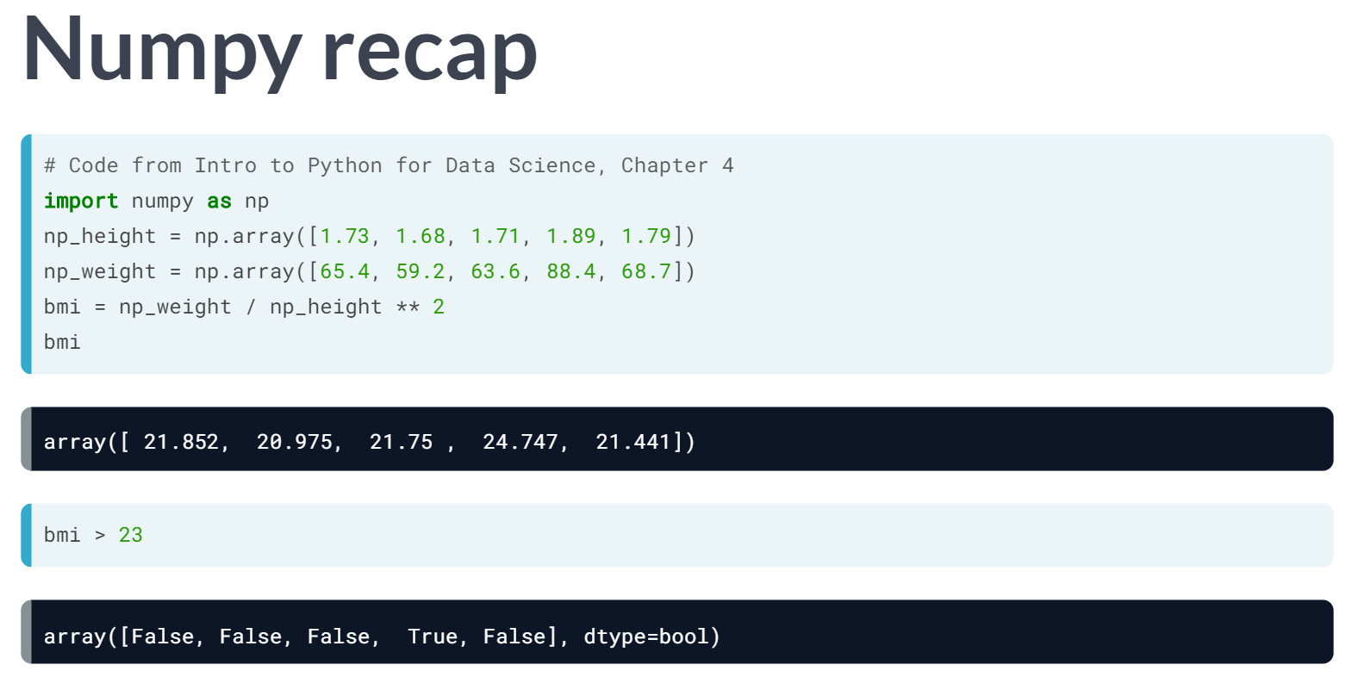  
Next, we used the resulting Boolean array to actually select the value. In this lesson, we will dive a little deeper into the world of comparison operator, like this greater than sign.

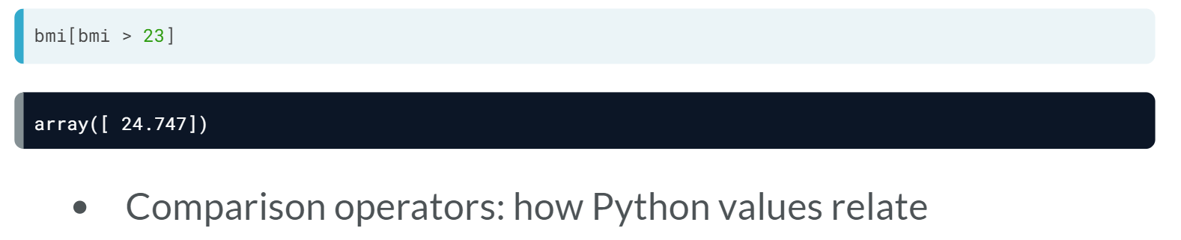  
Comparison operators are operators that can tell how two Python values relate and result in a Boolean.

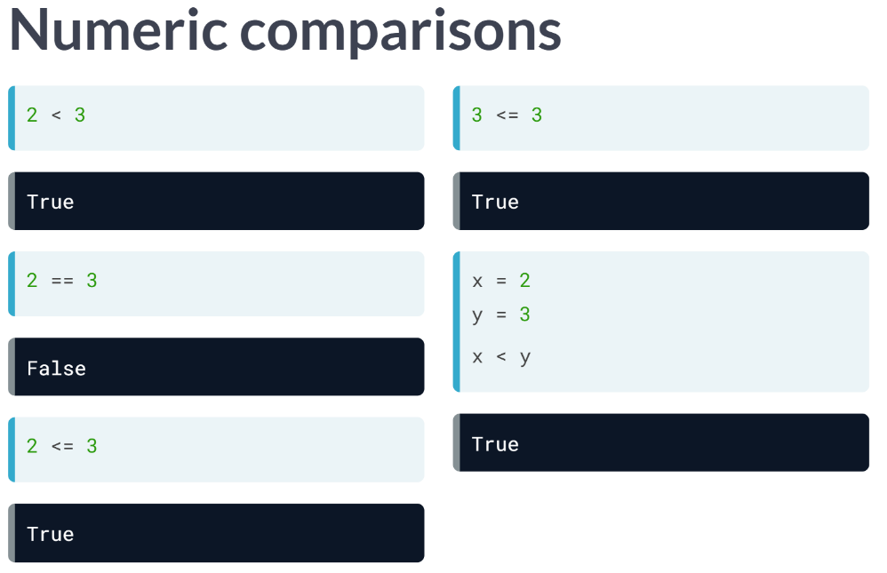  
In the simplest sense, we can use these operators on numbers. Say, for example, you want to check if 2 is smaller than 3. You type 2 less than sign 3 and hit Enter. Because this is the case, you get True. You can also check if two values are equal, with a double equals sign. From the second call, we see that 2 == 3 gives us False.

You can also make a combination of equality and smaller than. Have a look at this command that checks if 2 is smaller than or equal to 3. It's true, but also 3 smaller than or equal to 3 is true. Of course, we can also use comparison operators directly on variables that represent these integers as shown in the fifth call.

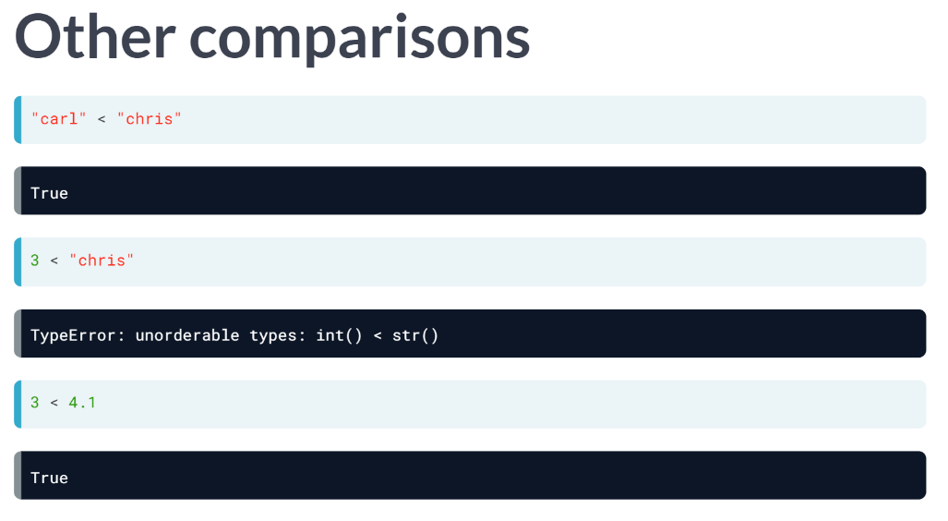  
All these operators also work for strings. Let's check if *‘carl’* is smaller than *‘chris’*. According to the alphabetical order, *‘carl’* comes before *‘chris’*, so the result is True. Do you think that comparing a string and an integer can work? However, comparing integers with strings won't work.

Typically, Python can't tell how two objects with different types relate. Different numeric types, such as floats and integers, are exceptions as this example shows: no errors this time. In general, always make sure that you make comparison between objects of the same type.

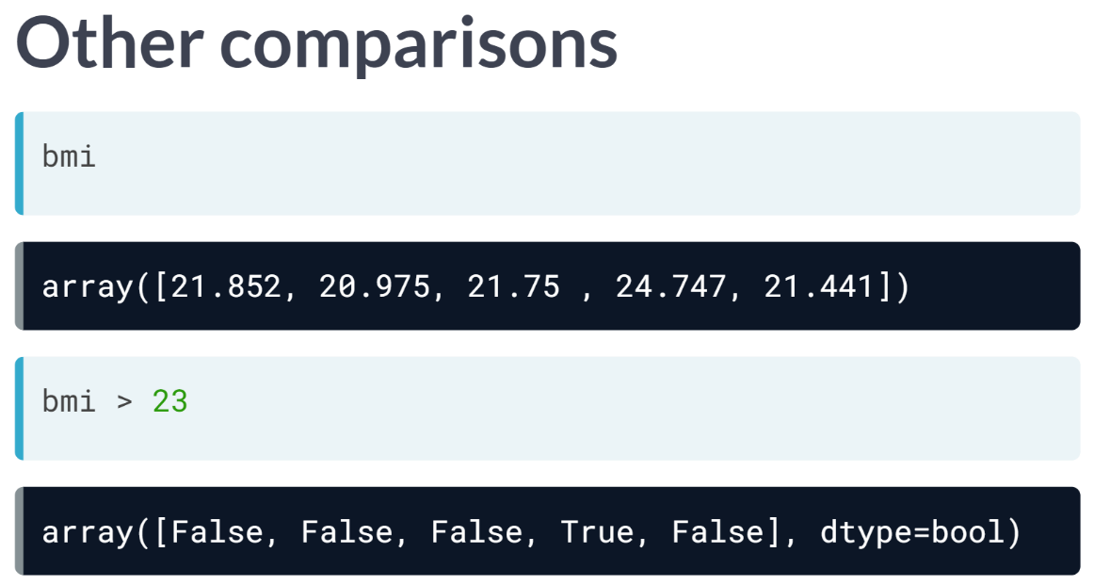  
Another exception arises when we move back to the example we move back to an example we started with, where we compared the Numpy array, *bmi*, with an integer, 23. This works perfectly. Numpy figures out that you want to compare every element in bmi with 23 and returns corresponding Booleans.

Behind the scenes, Numpy build a numpy array of the same size filled with the number 23, and then performs an elementwise comparison. This is concise, yet very efficient code, something data scientists love.

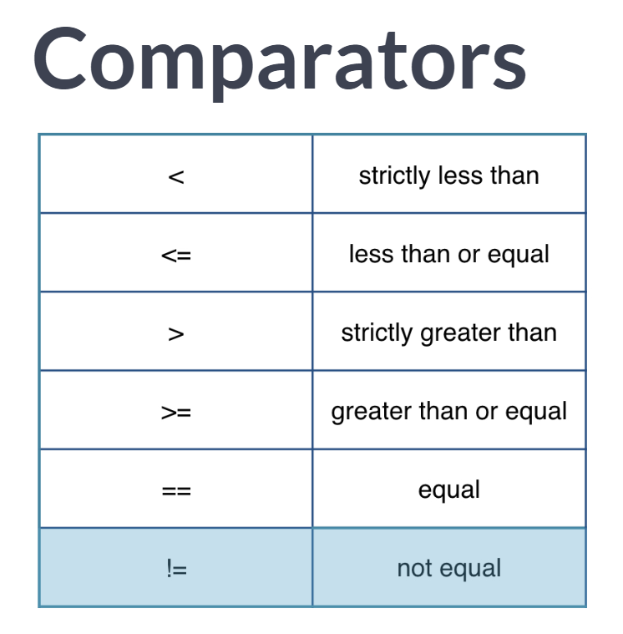  
Have a look at this table that summarizes all comparison operators. We already know about some of these.

# Equality

To check if two Python values, or variables, are equal you can use ==. To check for inequality, you need !=. As a refresher, have a look at the following examples that all result in True. Feel free to try them out in the IPython Shell.

2 == (1 + 1)

"intermediate" != "python"

True != False

"Python" != "python"

When you write these comparisons in a script, you will need to wrap a [**print()**](https://docs.python.org/3/library/functions.html#print) function around them to see the output.

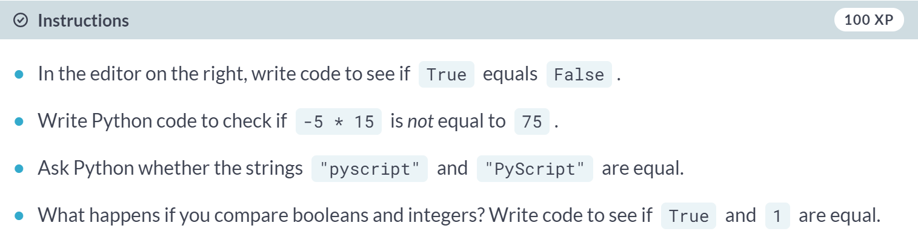

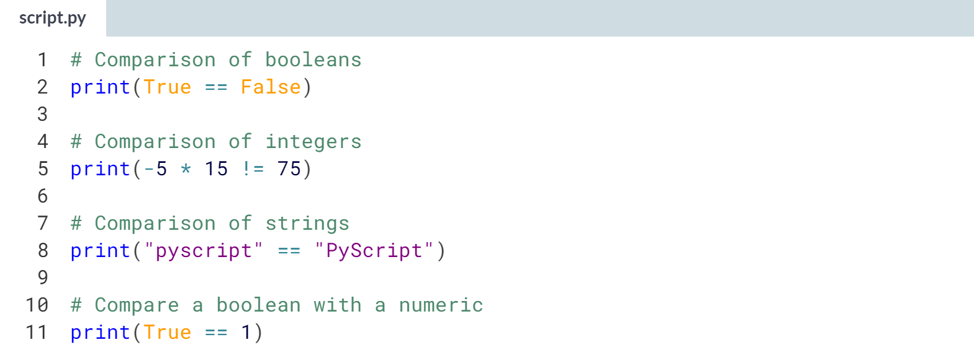  
  
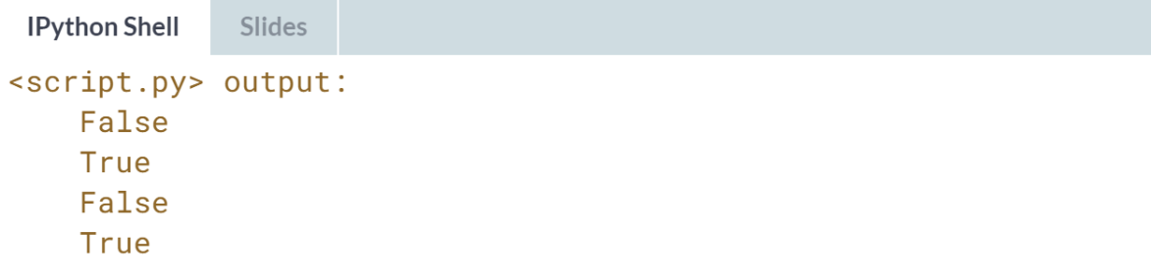  
The last comparison worked fine because actually, a Boolean is a special kind of integer: True corresponds to 1, False corresponds to 0.

# Greater and less than

In the video, Hugo also talked about the less than and greater than signs, < and > in Python. You can combine them with an equals sign: <= and >=. Pay attention: <= is valid syntax, but =< is not.

All Python expressions in the following code chunk evaluate to True:

3 < 4

3 <= 4

"alpha" <= "beta"

Remember that for string comparison, Python determines the relationship based on alphabetical order.

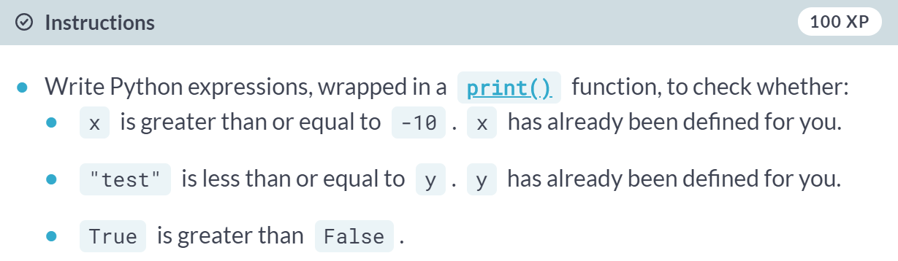

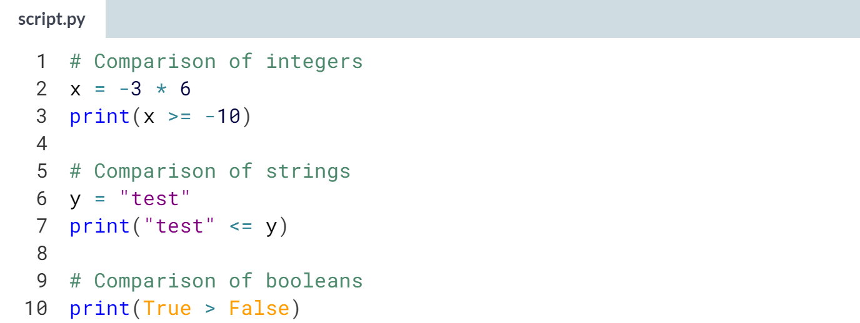  
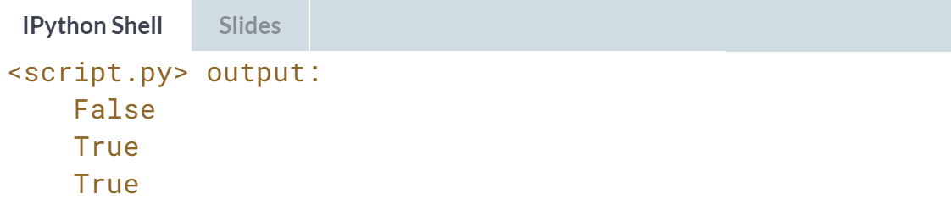

# Compare arrays

Out of the box, you can also use comparison operators with Numpy arrays.

Remember areas, the list of area measurements for different rooms in your house from Introduction to Python? This time there's two NumPy arrays: my\_house and your\_house. They both contain the areas for the kitchen, living room, bedroom, and bathroom in the same order, so you can compare them.

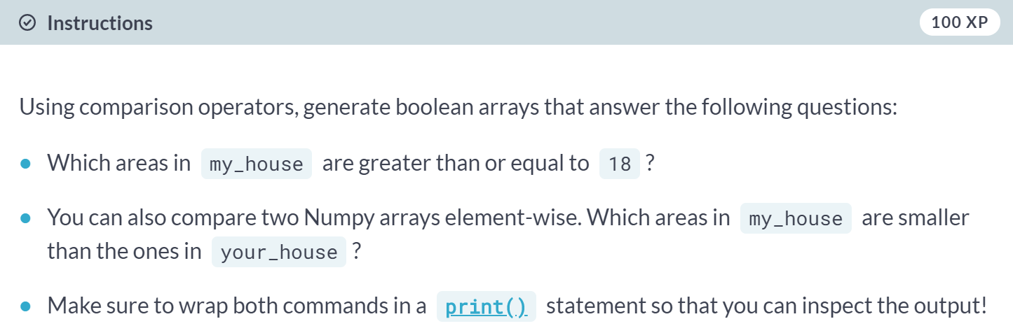  
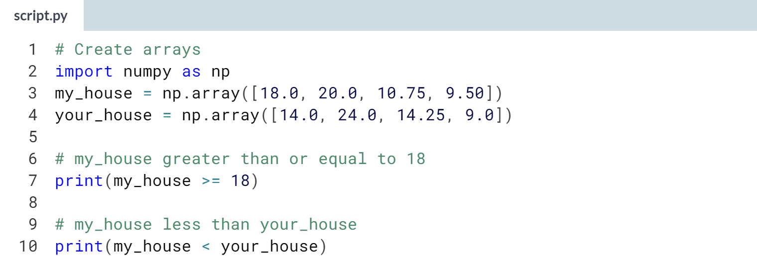  
  
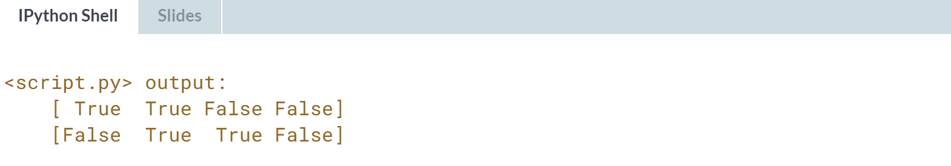  
Good job. It appears that the living room and bedroom in *my\_house* are smaller than the corresponding areas in *your\_house*.



Let's talk about combining the Booleans.

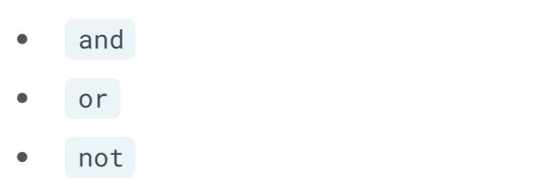  
The three most common ones are 'and', 'or', and 'not'.

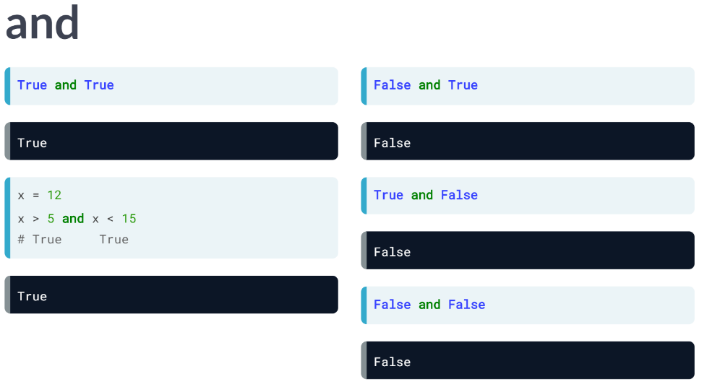

The and operator works just as you would expect. It takes two Booleans and returns *True* only if both the Booleans themselves are *True*. Instead of using Booleans, we can of course use the results of comparisons.

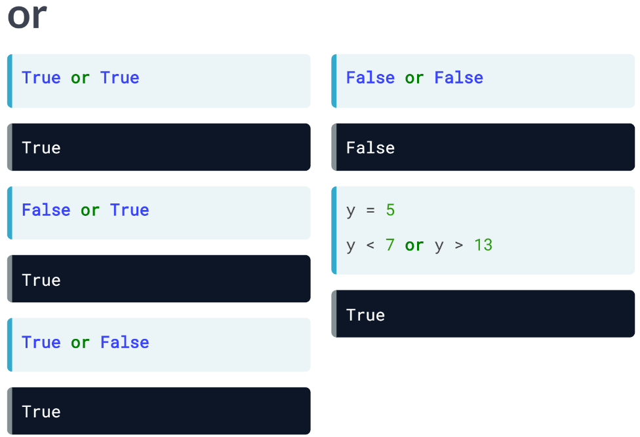  
The *'or'* operator works similarly, but the difference is that only at least one of the Booleans it uses should be True. Only *False* or *False* results in *False*. You can also make combinations with variables.

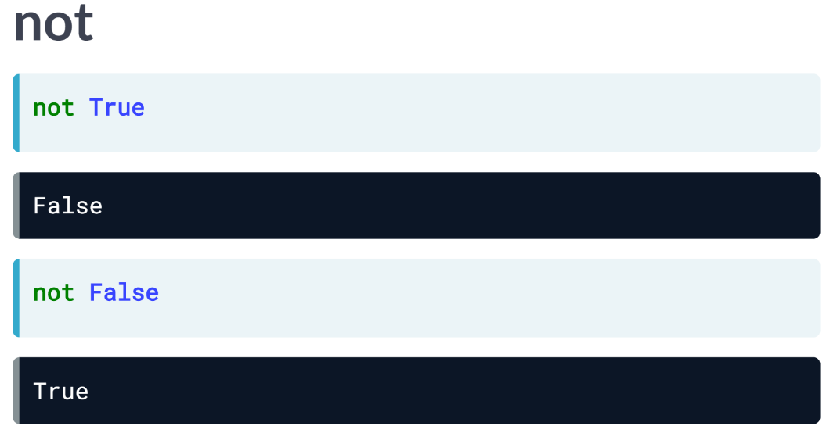  
Finally, there's the not operator. It simply negates the Boolean value you use it on. Not *True* is *False*, and not *False* it *True*.

This not operation is typically useful if you are combining different Boolean operations and then want to negate the result.

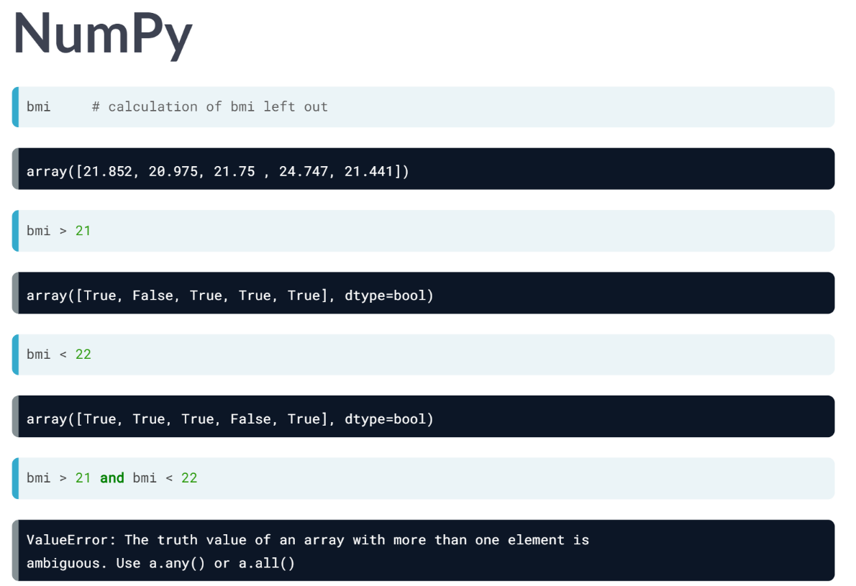  
Now, for NumPy array, things are different. Retaking the bmi example from the intro course, we can try to find out which bmis are higher than 21, but lower than 22.

The output of bmi greater than 21 or lower than 22 is easily found.

Let's now try to combine those with the and operator. Oops, an error. The truth value of an array with more than, one element is ambiguous, and clearly doesn't like an array of Booleans to work on.

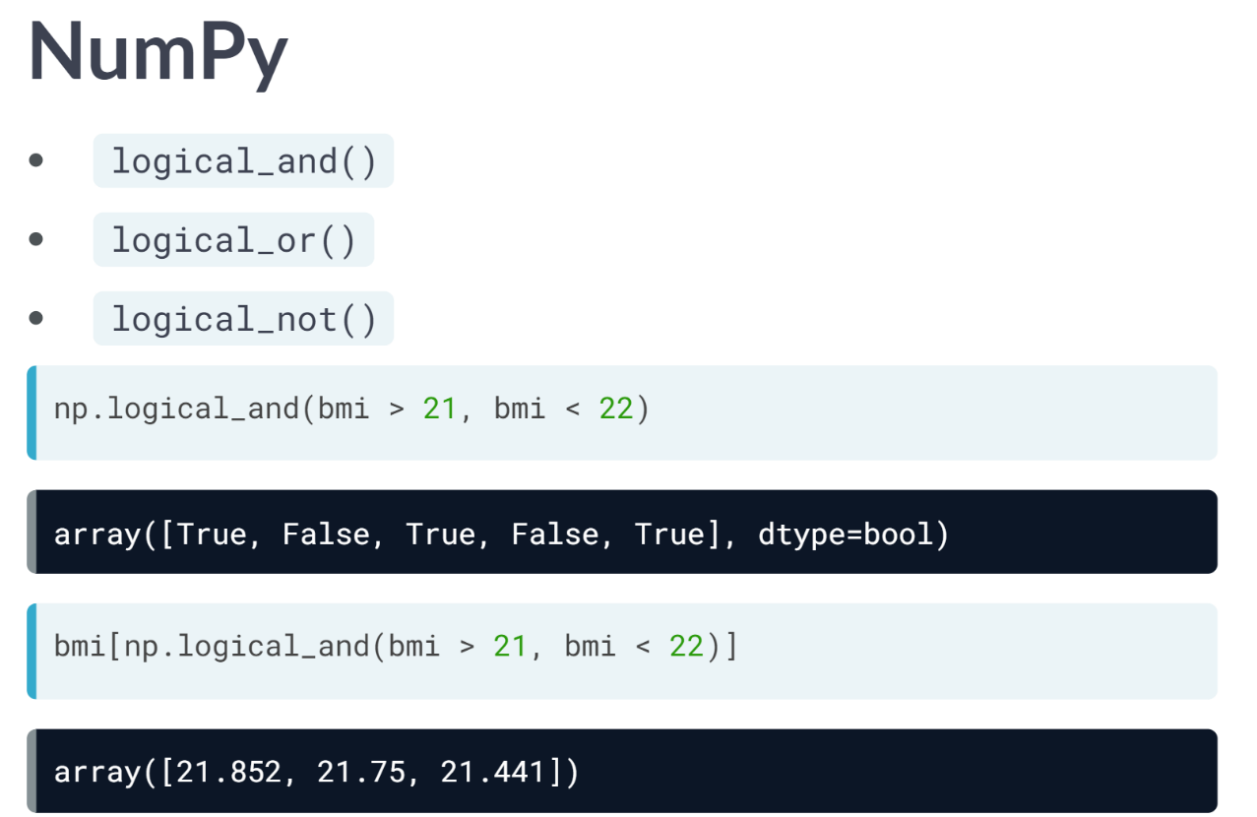

After digging in the numpy documentation, we can find three functions below. These are the "array equivalents" of *'and'*, *'or'*, and *'not'*.

To find out which bmis are between 21 and 22, we thus need this call above.

Again, as we expect from Numpy, the *'and'* operations is performed elementwise. To select only these bmis from the *bmi* array, we can use the resulting array of Booleans in square brackets.

Again, Numpy wins when it comes to writing short yet very expensive Python code.

# and, or, not (1)

A Boolean is either 1 or 0, True or False. With Boolean operators such as and, or and not, you can combine these Booleans to perform more advanced queries on your data.

In the sample code on the right, two variables are defined: my\_kitchen and your\_kitchen, representing areas.

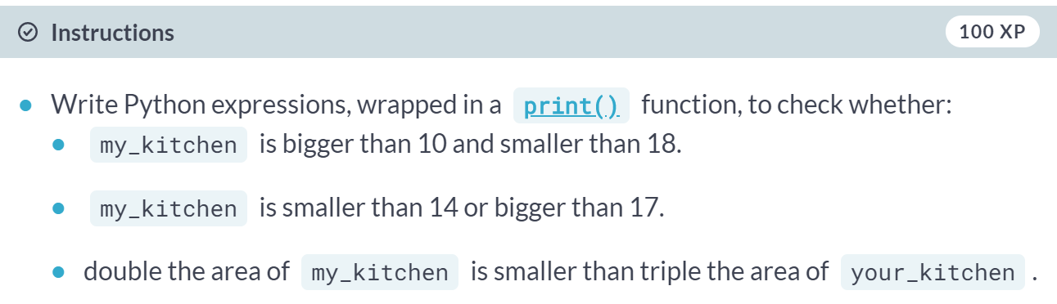

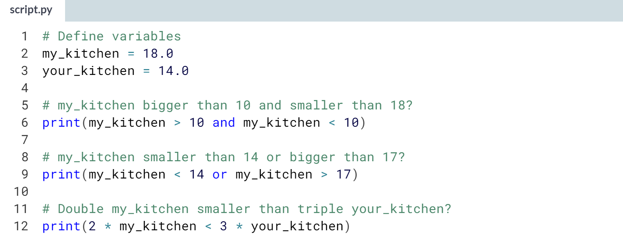

(Do not use capital letters for logical operators)

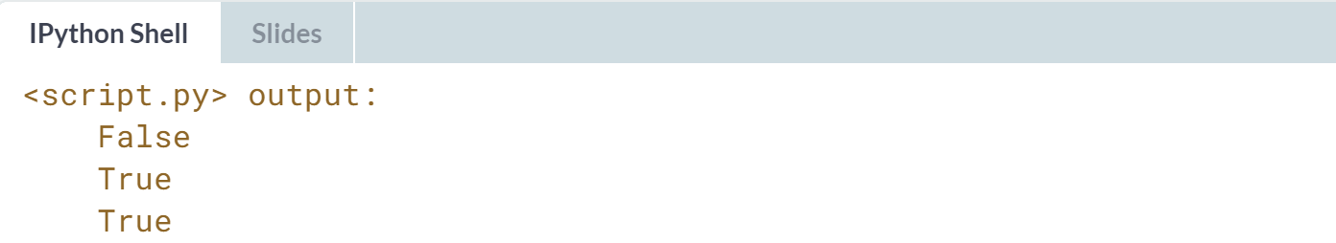

# and, or, not (2)

To see if you completely understood the Boolean operators, have a look at the following piece of Python code:

x = 8

y = 9

not(not(x < 3) and not(y > 14 or y > 10))

What will the result be if you execute these three commands in the IPython Shell?

NB: Notice that *not* has a higher priority than *and* and *or*, it is executed first.

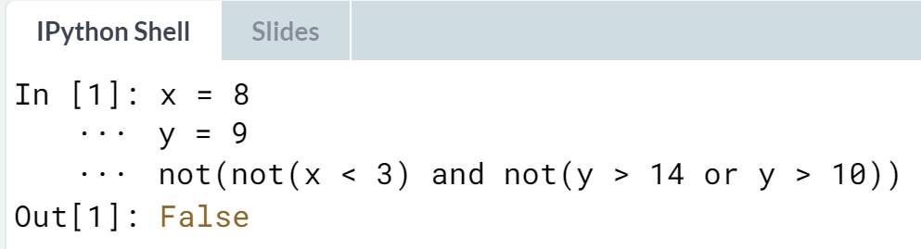

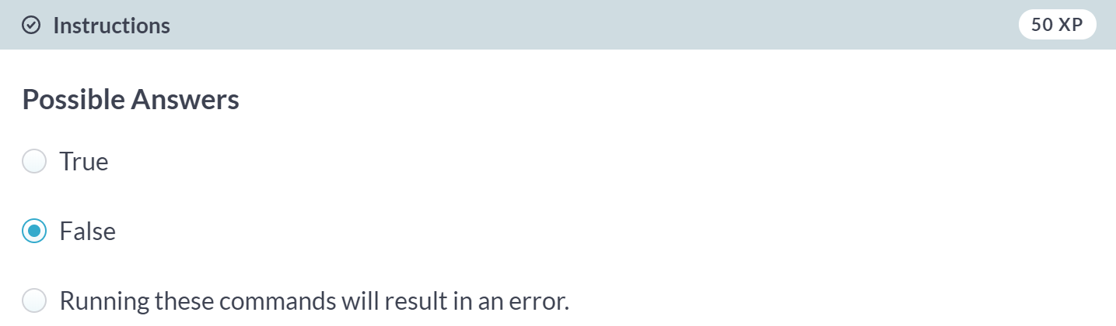

Correct! x < 3 is False. y > 14 or y > 10 is False as well. If you continue working like this, simplifying from inside outwards, you'll end up with False.

# Boolean operators with Numpy

Before, the operational operators like < and >= worked with Numpy arrays out of the box. Unfortunately, this is not true for the Boolean operators and, or, and not.

To use these operators with Numpy, you will need [**np.logical\_and()**](http://docs.scipy.org/doc/numpy-1.10.0/reference/generated/numpy.logical_and.html), [**np.logical\_or()**](http://docs.scipy.org/doc/numpy-1.10.0/reference/generated/numpy.logical_or.html) and [**np.logical\_not()**](http://docs.scipy.org/doc/numpy-1.10.0/reference/generated/numpy.logical_not.html). Here's an example on the my\_house and your\_house arrays from before to give you an idea:

np.logical\_and(my\_house > 13,

your\_house < 15)

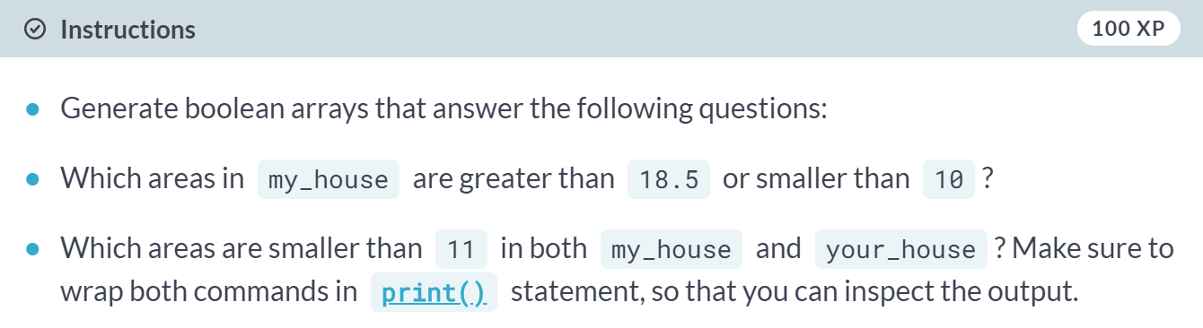

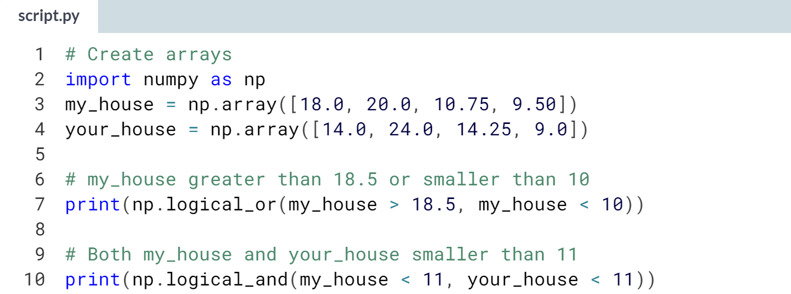  
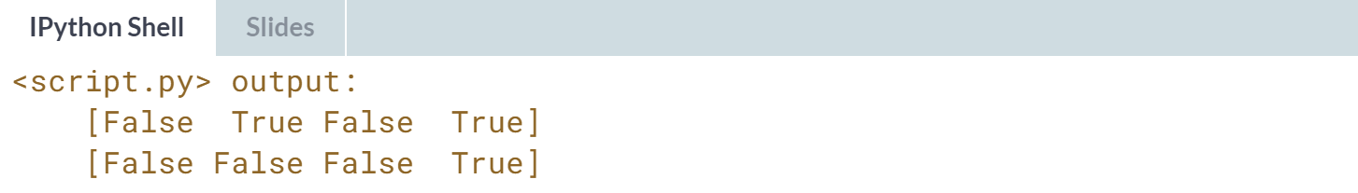



So, you now know about the comparison operators and also know about how to combine the Boolean results using and, or, not. Things get really interesting when you can actually use these concepts to change how your program behaves.  
  
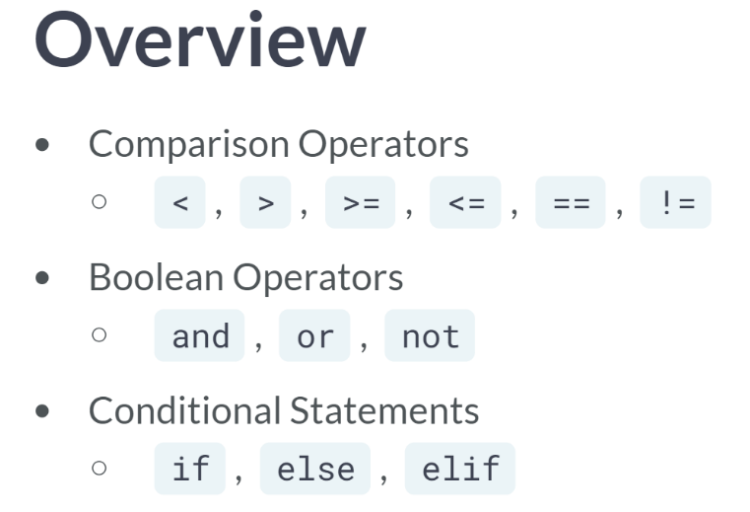

Depending on the outcome of your comparisons, you might want your Python code to behave differently. And we can do this with conditional statements in Python: *if*, *else*, and *elif*.

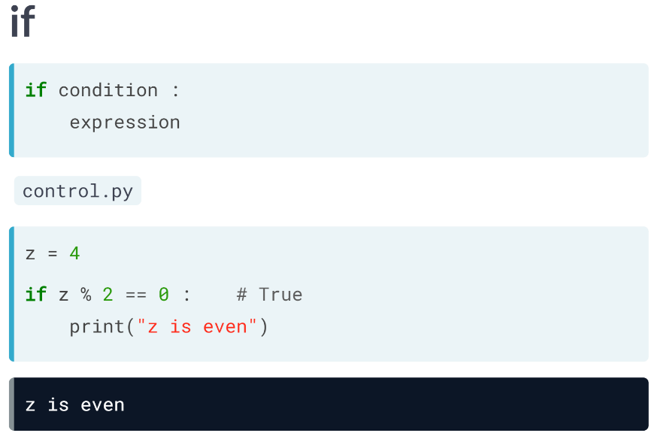  
Let's start working in a script, *control.py*. Suppose you have a variable *z*, equal to 4. If the value is even, you want to print out: *"z is even"*.

This code above does the trick. Modulo operator 2 will return 0 if z is even. If you run this, Python checks if the condition holds. It's true, so the corresponding code is executed: *"z is even"* gets printed out. Let's compare this to the general recipe for an if statement. It reads as follows: **if condition, execute expression.** Notice the colon at the end, and the fact that you simply have to indent the Python code with four spaces (or a tab) to tell Python what to do in the case the condition succeeds.

To exit the if statement, simply continue with some Python code without indentation, and Python will know that it's not part of the if statement.

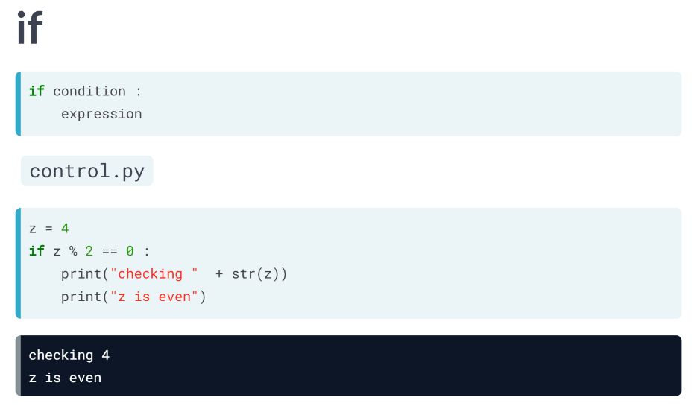  
It's perfectly possible to have more lines inside the if statement, like this for example. The script now prints out two lines if you run it. If the condition doesn't pass, the expression simply is not executed.

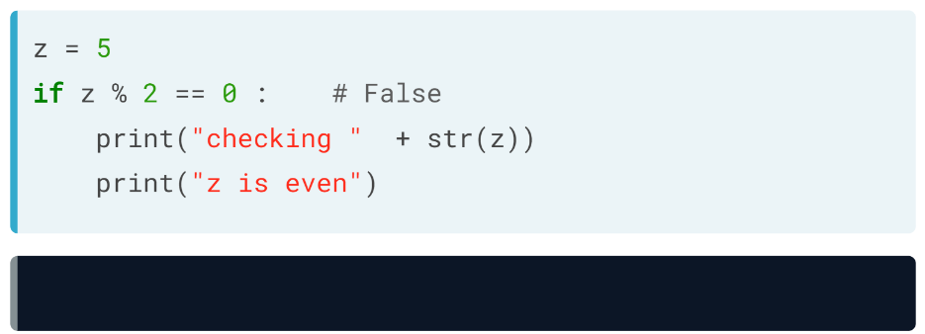  
You can see this if we change z to be 5 and rerun the code: there's no output. Suppose now that you want to print out "z is odd" in this case. How to do this?  
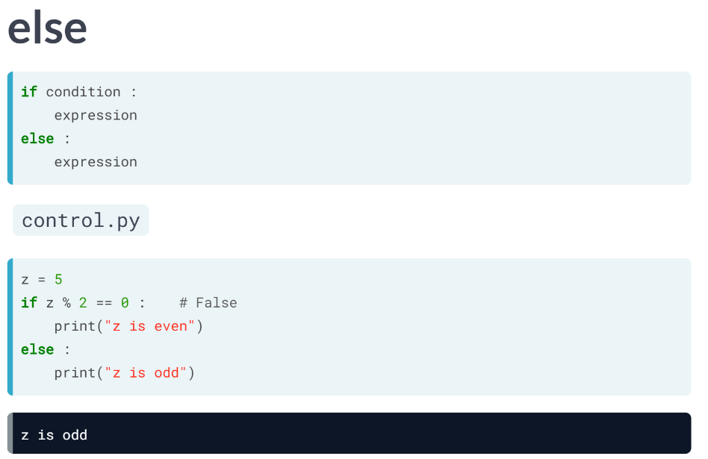  
Well, we can simply use an else statement, like this above. If we run it with z equals to 5, the condition is not true, so the expression for the else statement gets printed out. for the else statement, you don't need to specify a condition. The corresponding expression gets run if the condition of the if statement it belongs to doesn't hold.

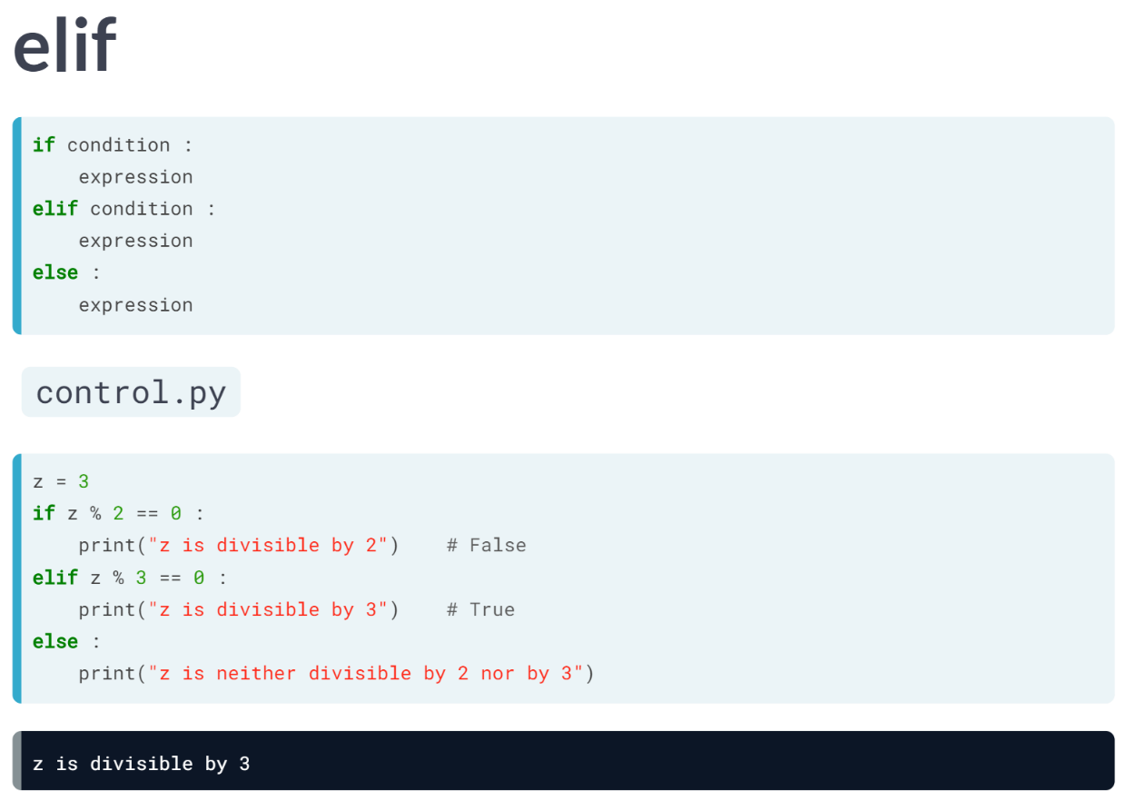  
You can think of cases where even more customized behavior is necessary.

Say you want different printouts for numbers that are divisible by 2 and by 3. You can throw some elifs in there to get the job done.

This condition does hold true when z is divisible by 3, so the corresponding print statement is executed.

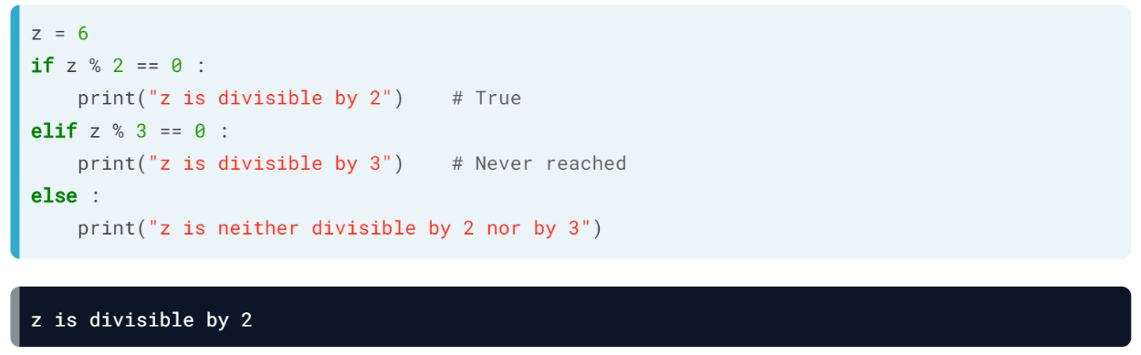

Suppose now that z equals 6. Both the if and elif conditions hold true in this case. But two printouts don't occur.

As soon as Python bumps into a condition that is true, it executes the corresponding code and then leaves the control structure after that.

This means the second condition, corresponding to the *elif*, is never reached so there's no corresponding printout.

Control flow can be extremely powerful when you're writing your own Python scripts.

# Warmup

To experiment with if and else a bit, have a look at this code sample:

area = 10.0

if(area < 9) :

print("small")

elif(area < 12) :

print("medium")

else :

print("large")

What will the output be if you run this piece of code in the IPython Shell?

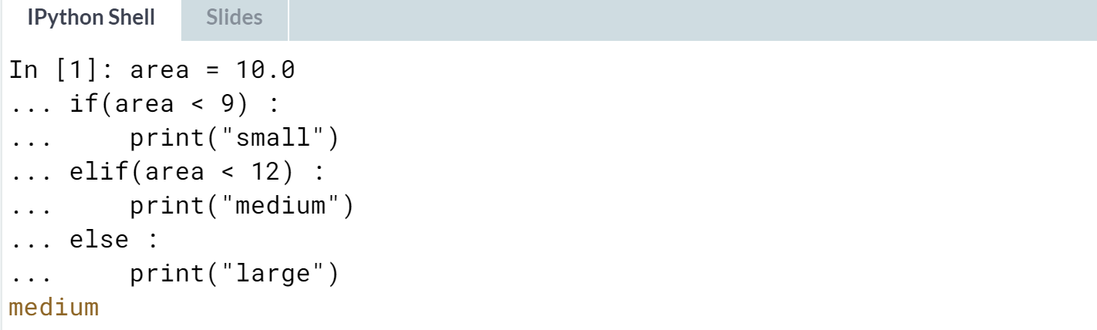  
  
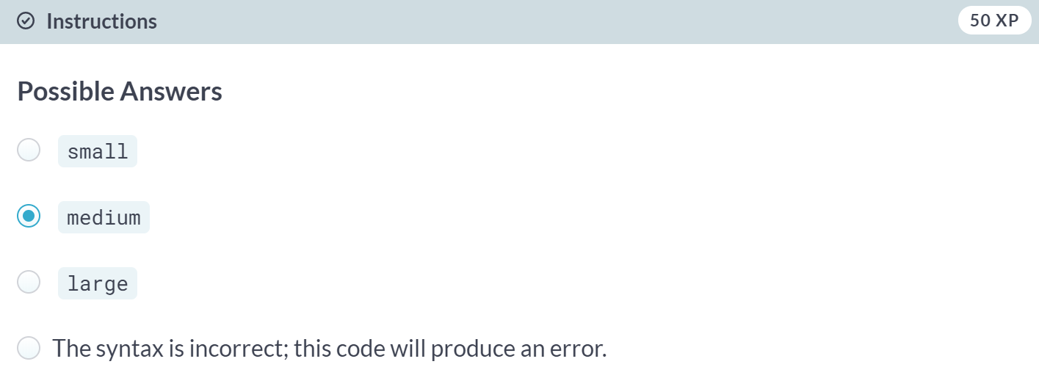

# if

It's time to take a closer look around in your house.

Two variables are defined in the sample code: room, a string that tells you which room of the house we're looking at, and area, the area of that room.

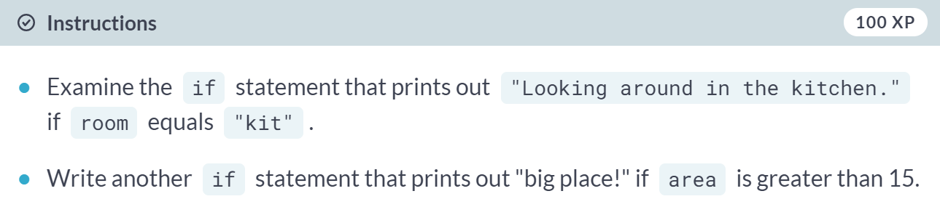

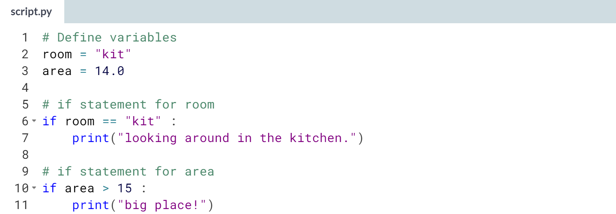

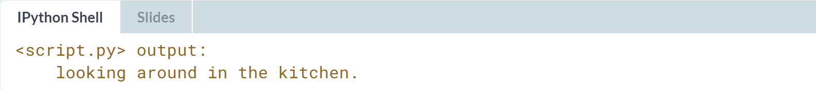

Great! big place! wasn't printed because *area > 15* is not True. Experiment with other values of room and area to see how the printouts change.

# Add else

On the right, the if construct for room has been extended with an else statement so that "looking around elsewhere." is printed if the condition room == "kit" evaluates to False.

Can you do a similar thing to add more functionality to the if construct for area?

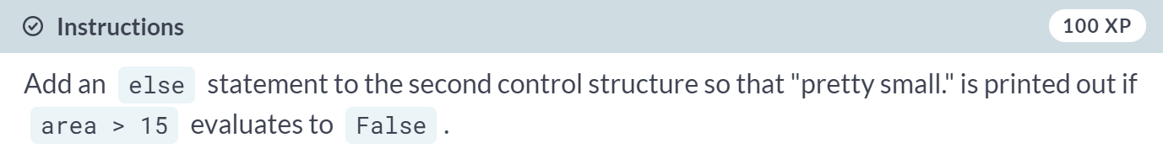

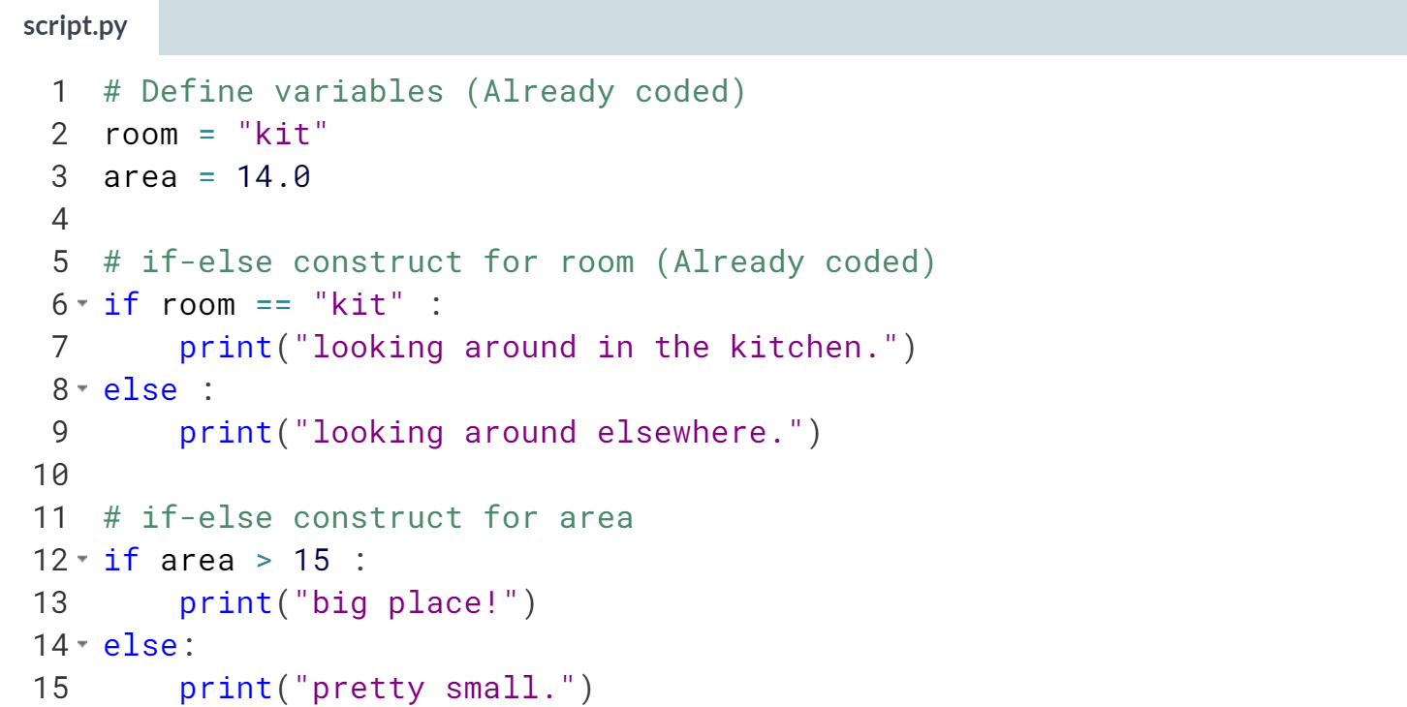  
  
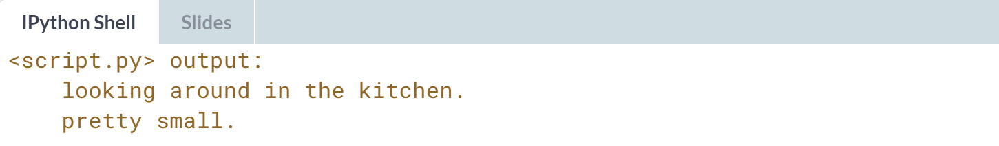  
Nice! Again, feel free to play around with different values of room and area some more. After, head over to the next exercise where you'll take this customization one step further!

# Customize further: elif

It's also possible to have a look around in the bedroom. The sample code contains an elif part that checks if room equals "bed". In that case, "looking around in the bedroom." is printed out.

It's up to you now! Make a similar addition to the second control structure to further customize the messages for different values of area.



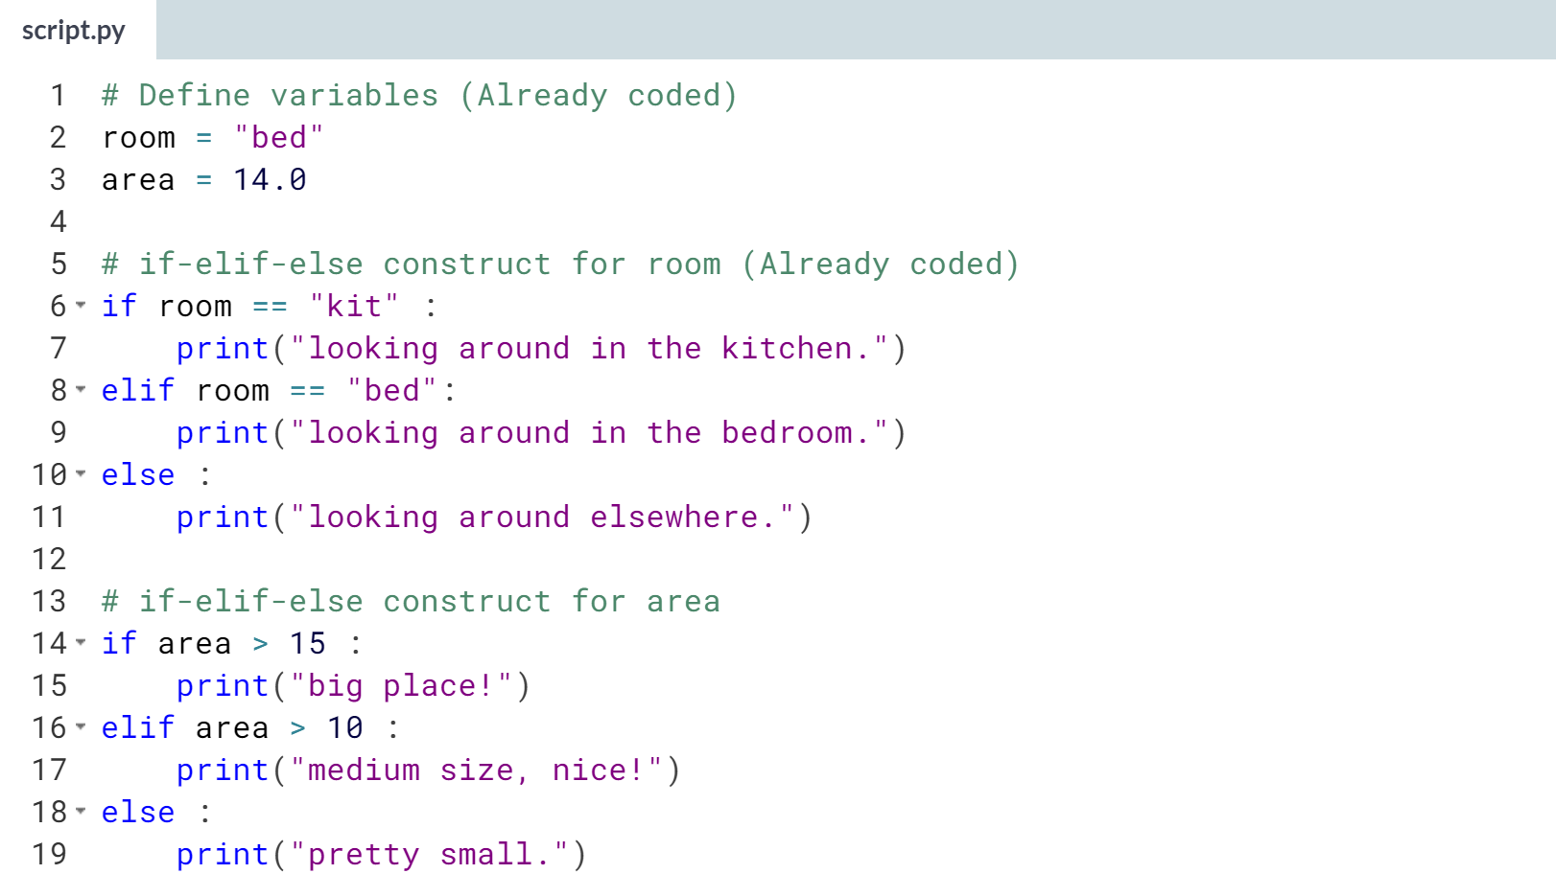

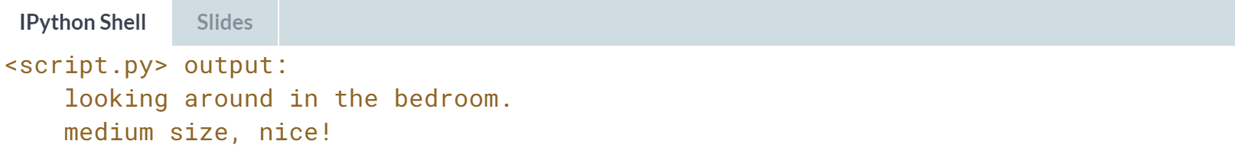



Let's now learn how we can use comparison and Boolean operations on an elementwise basis on the pandas DataFrames.

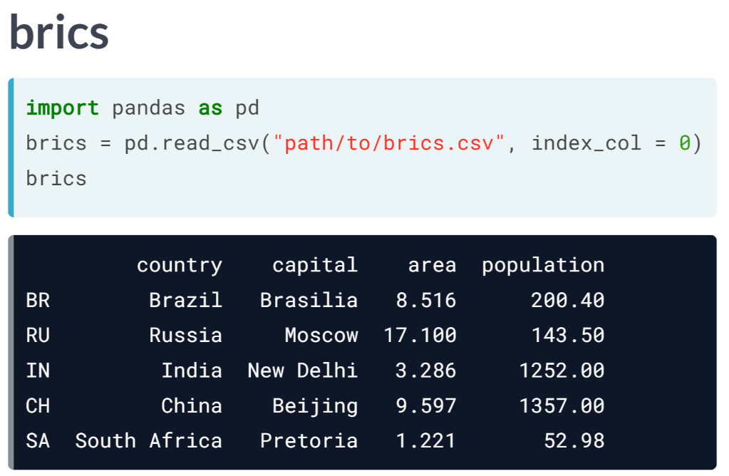  
Let's first import the BRICS dataset again from the CSV file.

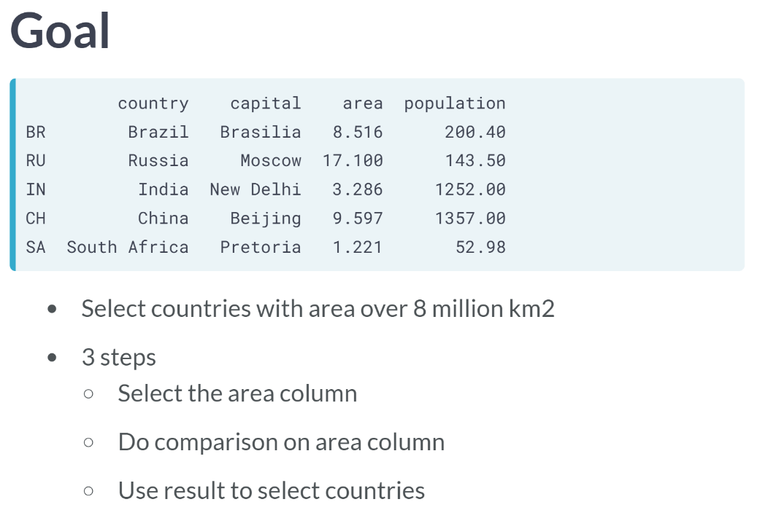  
Suppose you now want to keep the countries, so the observations in this case, for which the area is greater than 8 million square kilometers. There are three steps to this.

First, we want to get the area column from brics. Second, we perform the comparison on this column and store its result. Finally, we should use this result to do the appropriate selection on the DataFrame.

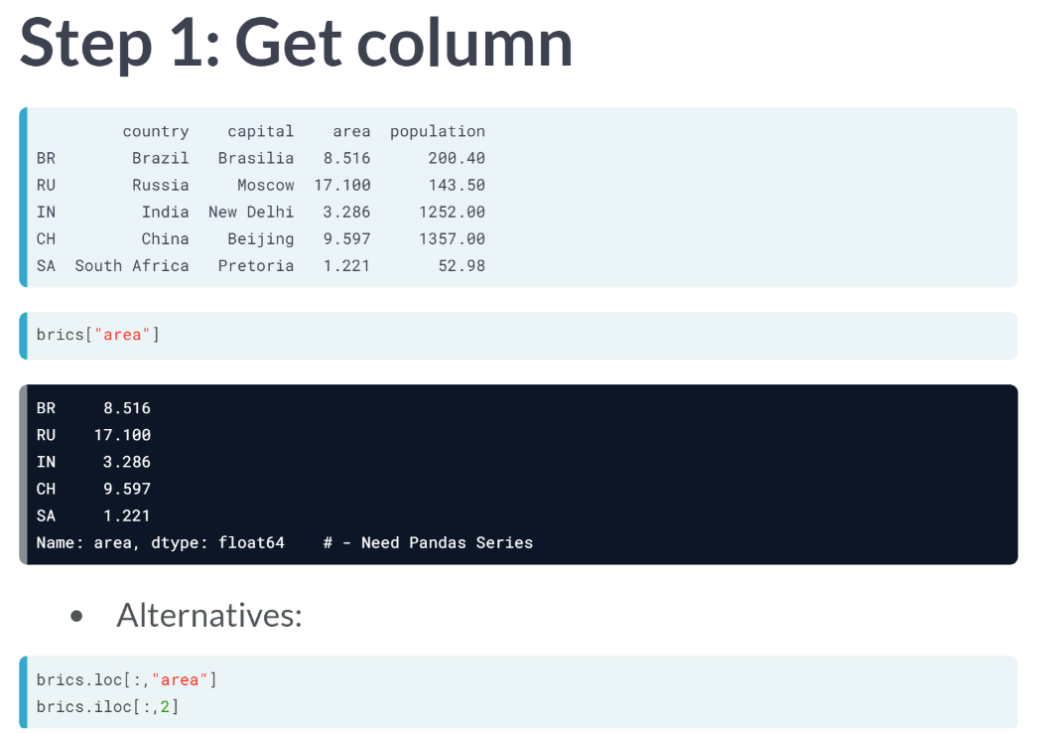  
First step, getting the area column from brics. There are many different ways to do this. What's important here, is that we ideally get a Pandas Series, not a Pandas DataFrame. Let's do this with single pair of square brackets, like this above. This *loc* alternative, and this *iloc* alternative, would also work perfectly fine.

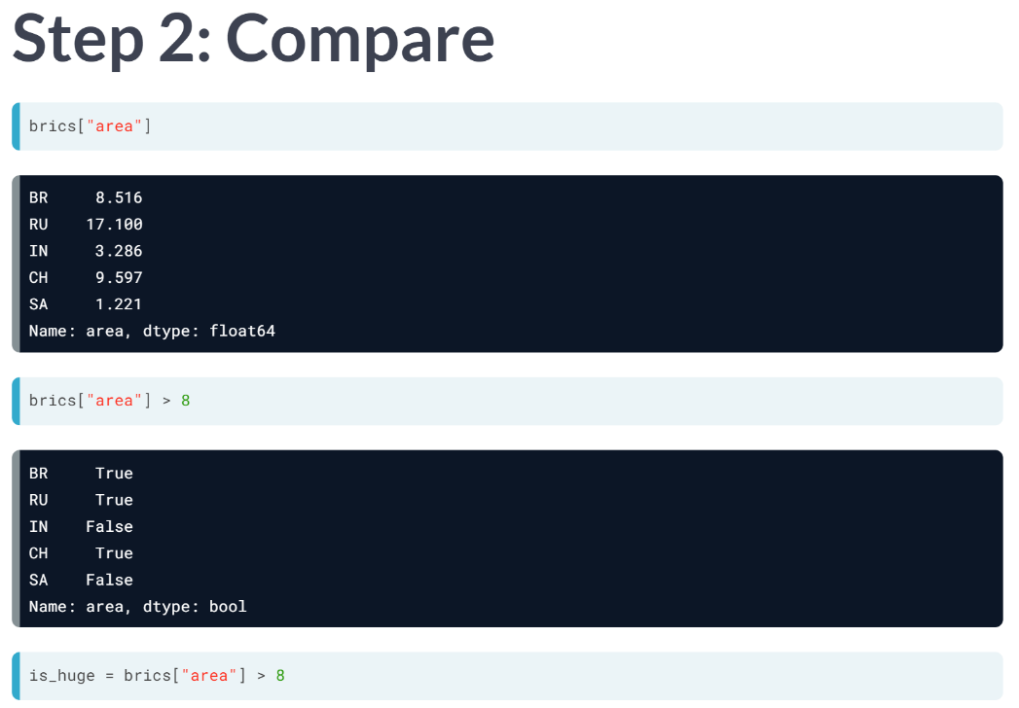  
Second, we actually perform the comparisons to see which rows have an area greater than 8, we simply append greater than 8 to the code from before, like the above. Now we get a series containing Booleans.

If you compare it to the actual values, you can see that the areas with a value over 8 corresponds to True, and the ones with a value under 8 correspond to False now. Let's store this Boolean series as *is\_huge*.

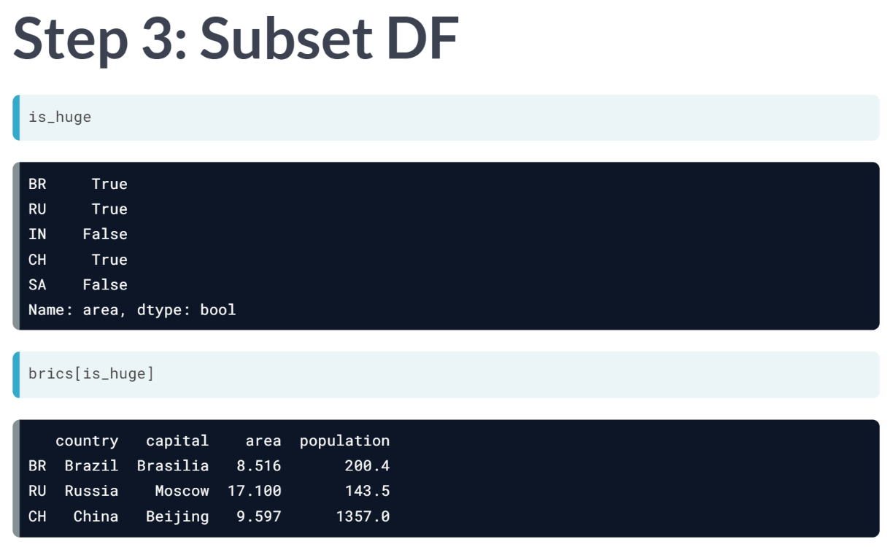  
The final step is using this Boolean Series to subset the Pandas DataFrame. To do this, we put *is\_huge* inside square brackets. The result is exactly what we want: only the countries with an area greater than 8, namely Brazil, Russia, and China.

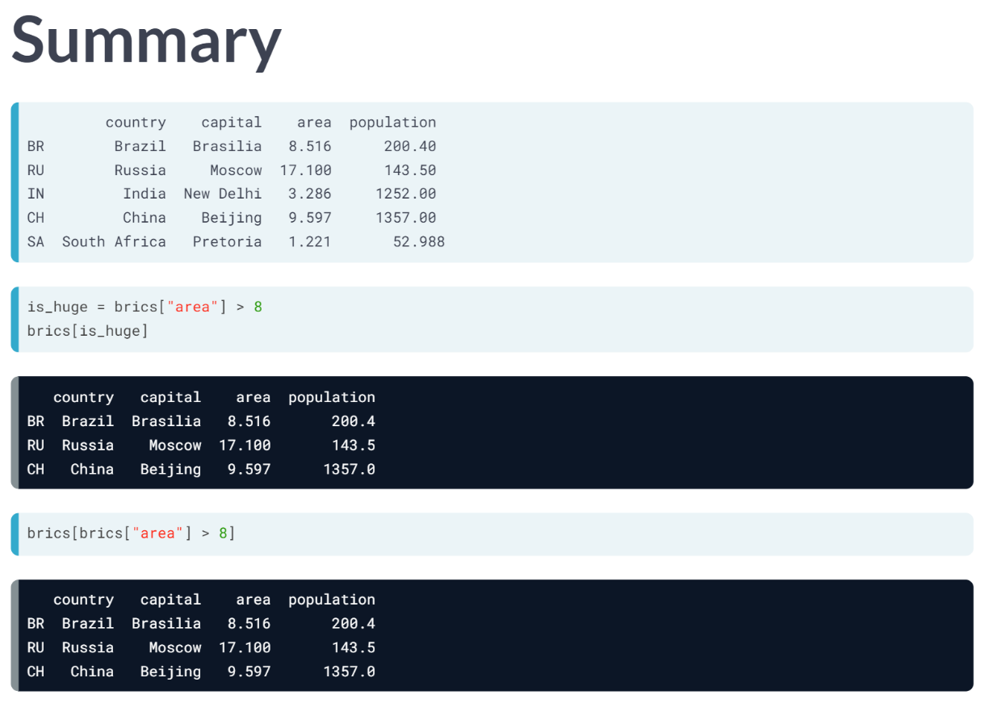  
To summarize, we selected the area column, performed a comparison on this column, and stored it as *is\_huge* so that I can use it to index the brics DataFrame. These different commands do the trick. However, we can also write this in a one-liner: simply put the code that defines *is\_huge* directly in the square brackets, as shown in the third call.

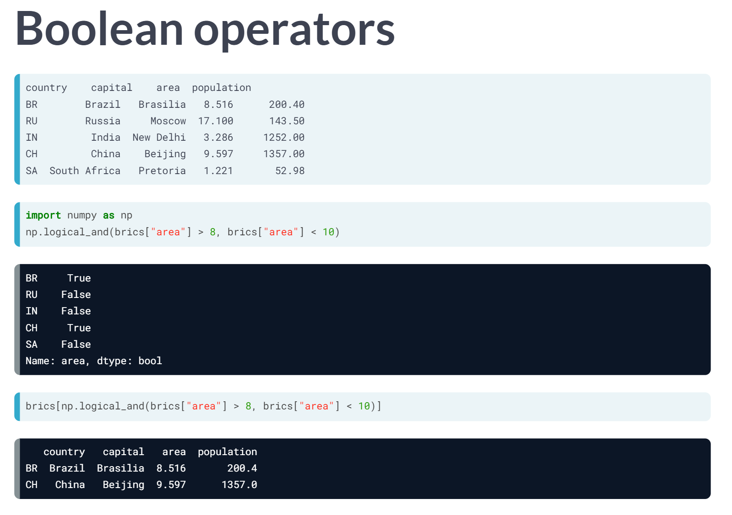  
Now we haven't used Boolean operators yet. Remember that we used this ***logical\_and()*** function from the NumPy package to do an elementwise Boolean operation on Numpy arrays?

Because Pandas is built on Numpy, you can also use that function here. Suppose you only want to keep the observations that have an area between 8 and 10 million squares kilometers.

After importing NumPy as np, we can use the ***logical\_and()*** function to create a Boolean Series.

The only thing left to do id placing this code inside square brackets to subset brics appropriately. This time, only Brazil and China are included. Russia has an area of 17 million square kilometers, which doesn't meet the conditions.

As we can see, filtering DataFrames to get interesting results is not difficult at all.

# Driving right (1)

Remember that cars dataset, containing the cars per 1000 people (cars\_per\_cap) and whether people drive right (drives\_right) for different countries (country)? The code that imports this data in CSV format into Python as a DataFrame is available on the right.

In the video, you saw a step-by-step approach to filter observations from a DataFrame based on Boolean arrays. Let's start simple and try to find all observations in cars where drives\_right is True.

drives\_right is a Boolean column, so you'll have to extract it as a Series and then use this Boolean Series to select observations from cars.

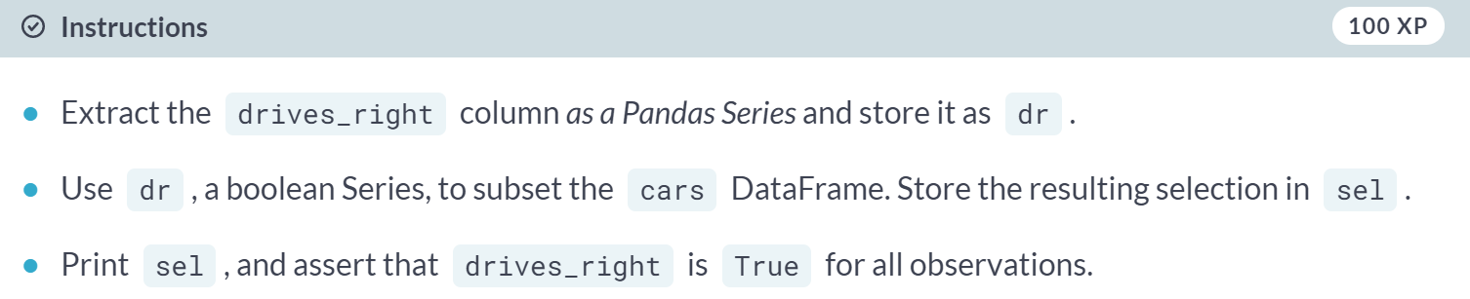  
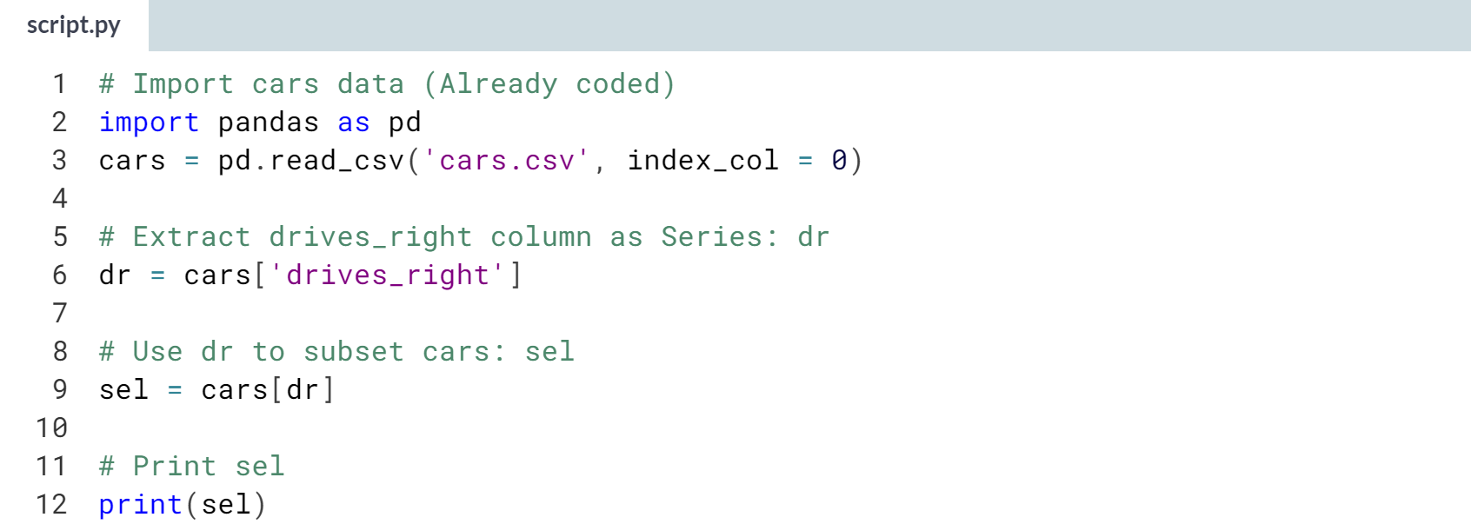  
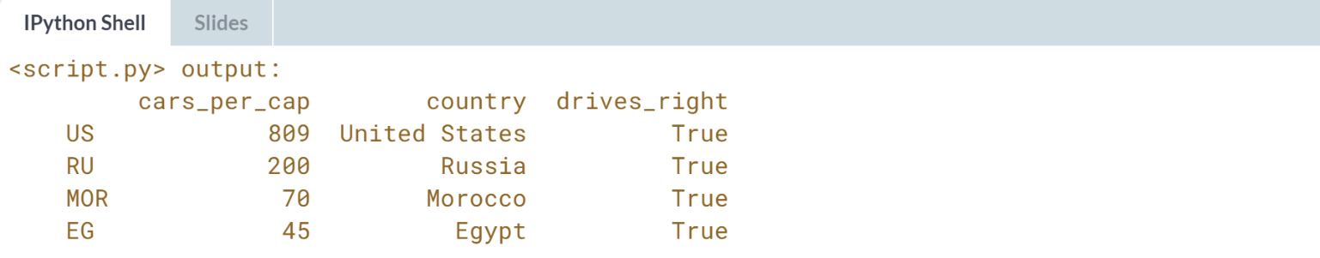

# Driving right (2)

The code in the previous example worked fine, but you actually unnecessarily created a new variable dr. You can achieve the same result without this intermediate variable. Put the code that computes dr straight into the square brackets that select observations from cars.

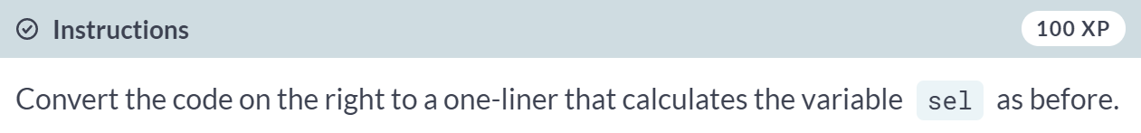

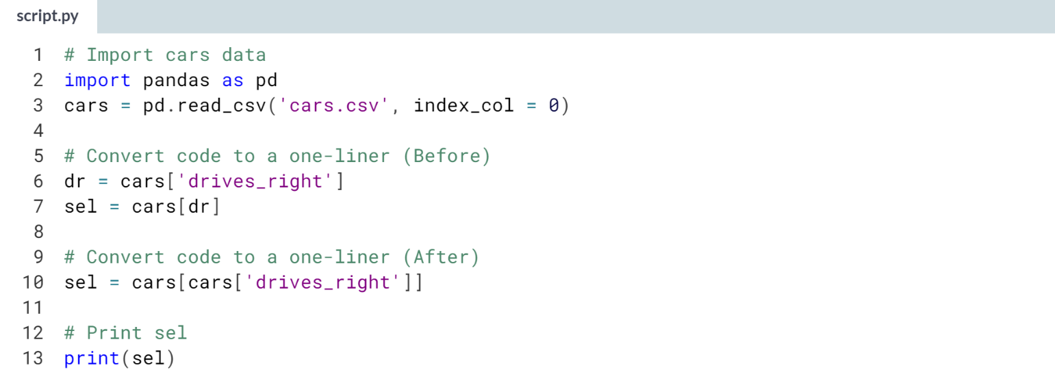

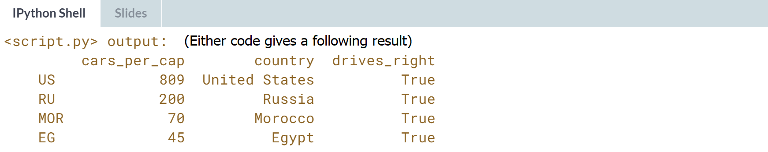  
Nice one! *cars* contains 7 rows or observations, *sel* contains 4; so in the majority of the countries in your dataset, people drive on the right side of the road.

# Cars per capita (1)

Let's stick to the cars data some more. This time you want to find out which countries have a high cars per capita figure. In other words, in which countries do many people have a car, or maybe multiple cars.

Similar to the previous example, you'll want to build up a Boolean Series, that you can then use to subset the cars DataFrame to select certain observations. If you want to do this in a one-liner, that's perfectly fine!

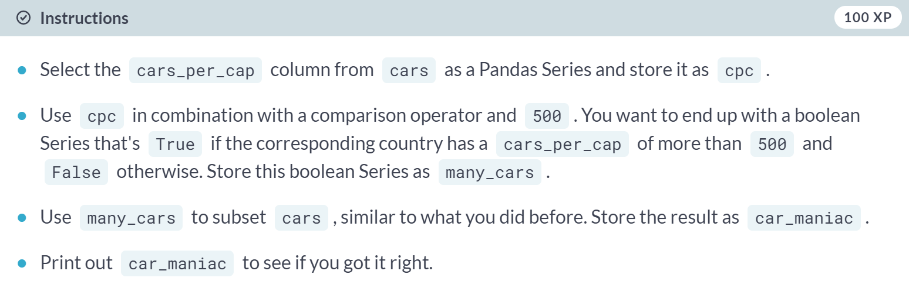

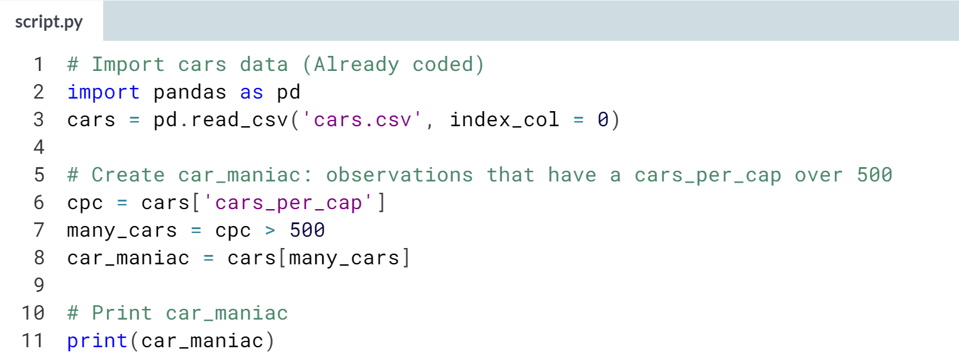

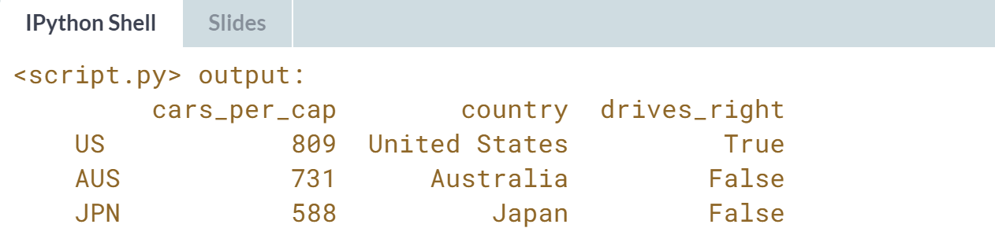  
Good job! The output shows that the US, Australia and Japan have a ***cars\_per\_cap*** of over 500.

# Cars per capita (2)

Remember about [**np.logical\_and()**](http://docs.scipy.org/doc/numpy-1.10.0/reference/generated/numpy.logical_and.html), [**np.logical\_or()**](http://docs.scipy.org/doc/numpy-1.10.0/reference/generated/numpy.logical_or.html) and [**np.logical\_not()**](http://docs.scipy.org/doc/numpy-1.10.0/reference/generated/numpy.logical_not.html), the Numpy variants of the and, or and not operators? You can also use them on Pandas Series to do more advanced filtering operations.

Take this example that selects the observations that have a cars\_per\_cap between 10 and 80. Try out these lines of code step by step to see what's happening.

cpc = cars['cars\_per\_cap']

between = np.logical\_and(cpc > 10, cpc < 80)

medium = cars[between]

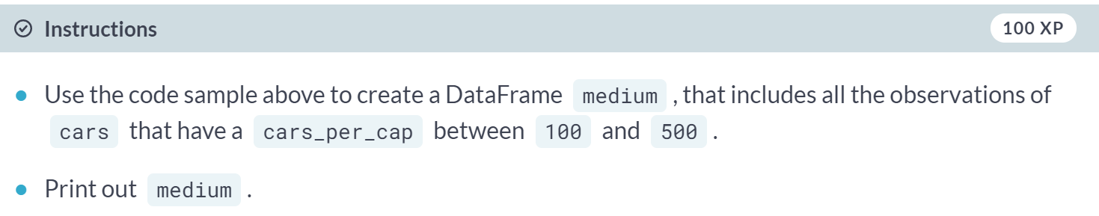

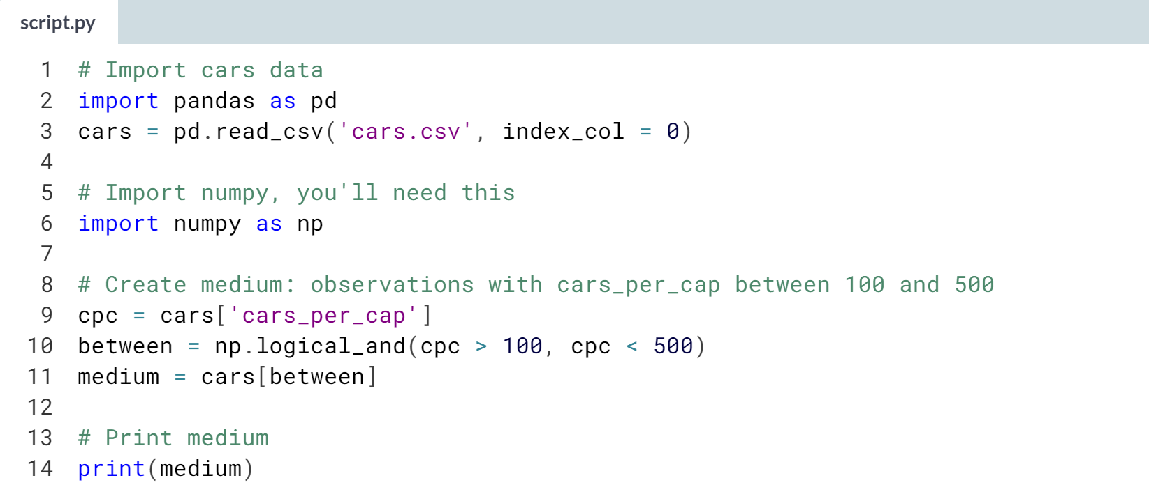

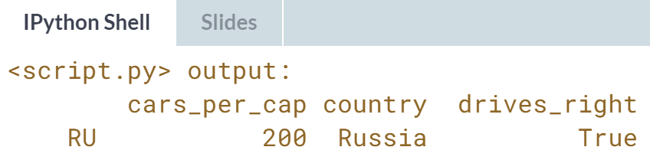

**4. Loops**

There are several techniques you can use to repeatedly execute Python code. While loops are like repeated if statements, the for loop iterates over all kinds of data structures. Learn all about them in this chapter.



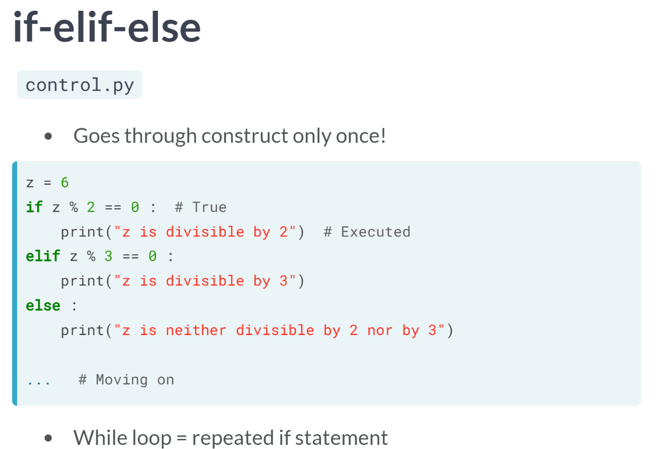  
As soon as Python encounters an if statement, it checks the condition. When this condition is True, the corresponding code is executed. If the condition evaluates to False, and if there are elif and else statements, Python continues the search.

Anyways, Python goes through this piece of code only once. After that, Python heads over to the next command in the script. The while loop is somewhat similar to an if statement: it executes the code inside if the condition is True. However, as opposed to the if statement, the while loop will continue to execute this code over and over again as long as the condition is true.

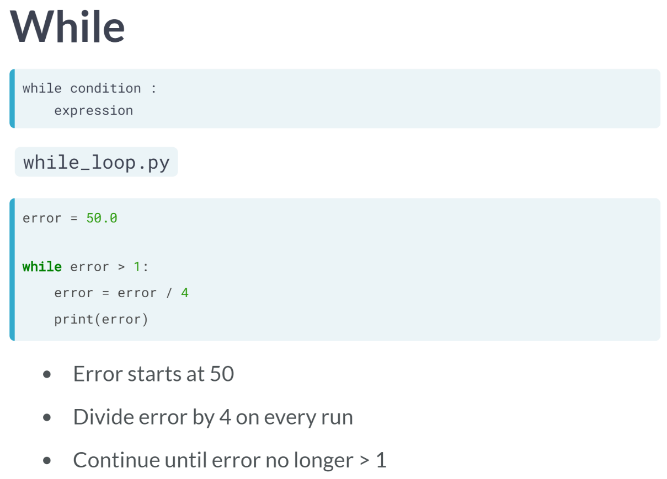  
The syntax of a while loop is very similar to the if statement. The while loop is not that common, but in some cases, it can be very useful.

As an example, suppose you're numerically calculating a model based on your data. This typically involves taking the same steps over and over again, until the error between your model and your data is below some boundary.

When you can reformulate the problem as 'repeating an action until a particular condition is met', a while loop is often the way to go.

Say that we start with an error of fifty and that our fancy algorithm divides the error by four on each run. We want to keep going until the error is no longer above 1. Now, heading over to the script, we start by adding the error we start with, 50.

Next, we write a while loop. In the condition part, we write error > 1, so that the while loop executes again as long as the error is above 1. Inside the code, we divide the error by four and update the error variable. This kind of simulates our fancy algorithm that divides the error by four on every run. Next, we also print this error. Let's go through what happens if you actually run this script, step by step.

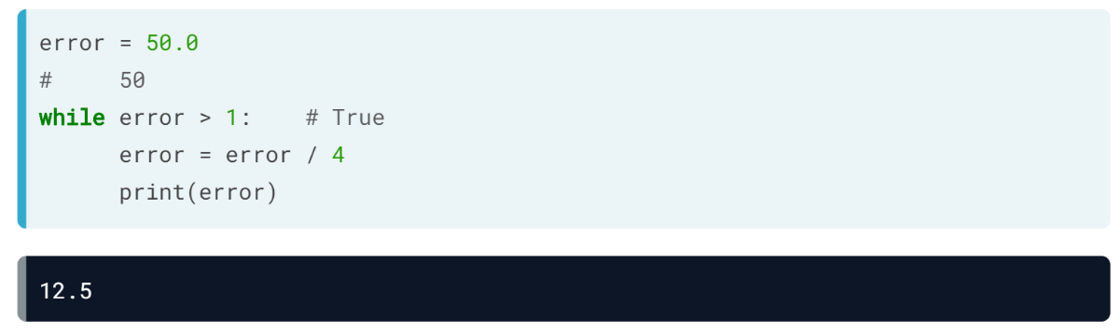  
On the first run, the error is 50, so the while condition is *True*, and the corresponding code is executed. The error is divided by four and printed out: 12.5

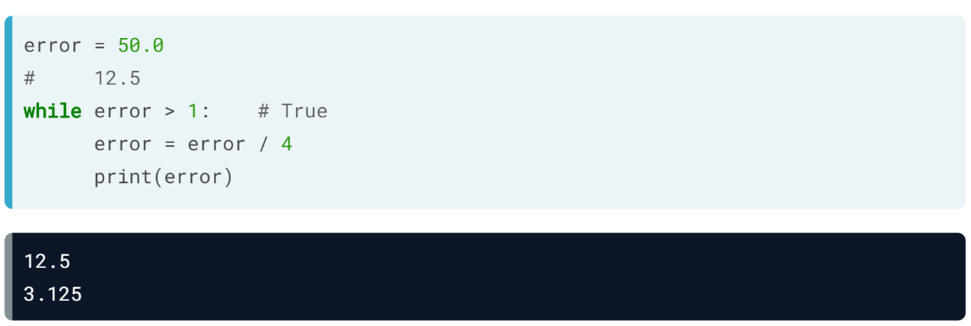  
Now, Python heads back to the condition of the while loop, with error equal to 12.5. Again, the condition is True, and the code is executed. The error is divided by 4 and printed out. Now the error is 3.125 and Python heads back to the while condition.

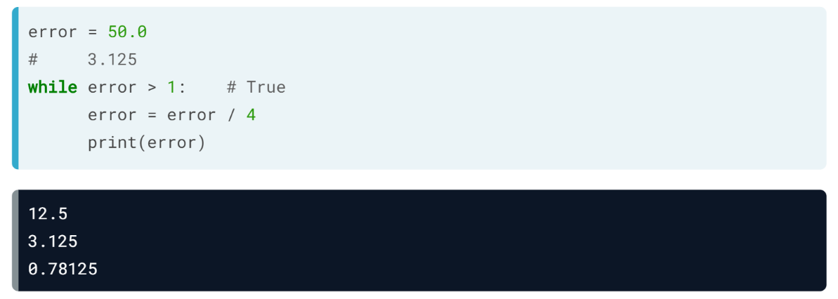  
3.125 is still greater than 1 so the corresponding code is executed again. Now, the error is only 0.78125. Once more, Python heads over to the while condition, but this time, the condition is False. The code in the while loop is not executed anymore, and Python moves on. Notice that inside this while loop, this update of error is crucial: the error had to go down to become lower than 1 at some point.

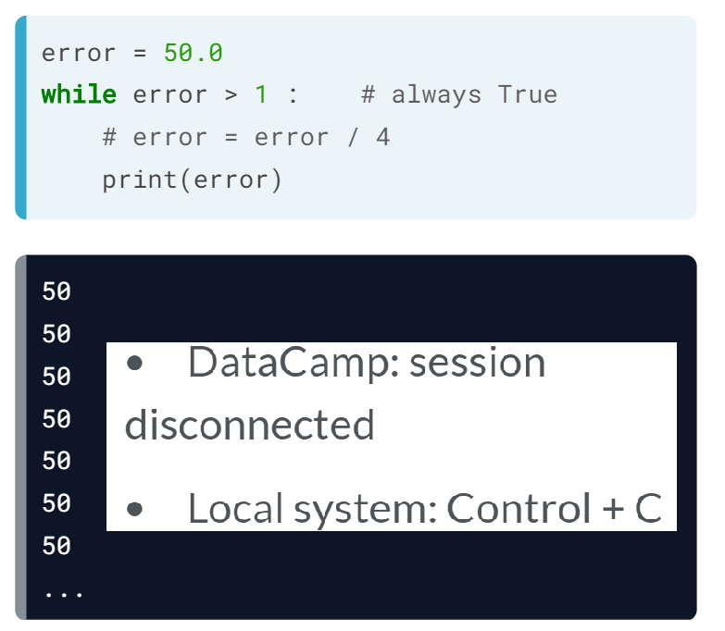  
Suppose that we comment out these updates of the error value and run the scripts again. The error isn't updated, so the condition is always *True*, and the while loop will go on forever. On DataCamp, this will cause your session to be disconnected. If you are making this mistake on your own system, you will have to interrupt the python program by pressing the control and C keys.

# while: warming up

The while loop is like a repeated if statement. The code is executed over and over again, as long as the condition is True. Have another look at its recipe.

while condition :

expression

Can you tell how many printouts the following while loop will do?

x = 1

while x < 4 :

print(x)

x = x + 1

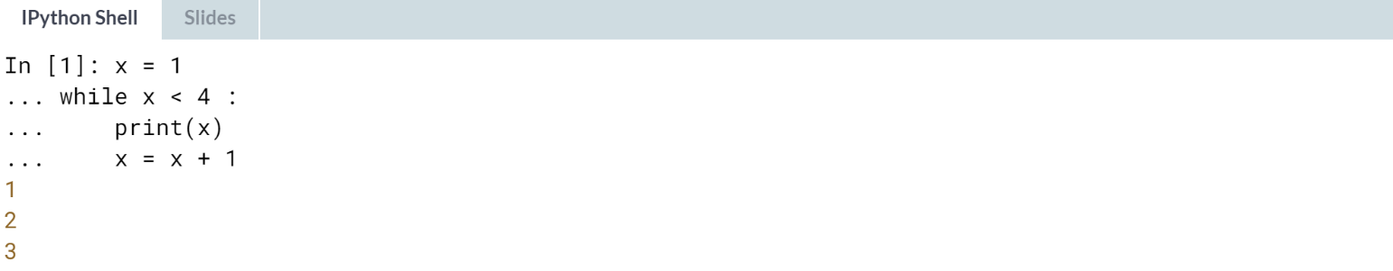

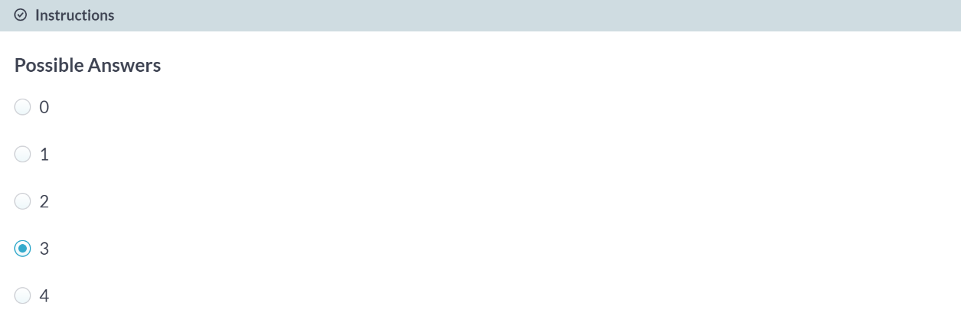  
Correct! After 3 runs, x will be equal to 4, causing x < 4 to evaluate to False. This means that the while loop is executed 3 times, giving three printouts.

# Basic while loop

Below you can find the example from the video where the error variable, initially equal to 50.0, is divided by 4 and printed out on every run:

error = 50.0

while error > 1 :

error = error / 4

print(error)

This example will come in handy, because it's time to build a while loop yourself! We're going to code a while loop that implements a very basic control system for an [**inverted pendulum**](https://en.wikipedia.org/wiki/Inverted_pendulum). If there's an offset from standing perfectly straight, the while loop will incrementally fix this offset.

Note that if your while loop takes too long to run, you might have made a mistake. In particular, remember to **indent** the contents of the loop!

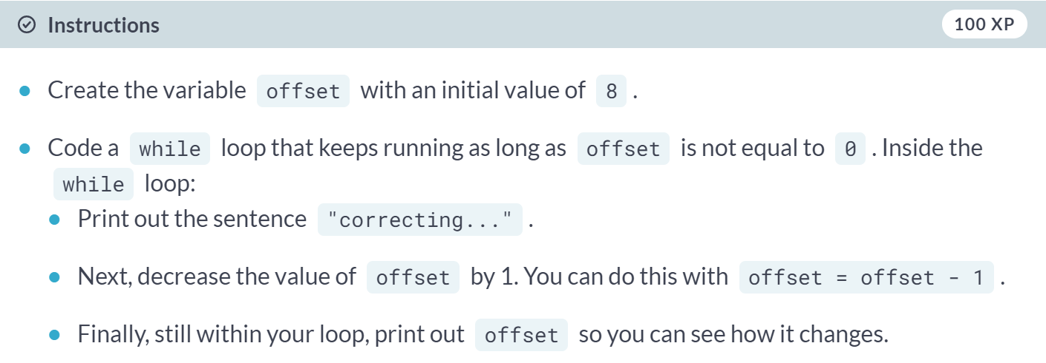

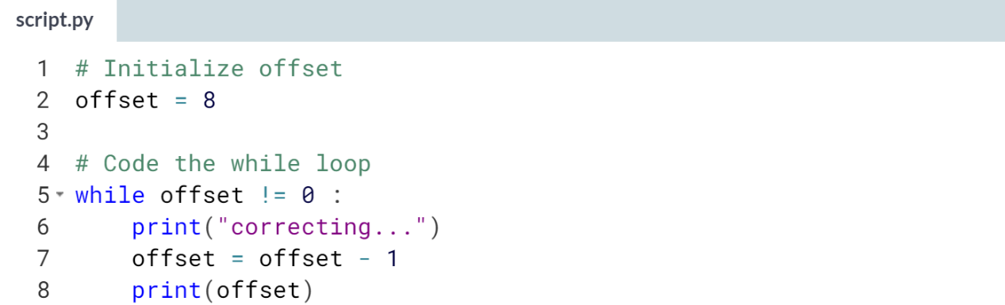  
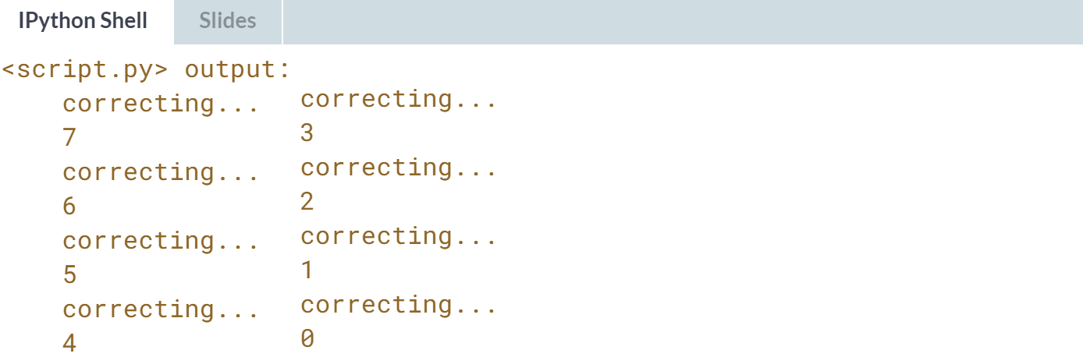

# Add conditionals

The while loop that corrects the offset is a good start, but what if offset is negative? You can try to run the following code where offset is initialized to -6:

# Initialize offset

offset = -6

# Code the while loop

while offset != 0 :

print("correcting...")

offset = offset - 1

print(offset)

but your session will be disconnected. The while loop will never stop running, because offset will be further decreased on every run. offset != 0 will never become False and the while loop continues forever.

Fix things by putting an if-else statement inside the while loop. If your code is still taking too long to run, you probably made a mistake!

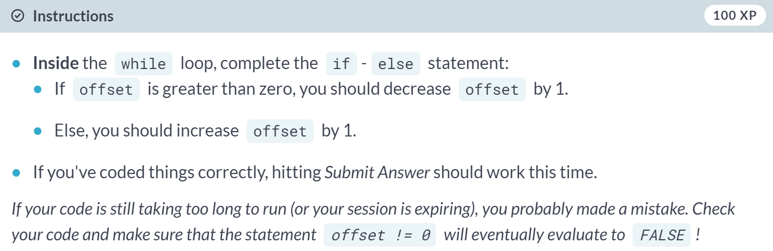

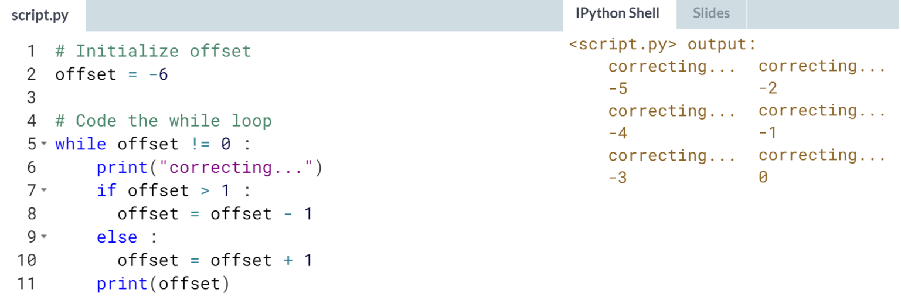  
Good work! The while loop is not that often used in Data Science, so let's head over to the for loop.



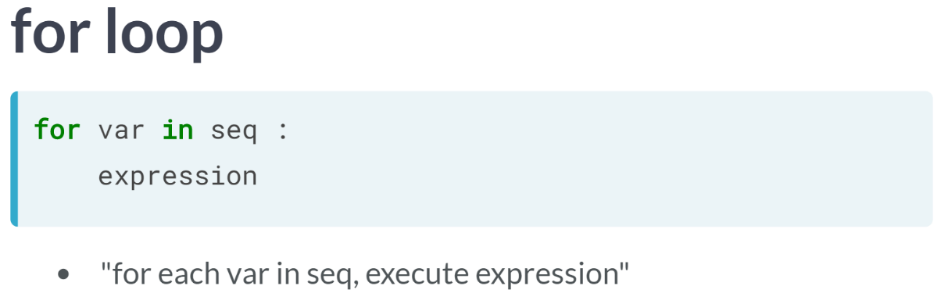

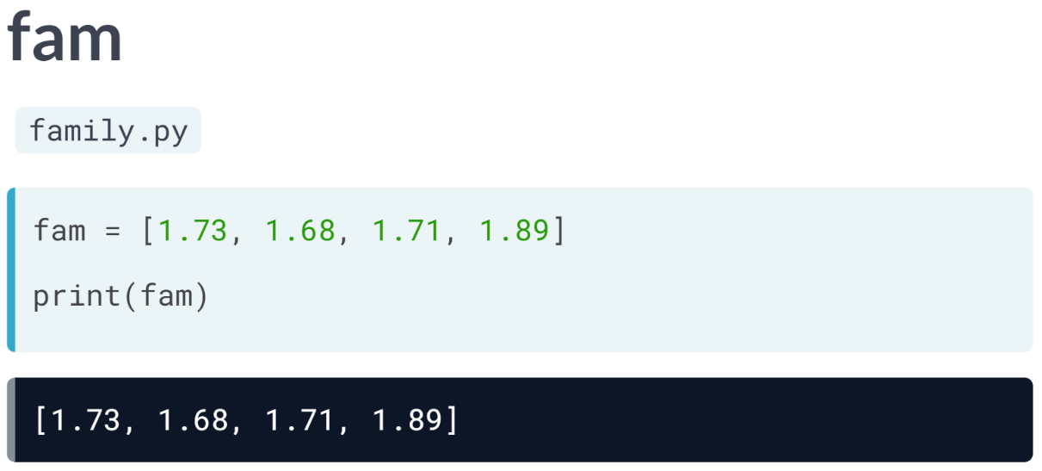  
Let's look at fam list to understand deeper. Suppose that instead of a single printout of the entire list, we want to print out each element in the list separately.

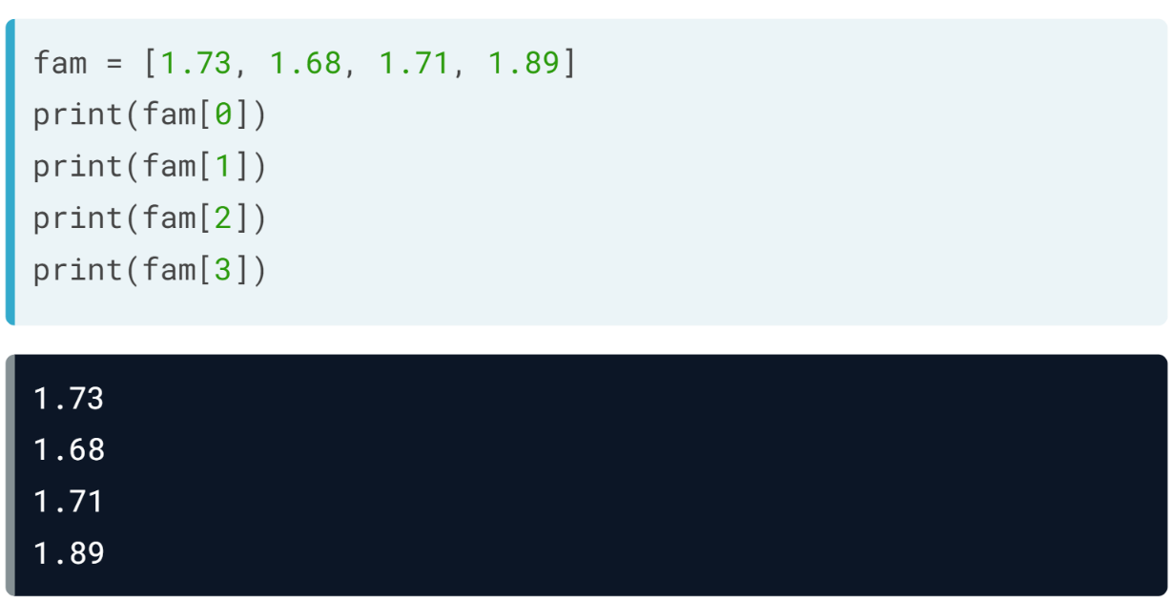  
You could do this by doing 4 print calls with the correct subsetting operations. Instead of this repetitive and tedious approach, you can use a for loop.

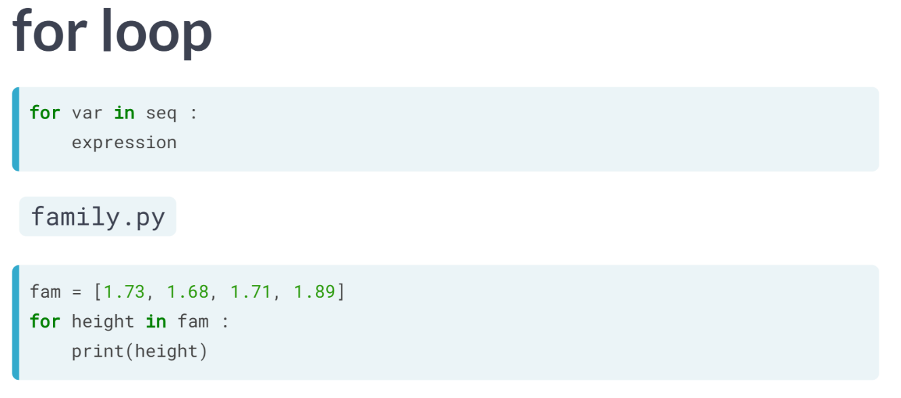  
Let's wipe the print calls and start a for loop: for height in fam, followed by a colon. This means that we want to execute some code for each height in the fam list. Height is an arbitrary name here; we could just as well call it h or something else.

Inside the for loop, on every iteration, we print out the value of height. When you run this script, Python encounters the for loop and evaluates the seq element, fam in this case. It sees that it's a list containing 4 elements. Then the actual iteration starts.

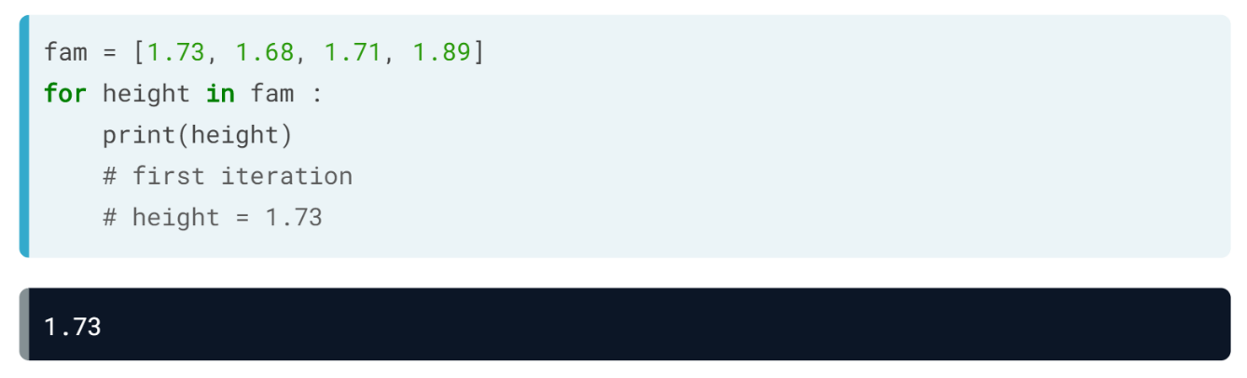  
In the first run, Python stores the first element, so the float 1.73, in the variable height. Next, the expression, print(height), is executed.

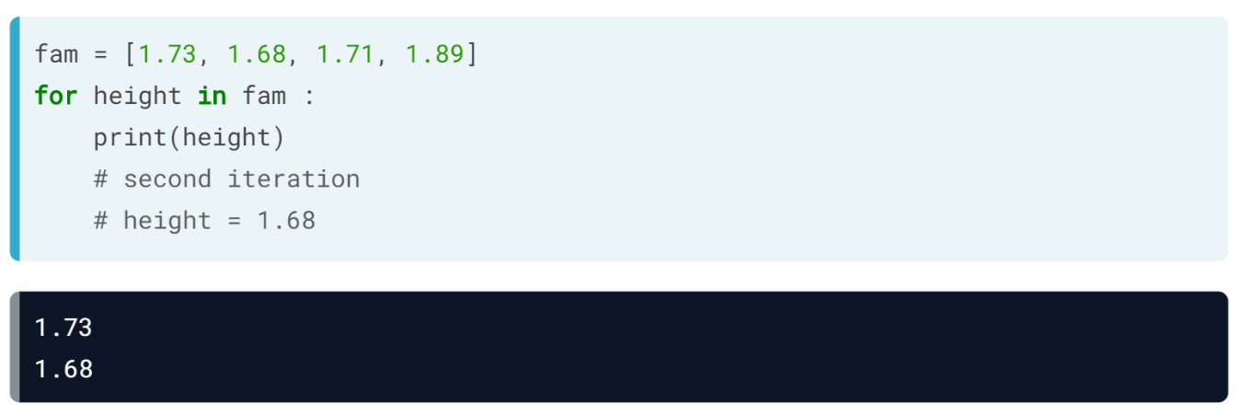  
In the second iteration, Python stores the second value of fam in height, being 1.68 now, and prints out heights again.

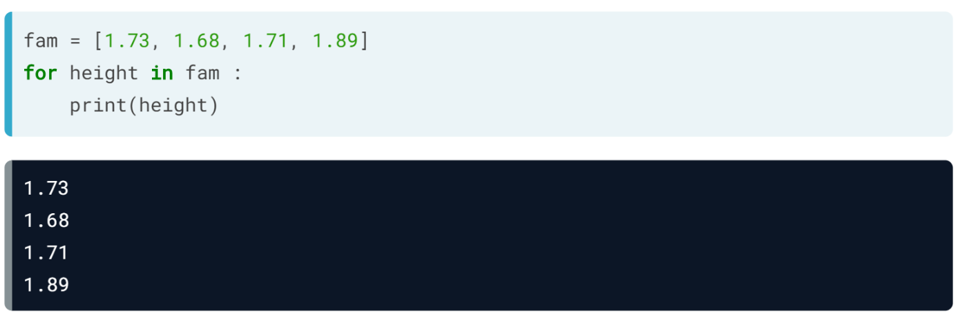  
This process continues until all heights in fam have been iterated over, and we end up with 4 separate printouts. In this solution, we don't have access to the index of the elements we are iterating over.

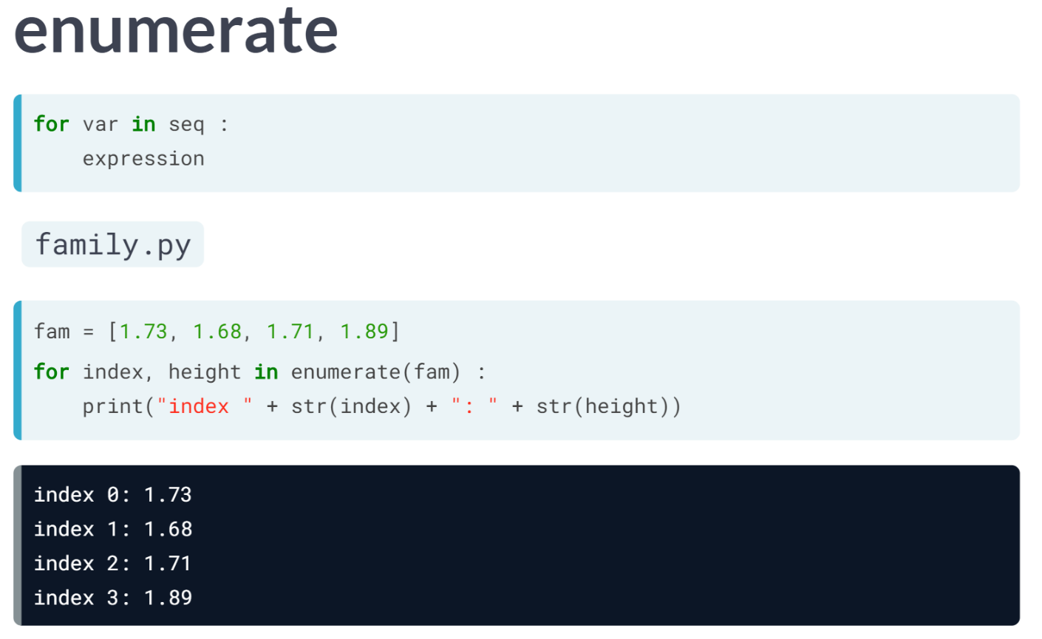  
Say that, together with printing out the height, you also want to display the index in the list, so that the printouts are converted to this. How should the for loop be built in this case? To achieve this, you can use ***enumerate()*** function. Let's update the for-loop definition like this above.

Now, enumerate(fam) produces two values on each iteration: the index on the value, and the value itself. Instead of a single variable height, you now write index, height. Now, on each iteration, index will contain the index, and heights will contain the float.

This means that we can now also update the statement inside the for loop with a more complicated ***print()*** call. Notice that we had to convert the floats to strings with ***str()*** so that we can add everything together in string format.

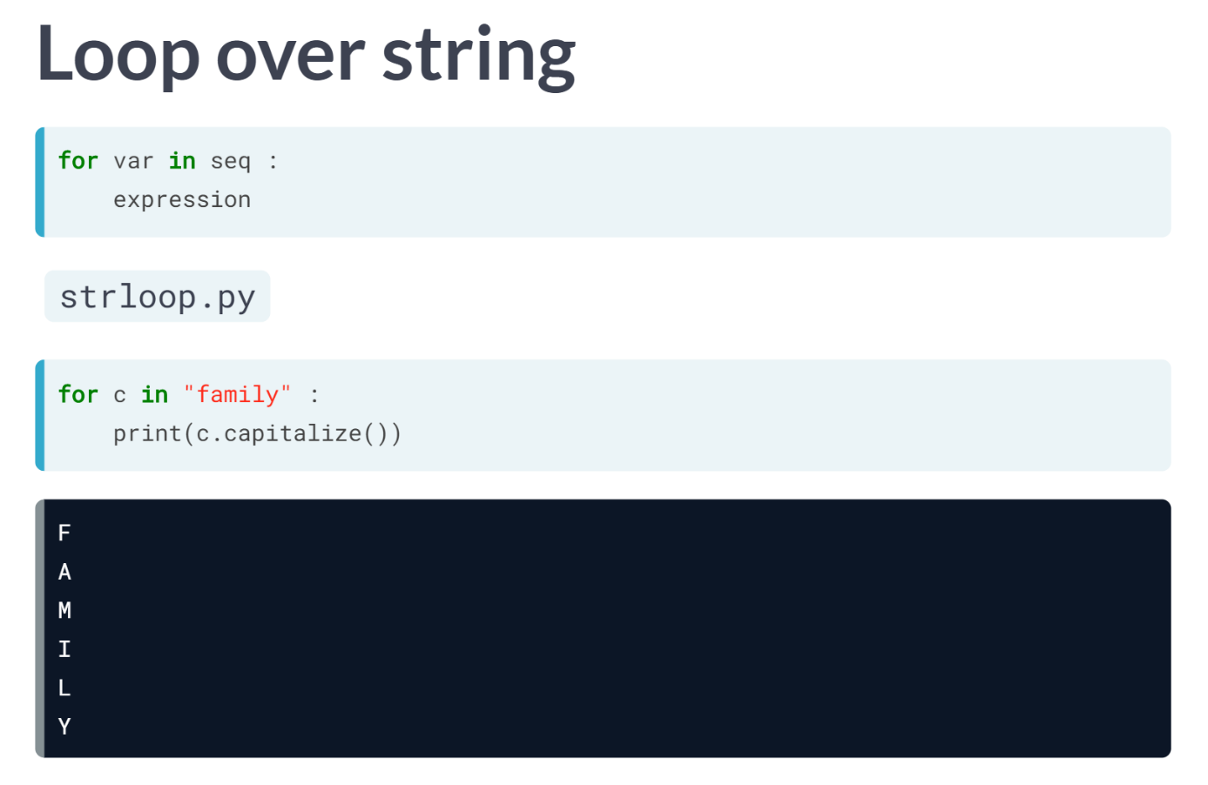  
The for loop doesn't only work with lists. You can also create a for loop that iterates over every character in a string, "family" for example, and stores it in c, one after the other. Inside the loop, the string c is capitalized and printed out. This time, 6 different printouts occur.

# Loop over a list

Have another look at the for loop that Hugo showed in the video:

fam = [1.73, 1.68, 1.71, 1.89]

for height in fam :

print(height)

As usual, you simply have to indent the code with 4 spaces to tell Python which code should be executed in the for loop.

The areas variable, containing the area of different rooms in your house, is already defined.



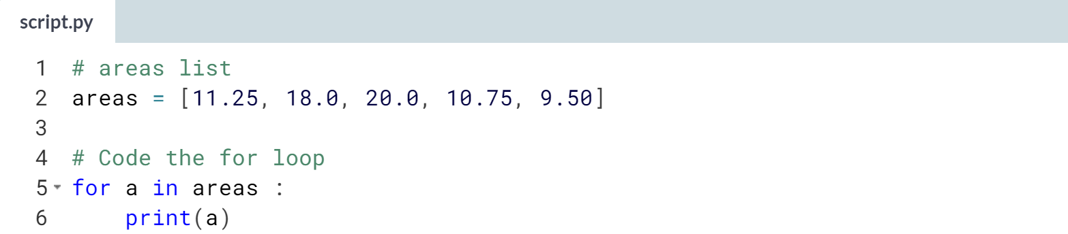

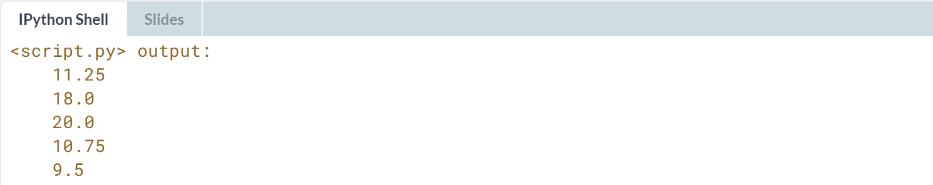

# Indexes and values (1)

Using a for loop to iterate over a list only gives you access to every list element in each run, one after the other. If you also want to access the index information, so where the list element you're iterating over is located, you can use [**enumerate()**](https://docs.python.org/3/library/functions.html#enumerate).

As an example, have a look at how the for loop from the video was converted:

fam = [1.73, 1.68, 1.71, 1.89]

for index, height in enumerate(fam) :

print("person " + str(index) + ": " + str(height))

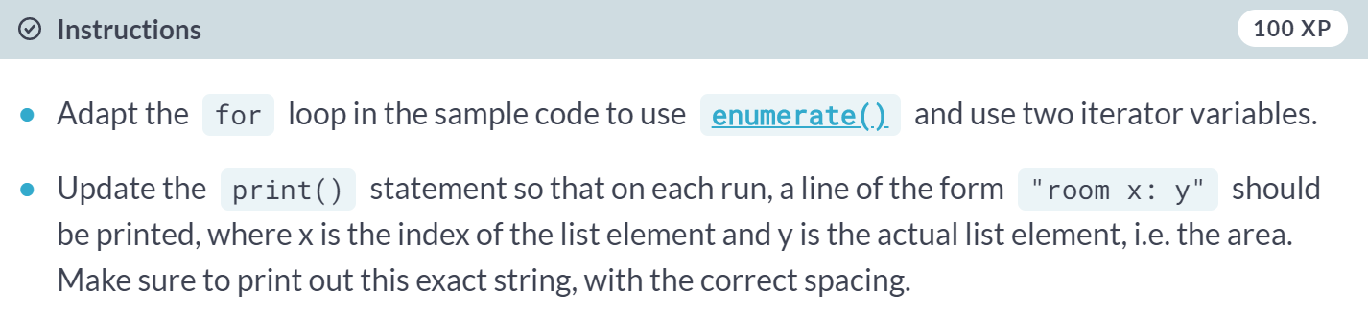

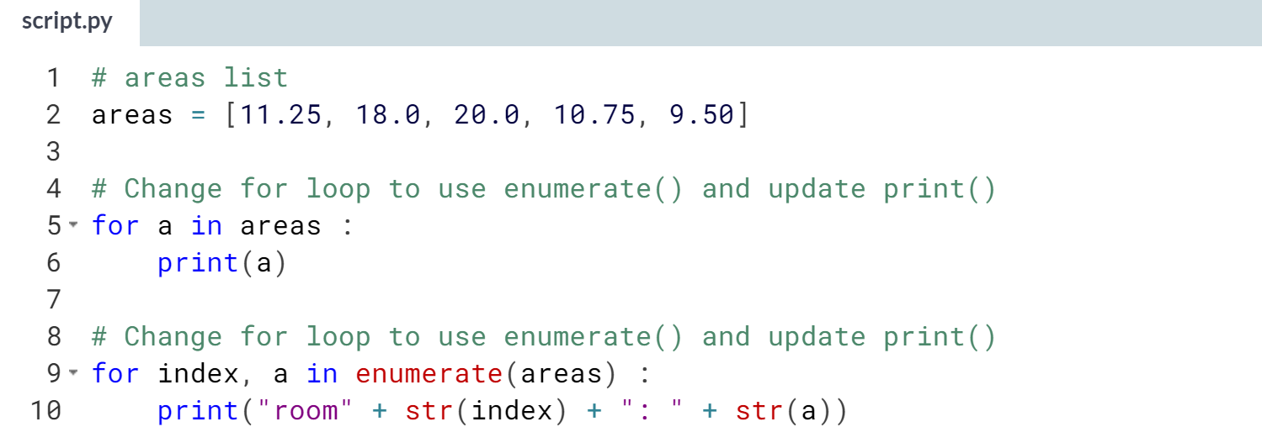

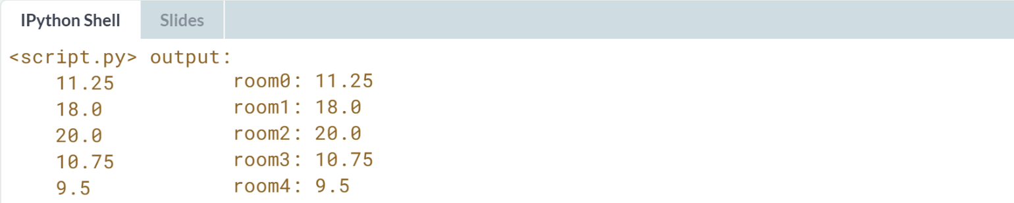

# Indexes and values (2)

For non-programmer folks, room 0: 11.25 is strange. Wouldn't it be better if the count started at 1?

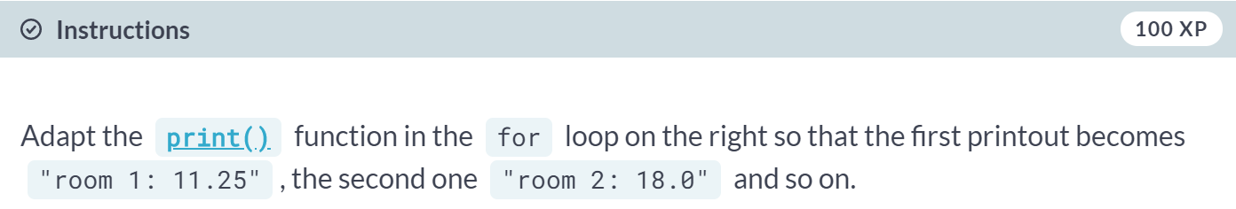

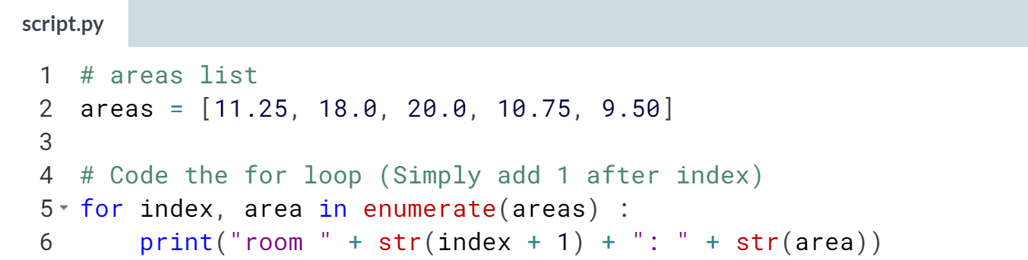

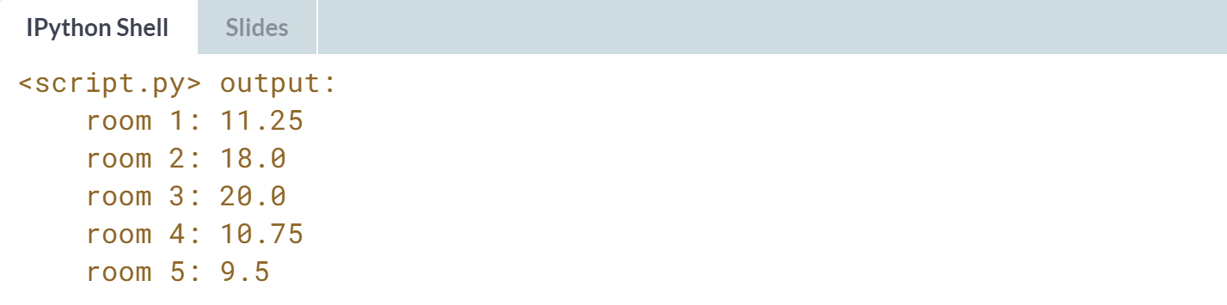

# Loop over list of lists

Remember the house variable from the Intro to Python course? Have a look at its definition on the right. It's basically a list of lists, where each sublist contains the name and area of a room in your house.

It's up to you to build a for loop from scratch this time!

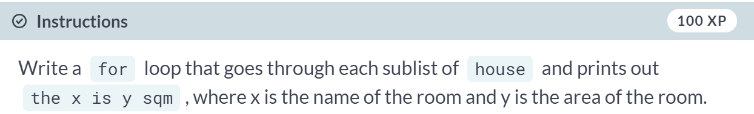

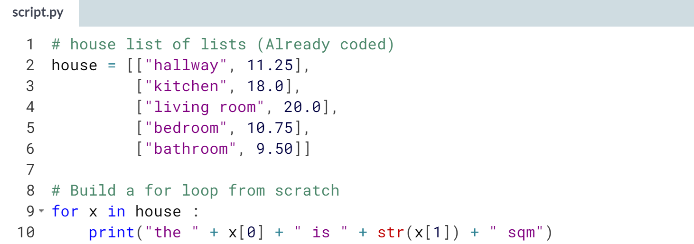

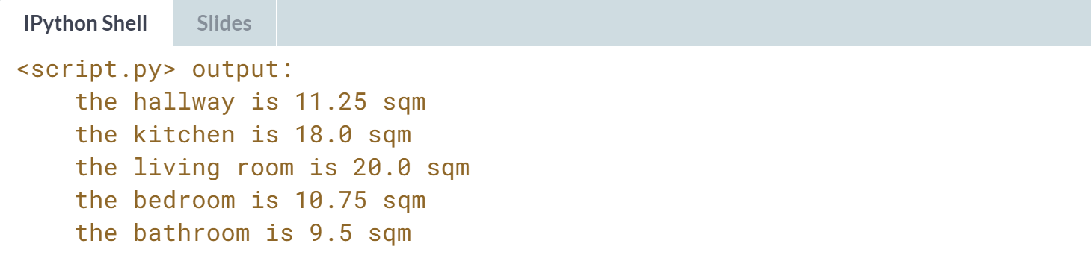



We already saw how looping works over lists and string, but what about those other data structures, such as dictionaries and NumPy arrays? Well, in both cases, you can use a similar for loop construct, but the way you define the "sequence" over which you're iterating will differ depending on the data structure.

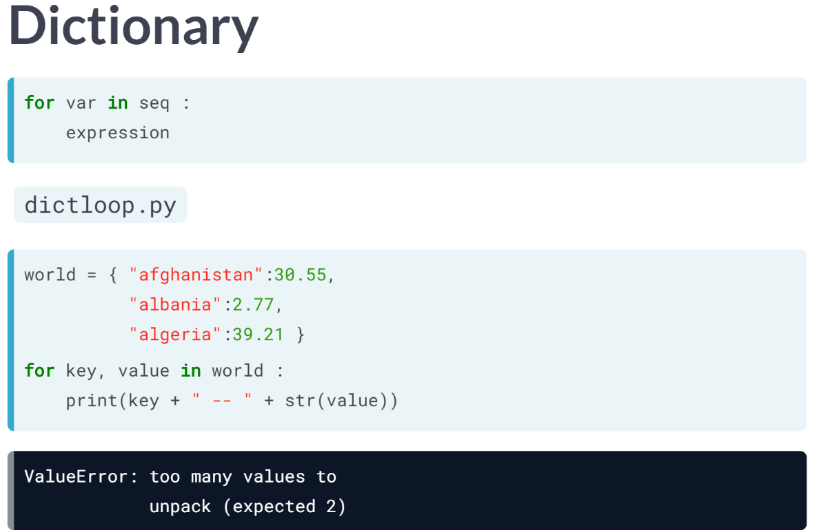  
Let's go back to our "world" dictionary, containing country names as keys and corresponding populations as values, shown here.

How should we approach this if we want to print out the key and corresponding values for each *key:value* pair on a new line? Maybe like the above, hoping that the key and values are correctly set?

Unfortunately, this leads to an error. Python sees that you expect two values in every iteration, like enumerate did before when we wanted the index and value from a list element, but in this case, Python has no idea how to go about this.

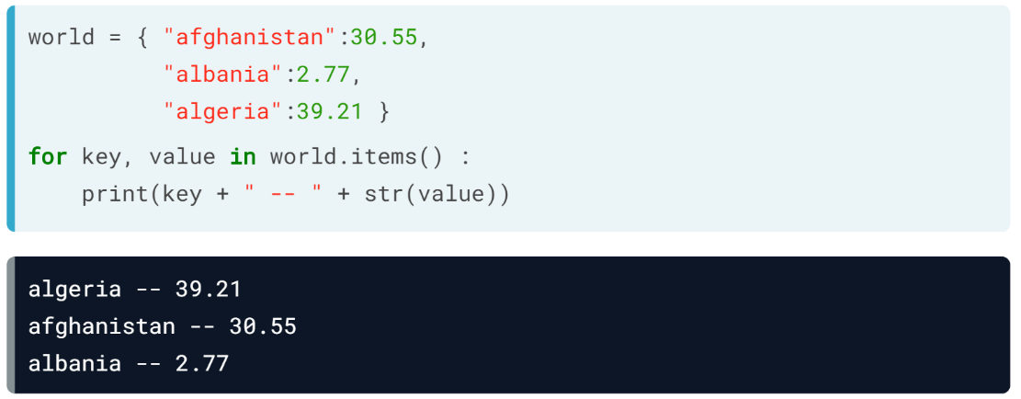  
We can fix this by calling the method ***items()*** on world. This will generate a key and value in each iteration. If you have a look at the printout, there's something strange: afghanistan comes first in the world, but not in the printout. That's because dictionaries are inherently unordered: the order: the order in which they're iterated over is not fixed, at least not in Python 3.5.

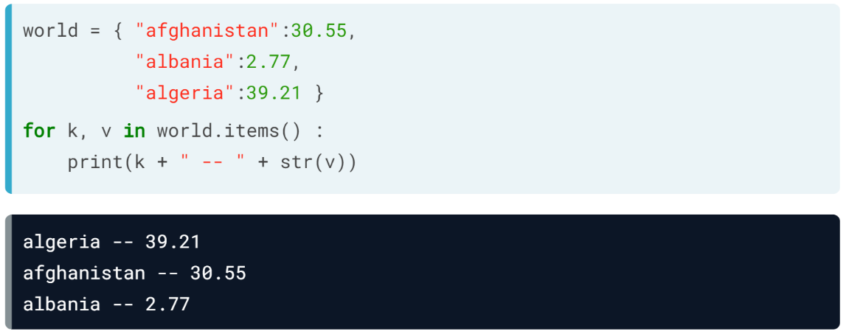  
The names key and value are totally arbitrary by the way, I can also call these *k* and *v*, like here. The order does matter here, though. The first variable gets the key, the second one gets the value.

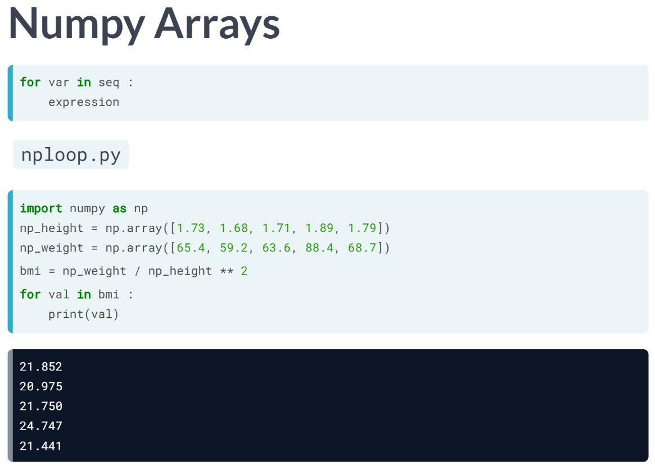  
Let's start from the *bmi* array that you already know - here it is.

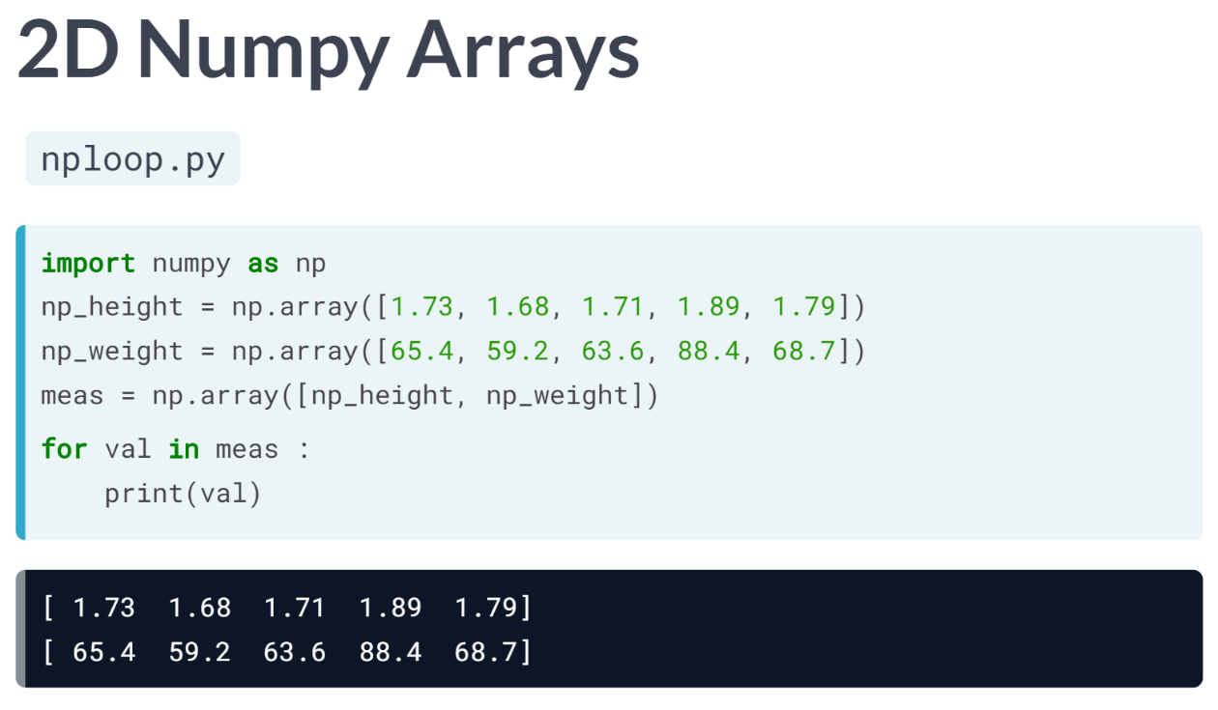  
Let's see if this also works with a 2D Numpy array. *meas* are created by combining the *np\_height* and *np\_weight* arrays. If we want to print out each element in this 2D array separately, the same basic for loop won't do the trick though. The 2D array is built up from an array of 1D arrays. The for loop simply prints out an entire array on each iteration.

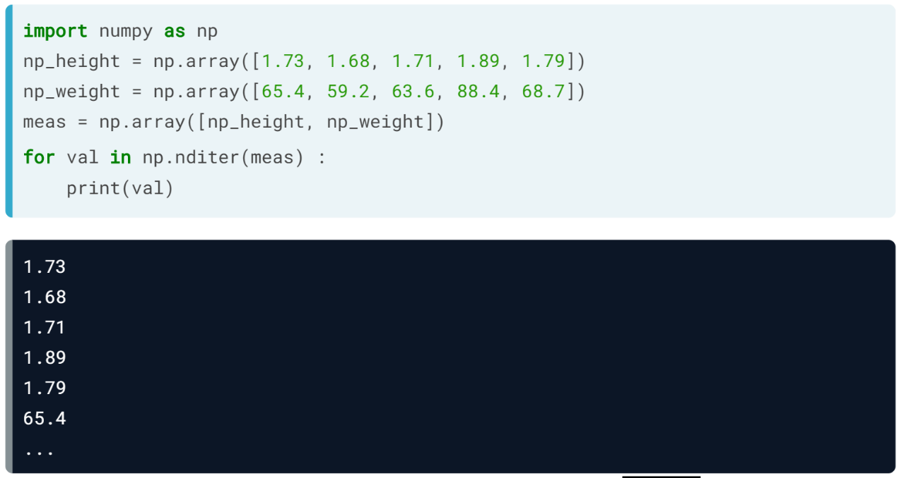  
To get every element of an array, you can use a Numpy function called *nditer().* The input is the array we want to iterate over, *meas* in this case. This time, we get 10 printouts, first all the heights, then all the weights.

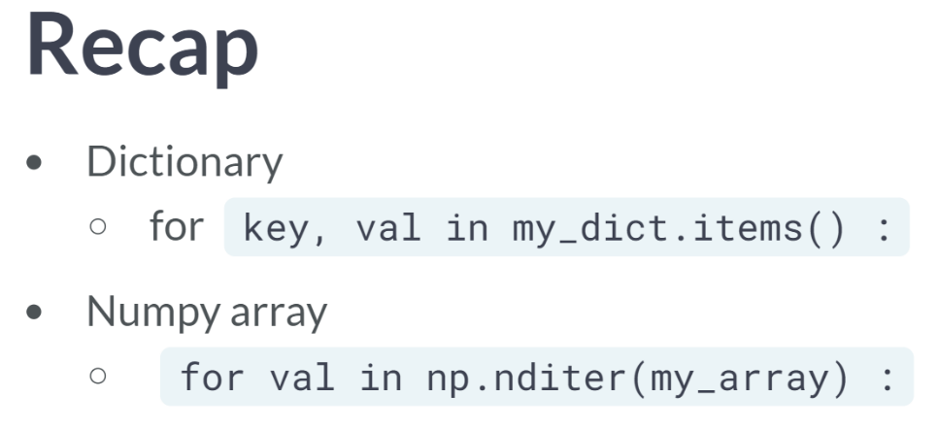  
If you want to iterate over key-value pairs in a dictionary, use the ***items()*** method on the dictionary to define the sequence in the for loop.

Whereas, if you want to iterate over all elements in a NumPy array, you should use ***nditer()*** function to specify the sequence. Note that dictionaries require a method, NumPy arrays use a function.

# Loop over dictionary

In Python 3, you need the [**items()**](https://docs.python.org/3/library/stdtypes.html#dict.items) method to loop over a dictionary:

world = { "afghanistan":30.55,

"albania":2.77,

"algeria":39.21 }

for key, value in world.items() :

print(key + " -- " + str(value))

Remember the europe dictionary that contained the names of some European countries as key and their capitals as corresponding value? Go ahead and write a loop to iterate over it!

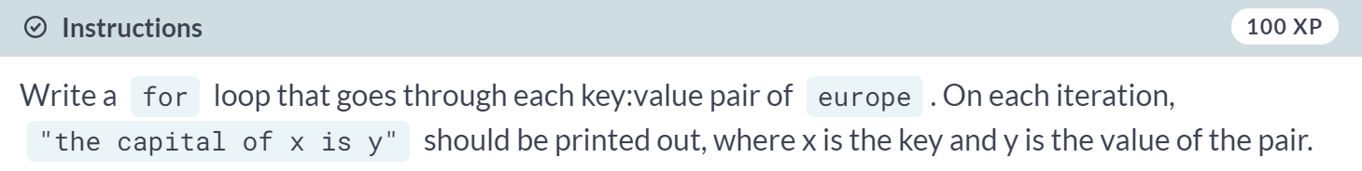

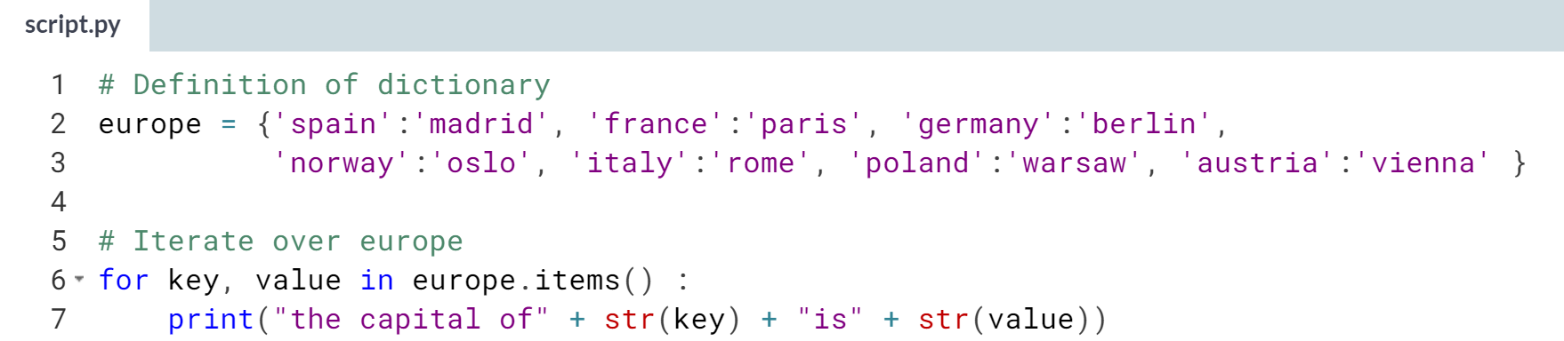

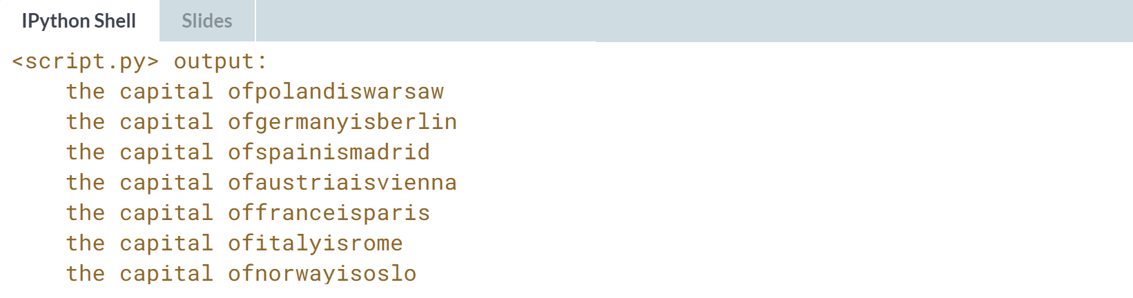  
Great! Notice that the order of the printouts doesn't necessarily correspond with the order used when defining *europe*. Remember: dictionaries are inherently unordered!

# Loop over Numpy array

If you're dealing with a 1D Numpy array, looping over all elements can be as simple as:

for x in my\_array :

...

If you're dealing with a 2D Numpy array, it's more complicated. A 2D array is built up of multiple 1D arrays. To explicitly iterate over all separate elements of a multi-dimensional array, you'll need this syntax:

for x in np.nditer(my\_array) :

...

Two Numpy arrays that you might recognize from the intro course are available in your Python session: np\_height, a Numpy array containing the heights of Major League Baseball players, and np\_baseball, a 2D Numpy array that contains both the heights (first column) and weights (second column) of those players.

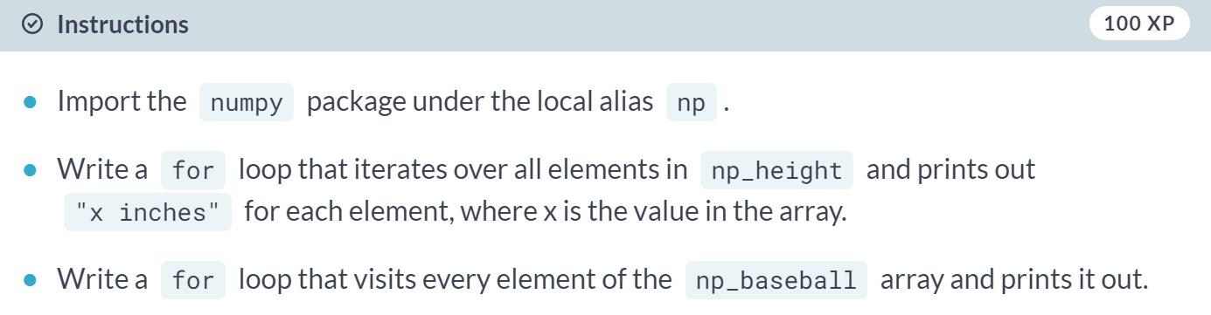

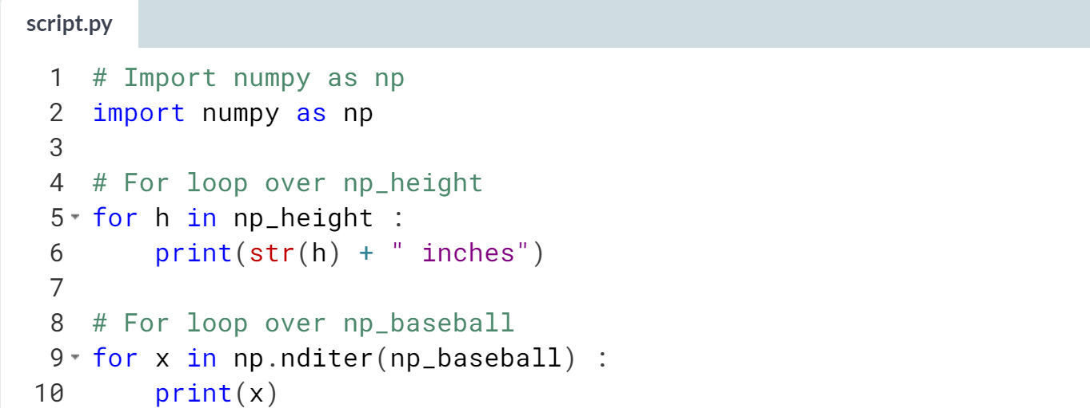  
(Output is not shown): Wow, that's a lot of output! Try to add an additional argument ***end =*** to the print() call - the output will be mesmerizing!



Let's learn about how looping the Pandas DataFrame.

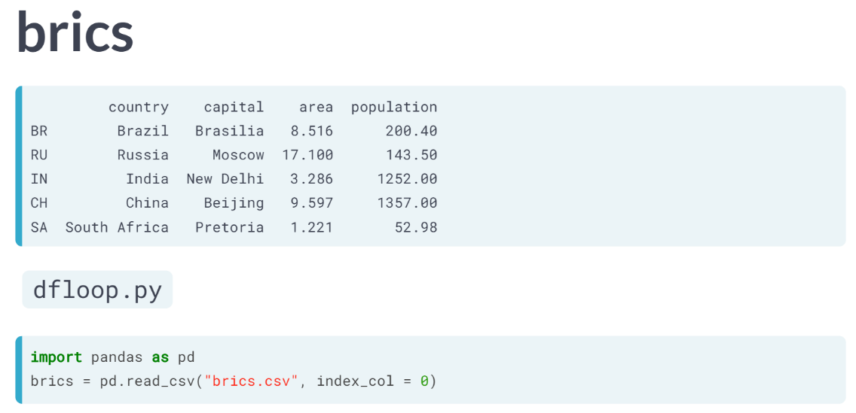

As previously, let’s follow along the *brics* DataFrame we’ve been using so far.

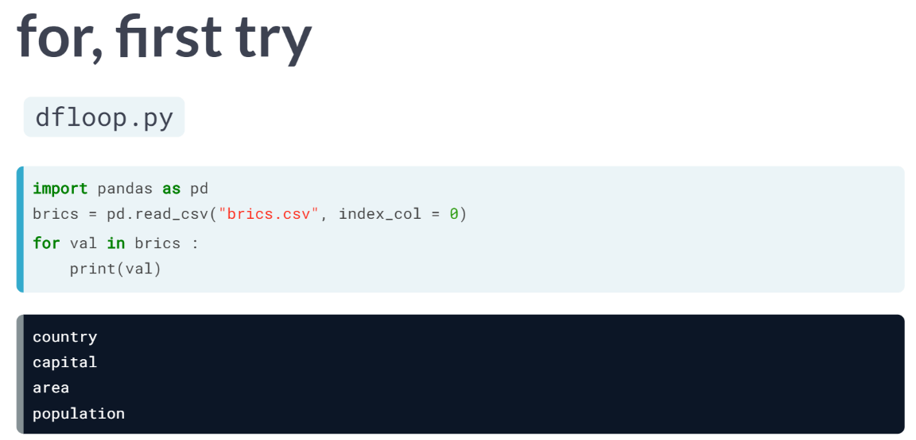  
If a Pandas DataFrame were to function the same way as a 2D NumPy array, then maybe a basic for loop like this, print out each row, could work.

But the output is rather unexpected as we simply got the column names. This is not what we want. In Pandas, we have to mention explicitly that we want to iterate over the rows.

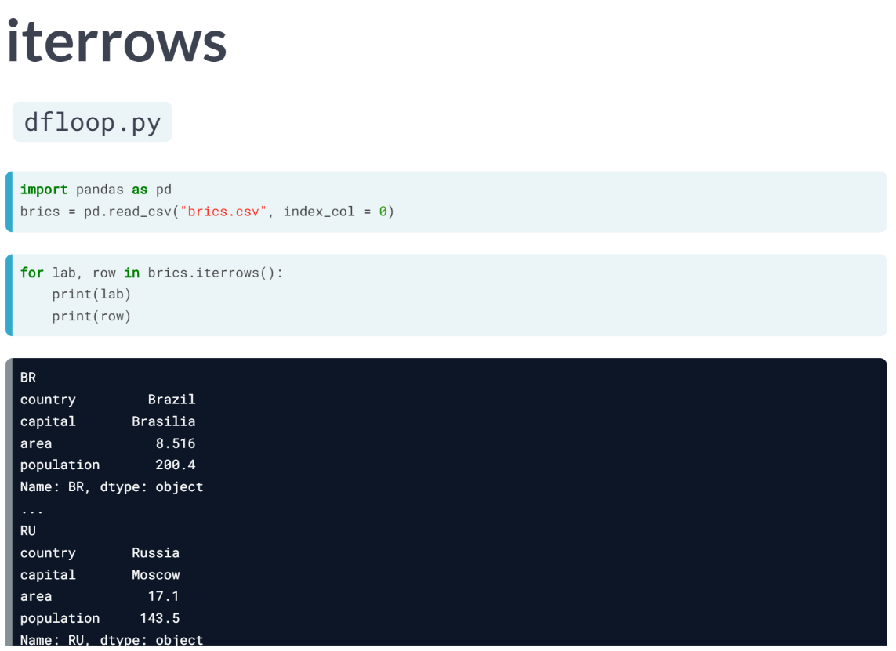  
We do this by calling the ***iterrows()*** method on the *brics* country, thus specifying another "sequence". The ***iterrows()*** method looks at the data frame, and, on each iteration, generates two pieces of data: the label of the row and then the actual data in the row as a Pandas Series.

Let's change the rest of the for loop to reflect this change: we store the row label as *lab*, and the row data as *row*. To understand what's happening, let's print *lab* and *row* separately inside the for loop.

In the first iteration, lab is BR, and row is this entire Pandas Series. Because this row variable on each iteration is a Series, you can easily select additional information from it using the subsetting techniques we learned earlier.

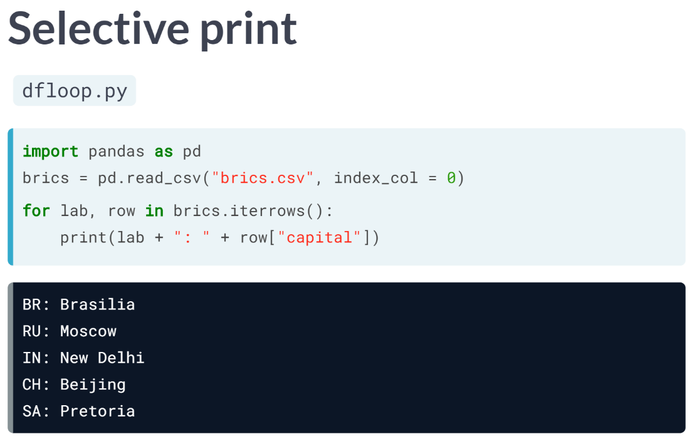  
Suppose you only want to print out the capital on each iteration: let's change the print statement as follows, printing the label and the capital together. You can take things further than simple printouts, though.

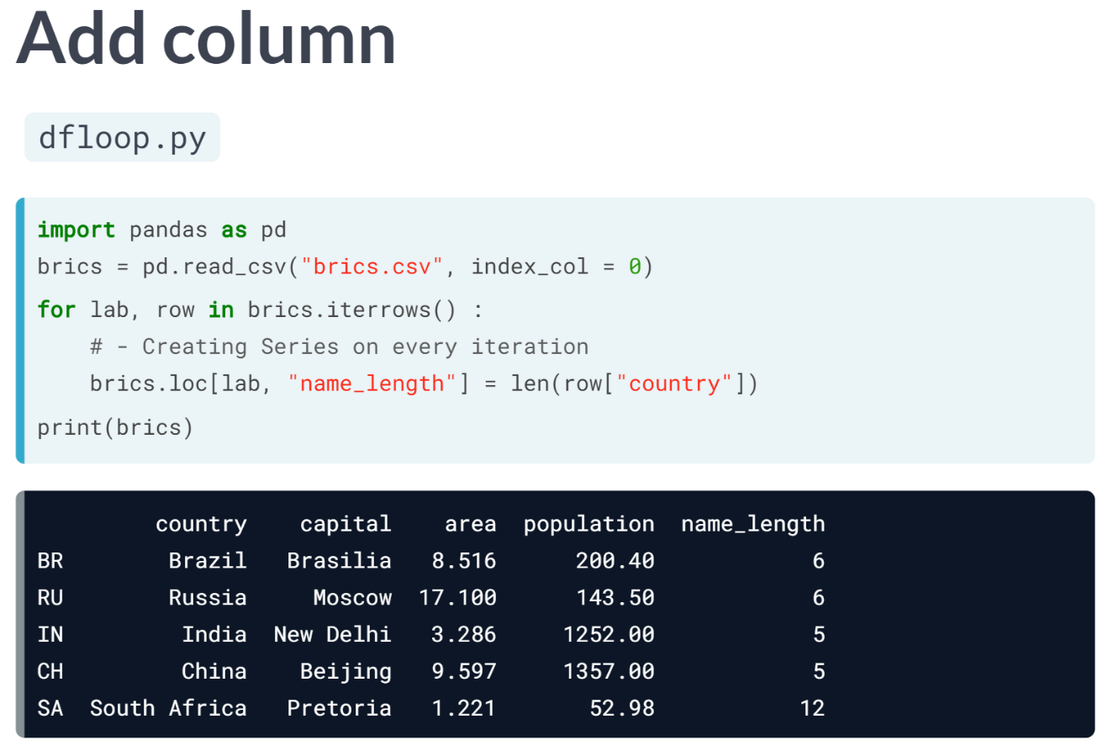  
Let's add a new column to the *brics* DataFrame, named *name\_length*, containing the number of characters in the country's name.

To do this, we will need to blend together a lot of the things we've learned. The specification of the for loop can be the same, because we will need both the row label and the row data.

Next, we can calculate the length of each country name by selecting the country column from row, and then passing it to the ***len()*** function, that determines the number of characters in a string.

Finally, we will have to add this new information to a new column, *name\_length*, at the appropriate location. We used *loc* here, which is label-based.

To see whether we coded things correctly, we are adding a printout of *brics* after the for loop, so without indentation. Running this script shows that it worked: there's a new column in there with the length of the country names.

Nice, but not especially efficient because you are creating a Series object on every iteration. For this small DataFrame, that doesn't matter, but if you are doing funky stuff on a ginormous dataset, this loss in efficiency can become quite problematic.

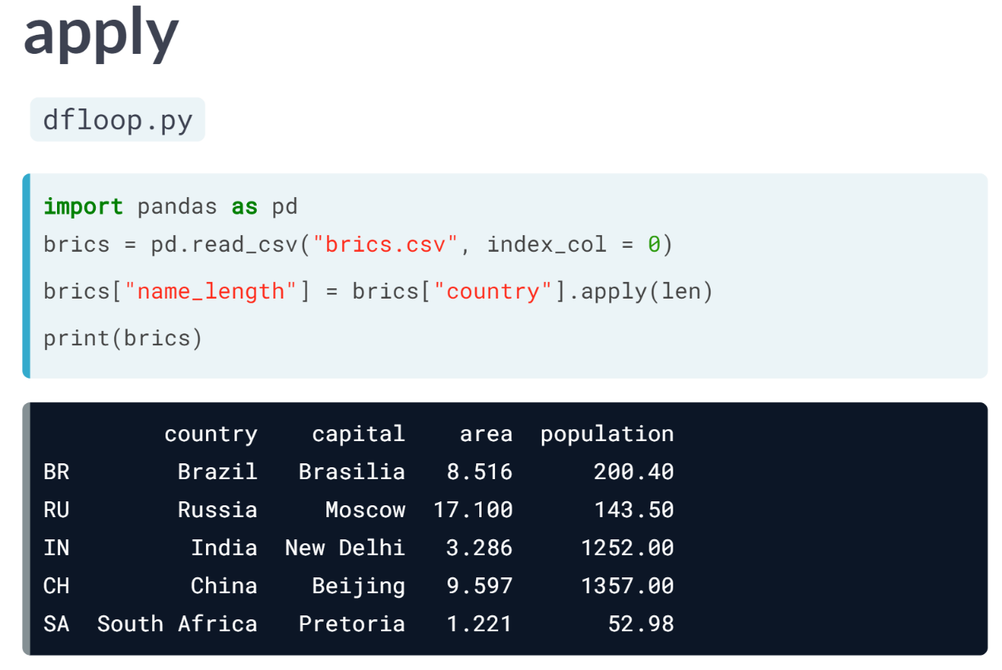  
A better approach if you want to calculate an entire DataFrame column by applying a function on a particular column in an elementwise fashion is ***apply()***. In this case, we don't even need a for loop. That is how it is done.

Basically, you are selecting the country column from the brics DataFrame, and then on this column, you apply the ***len()*** function.

Apply calls the len function with each country name as input and produces a new array, that you can easily store as a new column, *"name\_length"*.

This is way more efficient and easier to read. So, we have so far talked about how to iterate dataframes with a for loop, and how to do vectorized operations with the apply function. These skills will become very useful once you start transforming your own datasets!

# Loop over DataFrame (1)

Iterating over a Pandas DataFrame is typically done with the [**iterrows()**](http://pandas.pydata.org/pandas-docs/stable/generated/pandas.DataFrame.iterrows.html) method. Used in a for loop, every observation is iterated over and on every iteration the row label and actual row contents are available:

for lab, row in brics.iterrows() :

...

In this and the following exercises you will be working on the cars DataFrame. It contains information on the cars per capita and whether people drive right or left for seven countries in the world.

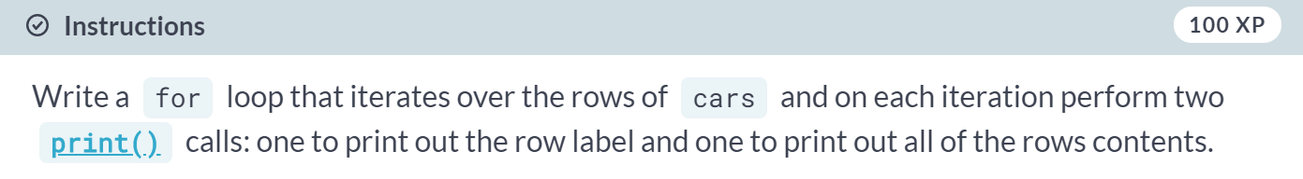

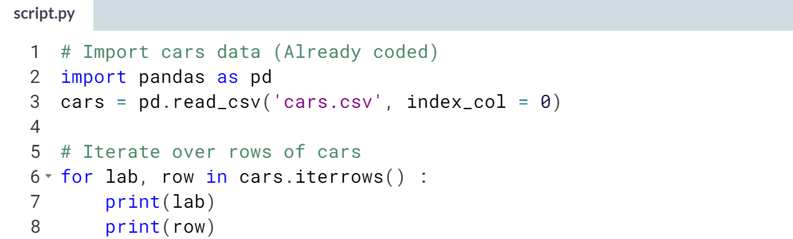  
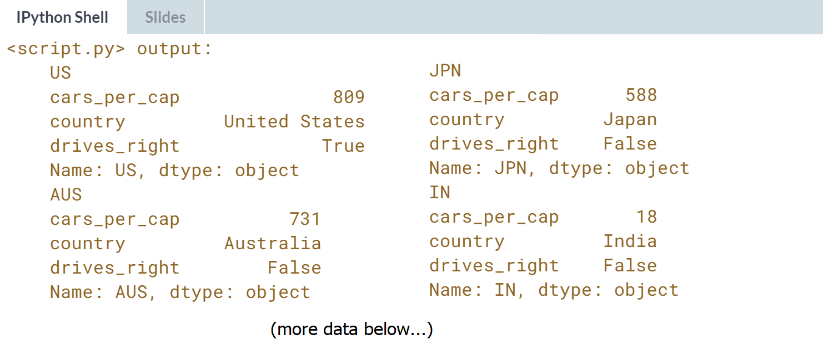

# Loop over DataFrame (2)

The row data that's generated by [**iterrows()**](http://pandas.pydata.org/pandas-docs/stable/generated/pandas.DataFrame.iterrows.html) on every run is a Pandas Series. This format is not very convenient to print out. Luckily, you can easily select variables from the Pandas Series using square brackets:

for lab, row in brics.iterrows() :

print(row['country'])

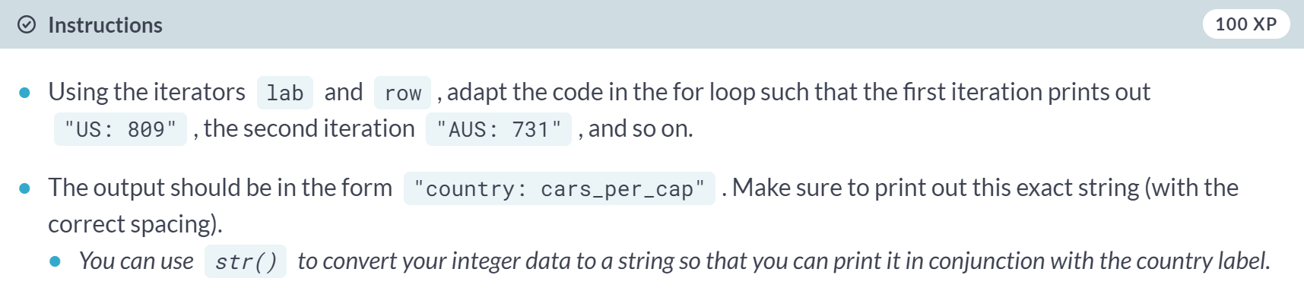

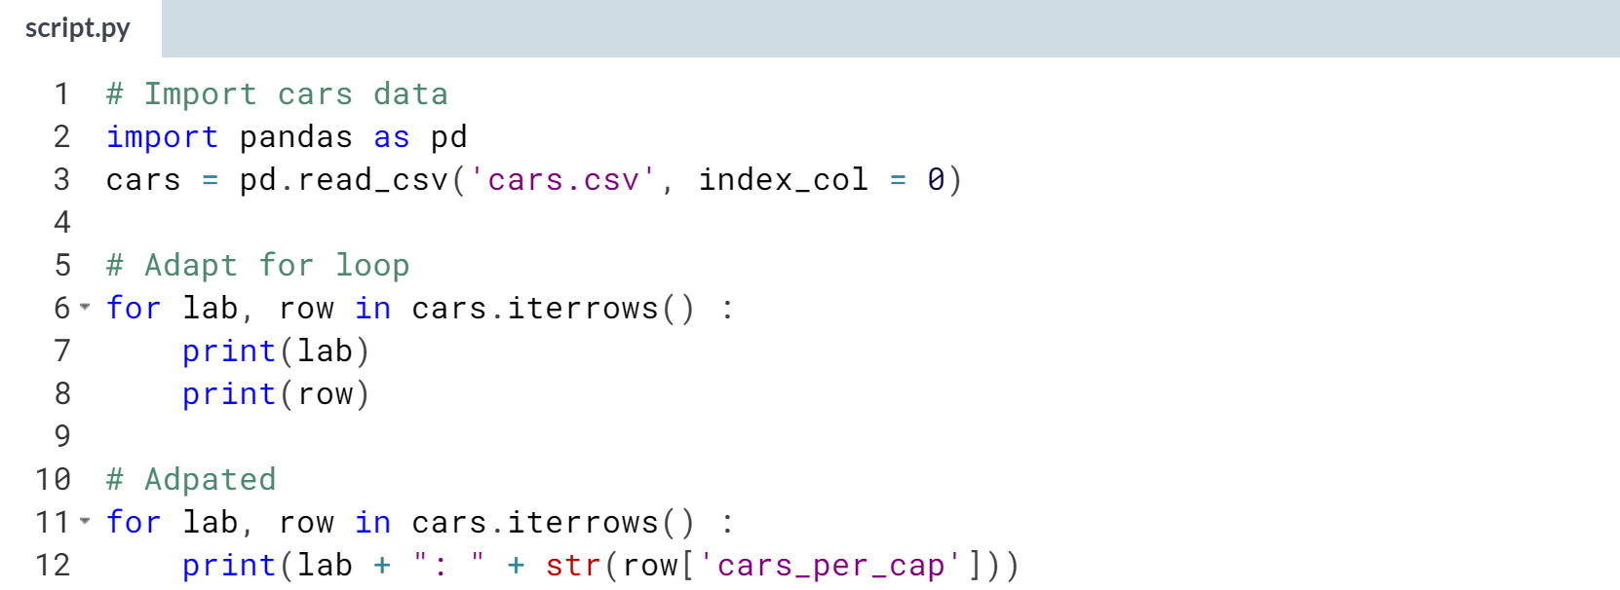

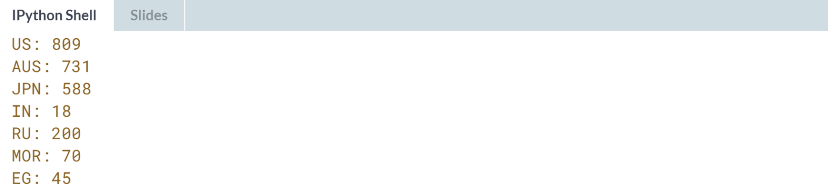

# Add column (1) – **REVIEW**

In the video, Hugo showed you how to add the length of the country names of the brics DataFrame in a new column:

for lab, row in brics.iterrows() :

brics.loc[lab, "name\_length"] = len(row["country"])

You can do similar things on the cars DataFrame.

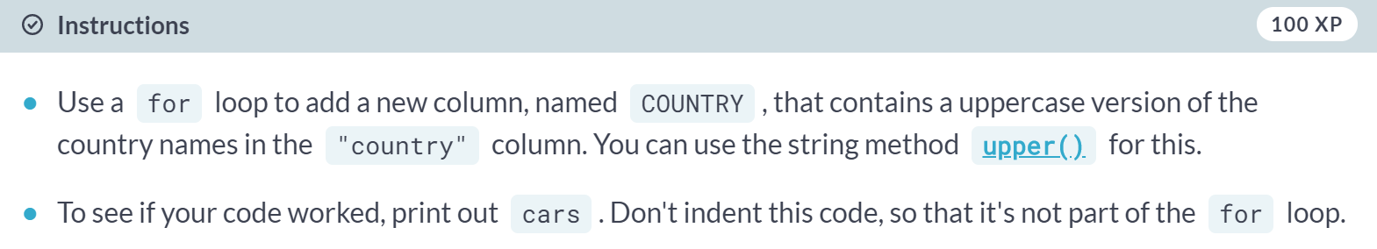

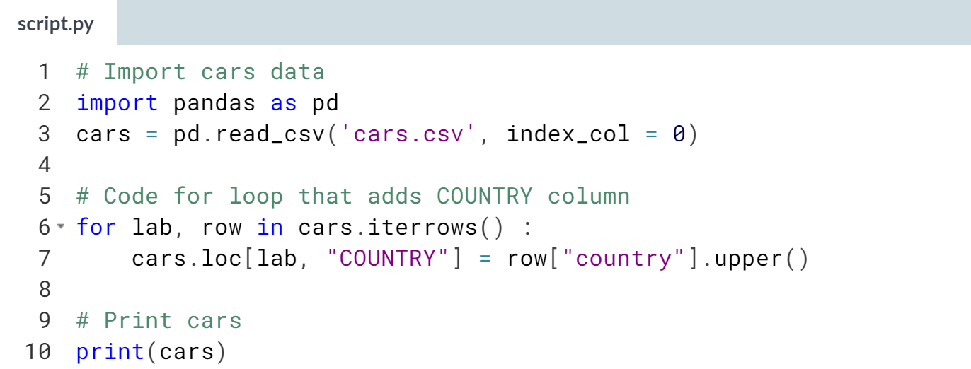  
  
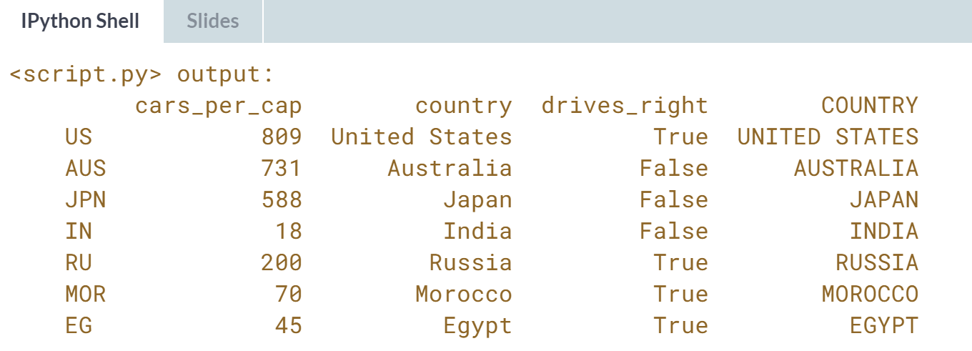  
Great, but you might remember that there is also an easier way to do this.

# Add column (2)

Using [**iterrows()**](http://pandas.pydata.org/pandas-docs/stable/generated/pandas.DataFrame.iterrows.html) to iterate over every observation of a Pandas DataFrame is easy to understand, but not very efficient. On every iteration, you're creating a new Pandas Series.

If you want to add a column to a DataFrame by calling a function on another column, the [**iterrows()**](http://pandas.pydata.org/pandas-docs/stable/generated/pandas.DataFrame.iterrows.html) method in combination with a for loop is not the preferred way to go. Instead, you'll want to use [**apply()**](http://pandas.pydata.org/pandas-docs/stable/generated/pandas.Series.apply.html).

Compare the [**iterrows()**](http://pandas.pydata.org/pandas-docs/stable/generated/pandas.DataFrame.iterrows.html) version with the [**apply()**](http://pandas.pydata.org/pandas-docs/stable/generated/pandas.Series.apply.html) version to get the same result in the brics DataFrame:

for lab, row in brics.iterrows() :

brics.loc[lab, "name\_length"] = len(row["country"])

brics["name\_length"] = brics["country"].apply(len)

We can do a similar thing to call the [**upper()**](https://docs.python.org/2/library/stdtypes.html#str.upper) method on every name in the country column. However, [**upper()**](https://docs.python.org/2/library/stdtypes.html#str.upper) is a **method**, so we'll need a slightly different approach:

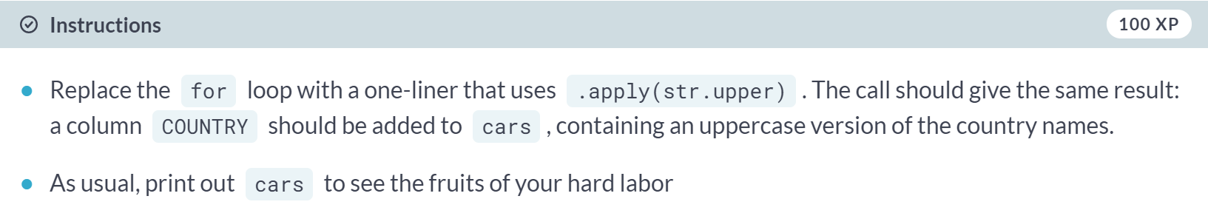

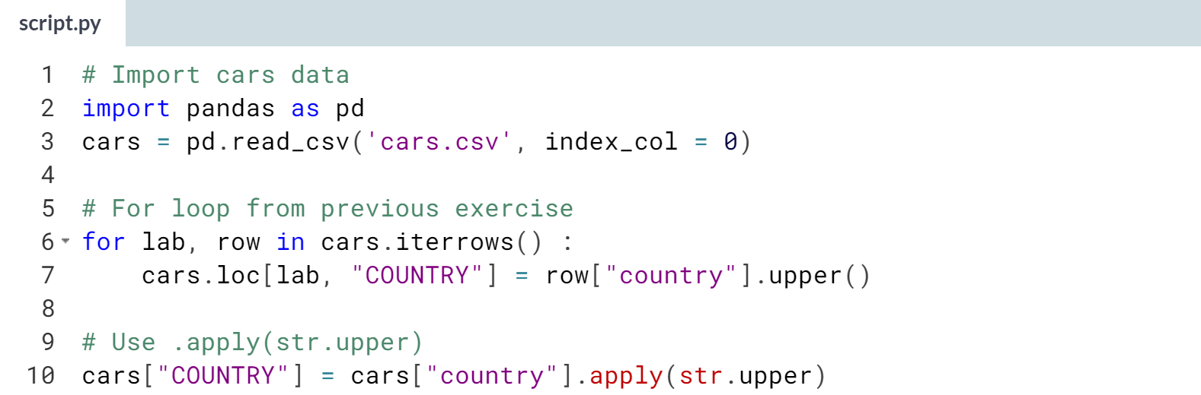  
Great job! It's time to blend everything you've learned together in a case-study. Head over to the next chapter!

**5. Case Study: Hacker Statistics**

This chapter will allow you to apply all the concepts you've learned in this course. You will use hacker statistics to calculate your chances of winning a bet. Use random number generators, loops, and Matplotlib to gain a competitive edge!



This chapter will be different from other chapters because we are going to work towards a cool script, using everything we've learned during this course.  
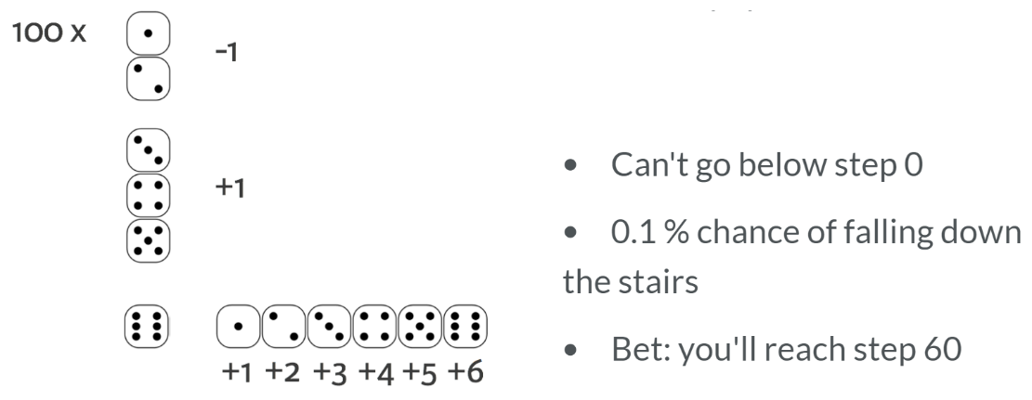  
Imagine you are walking up the empire state building to DataCamp Headquarters and you are playing a game with a friend. You throw a die one hundred times. If it is 1 or 2, you will go one step down. If it's 3,4, or 5, you will go one step up.

If you throw a 6, you'll throw the die again and will walk up the resulting number of steps. Of course, you cannot go lower that step number 0. And also, you admit that you are a bit clumsy and have a chance of 0.1 percent of falling down the stairs when you make a move.

Falling down means that you have to start again from step 0. With all of this in mind, you bet with your friend that you'll reach 60 steps high. What is the chance that you will win this bet?  
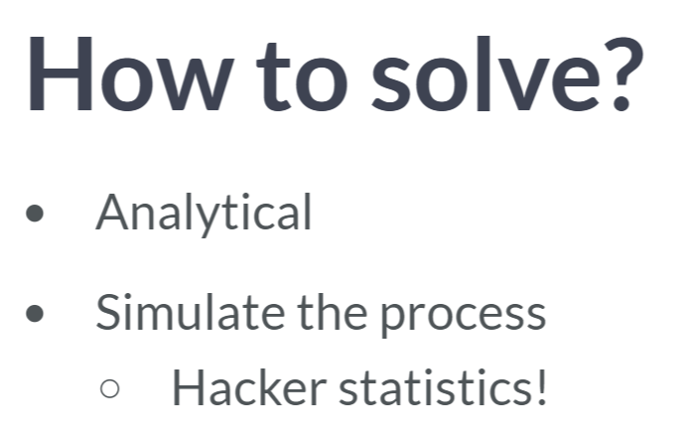  
What is the chance that you will win this bet? It's a complex assignment. One way to solve it would be to calculate the chance analytically using equations.

Another approach is to stimulate this process thousands of times and see in what fraction of the simulations that you will reach 60 steps. This is a form of hacker statistics. Yes, we are going to opt for the second approach.

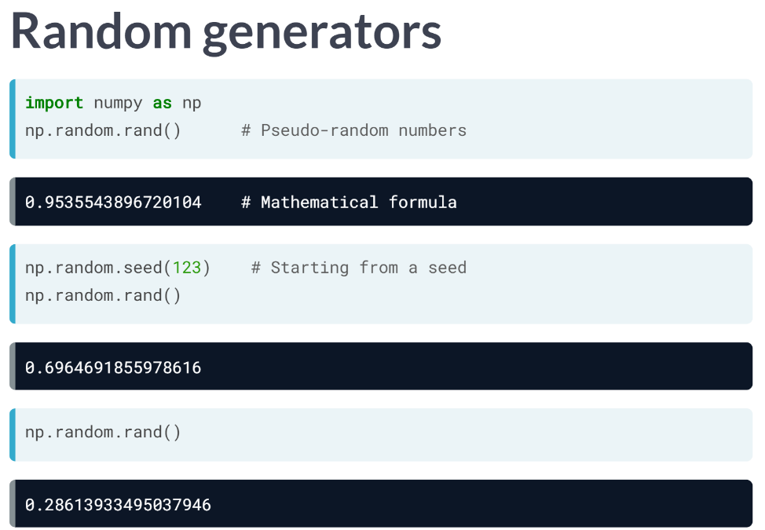  
The first thing we will need are random generators, so we can simulate the die. We need to import the NumPy and inside the NumPy, there is the random package. Inside that package, we find the "rand" function.

Let's try it out: we get a random number between zero and one. How was this random number created?

Computer typically generate so-called pseudo-random numbers, which are generated using a mathematical formula, starting from a random seed. This seed was chosen by Python when we called the ***rand()*** function, but you can also set this manually.

Suppose we set it to 123, just a number I chose, like this, and then call the rand function twice. We get two random numbers.  
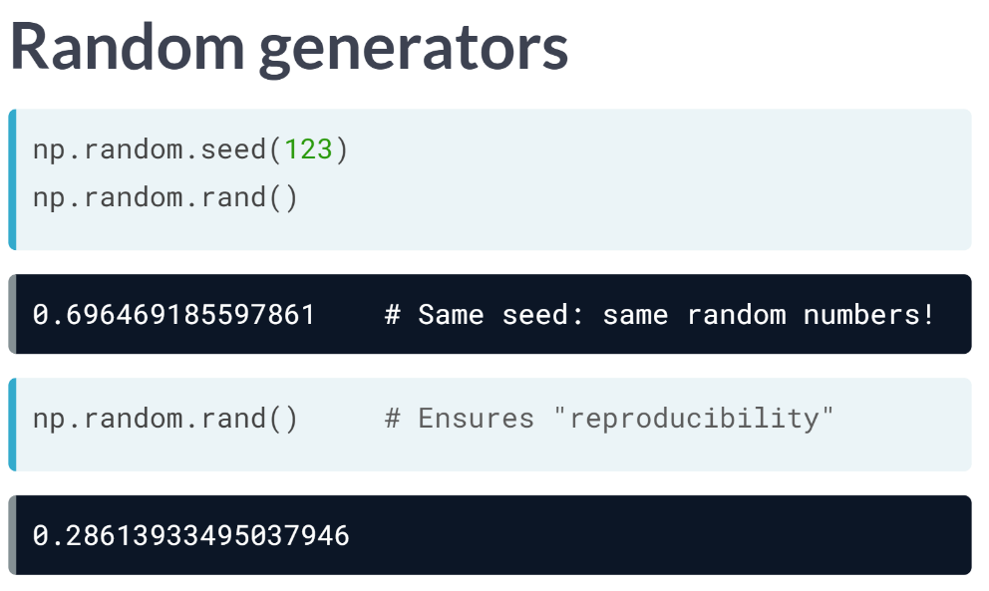  
Now, if I set the seed back to 123, and call rand() twice more, we get the exact same random numbers.

This is funky: you're generating random numbers, but for the same seed, you are generating the same random numbers. That's why it is called pseudo-random; it's random but consistent between runs; this is very useful, because this ensures "reproducibility". Other people can reproduce your analysis. Let's use this randomness in a new example now.

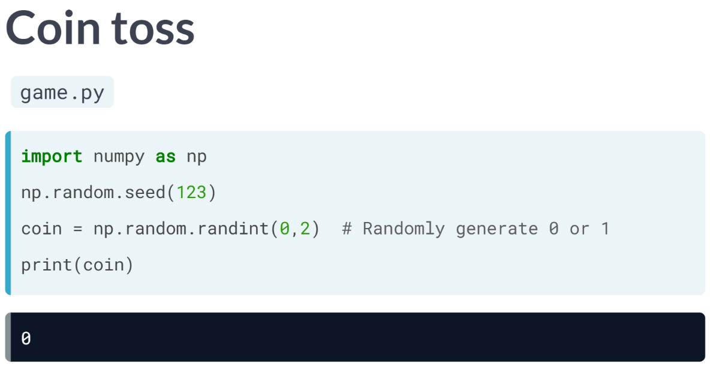  
Suppose we want to simulate a coin toss. First, set the seed - again, this could be anything - and then use the ***randint()*** function. To have it randomly generate either 0 or 1, we pass two arguments: the first argument should be 0, the second one is 2, because 2 is not going to be included. If we print out coin, we get a random integer, 0. We can now use this coin to play the game.

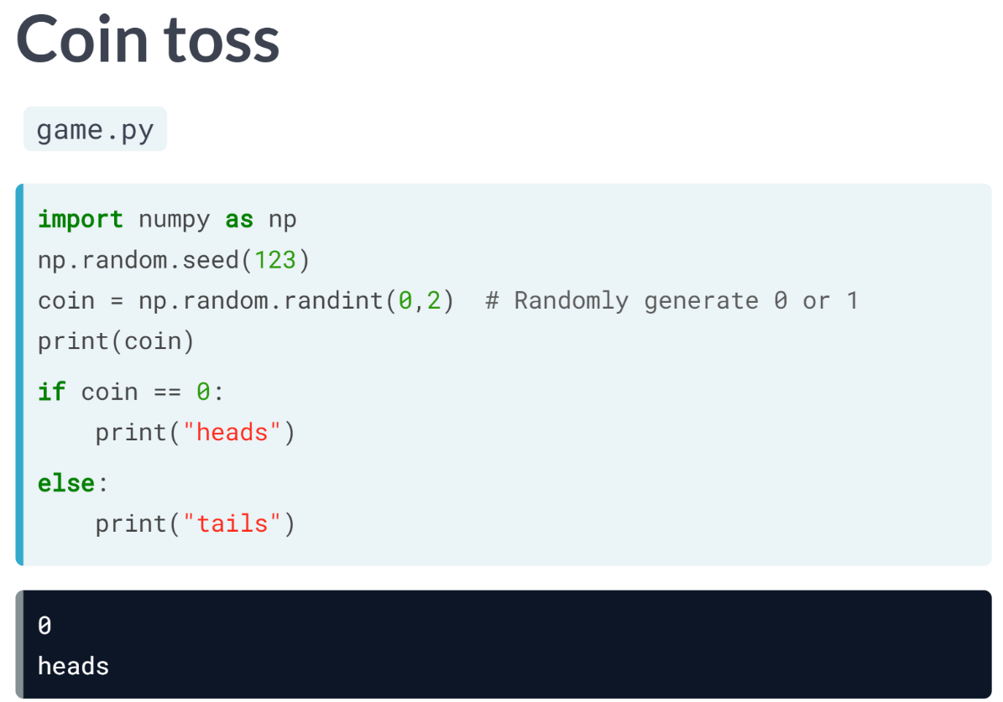  
We can also extend the code with an if-else statement: if coin equals 0, we print out *"heads"*. If it equals 1, we print out *"tails"*. If we now run the script again, coin will again equal 0, because seed is the same.

This also means that the if condition is *True*, so the string *heads* is printed out. This was the first example on how we can use random numbers to simulate real life situations that involve chance or probability.

# Random float

Randomness has many uses in science, art, statistics, cryptography, gaming, gambling, and other fields. You're going to use randomness to simulate a game.

All the functionality you need is contained in the random package, a sub-package of numpy. In this exercise, you'll be using two functions from this package:

* [**seed()**](http://docs.scipy.org/doc/numpy-1.10.1/reference/generated/numpy.random.seed.html): sets the random seed, so that your results are reproducible between simulations. As an argument, it takes an integer of your choosing. If you call the function, no output will be generated.
* [**rand()**](http://docs.scipy.org/doc/numpy-1.10.1/reference/generated/numpy.random.rand.html): if you don't specify any arguments, it generates a random float between zero and one.

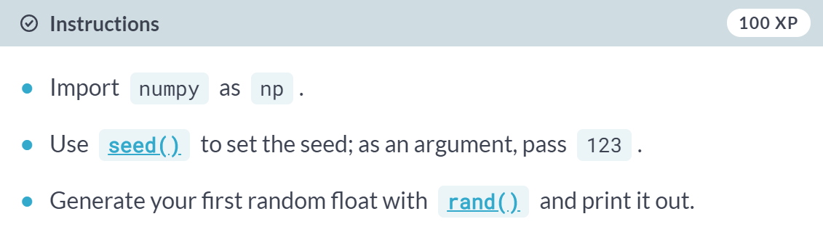  
  
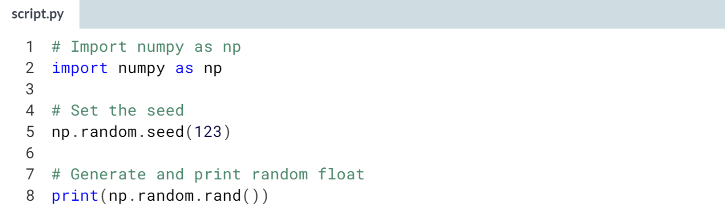  
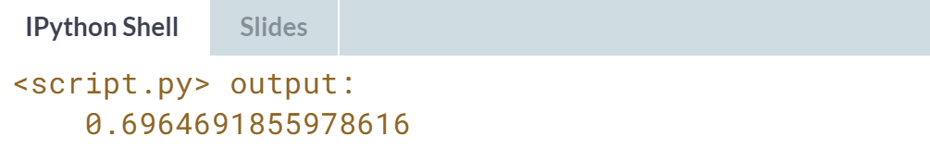

# Roll the dice

In the previous exercise, you used [**rand()**](http://docs.scipy.org/doc/numpy-1.10.1/reference/generated/numpy.random.rand.html), that generates a random float between 0 and 1.

As Hugo explained in the video you can just as well use **[randint()](http://docs.scipy.org/doc/numpy-1.10.1/reference/generated/numpy.random.randint.html" \t "_blank)**, also a function of the random package, to generate integers randomly. The following call generates the integer 4, 5, 6 or 7 randomly. **8 is not included**.

import numpy as np

np.random.randint(4, 8)

Numpy has already been imported as np and a seed has been set. Can you roll some dice?

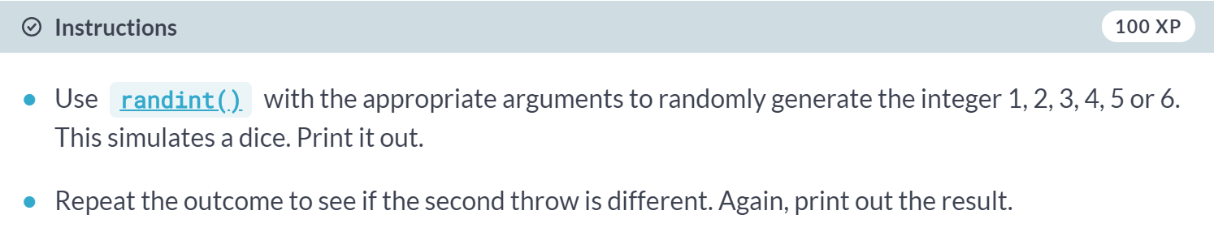

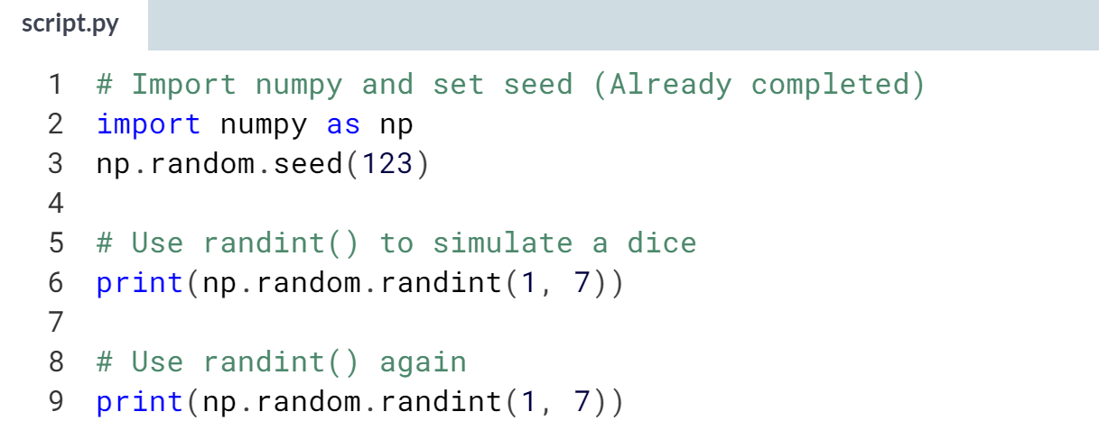

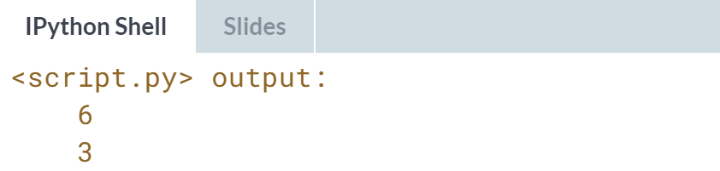  
Alright! Time to actually start coding things up!

# Determine your next move

In the Empire State Building bet, your next move depends on the number of eyes you throw with the dice. We can perfectly code this with an if-elif-else construct!

The sample code assumes that you're currently at step 50. Can you fill in the missing pieces to finish the script? numpy is already imported as np and the seed has been set to 123, so you don't have to worry about that anymore.

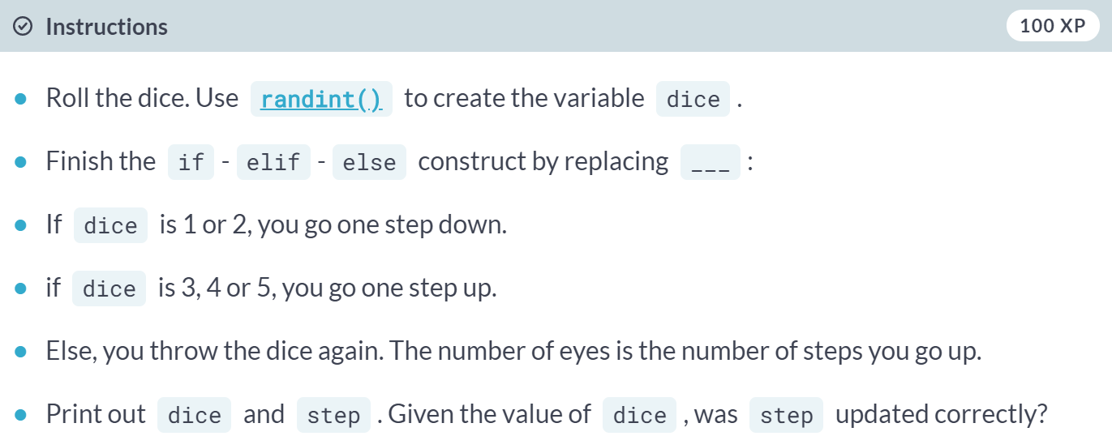  
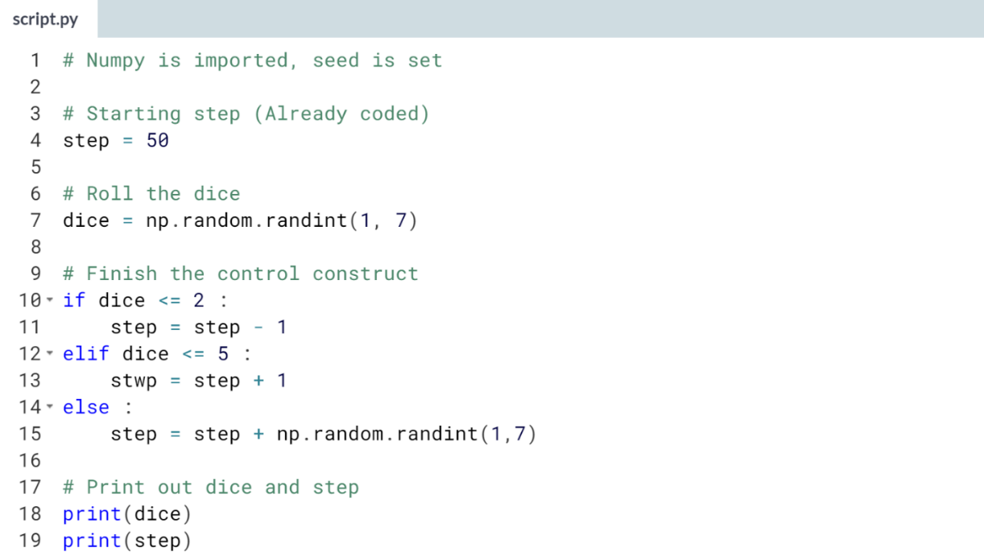  
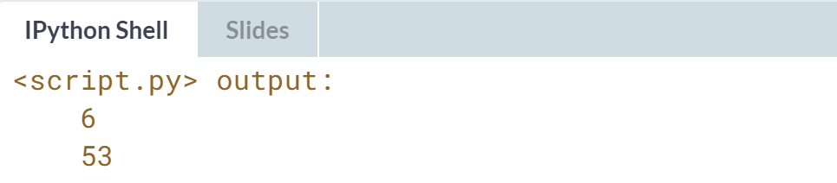  
Cool! You threw a 6, so the code for the else statement was executed. You threw again, and apparently you threw 3, causing you to take three steps up: you're currently at step 53.



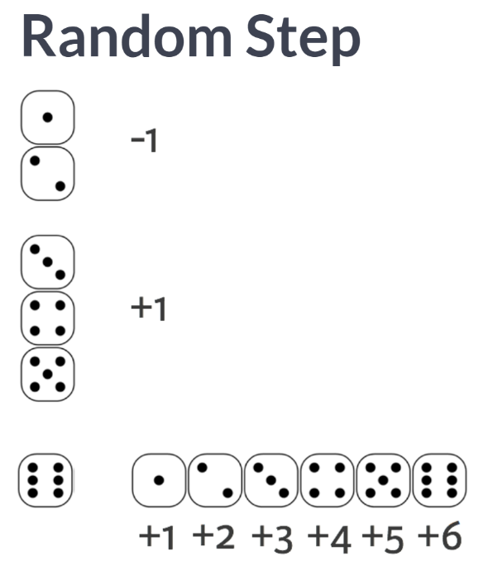  
  
If you use a dice to determine your next step, we can call this a random step.

What if you use a dice 100 times to determine your next steps? You would have a succession of random steps, or in other words, a random walk.

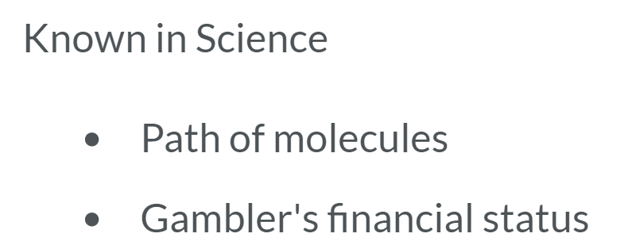  
  
This is well known concept in science, for example, the path traced by a molecule as it travels in a liquid or a gas can be modeled as a random walk.

Financial status of a gambler is another example. To record every step in your random walk, you need to learn how to gradually build a list with a for loop.

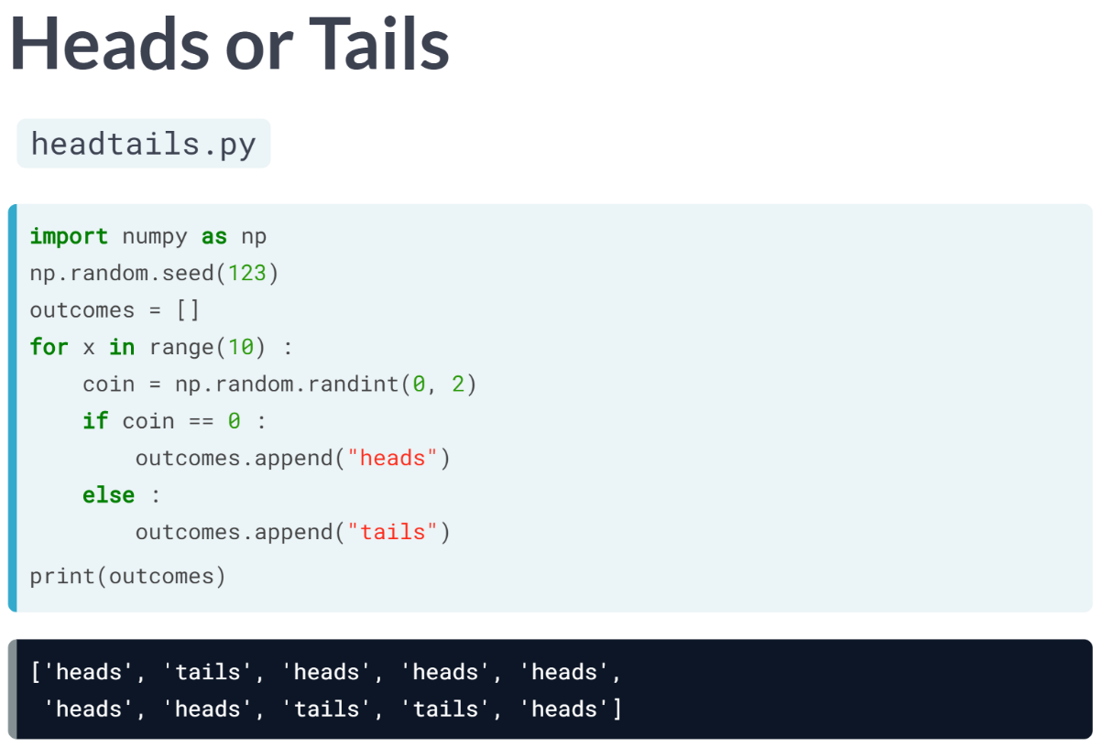  
Have a look at this code. It keeps the outcomes for playing a game of heads or tails ten times, with the random number generator we coded up in the previous video.

After importing NumPy and setting a seed for the random number generator, we initially an empty list *“outcomes”*.

Next, we build a for loop that should run ten times. We can do this with the ***range()*** function, that generates a list of numbers that you can use to iterate over.

Inside this for loop, we generate a random number integer coin that is either zero or one. Zero corresponds to heads, 1 to tails. If coin is zero, we append this string heads to the list.

Else, we append the string tails. In both cases, we do this with the append method, which we learned about in the intro course. Finally, we print the outcomes list we've built up in these 10 iterations.

If we run this script, eventually a list with 10 strings will be printed out. This list is random, but it's not a random walk, because the items in the list are not based on the previous one. It's just a bunch of random steps.

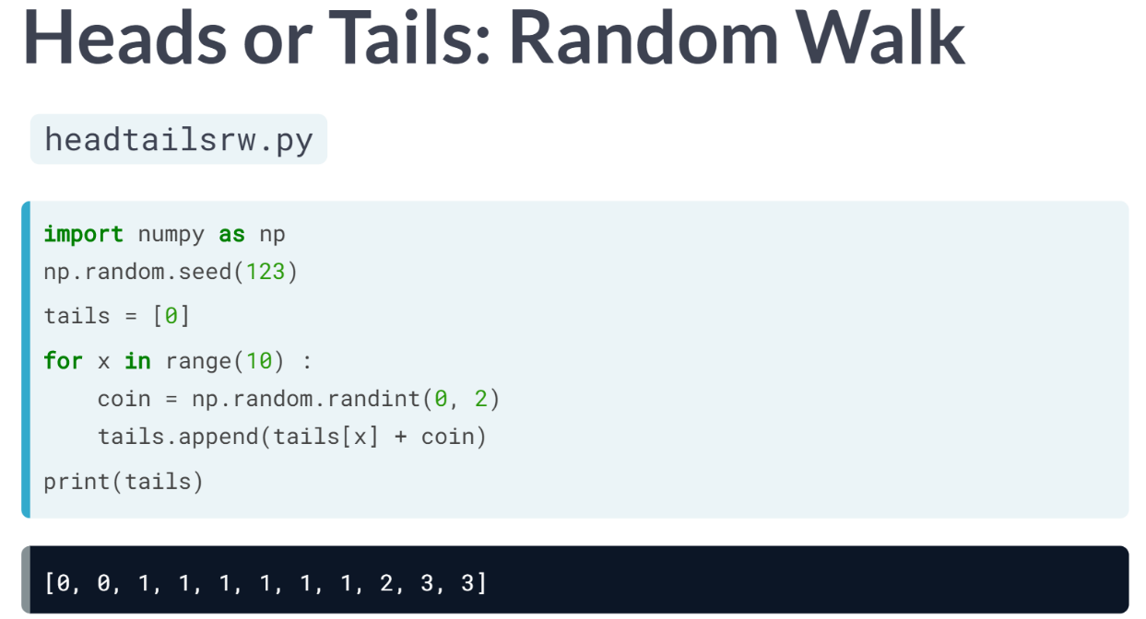  
You could turn this example into a random walk by tracking the total number of tails while you're simulating the game.

In this case, you start by creating a list, tails, that already contains number 0, because at the start, you haven't thrown any tails. Then you again start a for loop that runs 10 times, using the ***range()*** function. In there, you again generate a random number. Instead of the if-else structure, you can simplify things.

If coin is 0, so heads, the number of tails you've thrown shouldn't change. If a 1 is generated, the number of tails should be incremented with 1. This means that you can simply add coin to the previous number of tails and add this count to the list with append.

Finally, you again print the list tails. After running this script, a list with 11 elements will be printed out. The final element in this list tells us how often tails was thrown.

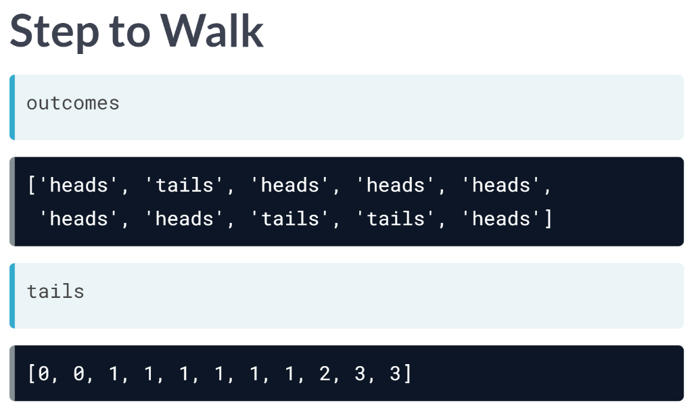  
If you compare the output of the first script to the output of the second script, you can see that the numbers in the tails list are incremented by one each time you threw tails.

This is exactly how a bunch of random steps are converted into a random walk.

# The next step

Before, you have already written Python code that determines the next step based on the previous step. Now it's time to put this code inside a for loop so that we can simulate a random walk.

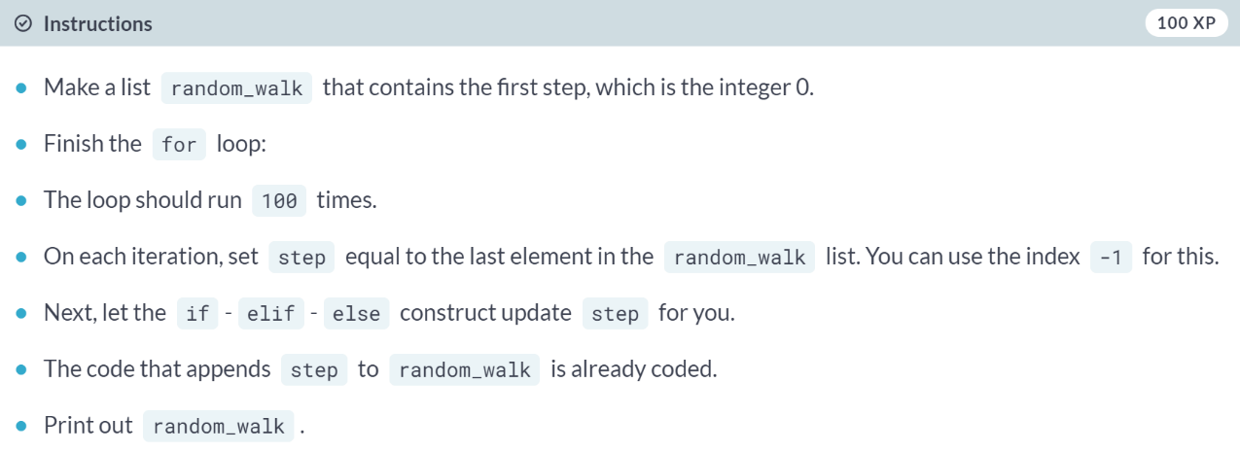  
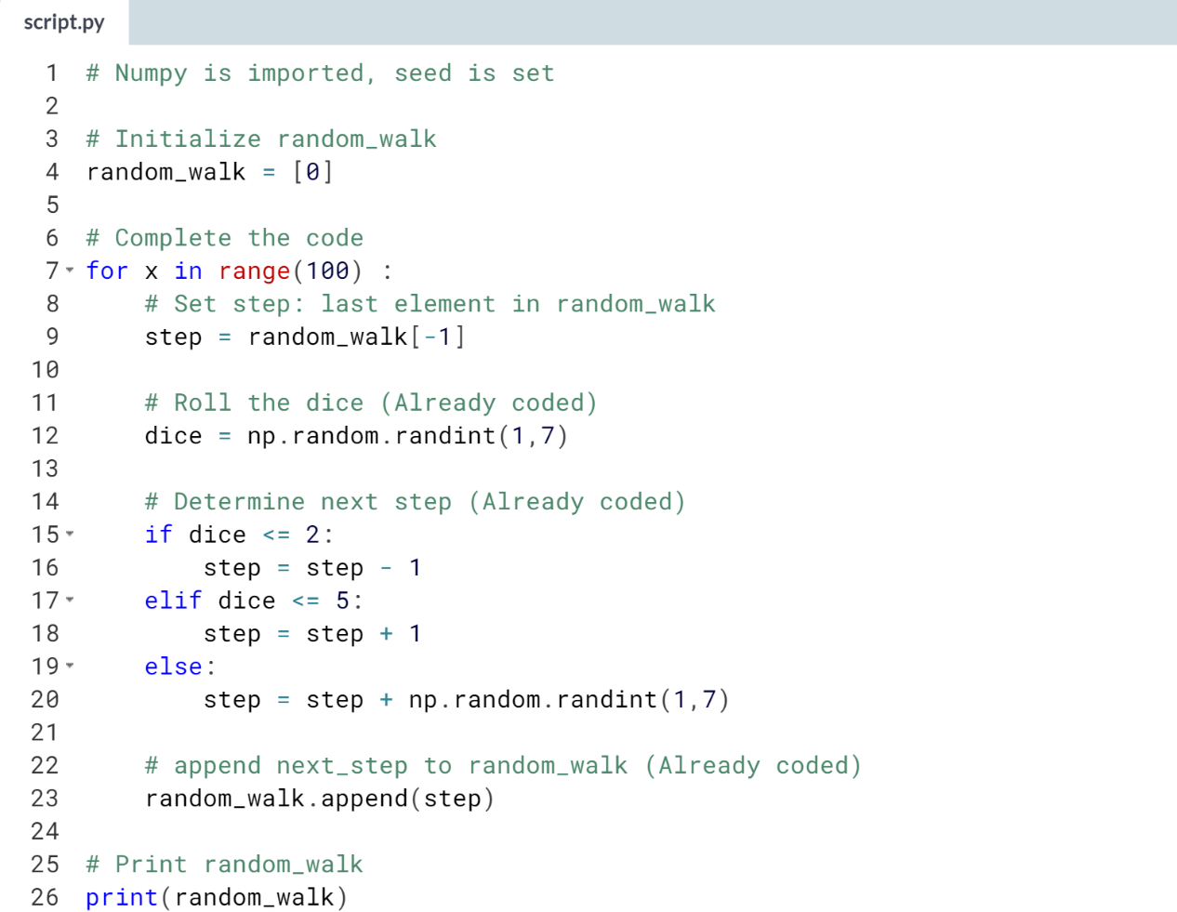  
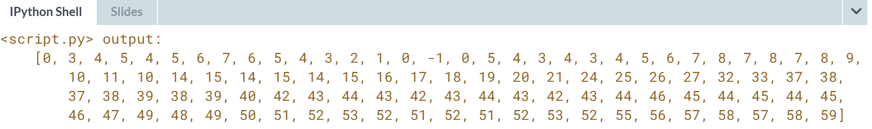  
Good job! There's still something wrong: the level at index 15 is negative number (-1)!

# How low can you go?

Things are shaping up nicely! You already have code that calculates your location in the Empire State Building after 100 dice throws. However, there's something we haven't thought about - you can't go below 0!

A typical way to solve problems like this is by using [**max()**](https://docs.python.org/3/library/functions.html#max). If you pass [**max()**](https://docs.python.org/3/library/functions.html#max) two arguments, the biggest one gets returned. For example, to make sure that a variable x never goes below 10 when you decrease it, you can use:

x = max(10, x - 1)

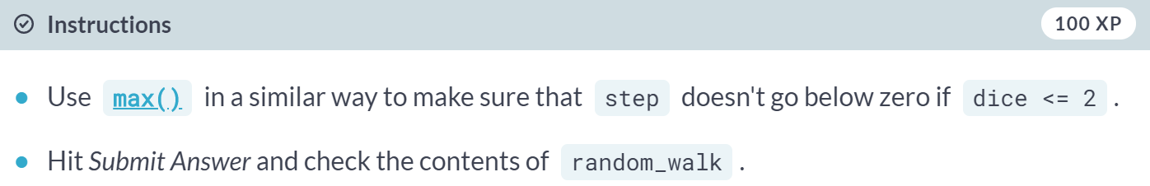  
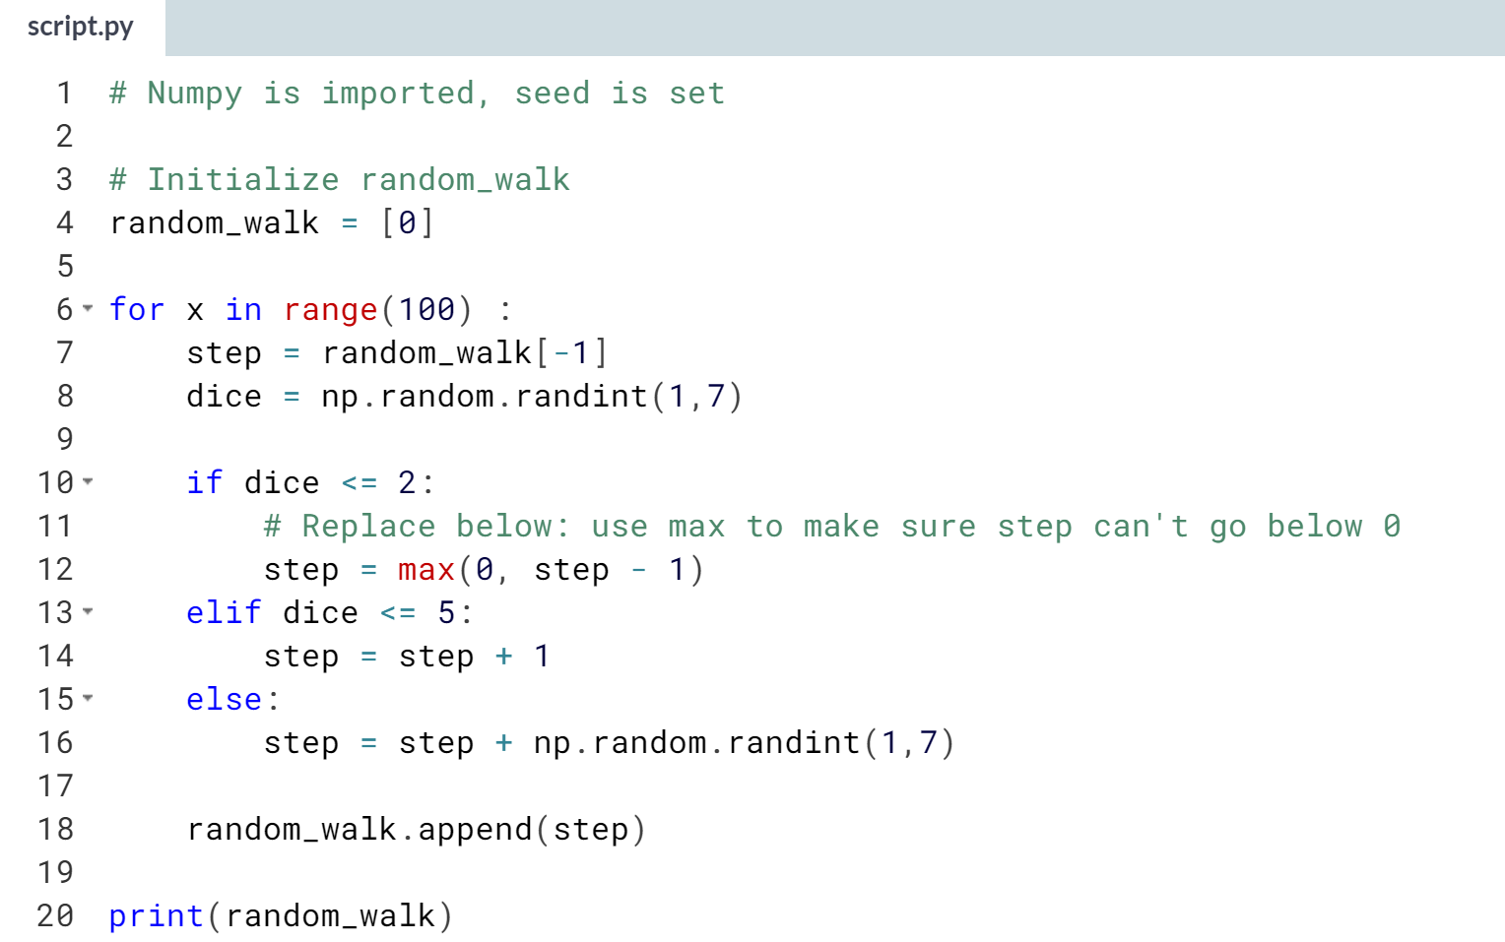  
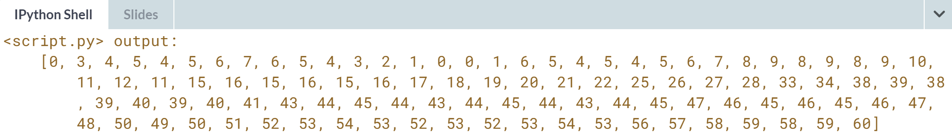  
If you look at the output, we see that around index 15 the step stays at 0. You're not going below zero anymore.

# Visualize the walk

Let's visualize this random walk! Remember how you could use matplotlib to build a line plot?

import matplotlib.pyplot as plt

plt.plot(x, y)

plt.show()

The first list you pass is mapped onto the x axis and the second list is mapped onto the y axis.

If you pass only one argument, Python will know what to do and will use the index of the list to map onto the x axis, and the values in the list onto the y axis.

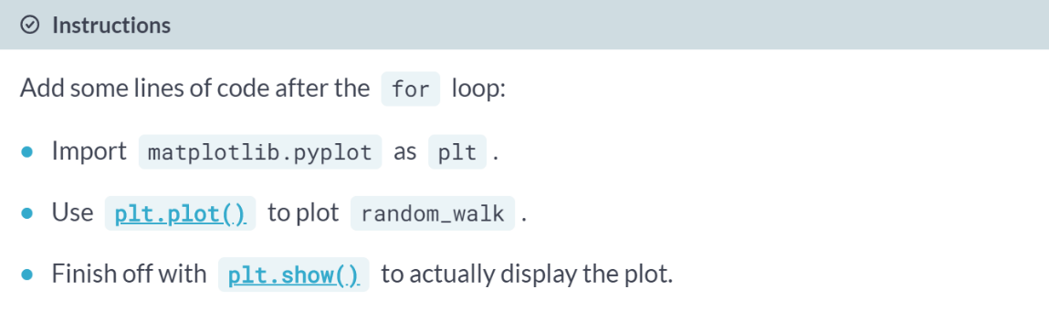  
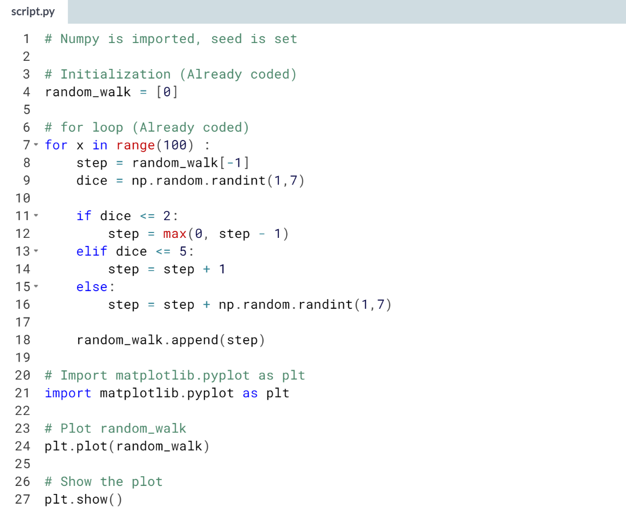

(Graph on the next page)

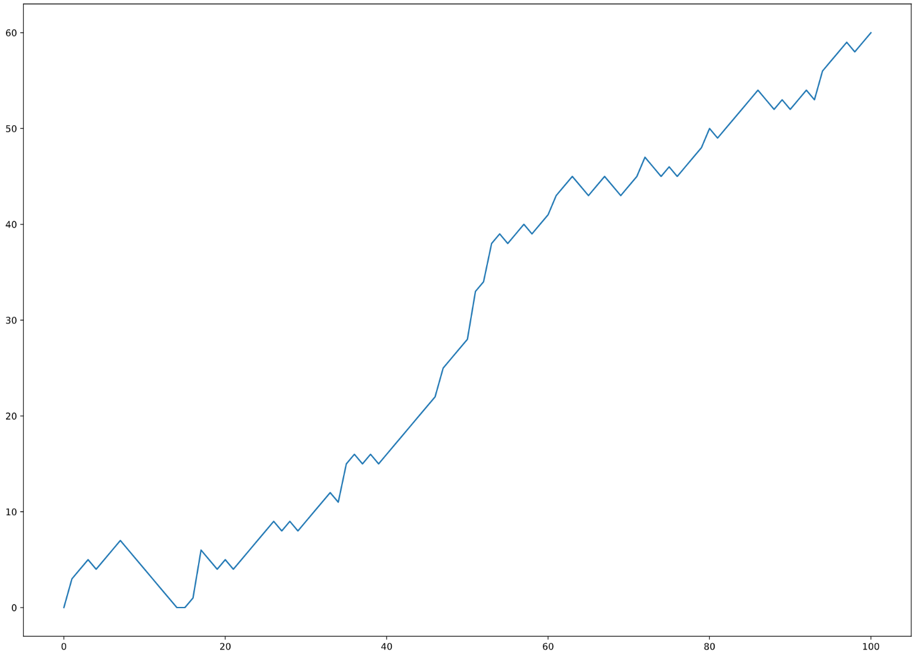  
This is pretty cool! You can clearly see how your random walk progressed.



We learned about the distribution of random walks. Let's go back to the initial problem.

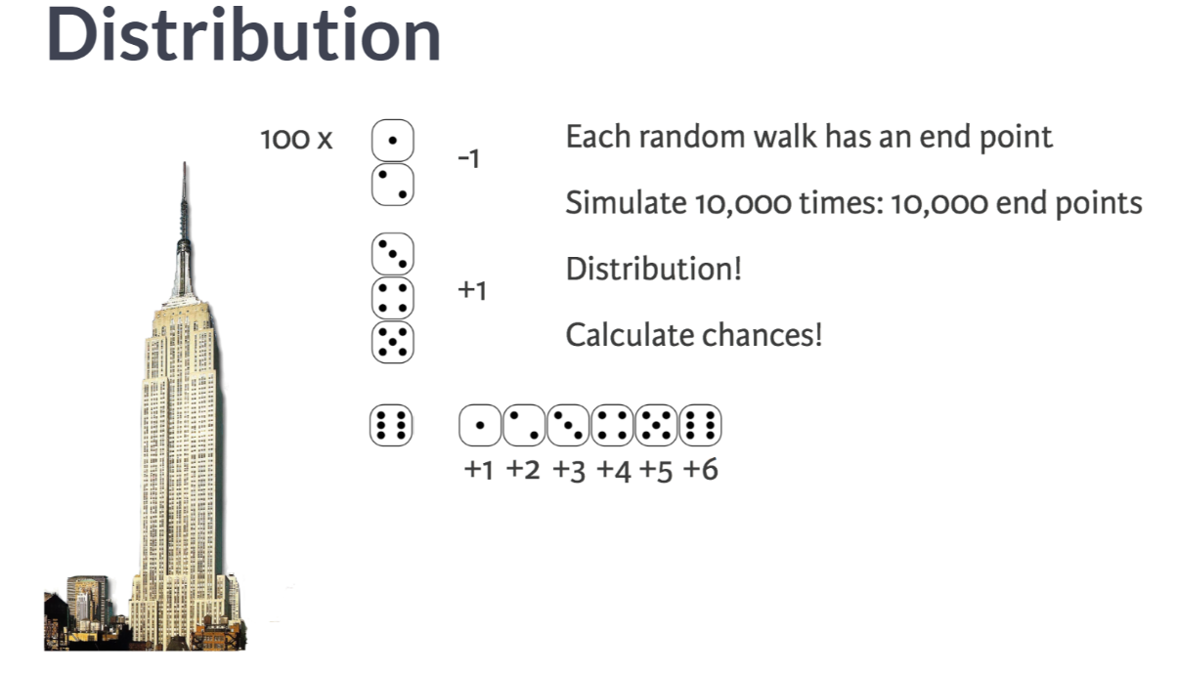  
You throw a die 100 times and depending on the result, you go some steps up or some steps down. This is called a random walk, and you know how to simulate this. But you still have to answer the main question: what is the chance that you will reach 60 steps high?

I'll give you a hint. Each random walk will end up on a different step. If you simulate this walk thousands of times, you will end up with thousands of final steps. This is actually a distribution of final steps. And once you know the distribution, you can start calculating chances.

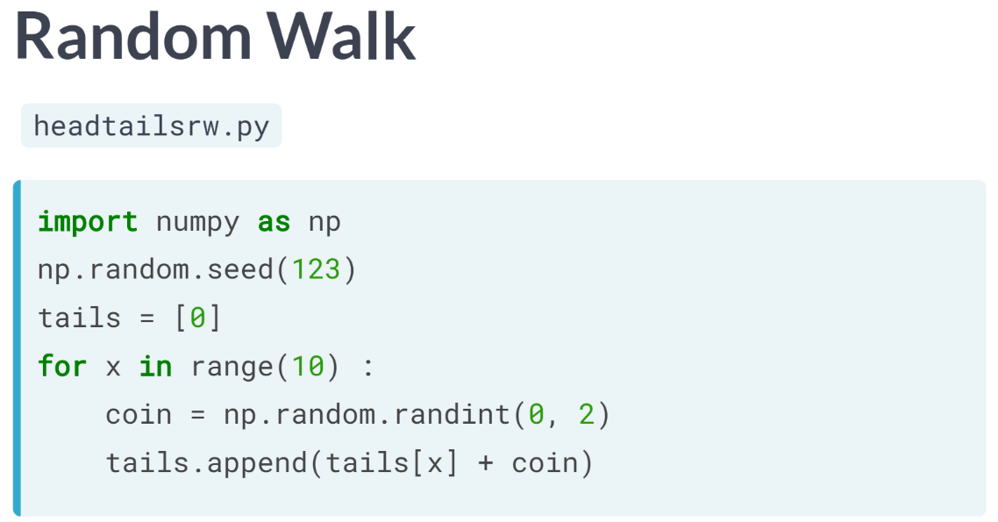  
Going back to the example of the total number of tails after 10 coin tosses, the number of tails starts at zero, and ten times, we calculate a random number, which is either 0 or 1. We then update the number of times tails has been thrown by appending it to the list.

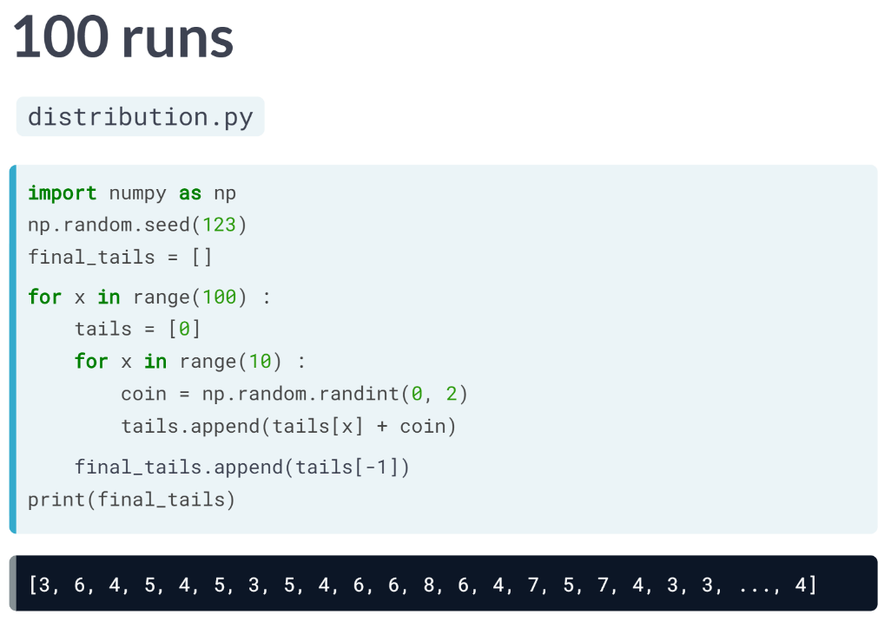  
To find the distribution of this walk, we start by setting a random seed, and then create an empty list named *final\_tails*.

This list will continue the number of tails you end up with if you play this game of tossing a coin 10 times over and over again.

Let's write a for loop that runs 100 times. Inside this for loop, we put the code from before, that gradually build up the tails list.

After simulating this single game, we append the last number, so the number of tails after tossing 10 times, to the *final\_tails* list.

Notice that the indentation here specifies that this last line is part of the top-level for loop.

If you put a last line in here to print *final\_tails*, outside of the for loops, and run the script, you see that *final\_tails* contains numbers between 0 and 10.

Each number is the number of tails that were thrown in a game of 10 tosses. All these values actually represent a distribution that we can visualize. Yes, we can use a histogram.

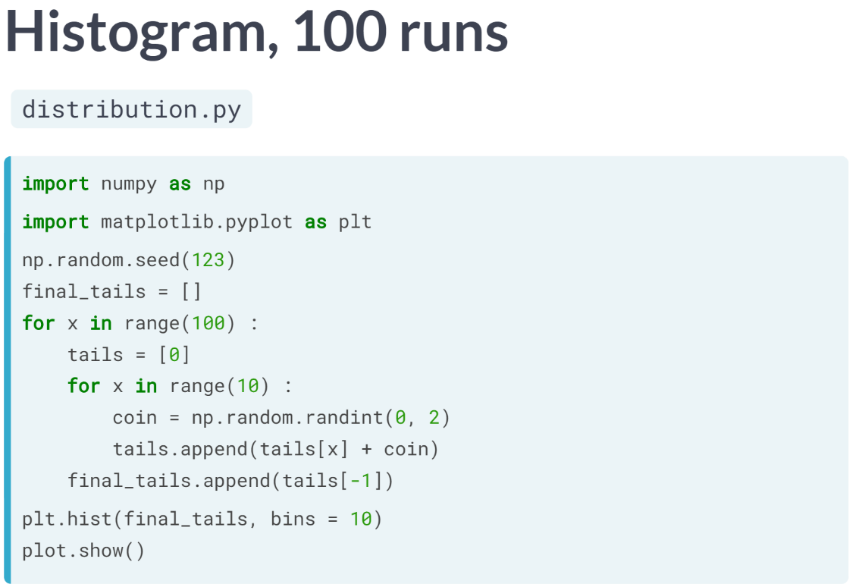  
On the top of the script, we add a line to import pyplot, and then, instead of the print statement, we call the ***hist()*** function and specify that we want 10 bins. Of course, to actually display the plot, we need ***plt.show()***.

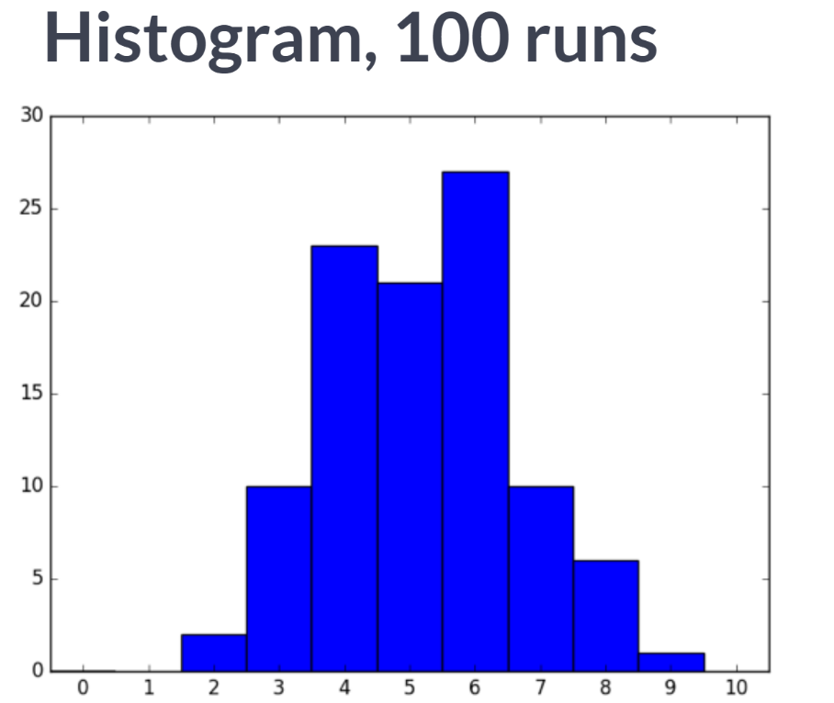   
If we run the script, the resulting histogram already gives an idea but is not very smooth yet.

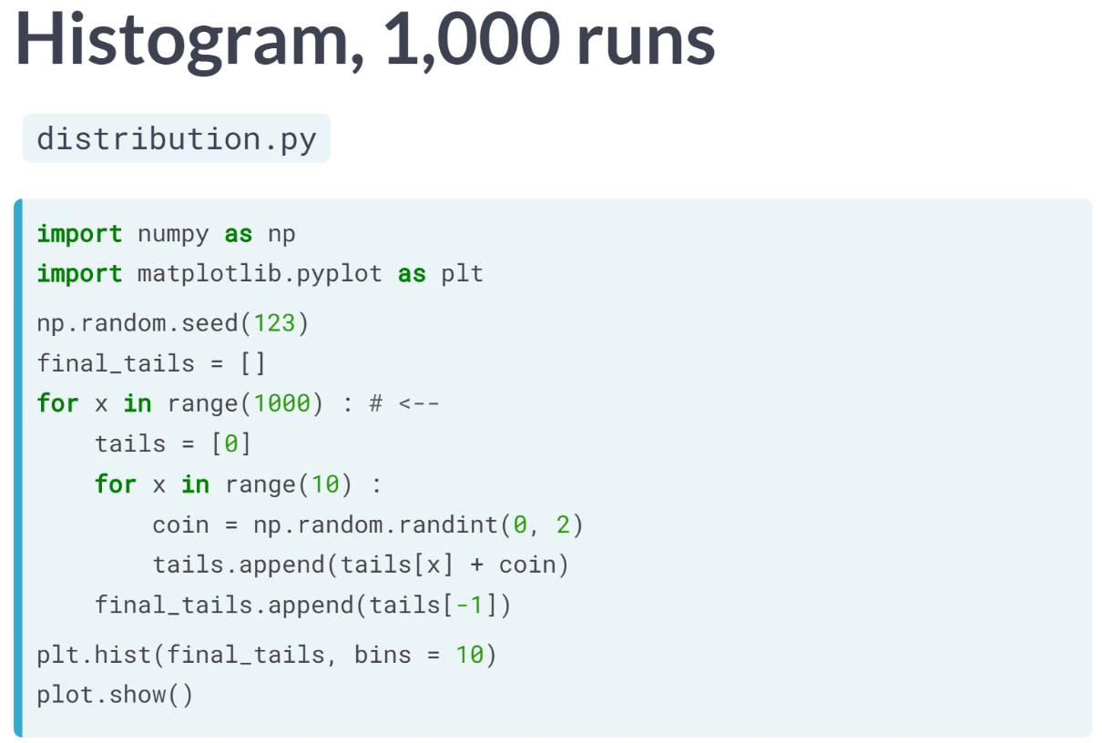  
Let's head back to the code and now simulate the coin toss game one thousand times, by changing the range in the top-level for loop.

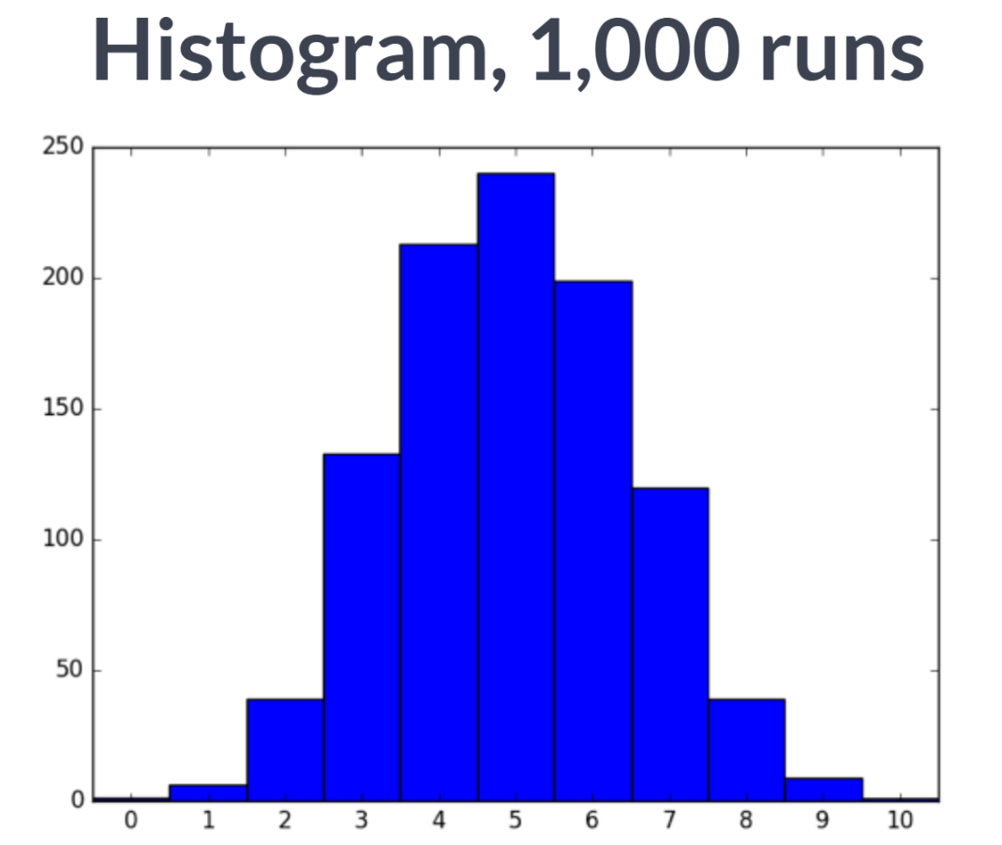  
This time, the histogram already looks better.

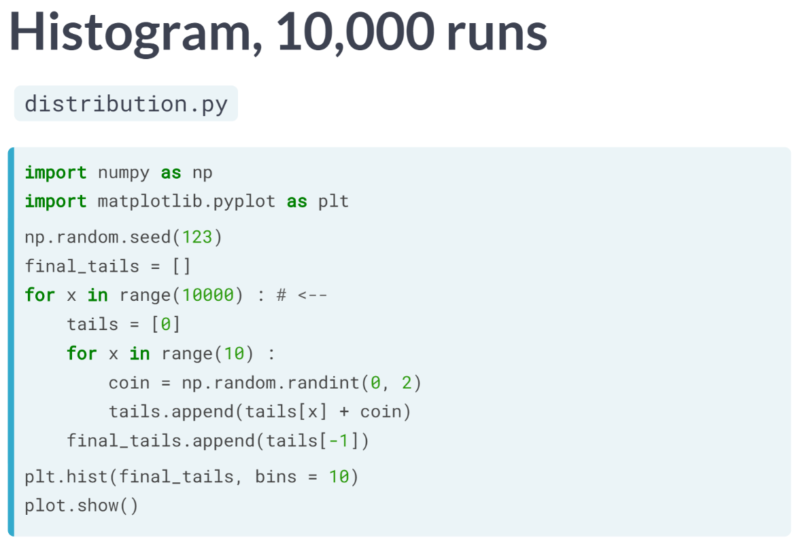   
If we change the code to do 10,000 simulations, the distribution starts to converge to a bell-shape.

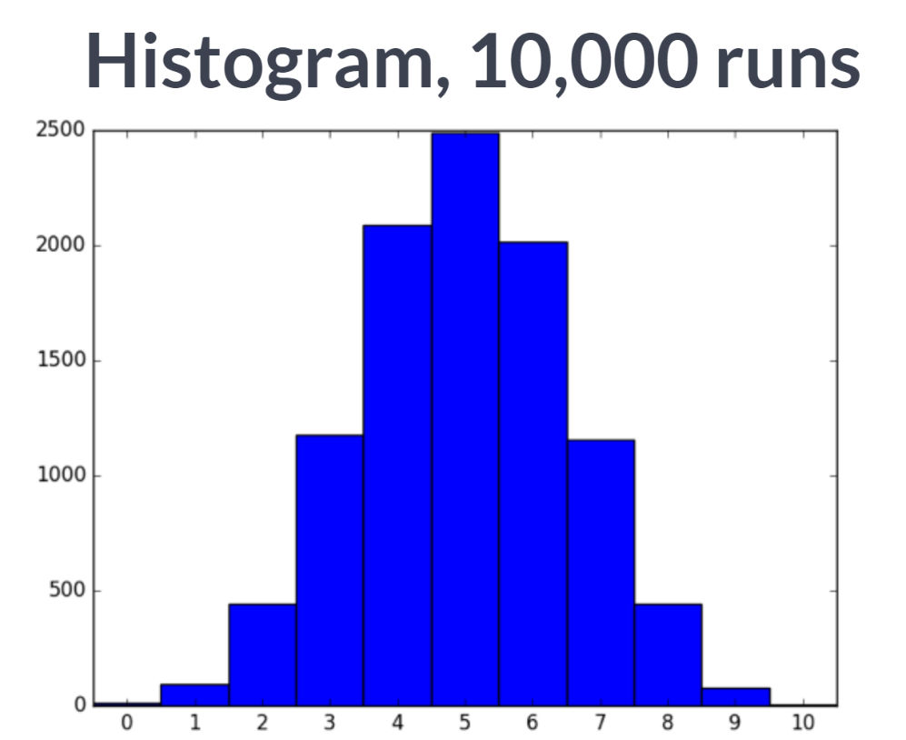  
In fact, it starts to look like the theoretical distribution. That means the distribution that you would find by doing analytical pen-and-paper calculations. Ideally, you want to carry out the experiment zillions of times to get a distribution that is exactly the same as the theoretical distribution.

This will take too much computer time, so ten thousand times already gives a good estimate. From this curve, we can see that in around 2500 games of the 10000 games played, you end up with tails 5 times.

# Simulate multiple walks

A single random walk is one thing, but that doesn't tell you if you have a good chance at winning the bet.

To get an idea about how big your chances are of reaching 60 steps, you can repeatedly simulate the random walk and collect the results. That's exactly what you'll do in this exercise.

The sample code already sets you off in the right direction. Another for loop is wrapped around the code you already wrote. It's up to you to add some bits and pieces to make sure all of the results are recorded correctly.

**Note: Don't change anything about the initialization of all\_walks that is given. Setting any number inside the list will cause the exercise to crash!**

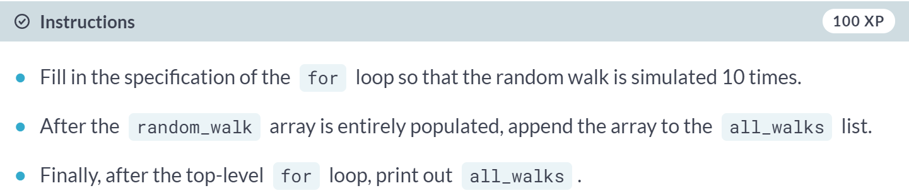  
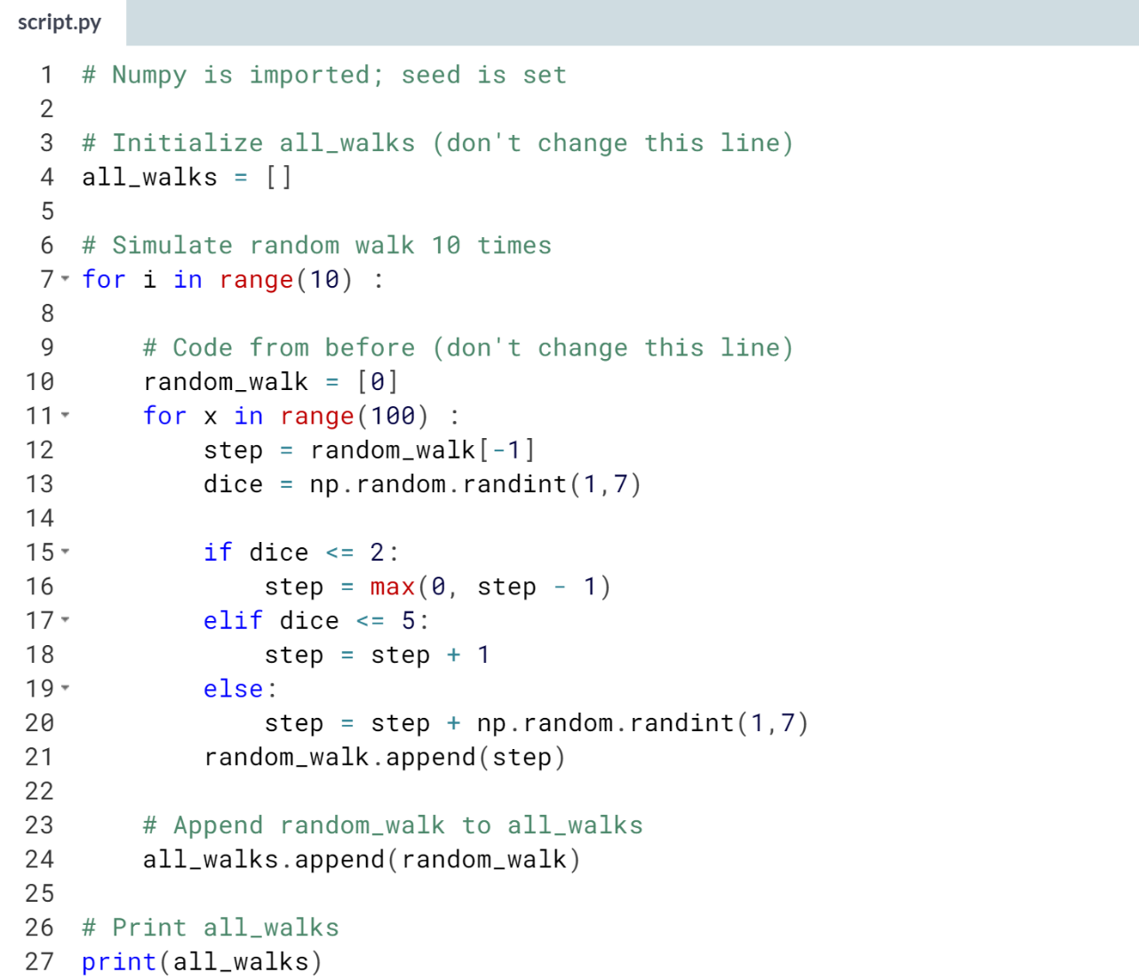  
(results not shown)

# Visualize all walks

all\_walks is a list of lists: every sub-list represents a single random walk. If you convert this list of lists to a Numpy array, you can start making interesting plots! matplotlib.pyplot is already imported as plt.

The nested for loop is already coded for you - don't worry about it. For now, focus on the code that comes after this for loop.

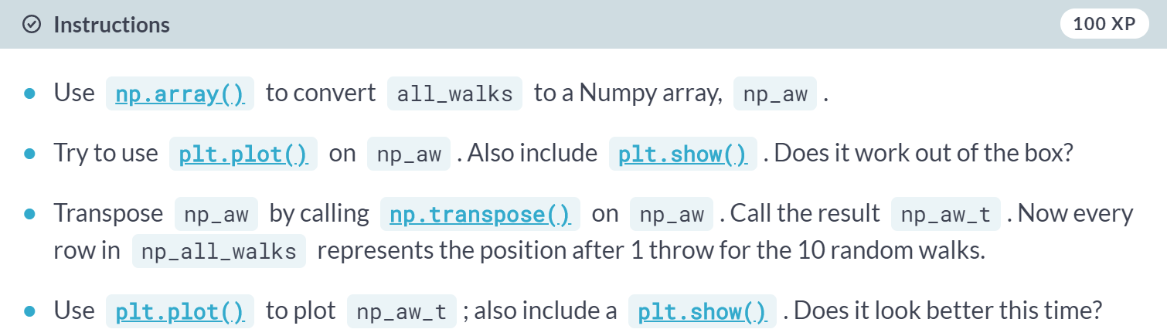

(Script on the next page)

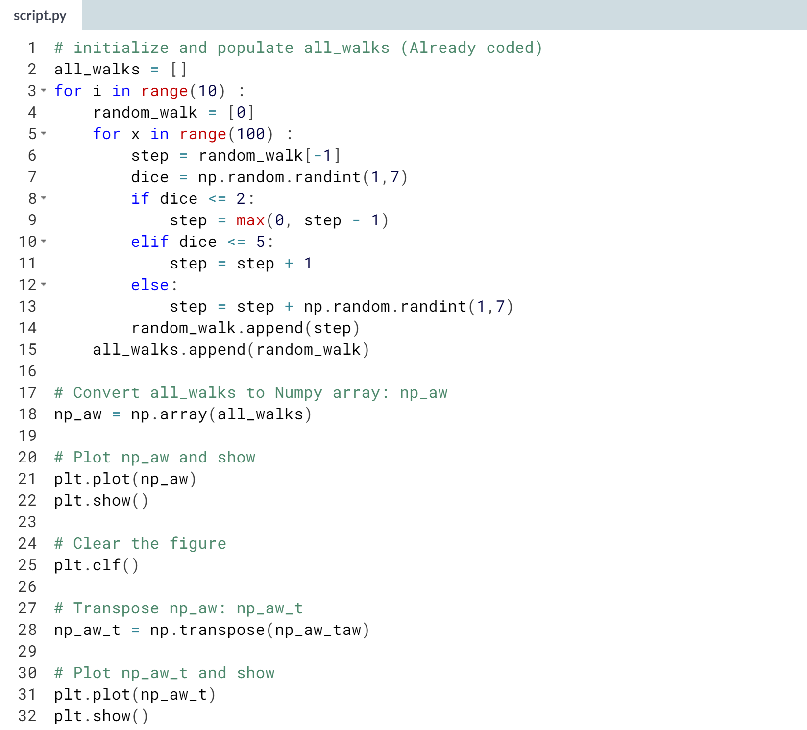

(Graphs on the next page)

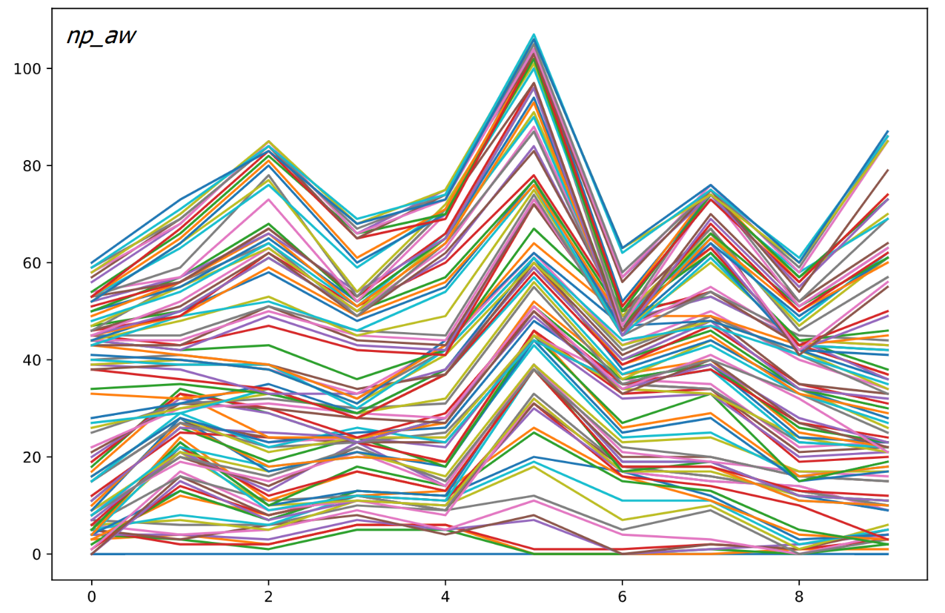  
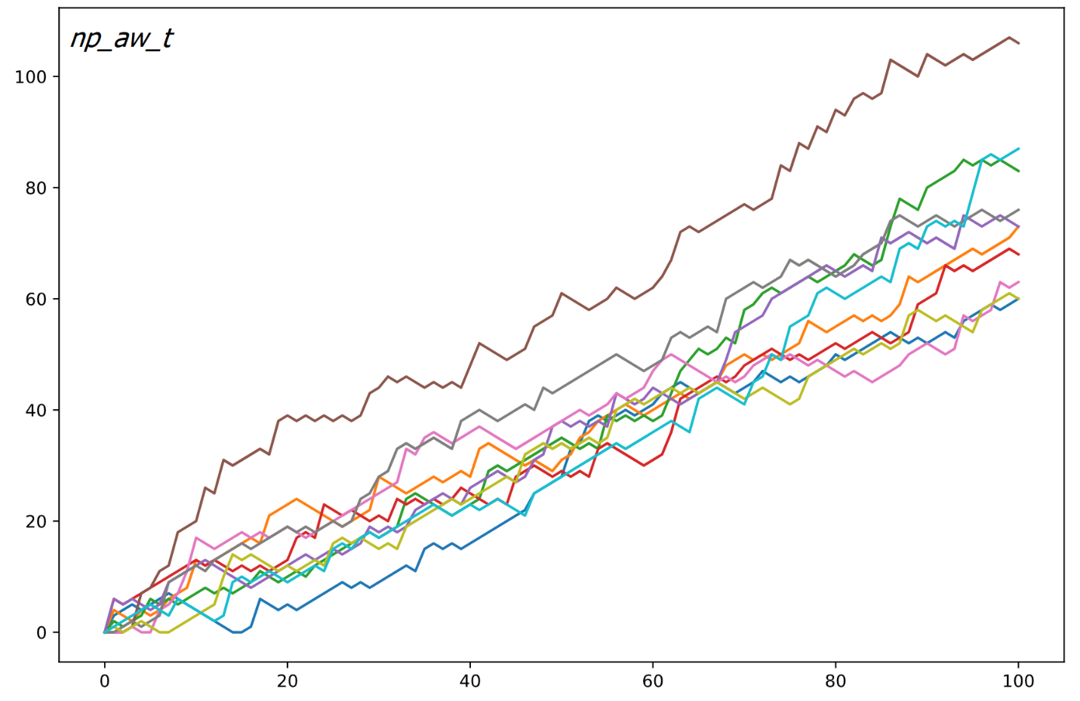  
Good job! You can clearly see how the different simulations of the random walk went. Transposing the 2D Numpy array was crucial; otherwise Python misunderstood.

# Implement clumsiness

With this neatly written code of yours, changing the number of times the random walk should be simulated is super-easy. You simply update the [**range()**](https://docs.python.org/3/library/functions.html#func-range) function in the top-level for loop.

There's still something we forgot! You're a bit clumsy and you have a 0.1% chance of falling down. That calls for another random number generation. Basically, you can generate a random float between 0 and 1. If this value is less than or equal to 0.001, you should reset step to 0.

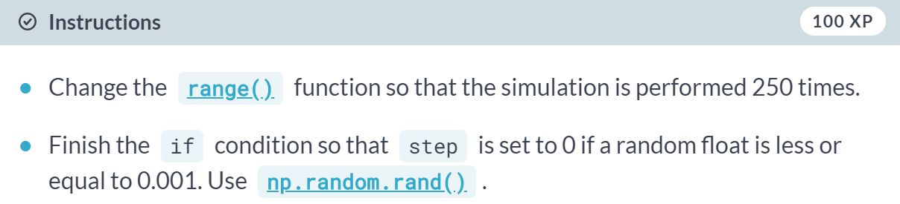  
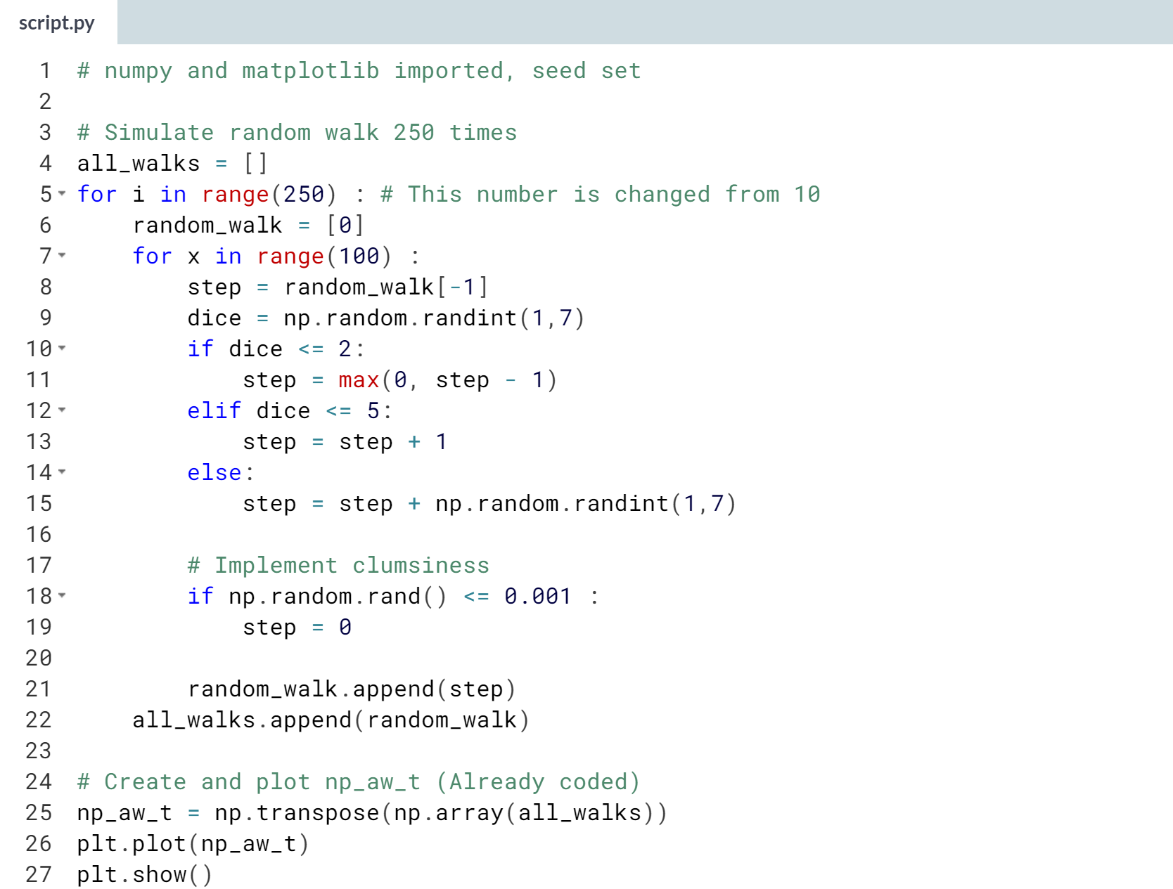  
(Graph on the next page)

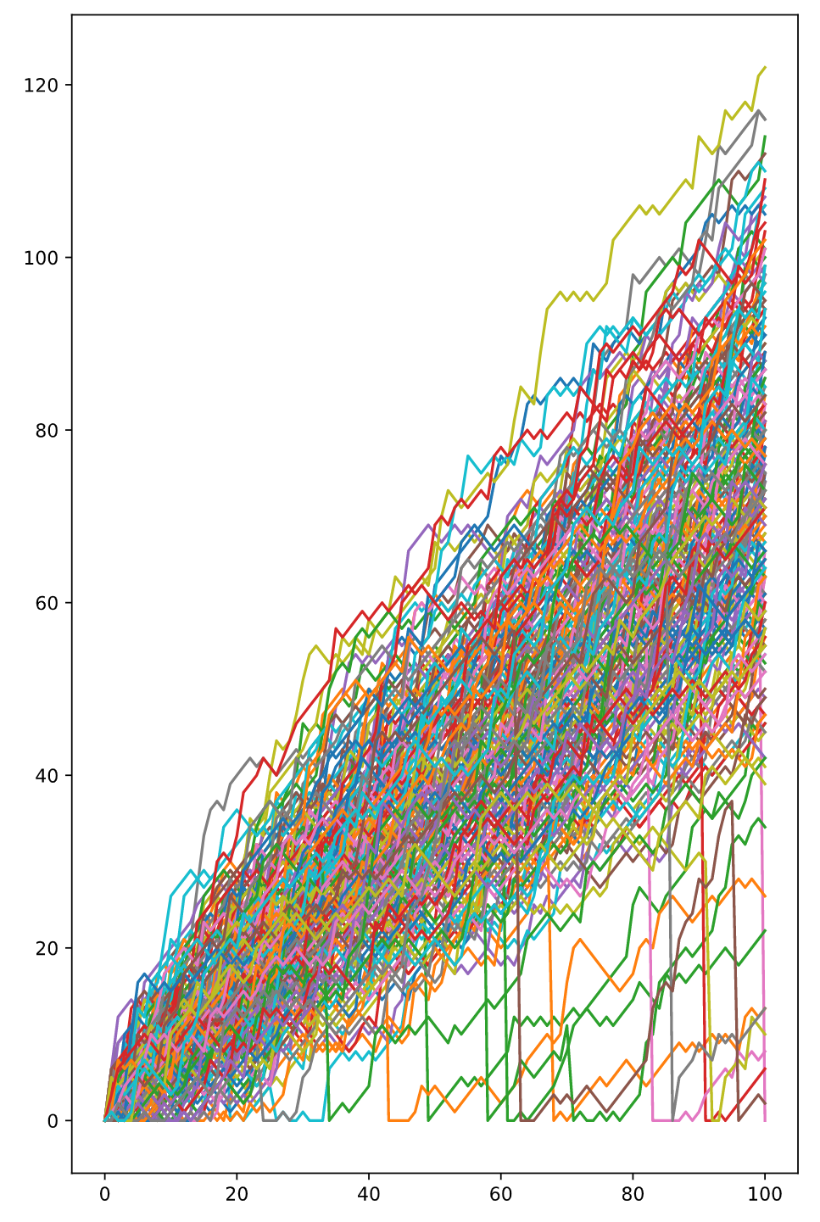

Superb! Look at the plot. In some of the 250 simulations you're indeed taking a deep dive down!

# Plot the distribution

All these fancy visualizations have put us on a sidetrack. We still have to solve the million-dollar problem: What are the odds that you'll reach 60 steps high on the Empire State Building?

Basically, you want to know about the end points of all the random walks you've simulated. These end points have a certain distribution that you can visualize with a histogram.

Note that if your code is taking too long to run, you might be plotting a histogram of the wrong data!

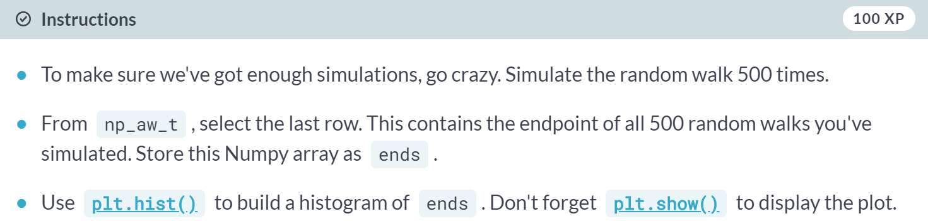  
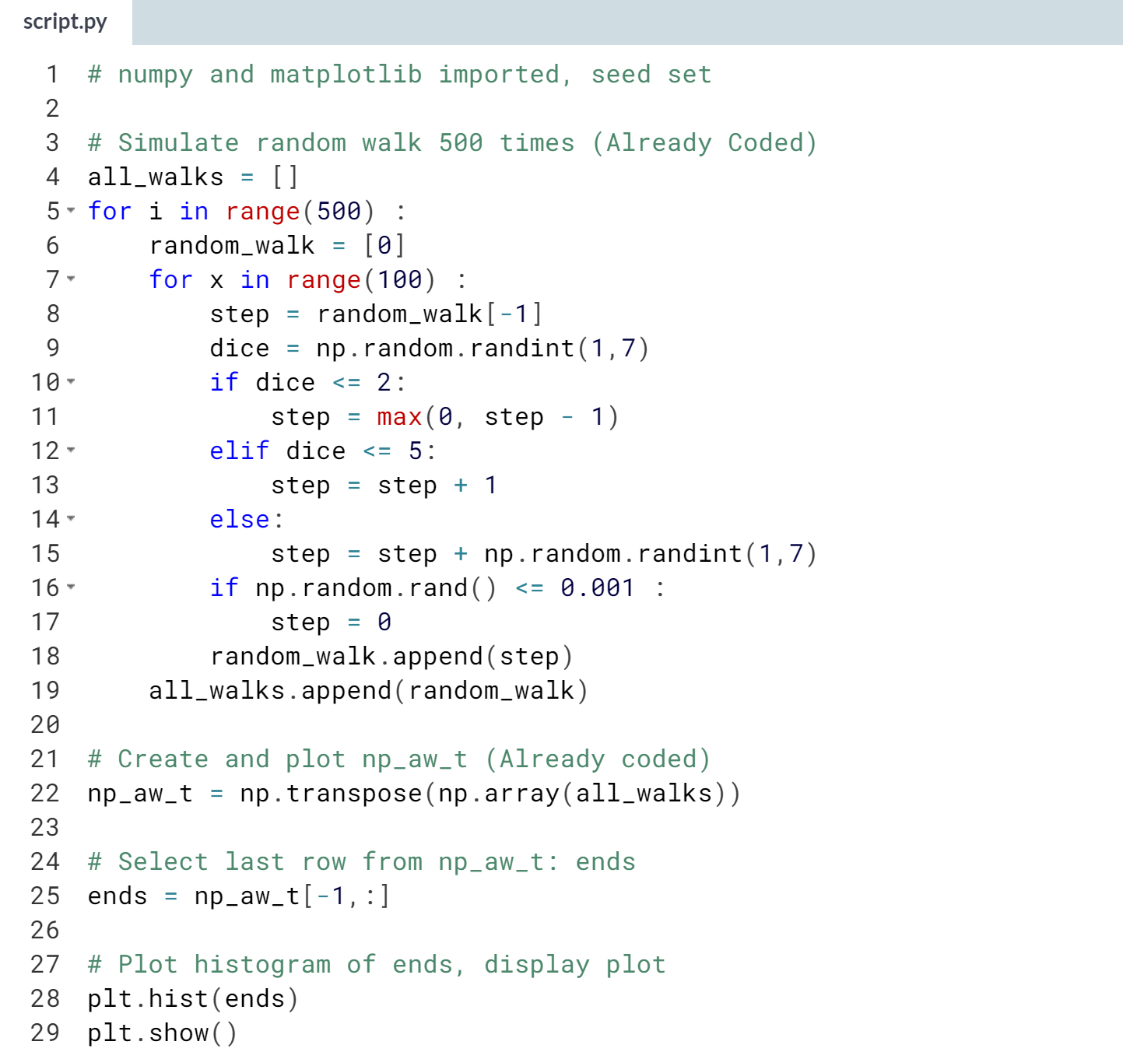

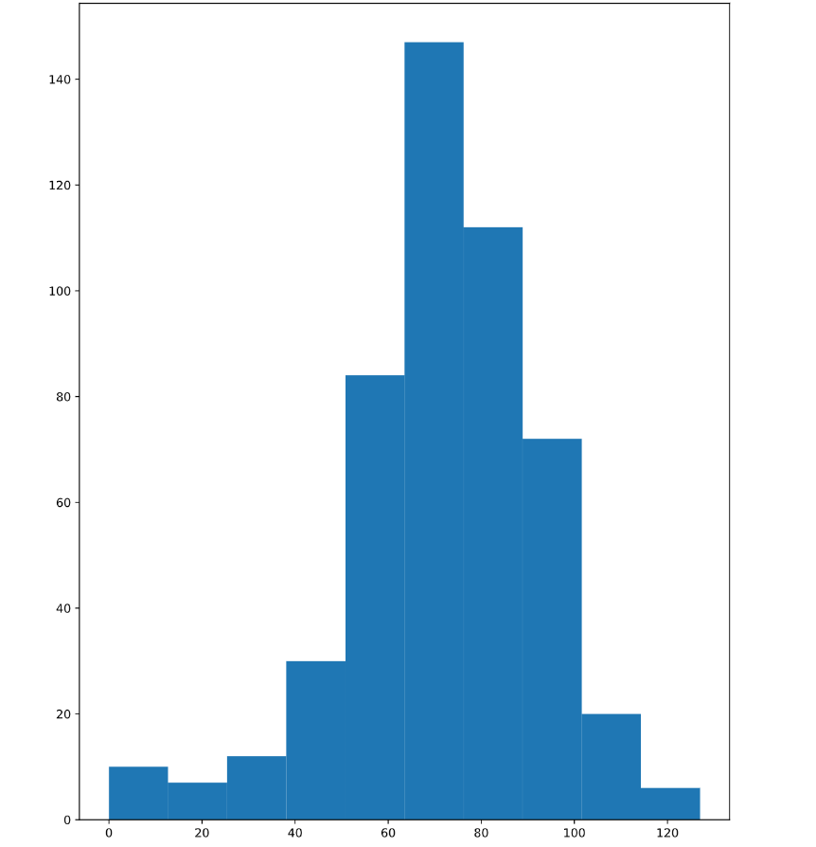  
Great job! Have a look at a histogram; what do you think your chances are?

# Calculate the odds

The histogram of the previous exercise was created from a Numpy array ends, that contains 500 integers. Each integer represents the end point of a random walk. To calculate the chance that this end point is greater than or equal to 60, you can count the number of integers in ends that are greater than or equal to 60 and divide that number by 500, the total number of simulations.

Well then, what's the estimated chance that you'll reach 60 steps high if you play this Empire State Building game? The ends array is everything you need; it's available in your Python session so you can make calculations in the IPython Shell.

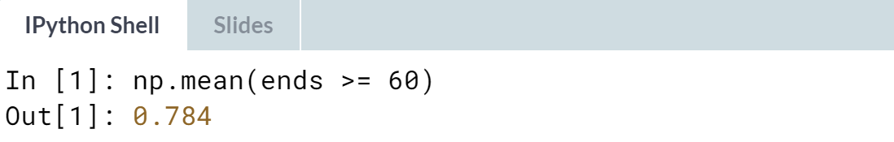  
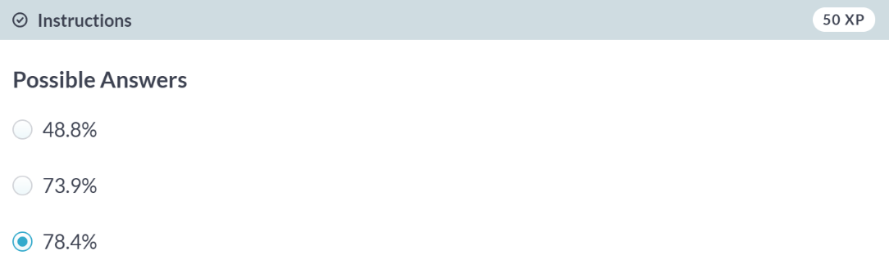  
Correct! Seems like you have a pretty high chance of winning the bet.